**User Guide**

Dear Users:

This program according to the paper *Guo D, Shi W, Hao M, et al. FSDAF 2.0: Improving the performance of retrieving land cover changes and preserving spatial details[J]. Remote Sensing of Environment, 2020,248:111973.* *https://doi.org/10.1016/j.rse.2020.111973.*

The authors greatly thank the great work of FSDAF, SFSDAF from Xiaolin Zhu, Eileen H. Helmer, Feng Gao, Desheng Liu, Jin Chen, Michael A. Lefsky, Xiaodong Li, Giles M. Foody, Doreen S. Boyd, Yong Ge, Yihang Zhang, Yun Du, Feng Ling.

Please double-click **FSDAF2AppInstaller_web.exe** to install FSDAF2APP and MATLAB Runtime version 9.9 (R2020b). Make sure you are connected to the network and anti-virus software (e.g., 360) is turned off during installation.

After installation, double-click **FSDAF2APP.exe**, then a simple GUI of FSDAF 2.0 will appear as below:

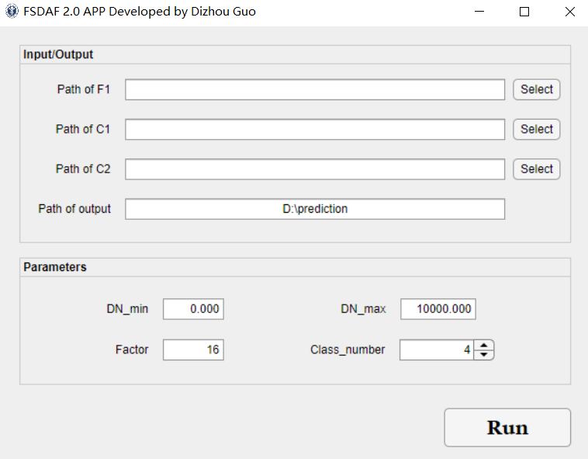

Path of F1 indicates the path of the fine image obtained at based phase, Paths of C1 and C2 indicate the paths of the coarse images obtained at based phase and predicted phase. Path of output needs to contain the file name of the output image.

Please ensure that the fine image and coarse images have the same size. This version of the program can process images in ENVI format and TIFF format (.tif and .tiff).

**Example of path of F1: E:\ testdata\L1**

**Example of path of output: E:\RASDF_APPGUI\testdata\FSDAF2_prediction**

Parameters seting:

DN_min: Minimum DN value

DN_max: Maximum DN value; if using reflectance, use 1 as DN_max

Factor: Resolution ratio of coarse image to fine image

Class number: The max number of classification in unmixing step (Recommended value: 4-10)

**Single click** the Run button to run the program. Once the program is running, the Run button will turn gray. There will be a window prompt after finishing the fusion.

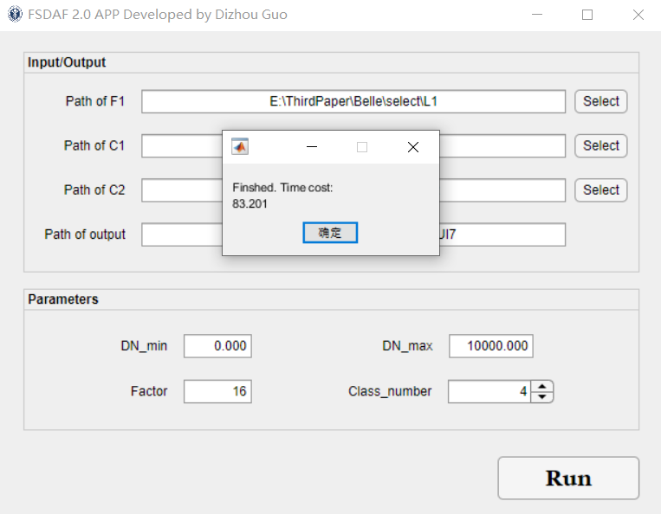

The first version of FSDAF 2.0 was developed on IDL platform, in order to improve efficiency and better share the program, this program is developed on MATLAB. Compared with the original version in the paper, we have made the following improvements:

1. FCM is used for soft classification, this strategy is same to that in another method we developed (*Shi W, Guo D, Zhang H. A reliable and adaptive spatiotemporal data fusion method for blending multi-spatiotemporal-resolution satellite images[J]. Remote Sensing of Environment, 2022,268:112770.* [*https://doi.org/10.1016/j.rse.2021.112770*](https://doi.org/10.1016/j.rse.2021.112770)*. Its program is freely available at https://github.com/ Andy-cumt/RASDF_GUI*).
2. Use bicubic interpolation instead of TPS interpolation to improve efficiency.

Should you have any problem, please contact us.

Thank you!

Best regards,

Dizhou Guo ([dizhou_guo@cumt.edu.cn](mailto:dizhou_guo@cumt.edu.cn))

2021.12.02

**Update history**

12/02/2021 First version of FSDAF2.0 GUI developed by MATLAB 2020b GUI.

01/10/2022 Modify and redesign the interface on the MATLAB 2020b APP designer for ease of use.

01/18/2022 Add TTIF format support and correct a bug in change detection.

01/20/2022 Correct a bug caused by too few candidate pixels for unmixing (If the number of pixels available for unmixing is not much larger than the number of classifications, the unmixing step is not performed).