**User Guide**

Dear Users:

This program according to the paper *D. Guo, W. Shi, H. Zhang and M. Hao, "A Flexible Object-Level Processing Strategy to Enhance the Weight Function-Based Spatiotemporal Fusion Method," in IEEE Transactions on Geoscience and Remote Sensing, vol. 60, pp. 1-11, 2022, Art no. 4414811, doi: 10.1109/TGRS.2022.3212474.*

The authors greatly thank the great work of STARFM, ESTARFM and Fit-FC from Feng Gao, Jeff Masek, Matt Schwaller, Forrest Hall, Xiaolin Zhu, Jin Chen, Xuehong Chen, Qunming Wang and Peter M. Atkinson.

Please double-click **OLfusionv1.0.exe** to install OLfusion_APPGUI and MATLAB Runtime version 9.9 (R2020b). Make sure you are connected to the network and anti-virus software (e.g., 360) is turned off during installation.

After installation, double-click **OLfusionmethodsV1.exe**, then a GUI of OL fusion methods will appear as below:

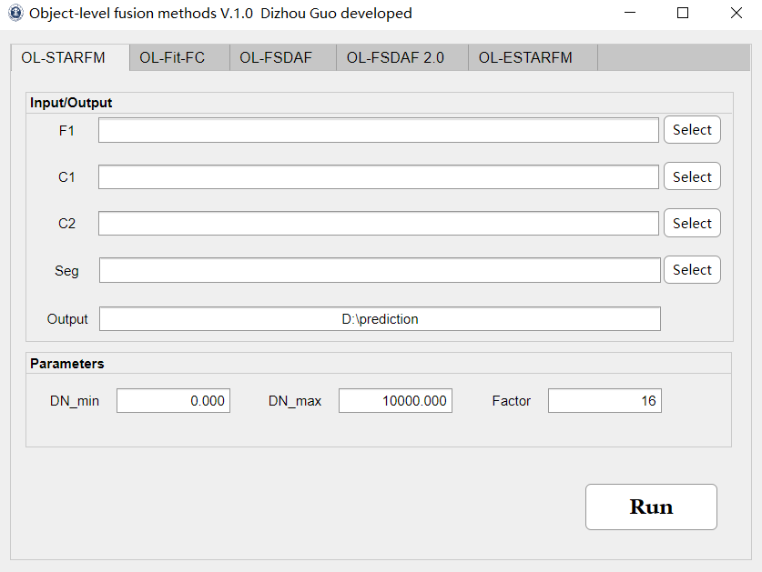

Path of F1 indicates the path of the fine image obtained at based phase, Paths of C1 and C2 indicate the paths of the coarse images obtained at based phase and predicted phase. Path of seg indicates the path of the segmentation result of F1. We recommend using the multiresolution segmentation algorithm of eCognition software to obtain the segmentation result. The specific segmentation operations can be found in the end of this world.

**Path of output needs to contain the file name of the output image.**

**Path of output needs to contain the file name of the output image.**

**Path of output needs to contain the file name of the output image.**

Please ensure that the fine image and coarse images have the same size, the length and width of the image can be divided with no remainder by the scale factor. This version of the program can process images in ENVI format and TIFF format (.tif and .tiff). **Please note: If your image is the ENVI format but the file suffix is .tif or .tiff, the program will not run correctly!**

Example of path of F1: E:\RASDF_APPGUI\testdata\L1

Example of path of output: E:\RASDF_APPGUI\testdata\RASDF_prediction

Parameters seting:

DN_min: Minimum DN value

DN_max: Maximum DN value; if using reflectance, use 1 as DN_max

Factor: Resolution ratio of coarse image to fine image

Class: The number of classification for F1

**Single click** the Run button to run the program. Once the program is running, the Run button will turn gray. There will be a window prompt after finishing the fusion.

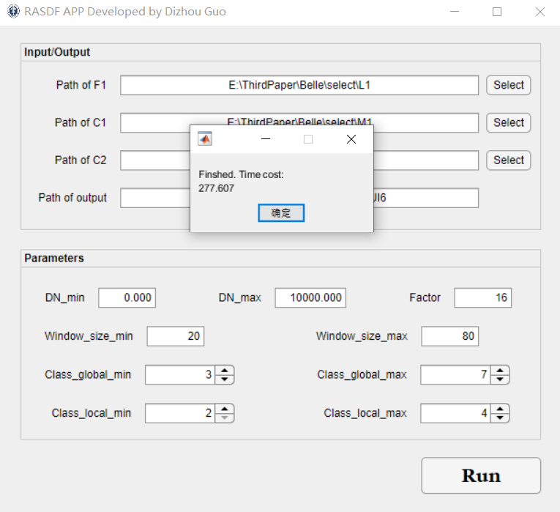

This is the first version of the program and will be updated later. More Object-Level fusion methods will be developed in future!

Should you have any problem, please contact us.

Thank you!

Best regards,

Dizhou Guo ([dizhou_guo@cumt.edu.cn](mailto:dizhou_guo@cumt.edu.cn))

2022.10.30

**Update history**

03/22/2022 First version of OL fusion method APP was developed by MATLAB 2020b APP designer.

**Segmentation operation**

Open the eCognition developer. Load the F1 image. If you have multiple auxiliary fine images, all auxiliary fine images can be stacked into one image in the spectral dimension as the input.

Click view-window-Process tree





Right click the Process tree and Append new. Select the multiresolution segmentation. The reference parameters we provide are as follows. The best scale value can be varied in different surface landscapes, please adjust them according to your dataset. We suggest using the ESP2 tool to help you determine the optimal range of scale for segmentation

Click the Execute to process and wait a few seconds (for the image of 800*800*6) you well get the segmentation result.

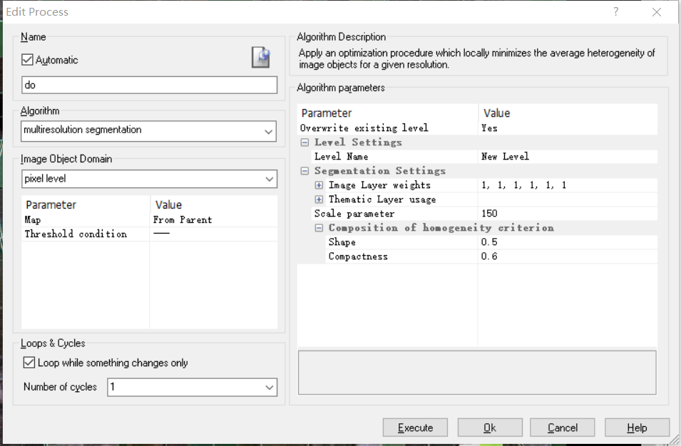

Export the segmentation result:



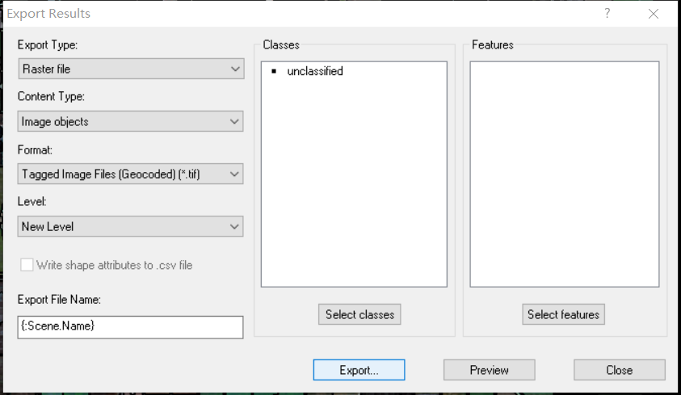

The .tif file is what you need.