**User Guide**

Dear Users:

Please double-click **MyAppInstaller_web.exe** to install RASDF_v1GUI and MATLAB Runtime version 9.9 (R2020b). Make sure you are connected to the network during installation.

After installation, double-click **RASDF_v1GUI.exe**, then a simple GUI of RASDF will appear as below:

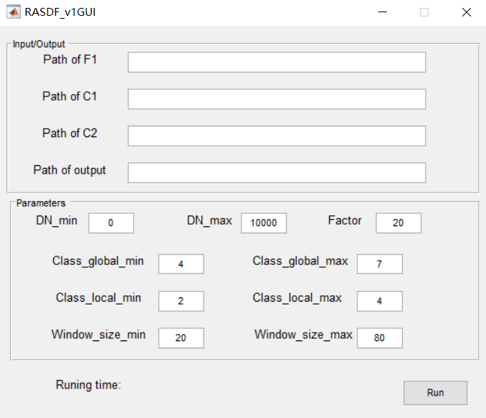

Path of F1 indicates the path of the fine image obtained at based phase, Paths of C1 and C2 indicate the paths of the coarse images obtained at based phase and predicted phase. Path of output needs to contain the file name of the output image.

Please ensure that the fine image and coarse images have the same size. This version of the program can only process images in ENVI format.

Example of path of F1: E:\RASDF_v1GUI\testdata\L1

Parameters seting:

DN_min: Minimum DN value

DN_max: Maximum DN value; if using reflectance, use 1 as DN_max

Factor: Resolution ratio of coarse image to fine image

Class_global_min: Minimum number of classification in Global unmixing step (Recommended value: 3-5)

Class_global_max: Maximum number of classification in Global unmixing step (Recommended value: 4-10)

Class_local_min: Minimum number of classification in Local unmixing step (Recommended value: 2-4)

Class_local_max: Maximum number of classification in Local unmixing step (Recommended value: 3-6)

Window_size_min: Minimum window size in filtering and residual compensation steps

Window_size_min: Maximum window size in filtering and residual compensation steps

Click the Run button to run the program. There will be a window prompt after finishing the fusion.

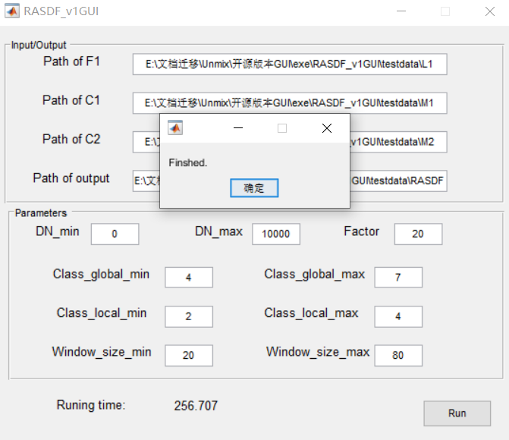

This is the first version of the program and will be updated later.

Should you have any problem, please contact us.

Thank you!

Best regards,

Dizhou Guo ([dizhou_guo@cumt.edu.cn](mailto:dizhou_guo@cumt.edu.cn))

2021.10.16