|  |  |  |  |
| --- | --- | --- | --- |
|  | 前端数据 | 后台返回数据 | 数据库项 |
| 登录返回代码 | username | username | username |
| json | userid | userid | userid |
|  | identity | identity | identity |
|  | telephone | telephone | telephone |
|  | password | password | password |

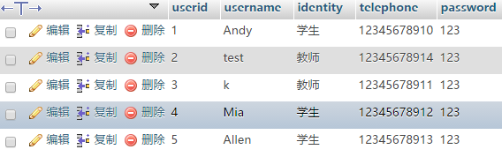

|  |  |  |  |
| --- | --- | --- | --- |
|  | Front_end | Backstage | Database |
| 登陆后查询课程（学生） | courseid | courseid | courseid |
|  | teacherid | teacherid | teacherid |
|  | classname | classname | classname |
|  | introduce | introduce | introduce |

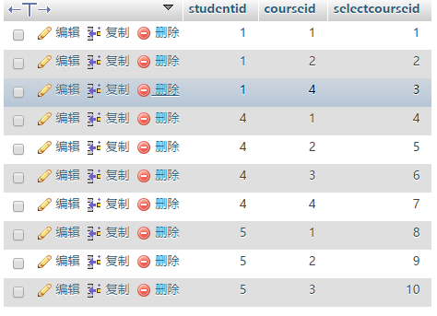

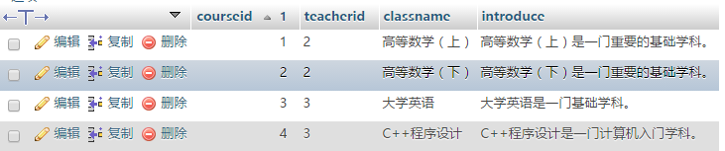

发布作业：

|  |  |  |
| --- | --- | --- |
| Front_end | Backstage | Database |
| **workname** | **workname** | **workname** |
| **content** | **content** | **content** |
| **answer** | **answer** | **answer** |
| **answername** | **answername** | **answername** |

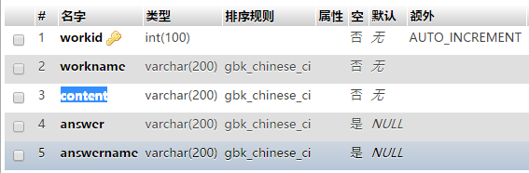

|  |  |  |
| --- | --- | --- |
| Front_end | Backstage | Database |
| studentid | **studentid** | **studentid** |
| **workid** | **workid** | **workid** |

