PROJECT 2: SIMPLIFIED BLACKJACK
Siyi Zhang | CSC/CIS 5 | July 30, 2026
Project Overview
This project revises my Project 1 Blackjack program. The basic game stays the same, but Project 2 reorganizes it with functions and adds arrays, Vectors, player records, searching, and sorting. The program can store up to ten players in players.txt.
Game Rules
- Get closer to 21 than the dealer without going over.
- Number cards use their value, face cards are 10, and an Ace is 11 or 1.
- The player may Hit or Stand. The dealer must Hit below 17.
- A normal win adds the bet. A player Blackjack pays 3 to 2 unless the dealer also has Blackjack. A tie is a push.
Program Design
Five parallel arrays store each player's name, bankroll, wins, losses, and pushes. A 4 x 13 array fills deck[52], and Vector hands hold the cards dealt to the player and dealer. Linear Search finds a player. Bubble Sort orders the bankroll leaderboard, while Selection Sort orders the wins leaderboard. The program loads the arrays at startup and saves them before exit. All money values use float.
Main Program Pseudocode
- Load the five player arrays from players.txt.
- Input a one-word name and use Linear Search to find it.
- Use the saved record, or add a new player with $100.00.
- Repeat the validated menu and run the selected feature.
- Save all player records and exit.
Game Round Pseudocode
- Check the bankroll and validate the bet.
- Build grid[4][13] and deck[52], shuffle, and deal two Vector hands.
- Run the player's Hit or Stand turn, then let the dealer Hit below 17.
- Compare natural Blackjacks, busts, and final totals.
- Update the bankroll and matching player record by reference.
The complete program logic is shown in the separate Project2_Blackjack_Flowchart.drawio file.

Proof of a Working Program
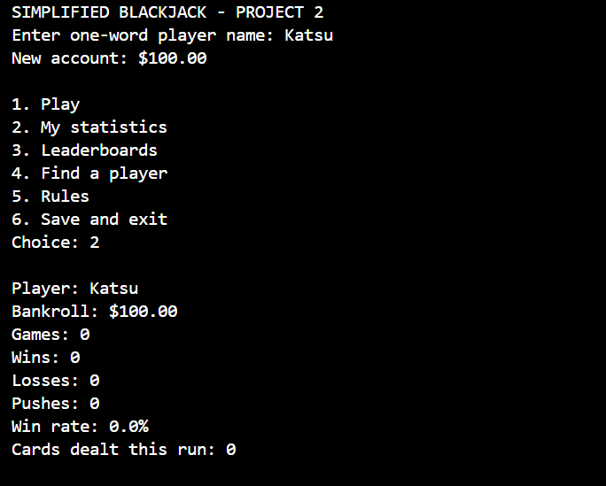
Figure 1. A new player account and its statistics. Katsu was not in the saved records, so the program created a $100.00 account.
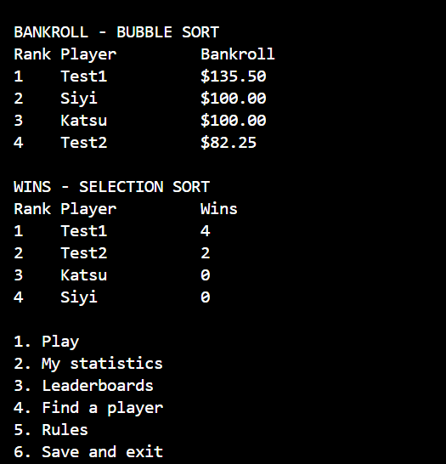
Figure 2. Bubble Sort orders players by bankroll, and Selection Sort orders them by wins.

Complete Game Test
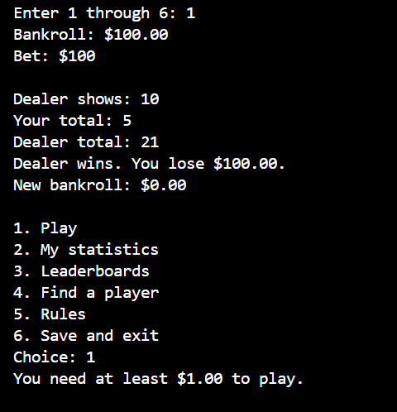
Figure 3. The $100.00 loss reduced the bankroll to $0.00, so the program blocked another game because at least $1.00 is required.
Result
These runs show player records, statistics, both required sorting methods, a complete game result, and bankroll validation. The separate checkoff sheet lists the exact source lines for the Project 1 and Project 2 requirements.

