DM2199  
Computer Graphics Project

140522J Almeda Glenn Paolo Maestro  
143343M Lim Wei Heng  
144108F Chan Kee Siang Andy  
140196G Rayner Tay Yi Zhe  
142039W Lee Chun Kiat

Technical Design Document

Team Spectacles presents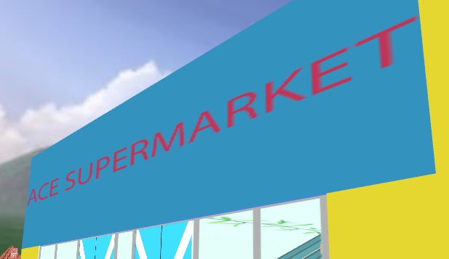Project Theme:

* Supermarket

Project Objectives:

* Conceptualize and code in a 3D environment
* Working in a team

Game Name

* Speed Shopping

Game Concepts

* Game Concept
  + Genre
    - Role Playing Game
    - Simulation
* Game Goals
  + To allow players to experience the possibility of gaming in the supermarket
  + Application of knowledge into a game
* References
  + Walmart Supermarket
  + NTUC

Story

* High Concept
  + Shen (the player) decides to go to the supermarket to buy some groceries.
* Synopsis
  + Shen decides to go to the supermarket to buy some groceries but the nearest one is about ten minutes’ walk from his home. By the time he reaches the ‘Ace Supermarket’, there is more than just buying groceries to do.

Gameplay

* Overview
  + This section elaborates on the general mechanics of the game.
* Abilities and Controls
  + Basic Controls
    - Mouse control to navigate the player’s field of vision
    - “WASD” pad to navigate the player across the space
    - “F” button for interactions with various NPCs in the game
* Available Mini Games
  + Scene 1
    - Breaking the fire alarm will cause panic in the supermarket
  + Scene 2
    - A checklist of items is given to the player to complete within a certain time.
  + Scene 3
    - A missing child roams around the supermarket area

User Interface

* Overview
  + This section elaborates on the user interface.
* Game Flow
  + …
* Main Menu
  + …
* Instructions
  + …
* Game
  + The player is allowed to roam freely in the space even when he triggers a scenario.
  + There are three scenarios for the player to complete.
  + Scenarios that are yet to be completed or is in progress will be written in red font.
  + Scenarios that are successfully completed will be written in green font.
  + Scenarios can only be done once. If player fails the scenario, it will be recorded as a failure.

Technical Design

* Overview
  + To create the game, we made use of the following software.
    - Microsoft Visual Studios 2010
    - Autodesk Maya 2015
    - Adobe Photoshop CC 2014
  + Microsoft Visual Studios 2010
    - The main platform for programming the logic and rendering the models in the game.
    - Rendering the graphics is done by OpenGL.
  + Autodesk Maya 2015
    - Primarily used to create object files (.obj) with their unique textures for enhanced aesthetics appeal
  + Adobe Photoshop CC 2014
    - Primarily used to set up unique textures for the object files to be rendered in Autodesk Maya 2015.

Animation

* Overview
  + This section elaborate on the animation schemes used in this project
* Frames per second
  + Expected frames per second is between 30 and 60.
* Moving models
  + There are models walking around the supermarket to check out the items sold.

Directory

* Overview
  + This section contains information where the files are located
* …

Development

* Overview
  + The development of the game is documented in this section
* Initial Gameplay
  + This is what the game looks like in its early stages with no functions available yet

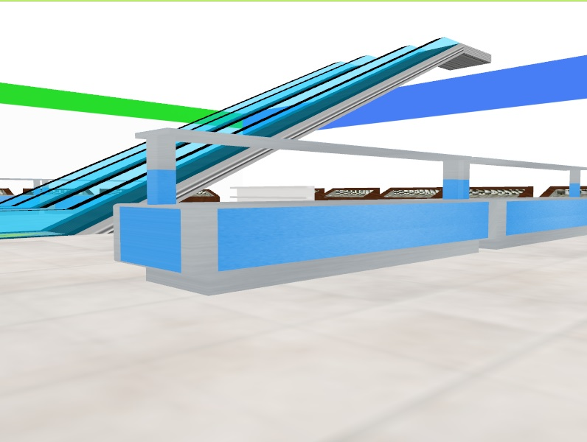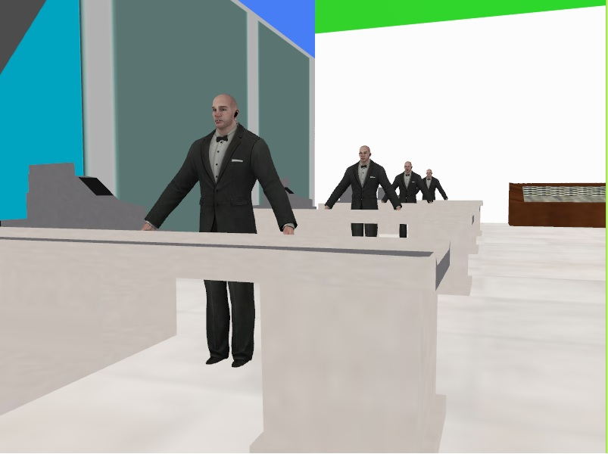

Game Guide

* Overview
  + This section will provide some information to help players get started.
* Basics
  + This game is a first person game
  + Use the “WASD” keys to move the character
  + There are a few scenarios for the player to play. Once the player engages into a scenario, it cannot be repeated.
* Advanced
  + …