**ASSIGNMENT FOR THE DEVELOPERS**

## What are your views on chatbots? Do you think there is need for such a technology? Justify

Views: Since I am developing a well functioned chatbot for a period of time, and while that, I tested many other types of forms chatbots, entertain-targeted, industrial oriented, and sex seduction type…... Rule-based, IR-based Generation-based, QA Based…… Kuki, Siri, Alexa, Cortana, and Georgia Tech’s Jill Waston…… all the forms you can ever imagine. **I do believe, that the world would be entirely changed into another kind because of chatbot, here is my reason:**

Firstly, I need to introduce a little background, please bear with me. I am an ardent follower of **Marshall McLuhan's "the Medium is the Message",** what it means is that, the way that we send and receive information is much more important than the information itself, situations like when we want customers absorbing information by watching television or listening to the radio would be totally different.

The mediums also have changed the way we behave. Researches shows that our memory capacity have been declined because of digital technology. News stories have been replaced with 140-character tweets (You must know it’s Twitter, but my Chinese friends are clearly not familiar with it). Conversations have been replaced with emojis. And before the news stories, there were books and magazines, all have been replaced by following mediums. **The Mediums changed the Message.**

Importantly, **chatbot is one new form of medium! A medium that’s destined to revolutionize the way people express their messages.**

Need: I do think there’s great need for developing chatbots:

When we visit a website, we are getting used to check information through the chatbot, which normally welcomes us and say: “Hello there, what can I do for you”. When we are shopping on a website, an instant response chatbot would really ease us. It changes how you think (think like a bot) and express (express like a bot). For a real case, when we are using Zoom to have our lessons, the onboarding page has a chatbot that can almost solve all the problems I had when using Zoom:

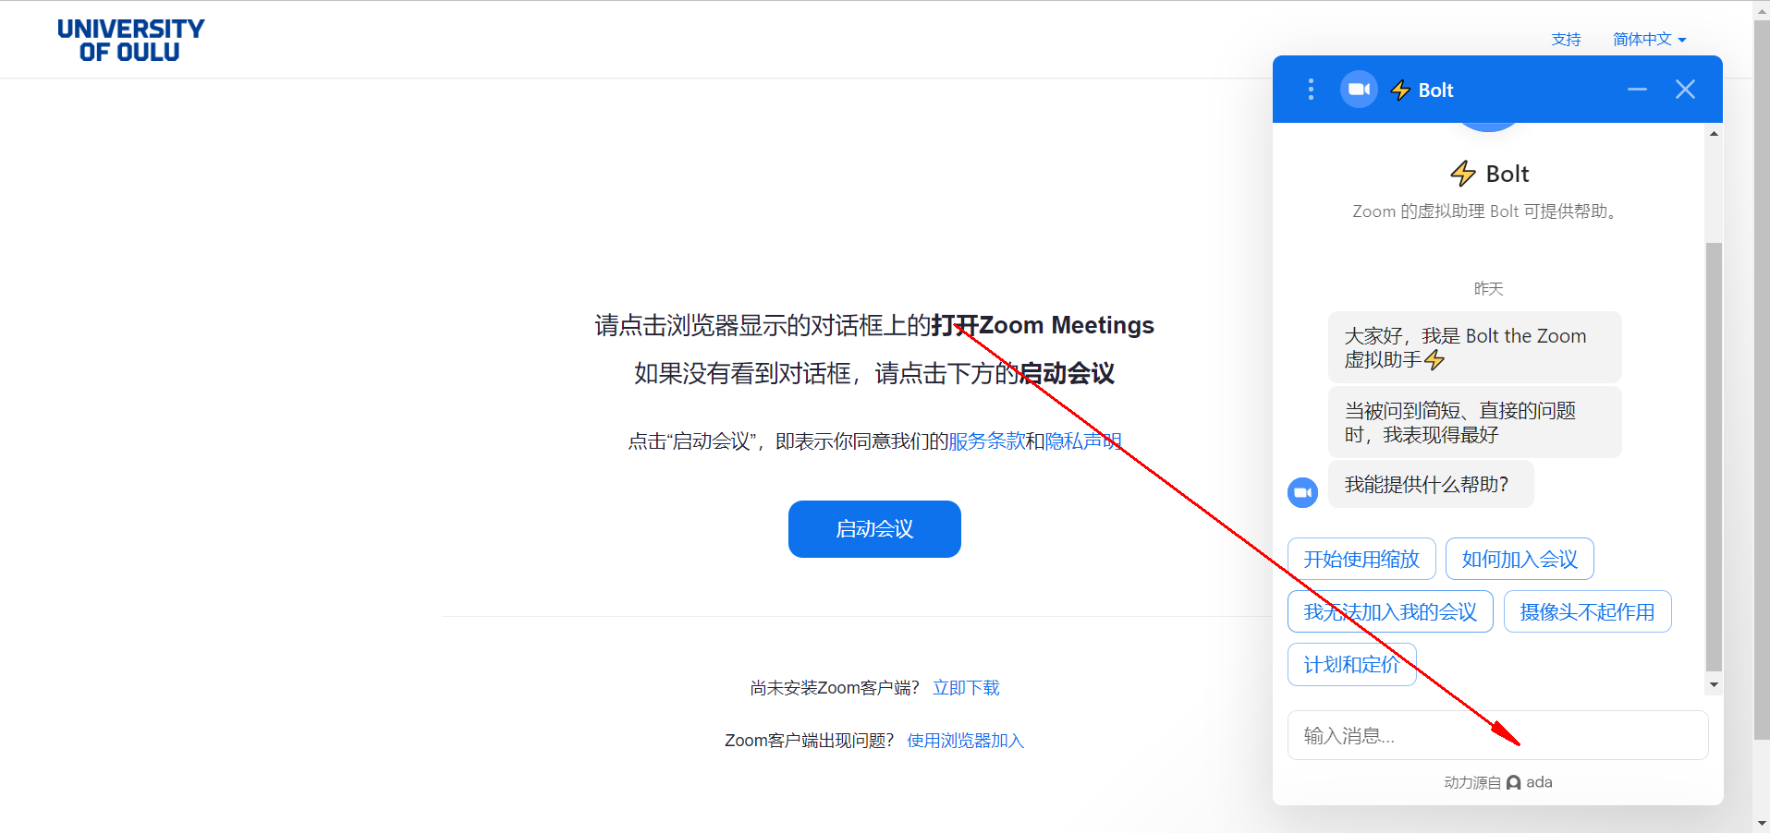

**Figure 1.** Zoom example showing how chatbot influence us

**So yes. I honestly think, there are a great need for this technology.**

## Can chatbots be developed without the use of Artificial Intelligence? Justify

Before answering this question, we have to **define and figure out, what is AI**. There are many descriptions, we can simply put it like: “the combination of techniques allowing computers to utilize human intelligence like making decisions, having conversations, creating arts, etc.”

And **we need the machine learning part to make the chatbot capable of adapting information and examples.**

**Therefore, NO!! Chatbot cannot be developed without the use of AI!** I can be more specific:

When we are adding intent examples to the NLU (Natural Language Understanding) part, for example, greeting part. We certainly would fill examples like: ‘Hi’, ‘Hello’, ‘hey’. But, if the user types ‘Hiiiiiiiiiii’, the chatbot without NLU would be totally lost. They are not capable of understanding the dialogues!  **And that’s what a memorization policy would help in this situation.**

If someone want to debate: “I can write tons of examples to adapt to information” well, I admit it can work in some occasions, but the cost is too big, and you would never want to undertake that. **Also, that’s not a chatbot, that’s a dictionary.**

Therefore, **I insist that Chatbot cannot be developed without the use of AI!**

## Where do you think chatbots are absolutely needed?

Considering the capacity, features and functions, several occasions can apply chatbot:

Online Commerce, Marketing, Customer Support, Live chat, Lead Generation.

If we have to narrow them to absolutely needed, we can say **e-commerce and customer support absolutely need chatbots to support them**, since dealing enormous information manually can be terrifying and cause a lot resource waste, and some questions are asked over a million times before, which can be saved if using chatbot.

## Conversely, where do you think chatbots are not necessary?

It’s hard to say ‘not necessary’ in some occasions, let’s take examples above, if the customer ground is big enough, then it’s almost all necessary to have a chatbot. However, there still are situation applying a chatbot would do harm to the companies, for example, **undertakers and fishmongers are not suitable for applying one**. For the first, it’s about the taste and manner, for the second, selling fresh fish should be live, which will be boring and against nature if taking a bot.

Also, there are occasions that, when a company has not figured out what it wants the bot to do, when there’s no way of measuring the bot’s success or impact, when customers feel weird talking to a bot and it failed to have valuable traction, when developer uses complicated technics and makes the situation more overcomplicating, are all not necessary to take a chatbot.

## What are the unintended consequences of relying on chatbots?

To my understanding, unintended consequences often mean risks, so I will explain my thought on this aspect.

First, hackers can easily **create bots that disguise as buyers**, striking up dialogues as the in-house personnel of businesses.

Secondly, since the bot can process information so fast, **it could displace low-level human workers** in the future. Especially in developing countries.

Thirdly, chatbot can be manipulated into saying ***racist, sexist and other offensive content*** through social engineering attacks.

Lastly, it’s **impossible to be held accountable** when the bot expresses anything, it can cause potential harm to ‘digital trust’. It looks like we are in a Blackbox, don’t know how decisions are made.

## Imagine you have an open-domain chatbot developed using IBM Watson Assistant

* 1. “*The Professor talked about quantum mechanics. I am lost.*”
  2. “*That’s one small step for man, one giant leap for mankind*”

a: “The professor talked about quantum mechanics. I am lost”

There are **two ways** I could think of how would a well-trained bot could analyze and react:

The intend should be the same:

**intent:** Receiving the sentence that “I am lost.”, **I assume the bot would define it like a kind of ‘sad path’ intent**, which will trigger stories.yml, following a ‘utter_dont_worry’ utterance. Which I will discuss it later.

Entities and slots can be the same:

**entities**: There should be entities to identify, like who is it, what subject are we talking about, what content has it included. To simplify, I would say: **person; subject; content.**

**slots**: Because the slot saves memory, and correspond to the entity. So, there would be **person; subject; content.** But I want to discuss more about it. What kind of mapping should it utilize, it’s not a Boolean or categorical or float, they can be item and text, or it can be customized, depends on how we want to use them. **For this specific case, person: professor; subject: quantum mechanics; content: ???(to fill)**

When coming to actions, there are two way to go:

First:

**custom actions**: Because of having one slot to fill, I would like to write **a method to ask the user to fill the missing part of slot**, like “Which part of the content are you not familiar with?” and based on the users’ responses to react the next utterances.

Second:

**custom actions:** The other way I have in mind is when I used a bot named Chai, I was shocked at what it provides me when I said I liked ‘John Travolta’, and then it provides me a link that tells all about John. So, I think there’s a way to develop the bot into **providing a link search on Internet, based on the entity: subject and person.** For this case, person: professor is not much of use. But the subject: quantum mechanics can do a role in this. Like providing a link connected with quantum mechanics.

**stories.yml**: I would say the general story for this would be like this:

(intent: sad path + utterance: utter_dont_worry)

+ [ (action: fill_up; ) + utterance: utter_what_content) ] OR

[(action: search_entity) + (utterance: help_entity)]

So, the two way to go can be like this:

**First:** Utterance: “Don’t worry” + “Which part of the content are you not familiar with?” then action_listen.

**Second:** Utterance: “Don’t worry” + “I can help you find more information on Quantum Mechanics[content]: here’s the link” then action_listen.

b: “That’s one small step for man, one giant leap for mankind”

Developing an AI chatbot is mainly based on what would a human reacts, but to be honest, I don’t even know what to say when someone make this to me, but I will still try to analyze it. And since we imagined this bot is a KNOW-IT-ALL type, I would assume it can do something the Rasa Framework cannot process, therefore, I might make up some concepts that’s not appeared in the Rasa, but which would be reasonable to have one.

**intent**: (I think there should be no intent actually, it is simply a declarative sentence or a sentiment, that should not trigger any utterance in the traditional way, but in our imagined bot, it can be triggered in some way, I’ll explain later)

**action:** (Because a perfect bot should know everything, so I would say **it won’t include this obviously rational sentence into an ‘out-of-scope’ intent or a ‘default_fallback_action’,** but also because it’s just a plain statement, the bot doesn’t have any saved utterance to answer this, I would say, **it can have an action, which can link through Internet to search the sentence, which it will get answers in json format(most likely), and parse it.** We can imagine the most likely occurred sentence would be consisted of keywords like ‘*Neil Armstrong*’ + ‘*first set foot on the moon*’ + ‘*1969*’, and we can do something about this. ) First, return all those [information], get one by one in the slots.

**slots:** (I would say it consist the common parts of 3W. Who:[person] What:[thing] When[time], and each can be filled with the above mentioned information)

action again: (the bot can reorganize the slots, like a rhetorical question to encourage the user to say more about this, which will give the bot more information)

So, the response I imagine would be:

“Is it said by *Neil Armstrong[person]* at *1969[time]* when he *first set foot on the moon[thing] ?* ” then action_listen