# RE职责：

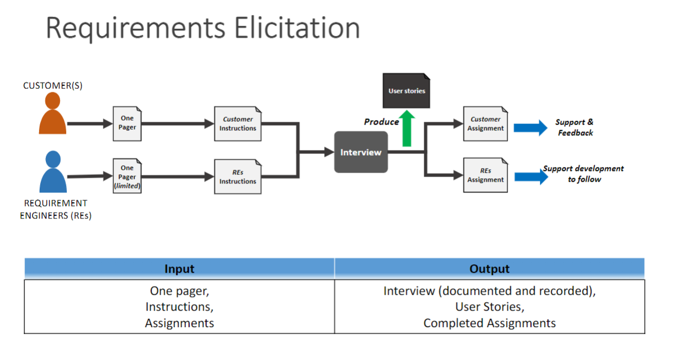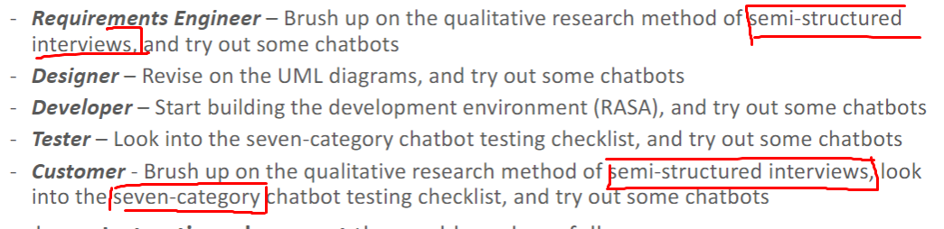

# 什么是Semi-Structure：

[Semi-Structured Interview | Definition, Guide & Examples (scribbr.com)](https://www.scribbr.com/methodology/semi-structured-interview/)

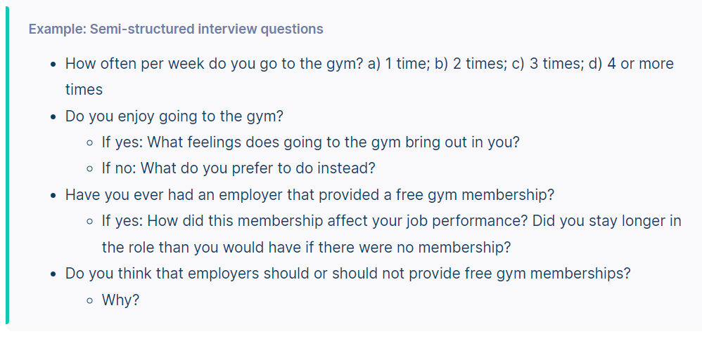

# 经典Chatbot：

