Project Overview

Executive Summary 1
System Operation and Workflow 2
Verification and Validation of AI Outputs 4
Immersive Environment Deployment 4
Trainee Monitoring and Multimodal Sensing 5
Architectural Advantages 5

Executive Summary
This project develops and deploys an AI-driven, real-time adaptive training platform for emergency response, designed to transform how firefighters and EMTs prepare for complex, high-risk situations. The system integrates advanced artificial intelligence, including agentic AI, with immersive environments to create dynamic training scenarios that evolve in response to trainee actions.
At its core, the platform uses cloud-based AI models to generate, interpret, and continuously adapt scenarios, enabling a closed-loop training experience in which decisions directly influence outcomes. These scenarios are delivered through a scalable hub-and-spoke architecture, with a central hub at Virginia Tech and pilot deployments at the Alexandria Fire Department and the City of Philadelphia. Trainees interact with immersive environments and physical mannequins, while multimodal sensing captures voice, movement, and procedural actions for real-time AI interpretation.
A key component of the system is a robust verification and validation framework that ensures the safety, accuracy, and instructional value of AI-generated scenarios and responses. This framework leverages models trained on structured medical knowledge, including medical dictionaries, treatment protocols, dosage guidelines, and documented expected outcomes. Initial datasets are drawn from materials provided by the Alexandria Fire Department, with ongoing expansion to incorporate additional validated sources. The system continuously evaluates AI outputs against these standards, enabling rule-based and model-based validation of clinical appropriateness and scenario coherence. This validation layer is continuously updated as new guidelines, best practices, and treatment data emerge.
The system is designed for both high-fidelity immersive deployment and broader accessibility through a tiered model that supports lower-cost configurations. This ensures that departments of varying size and resources—including under-resourced and geographically dispersed communities—can benefit from advanced training capabilities.
By combining immersive technology with agentic AI and a rigorous validation framework, this project advances beyond static simulation toward fully adaptive, safe, and responsive training environments. The result is improved decision-making, increased preparedness, and enhanced community resilience, with a scalable pathway for regional and national deployment.

System Operation and Workflow
The proposed system operates through a coordinated, AI-driven, cloud-enabled hub-and-spoke architecture that enables real-time, adaptive training across distributed sites as seen in Figure 1.
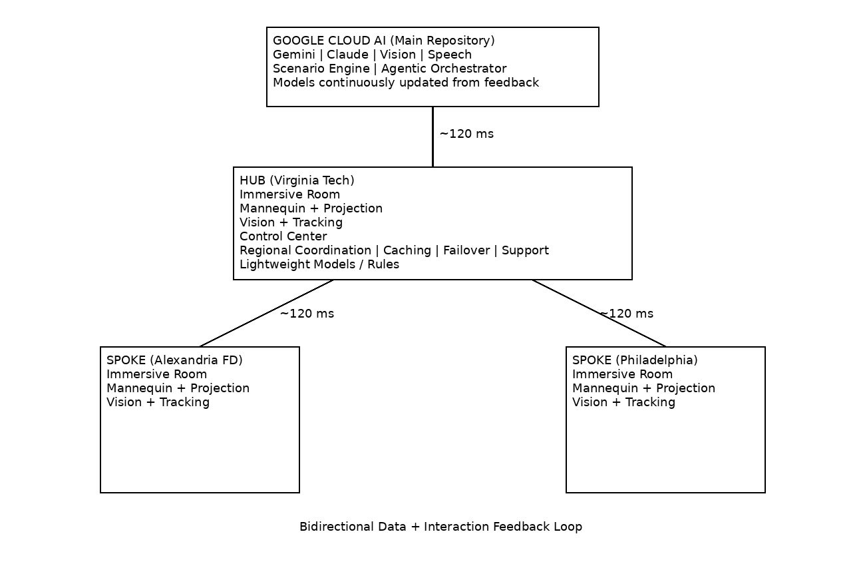
Figure 1. AI-Driven Hub-and-Spoke Training Architecture of Pilot System.
A cloud-centered system where generative and agentic AI models create and adapt emergency response scenarios in real time. A regional hub at Virginia Tech provides coordination, caching, and resilience, while spoke sites (e.g., Alexandria and Philadelphia) deliver immersive training. Bidirectional feedback loops enable continuous model improvement with low-latency (~120 ms) distributed operation.
At the core of the system is a suite of advanced AI and agentic AI models that generate, orchestrate, and continuously adapt emergency response scenarios. These models dynamically construct firefighting and EMT scenarios, including evolving environmental conditions, patient states, and situational variables, without reliance on fully pre-scripted narratives.
These AI-generated scenarios are deployed from the cloud to regional hubs and distributed to connected spoke sites, including pilot locations at Virginia Tech, the Alexandria Fire Department, and the City of Philadelphia. The hub-and-spoke model enables low-latency performance through regional caching and coordination, reduces reliance on continuous cloud connectivity, and provides failover capabilities to maintain operation during network disruptions. Hubs also support lightweight models and rule-based validation locally, improving responsiveness and reliability. Additionally, distributed, distance-based training allows centralized instructors to support multiple sites simultaneously, reducing the need for dedicated training staff at each spoke location. This architecture enhances scalability by allowing new sites to be added with minimal infrastructure while maintaining consistency, centralized oversight, and cost-effective deployment across diverse and resource-constrained environments.
At each site, trainees engage directly with the system by speaking, moving within the environment, and performing procedures on physical mannequins. These interactions are captured through multimodal sensing systems, including voice input, computer vision (pose and object detection), and motion tracking technologies.
Captured data is transmitted to the cloud, where AI models interpret trainee actions in real time. Through agentic reasoning, the system evaluates correctness, timing, and decision quality, enabling continuous assessment and context-aware decision-making.
Based on this analysis, the system performs real-time AI-driven scenario adaptation. Agentic AI dynamically modifies environmental conditions (e.g., fire progression and hazards), patient states (e.g., vitals, responsiveness, and symptoms), and event trajectories in response to trainee actions. This creates a closed-loop system in which trainee decisions directly influence scenario evolution.
These updates are delivered back to each site and rendered through immersive environments and physical interfaces, ensuring that trainees experience the immediate consequences of their actions.
All trainee interactions and outcomes are logged and incorporated into a continuous AI-driven learning loop. This feedback is used to refine scenarios, improve model performance, and enhance system intelligence over time, enabling increasingly realistic, responsive, and personalized training experiences.

Verification and Validation of AI Outputs
A critical component of the proposed system is a comprehensive verification and validation (V&V) framework designed to ensure that AI-generated scenarios, patient states, and adaptive responses remain clinically accurate, instructionally appropriate, and operationally safe.
This framework integrates both rule-based and model-based validation mechanisms. A dedicated validation model is trained on structured medical knowledge sources, including medical dictionaries, dosage guidelines, treatment protocols, and documented expected outcomes for emergency interventions. These resources are initially sourced from the Alexandria Fire Department and will be expanded to include additional validated clinical and training datasets. The system continuously compares AI-generated outputs against these references to ensure consistency with established medical standards.
During operation, all generated or adapted scenario elements—such as patient condition changes, recommended interventions, and environmental responses—are evaluated against this validation layer. Outputs that fall outside acceptable bounds can be flagged, corrected, or regenerated in real time. This ensures that trainees are exposed only to scenarios that reinforce correct practices and do not propagate unsafe or unrealistic behaviors.
The validation framework is designed to evolve over time. As new clinical guidelines, best practices, and treatment outcome data become available, they can be incorporated into the validation models and rule sets. This enables the system to remain current with evolving standards of care and continuously improve the fidelity and reliability of training scenarios.

Immersive Environment Deployment
Each training site is implemented as an immersive room designed to support high-fidelity, AI-driven interaction. The environment utilizes a multi-projector configuration (typically three projectors) to create a continuous, large-scale visual field surrounding trainees. Within this space, a physical training mannequin is integrated as a central interaction point.
AI-generated visual content is projected both onto the surrounding environment and onto the mannequin using projection mapping techniques. Projection may be applied externally to the mannequin surface or, where feasible, from beneath or within the mannequin structure to create more realistic subsurface effects such as skin tone changes, injury visualization, or physiological responses. The system incorporates mannequin localization and tracking to ensure precise alignment between projected content and the physical model, even as trainees move and interact.
This integration enables the AI system to visually and physically represent patient condition changes in real time, synchronized with environmental updates and audio feedback, creating a cohesive and highly realistic training experience.

Trainee Monitoring and Multimodal Sensing
The system incorporates a comprehensive, AI-enabled trainee monitoring framework that captures and interprets user behavior in real time. Multimodal sensing includes voice input, vision-based pose and gesture recognition, and motion tracking through wearable or environmental sensors. These inputs allow the system to observe not only what actions are taken, but how and when they are performed.
AI and agentic models process these inputs to assess procedural correctness, timing, coordination, and decision-making under pressure. The system can detect key actions such as airway management, wound treatment, or situational assessment, as well as identify omissions, delays, or unsafe behaviors.
This continuous monitoring enables the AI system to respond immediately by adapting the scenario, providing implicit feedback through environmental or patient changes, and generating structured performance data. The result is a real-time, data-rich evaluation process that supports both formative training and post-scenario review, while also feeding into the broader learning loop for system improvement.

Architectural Advantages
The proposed architecture offers several key advantages:
Scalable and AI-Centric:
The hub-and-spoke design, combined with centralized AI and agentic orchestration, enables rapid expansion while maintaining consistent, continuously improving intelligence across all sites.
Real-Time AI-Driven Distributed Training:
The system supports synchronized, geographically distributed training powered by real-time AI inference and adaptation. Prior prototype results demonstrate connectivity across distances exceeding 4,000 miles with approximately 120 ms latency, enabling effective real-time interaction.
Cost-Effective Through Cloud-Based AI and Centralized Staffing:
By centralizing AI models and compute in the cloud, the system reduces the need for expensive local GPU infrastructure. In parallel, the hub-and-spoke model enables centralized instructors to support multiple sites simultaneously, reducing the need for dedicated training personnel at each spoke and lowering overall operational costs.
Adaptive, Agentic Intelligence:
Agentic AI enables continuous, context-aware scenario evolution driven by trainee behavior, moving beyond static simulations to fully interactive, decision-responsive training environments.
Interoperable and Accessible:
The tiered system design supports deployment across diverse environments, including urban, rural, and volunteer-based departments, expanding access to advanced AI-powered training capabilities.

