Organization Overview
Domino’s Pizza is a global quick-service restaurant brand with significant delivery and carryout operations. Its current five-year strategy, “Hungry for MORE,” emphasizes food quality, operational excellence, value, and franchisee support.¹ These priorities depend on an ordering process that is accurate, convenient, and consistent for customers and stores.
Digital ordering is central to Domino’s business model. Domino’s reports that more than 85 percent of sales come through digital ordering channels.² Its website allows customers to begin an order for delivery or carryout, choose a store, build an order, and track its progress.³ The public ordering experience therefore provides a useful basis for identifying the data needed to support customer orders.
Figure 1: Domino’s carryout store-selection interface. The customer chooses delivery or carryout and identifies a store before browsing available offerings.³
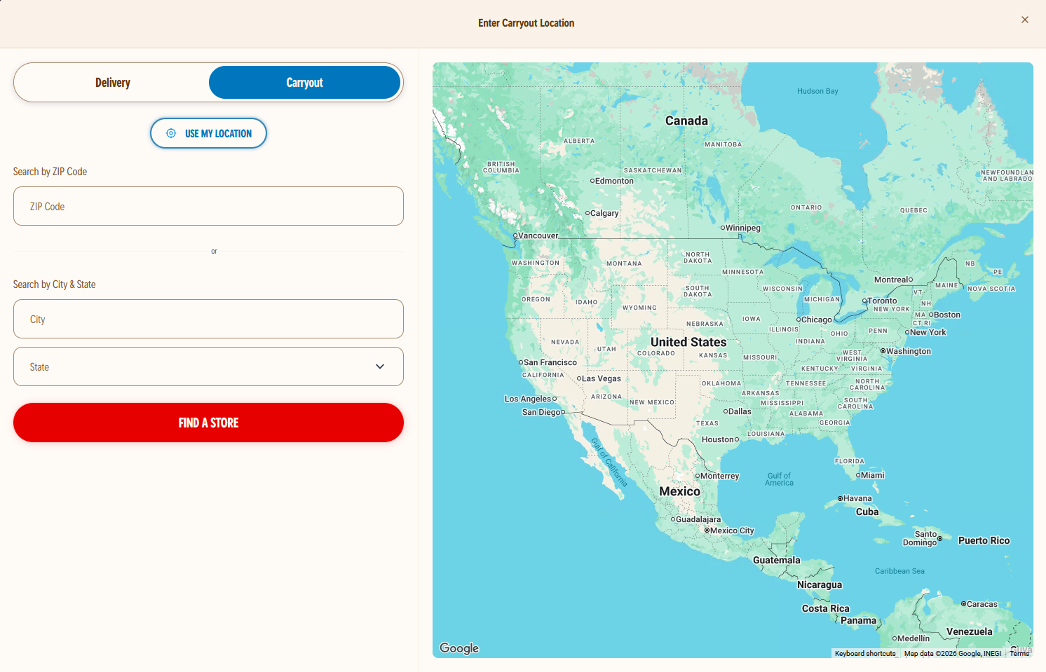
The ordering process begins with the customer’s fulfillment choice and selected store. The selected store affects menu availability and price. Customers then browse products and configure eligible variations. For example, a pizza may require a size and crust selection. The database must preserve the final selections and charged prices when the customer submits the order. Later menu or pricing changes should not alter the historical order record.
Figure 2: Domino’s store-specific menu categories. The menu groups items into product categories after the customer selects a store. ⁴
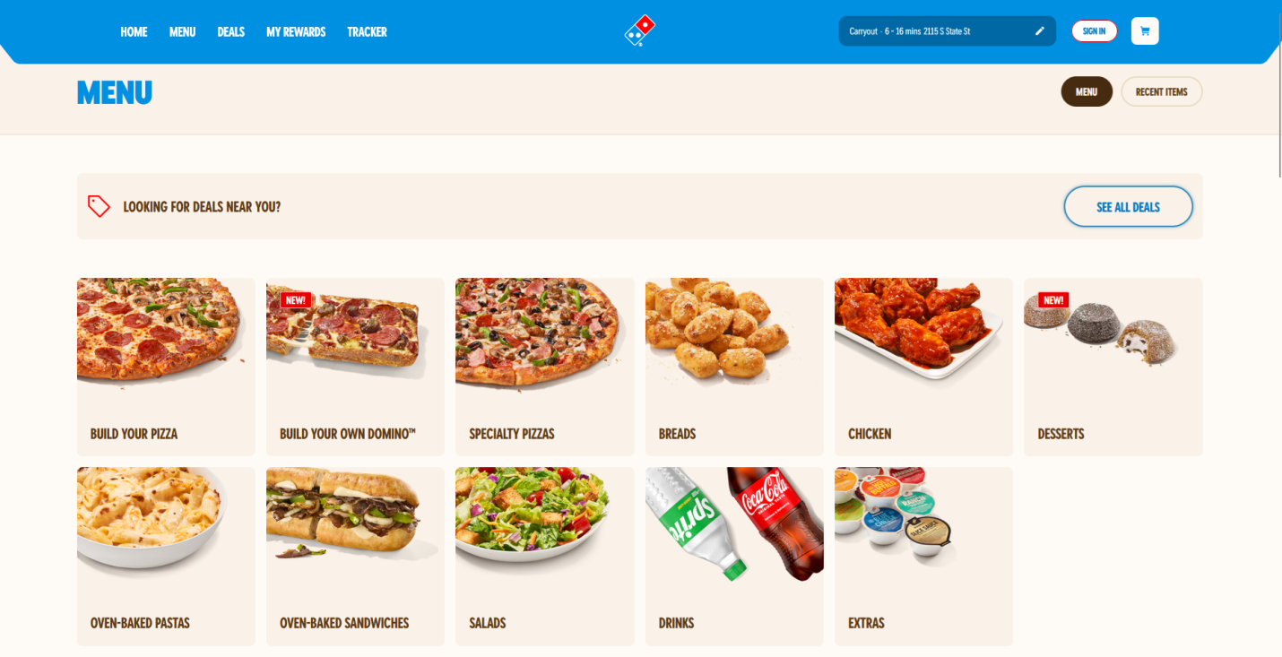
Figure 3: Domino’s pizza-configuration interface. Customers select crust and size before adding a pizza to the cart. ⁵
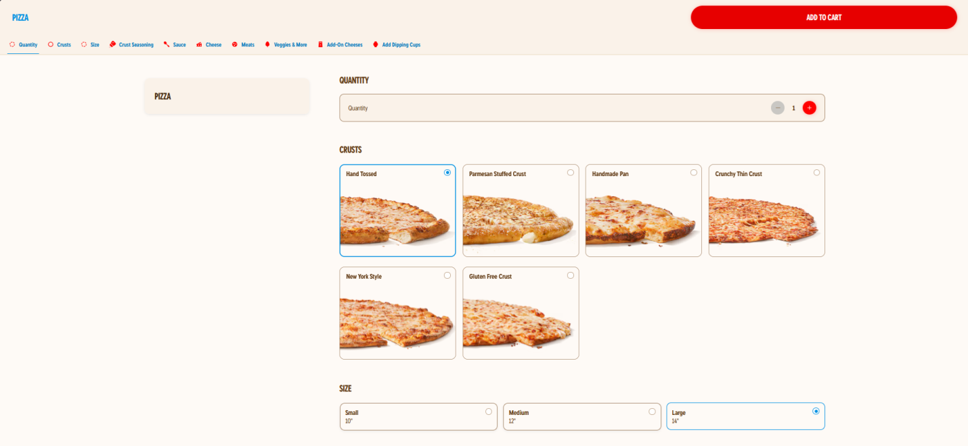
The system must record the financial and fulfillment information needed to complete an order. This includes item quantities, prices, promotions, tax, delivery fees, payment status, and order total. It must also support both registered and guest customers. Registered customers may retain profile information, delivery addresses, and loyalty activity. Guest orders require only the contact and fulfillment information needed for that transaction.
Promotions and loyalty programs create additional recordkeeping needs. Domino’s Rewards allows qualifying orders to earn points toward eligible rewards. ⁶ The database must retain each promotion applied to an order and the discount amount actually given. It must also retain loyalty earning and redemption events. This history supports customer service and allows the business to evaluate promotion and loyalty-program activity.
Once submitted, an order moves through preparation and fulfillment. Domino’s Tracker gives customers access to order-progress information. ⁷ The project therefore records order-status events instead of only a final status. A status history supports customer visibility and operational reporting. It also allows the business to identify open orders and evaluate fulfillment time.
Figure 4: Domino’s Tracker interface. Customers can use the Tracker to retrieve order-progress information. ⁷
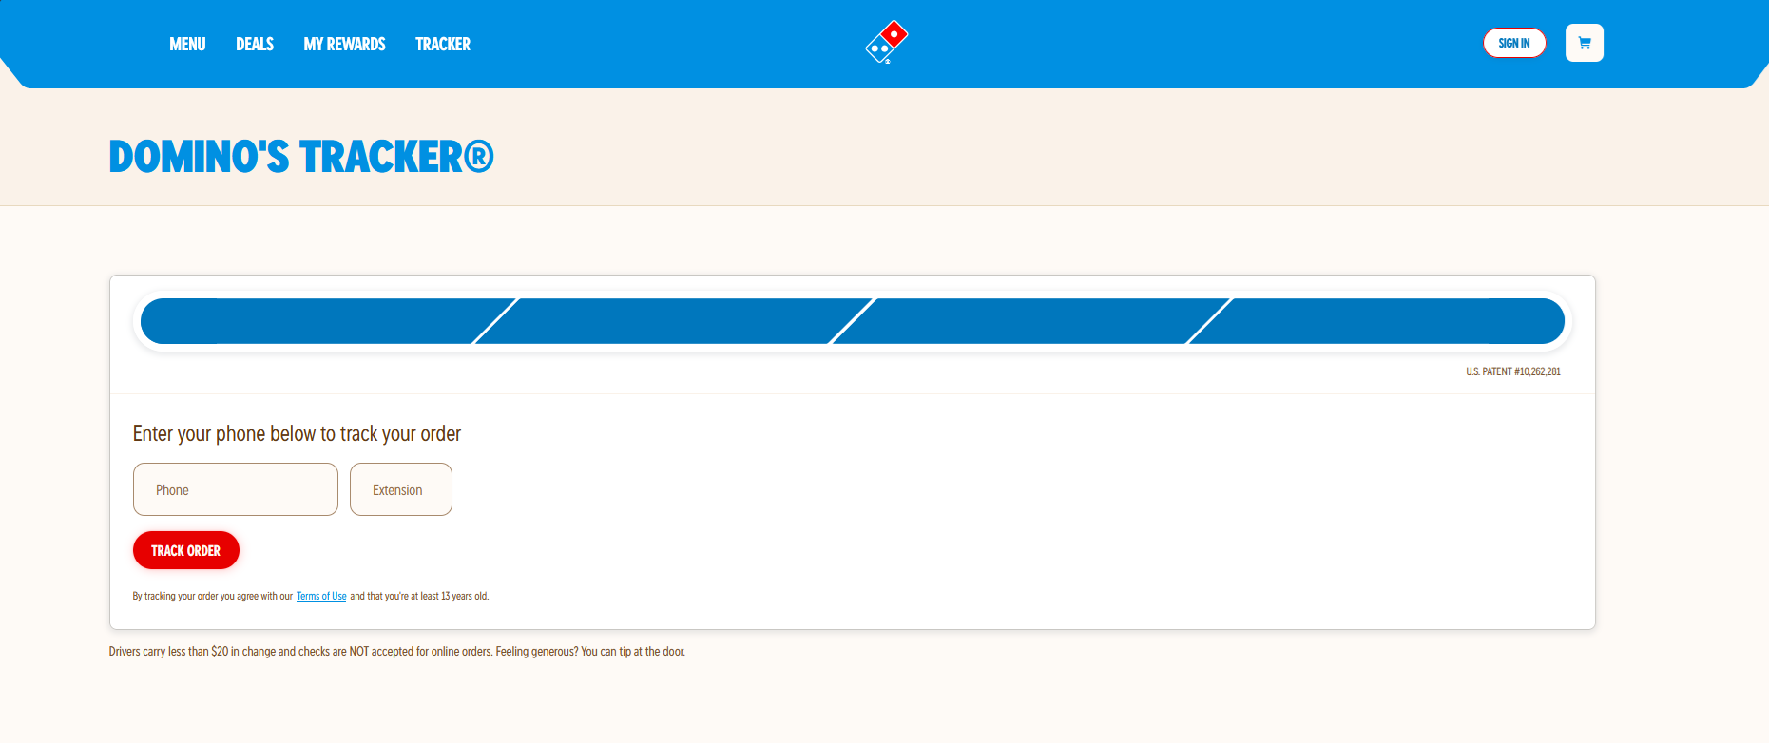
This project models the customer-facing online-ordering process for three illustrative stores. It is an educational reconstruction based on publicly available information. It does not reproduce Domino’s internal systems, full menu, or actual customer data. The database focuses on the information needed to place, fulfill, and analyze an order. It also includes Meal Club, a proposed subscription venture that records available plans, customer enrollment, and benefit-use events.
The resulting database serves as the system of record after an order is submitted. It preserves the information needed for fulfillment, customer service, and reporting. This supports Domino’s focus on convenience, value, and dependable digital ordering.

Scope and Assumptions
The organization overview describes a customer-facing ordering experience in which a customer selects a store, configures products, completes a purchase, and receives fulfillment updates. This project narrows that experience to the information the database must retain during and after an online order. The resulting model supports delivery and carryout orders for three illustrative Domino’s stores.
The process begins when a customer provides a location and selects an available store. The customer then chooses delivery or carryout, browses that store’s offerings, configures eligible product variations, and submits an order. The database records the selected items, customizations, charged prices, promotions, payment result, fulfillment method, and order-status history. It supports both registered customers and guest orders. Registered customers may maintain addresses and participate in the loyalty program.
The model also includes the proposed Meal Club venture. Meal Club extends the core ordering process through subscription plans, customer enrollment, and benefit-use events. It is limited to the data needed to administer the venture and report on customer participation.
The model does not attempt to reproduce Domino’s complete operating environment. The detailed scope boundaries and project assumptions are provided in Appendix A. This scope defines the business objects and relationships represented in the conceptual and logical models that follow.

