Appendix A: Project Scope and Assumptions

In Scope:
- Registered customers and guest orders
- Customer addresses and store selection
- Store-specific menus, products, variations, and customizations
- Orders, order items, promotions, payments, and fulfillment method
- Order-status history and customer loyalty activity
- Synthetic sample data
- Meal Club, the proposed pizza-subscription venture

Out of Scope:
- Ingredient-level inventory, suppliers, and distribution centers
- Employee scheduling, payroll, and franchise accounting
- Detailed kitchen preparation, driver assignment, and GPS tracking
- Corporate marketing systems and customer-service case management
- Payment-card storage, processor internals, and tax-calculation rules

Key Assumptions:
- Each order is fulfilled by one store.
- An order may be associated with a registered customer or placed as a guest order.
- A customer may maintain multiple addresses.
- Product availability, prices, and promotions may vary by store.
- An order contains one or more order items.
- Each order item represents one selected product variation and may include multiple customizations.
- Each order uses either pickup or delivery.
- The system records payment results but does not store complete card information.
- All project data is synthetic.

Appendix B: Business Requirements Register
Table B.1. Complete business requirements register for the Domino’s online-ordering database.
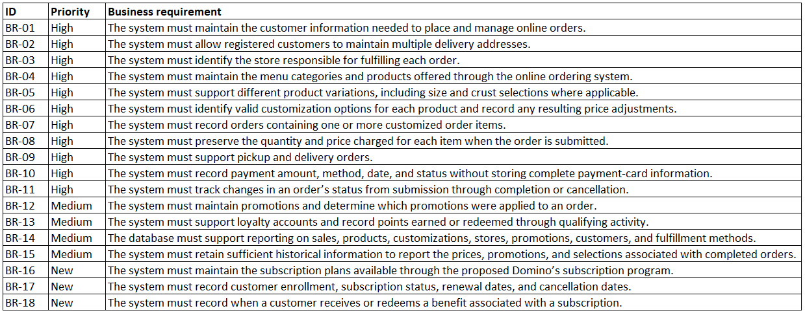

Appendix C: Final Relational Model and Development Evidence
Figure C.1. Complete final relational model for the Domino’s online-ordering database.
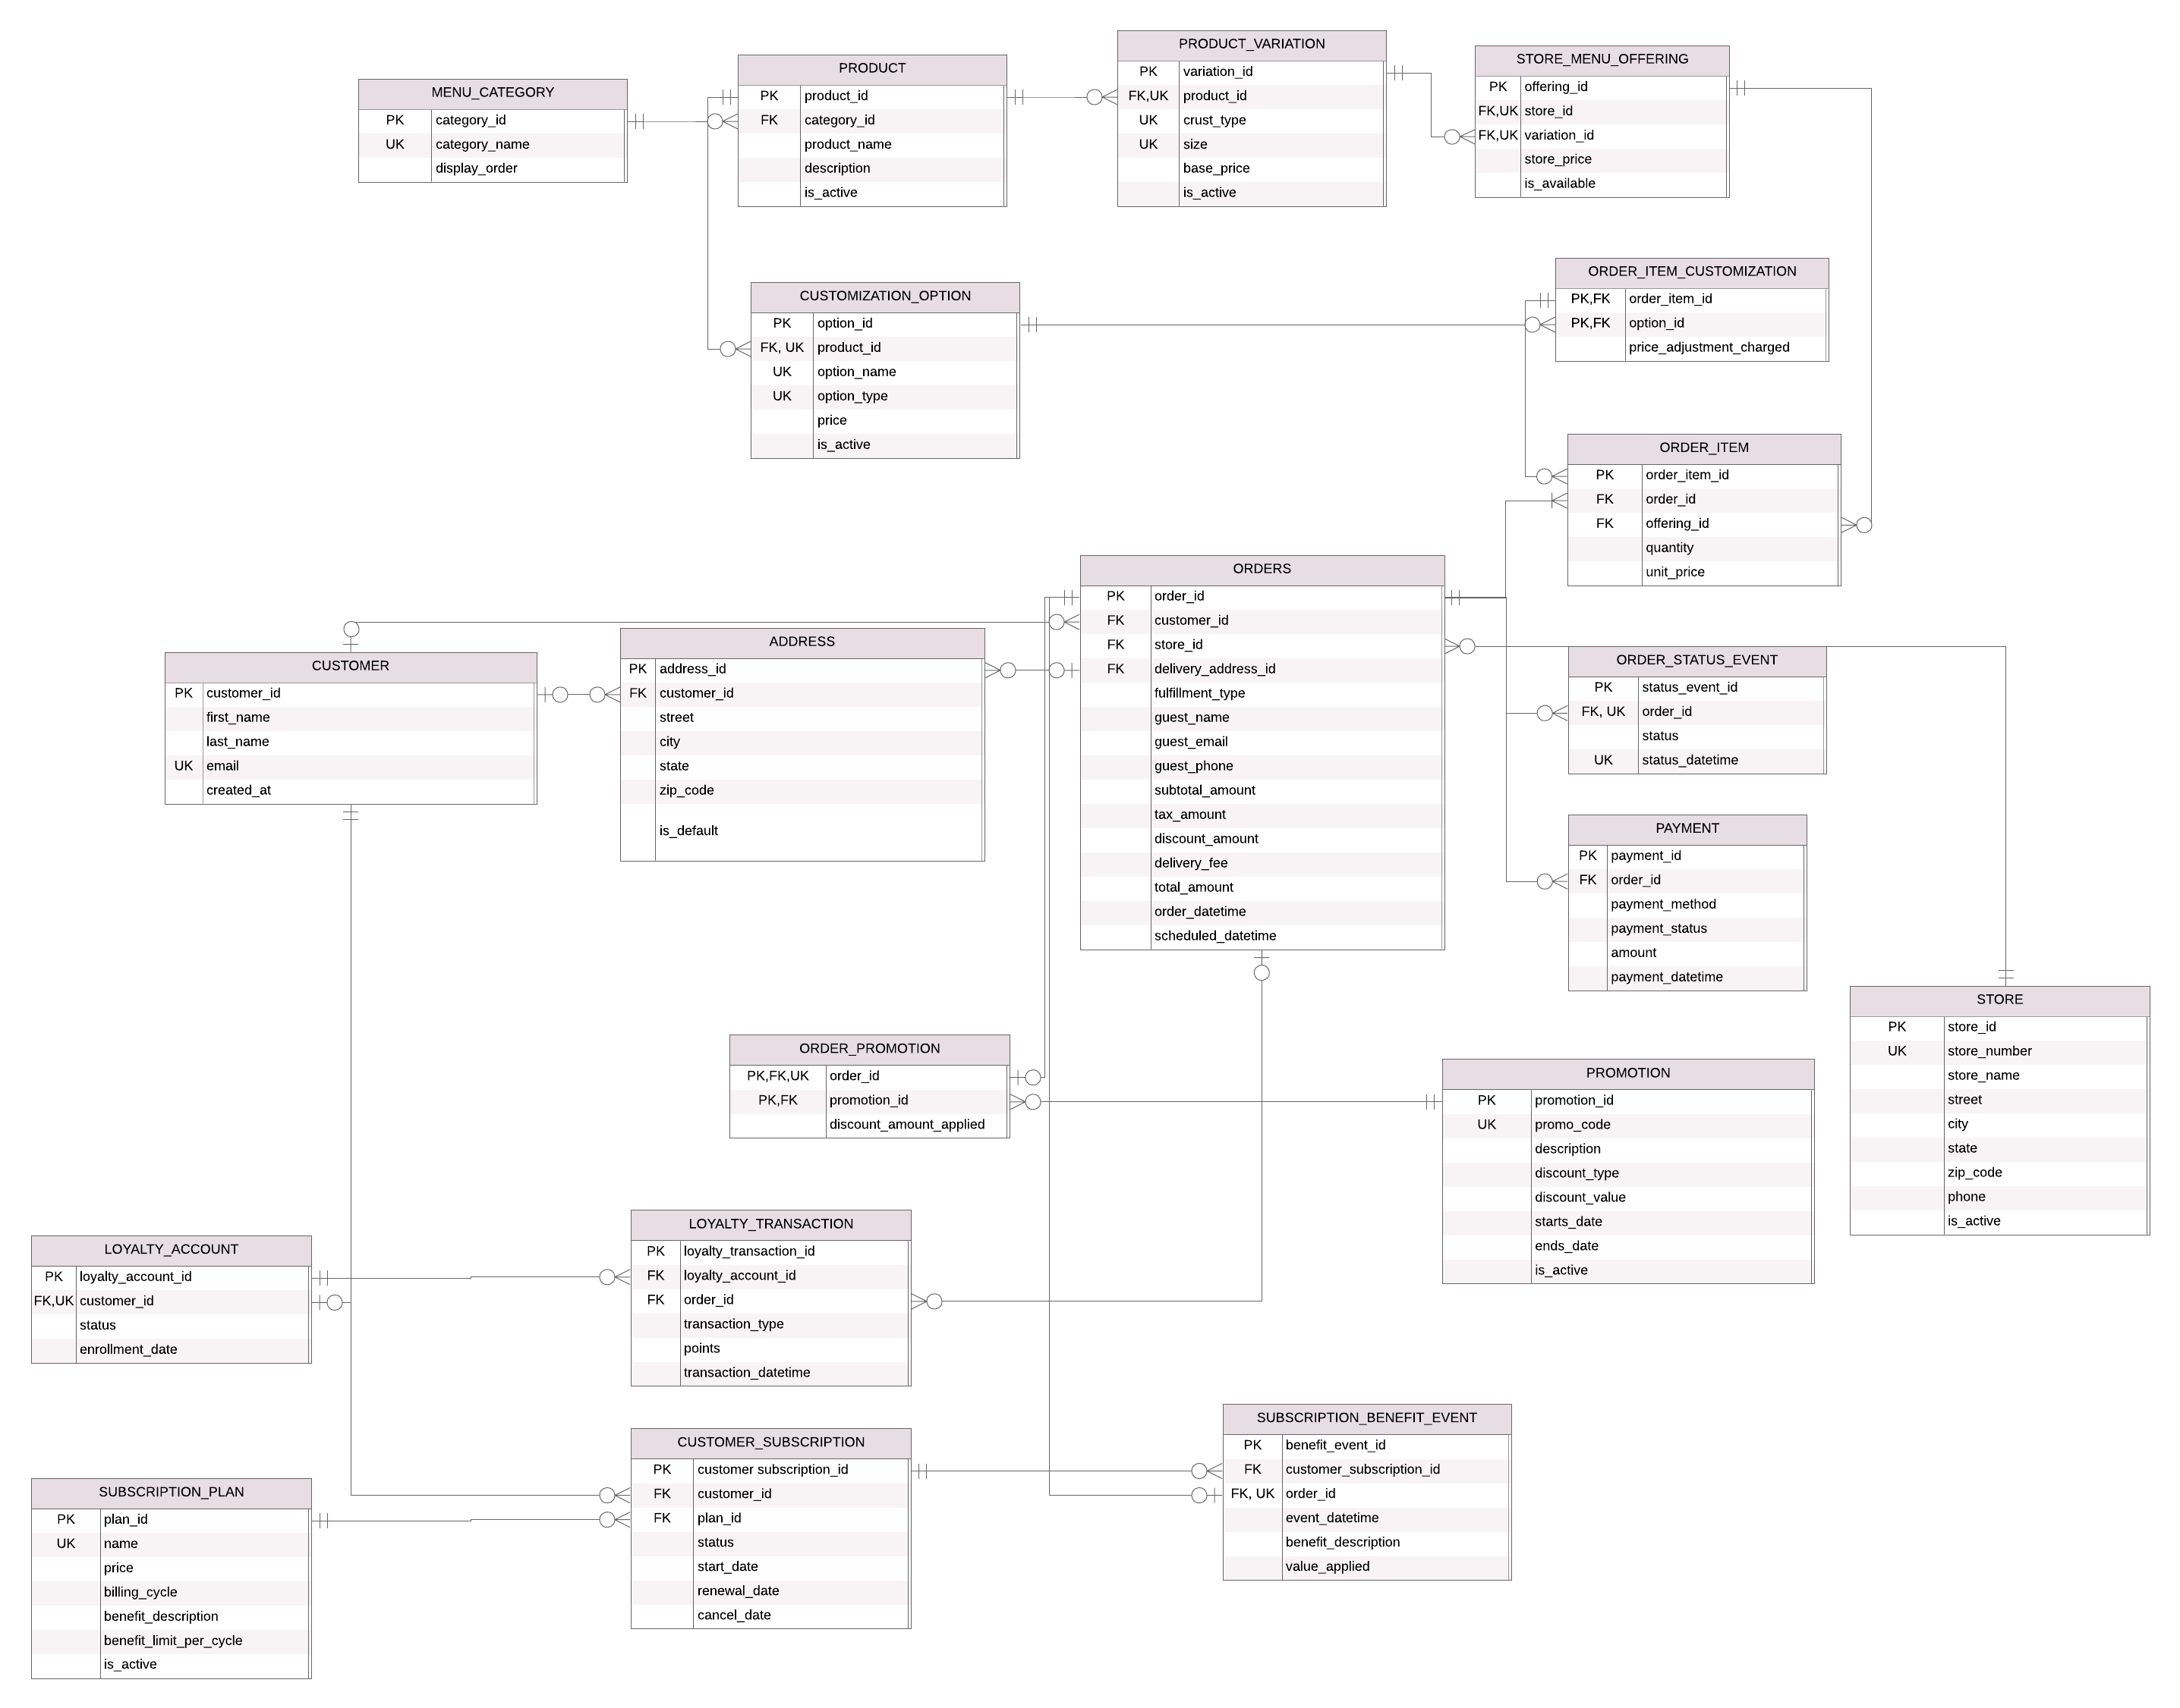

Relational Model Evolution and Design Evidence
The relational model was refined through instructor feedback, team review, and clarification of the business requirements. The conceptual model contains 18 entities. The final relational model contains 20 tables. The additional tables, ORDER_PROMOTION and ORDER_ITEM_CUSTOMIZATION, represent relationship details required for implementation.

Initial Relational Model
The initial relational model included physical implementation details such as data types, field lengths, NOT NULL constraints, and labels on relationship lines. Although useful during implementation, these details made the diagram function more like a physical model than a logical model.

Figure C.2. Initial relational model. The original diagram included data types, field lengths, NOT NULL constraints, and relationship-line labels.
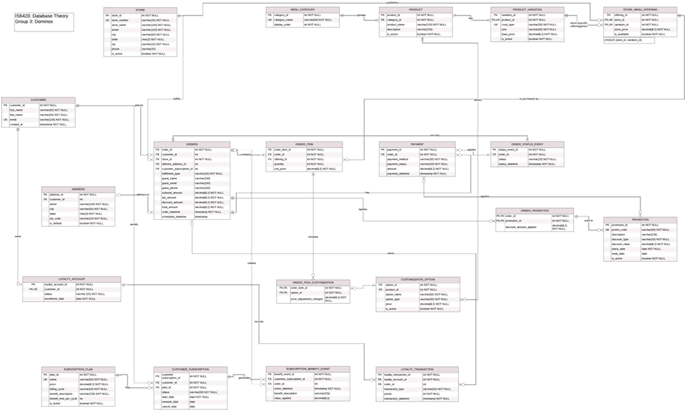

Intermediate Relational Model
Following review of the initial submission, the model was revised to better distinguish logical design from physical implementation. Data types, field lengths, and NOT NULL constraints were removed from the table displays. The intermediate diagram retained the relationship-line labels.
Figure C.3. Intermediate relational model. The tables show names, attributes, and key markers, while relationship-line labels are still present.
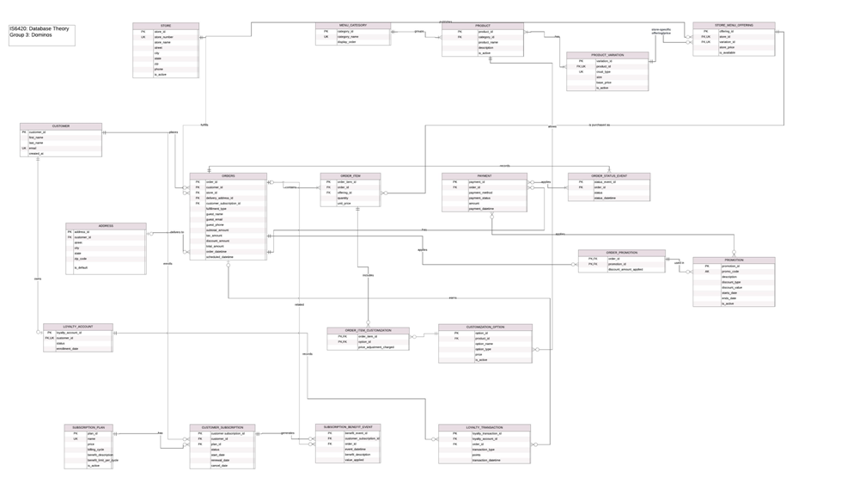

Final Relational Model
The final relational model displays each table name, attribute name, and PK, FK, or UK marker. It uses crow’s-foot notation to show cardinality and optionality while removing relationship-line labels and physical implementation details. The accompanying SQL script retains the data types, lengths, constraints, and other implementation-specific details.

Figure C.4. Final relational model for the Domino’s online-ordering database.

Key Design Revisions
Several business rules were clarified during the model-review process. The delivery_address_id attribute is optional because pickup orders do not require a delivery address. A customer may have zero or one loyalty account. Each subscription benefit event belongs to exactly one customer subscription and exactly one order. An order may have zero or one subscription benefit event.
The final model also uses composite unique keys to enforce business rules. STORE_MENU_OFFERING uses a composite unique key on store_id and variation_id so a store cannot offer the same product variation more than once. PRODUCT_VARIATION uses a composite unique key on product_id, crust_type, and size so each product variation is uniquely identified within its product.
ORDER_ITEM_CUSTOMIZATION resolves the many-to-many relationship between order items and customization options. ORDER_PROMOTION records the promotion, if any, applied to an order. A promotion may be applied to many orders, but each order may use only one promotion. During final review, the benefit_descrription attribute was corrected to benefit_description.

Instructor and Team Feedback
The revisions were based on instructor and team feedback. The instructor noted that the initial relational model included physical-model attributes and did not require relationship-line labels. Team review identified the benefit_description typo and clarified that the STORE_MENU_OFFERING unique constraint applies to the combined store_id and variation_id values rather than to either attribute independently.
Figure C.5. Instructor feedback on the first relational-model submission.
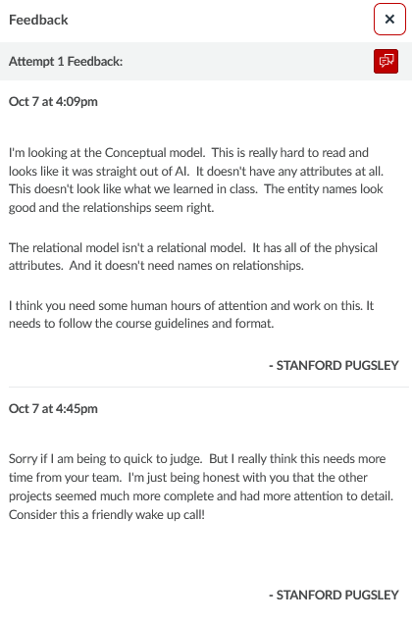

Figure C.6. Team feedback on the relational model.

