Documentation
Uniforum Project
Secrets & Deployment
Each microservice has its own GitHub Actions workflow for CI/CD:
- Triggers on pull_request: closed to main (prod)
- Builds Docker image, pushes to DockerHub
- Connects to EC2 instance and runs container with correct port
Required GitHub secrets per service:
- DOCKER_USERNAME, DOCKER_PASSWORD
- EC2_SSH_KEY (private key as string)
- EC2_HOST (public IP of instance)

📡 Load Balancing & High Availability
- Each service is behind an Application Load Balancer (ALB)
- Connected to Auto Scaling Groups spanning 2 Availability Zones
- Health checks via ELB and EC2

📸 Screenshots
Here we have a principal page of the project.

The discussion-service is currently operational with the React frontend. This microservice handles both retrieval and submission of forum content.
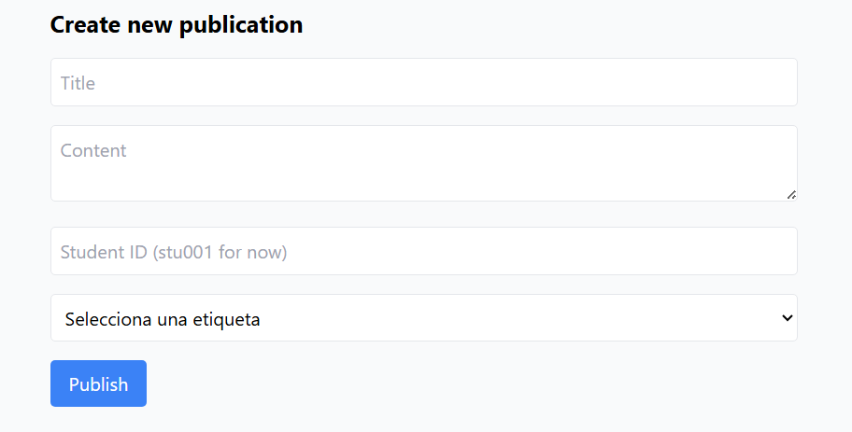
Live microservices: tagging-service, moderation-service, voting-service.
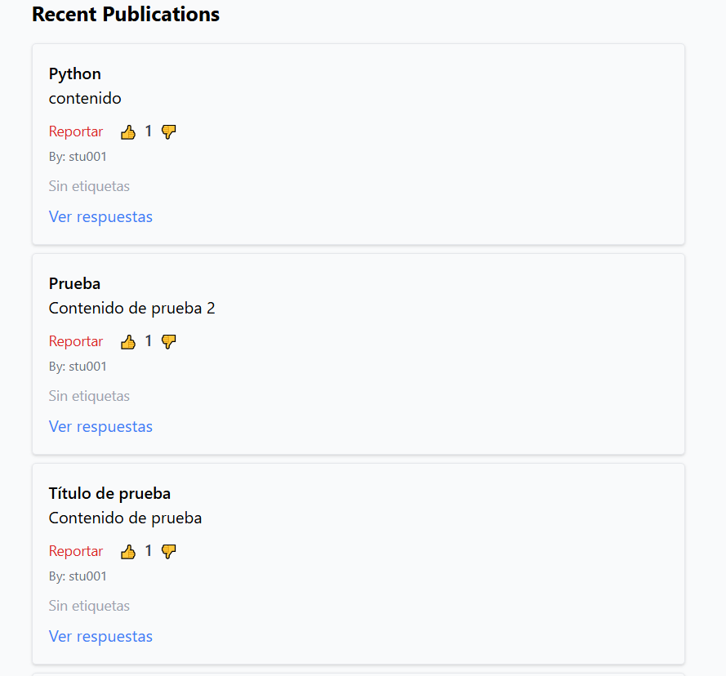
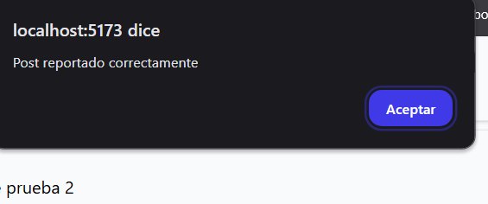

The reply-service (handling forum post replies) is active
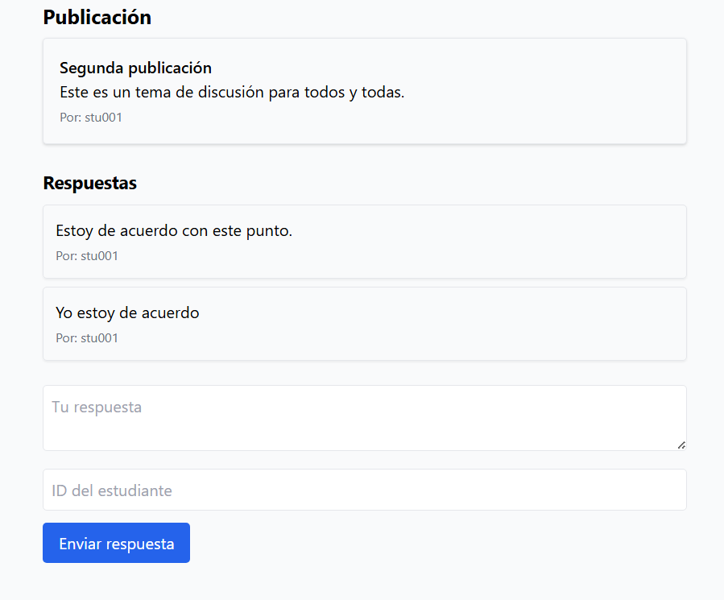

📁 Project Structure
bash
CopiarEditar
uniforum-backend/
├── discussion-service/
├── reply-service/
├── moderation-service/
├── voting-service/
├── tagging-service/
└── .github/workflows/
├── discussion-deploy.yml
├── reply-deploy.yml
├── ...

📝 Future Improvements
- Full test coverage for all services
- Frontend deployment
- Monitoring with Prometheus/Grafana
- Centralized logging (e.g. ELK stack)

