Sudoku

* Wi-fi –
* Network is : YSJ Guest
* Password is:  Cycleimpound7
* Useful website - <https://www.sudokuoftheday.com/techniques/>
* Easy Sample Game:

https://github.com/YorkCodeDojo/Sudoku/blob/master/emptyboard.txt

[https://github.com/YorkCodeDojo/Sudoku/blob/master/[completed.txt](https://github.com/YorkCodeDojo/Sudoku/blob/master/completed.txt)](https://github.com/YorkCodeDojo/Sudoku/blob/master/emptyboard.txt)

* To get started - write a function to check a completed board is valid
* Try completing a board with just one number missing
* Implement code for with the Single Position technique

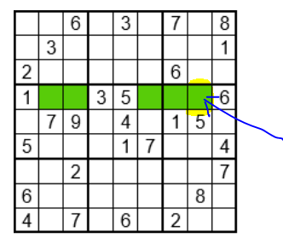

* Implement code for with the Single Candidate technique

