The activity that I participated in was the Crimson Code hackathon. The expectations were to form a team of up to four people and create an app, game, etc. related to the theme of the hackathon. The theme this year was “reinvent the wheel,” in other words take something that already exists and make it better. My group decided to make a calendar app similar to the one provided by Microsoft Outlook. Here is the link to the repo: https://github.com/Tz-Ray/Crimsoncode-repo. What sets this app apart from other calendar apps is the features. The app gives you recommendations on how to plan out your days using AI. It also provides AI summaries for the day/week/month you are looking at. Furthermore, it notifies you of upcoming tasks on your calendar. Here is a screenshot of the app working:
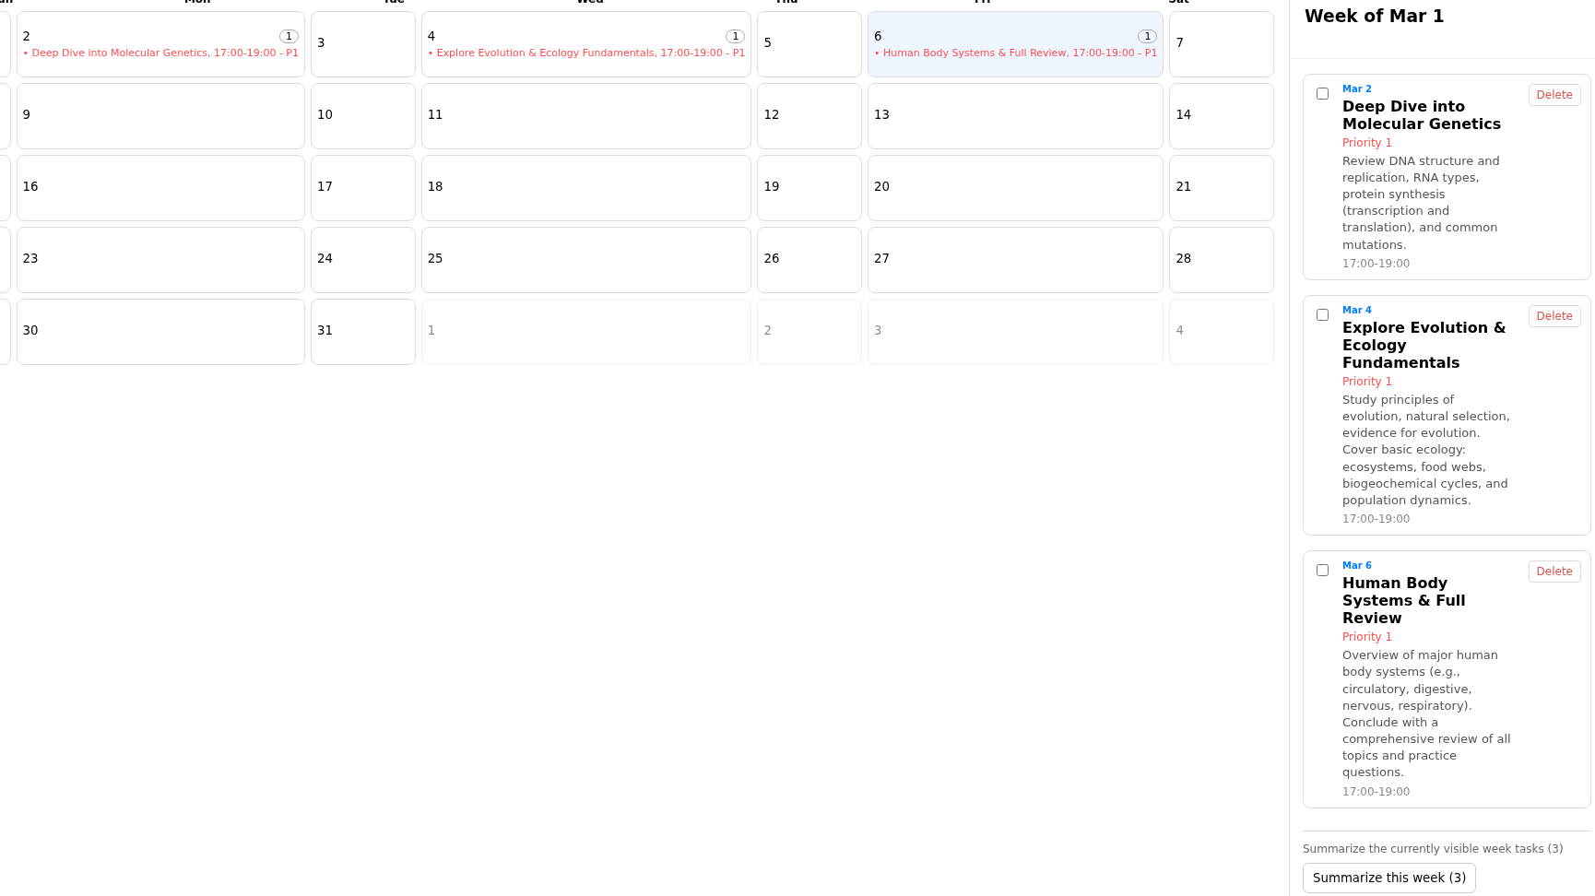
The first technical decision we had to make was what features to include in our app. We came up with a list of features as a group. The features included adding tasks, AI recommendations, search functionality, and a few others. Then we had to decide how to divide up the work. We did this by listing the tasks that needed to be completed and having people volunteer for each task. We also had to get rid of some features towards the end due to time limitations, we only had 24 hours to complete the application. I contributed by working on some of the features and taking part in the decision-making discussions. Some of the features I worked on include the search functionality, the task making functionality, and the AI summary functionality. I also did some documenting. I also took part in the demo/presentation at the end of the event. I would give myself a 9/10 for my participation in this event. I took part in team discussions and did the tasks that were assigned to me. I also took part in the demo and presentation at the end of the event. One thing I would improve would be to come up with more features for the app. I only came up with a couple features that were included in the app.

