院 系 数据科学与计算机学院 班 级 计科一班 学 号 18340013 姓 名 陈琮昊
【实验题目】Echo实验
【实验目的】掌握套节字的基本使用方法。
【实验说明】
- 把源程序和可执行文件放在相应的上交源码目录中。
- 截屏用按键(Ctrl+Alt+PrintScreen)截取当前窗口
【参考资料】
- https://www.cnblogs.com/hgwang/p/6074038.html （套接字）
- https://www.jb51.net/article/37410.htm （字符串）
- https://docs.microsoft.com/en-us/cpp/c-runtime-library/stream-i-o?view=vs-2017 （字符串）
- https://docs.microsoft.com/en-us/cpp/c-runtime-library/reference/crt-alphabetical-function-reference?view=vs-2017#s （字符串）
- http://www.runoob.com/cprogramming/ （字符串）
- https://www.runoob.com/cprogramming/c-function-sscanf.html (sscanf)
- sprintf可以用于合并多个字符串和整数等：
char buffer[50];
char *test = "Hello world!";
sprintf(buffer,"The length of %s is %d",test,strlen(test));/*赋予数值*/
【实验环境】
- 172.18.187.251为校园网内的服务器地址，需要先用VPN连入校园网才能访问。
- Windows + VS 2012 http://172.18.187.251/netdisk/default.aspx?vm=18net
- 对于VS2015和VS2017默认使用安全周期检查，如果不关闭VS的安全周期检查，很多字符串函数都不能用。
- Linux + gcc
【实验内容】
先尝试运行文件夹“TCP”中的程序：先运行Server程序(打开TCPServer.sln，然后执行)再运行Client程序(打开TCPClient.sln，然后执行)。这两个程序的功能是客户端从服务器获取当前时间。
(1)编写TCP Echo程序
- 实验要求：
服务器把客户端发送来的任何消息都返回给客户端，返回的消息前面要加上服务器的当前时间。客户端把返回的消息显示出来。客户端每输入一条消息就建立TCP连接，并把消息发送给服务器，在收到服务器回应后关闭连接。
- 参考运行截屏：
客户端（两次运行）
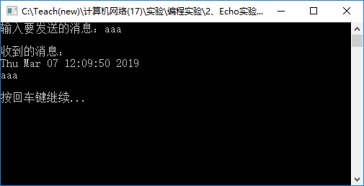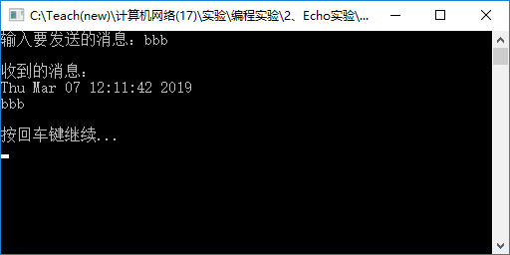
服务器：
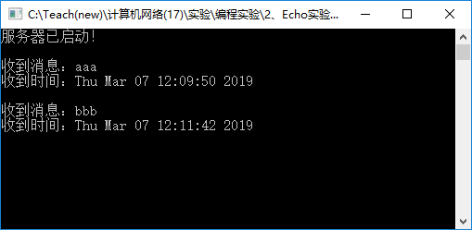
- 只运行客户端程序而不运行服务器程序会出现什么错误，截屏并说明原因。
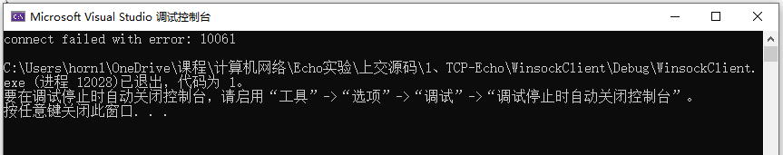
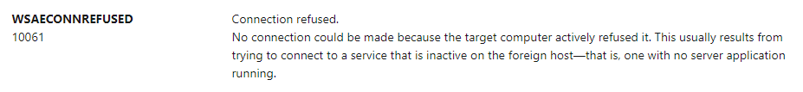
只运行客户端程序而不运行服务器程序的情况下，创建socket后将无法正常调用connect函数进行tcp连接，返回错误码为10061，经过查询Microsoft Doc官方文档可以了解到出现该错误的原因便是目标主机拒绝连接。由于服务器程序没有启动，对应端口没有处于监听状态，连接请求则会被拒绝并返回错误信息，该错误信息在客户端检查代码中被识别并将错误码10061打印到屏幕。
- 服务器如何可以退出循环？
对服务器端范例代码尤其是while循环进行修改，去除了getchar()函数以后，利用_kbhit()函数特性，若要在下一次连接关闭后退出循环，只需选中服务器端运行窗口并提前敲击一次键盘即可，服务器端程序将在下一次连接关闭后识别到stdin输入缓冲区的键盘输入并退出while循环。
- 截屏（ctrl+alt+PrintScreen）服务器和客户端的运行结果（注明客户端和服务器）：
客户端：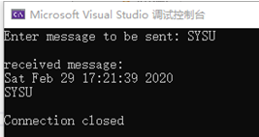 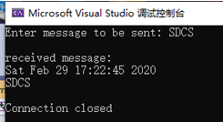

服务器：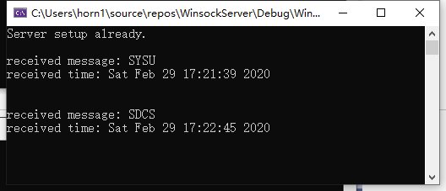
- 服务器的全部源代码（或自选主要代码）：
#ifndef WIN32_LEAN_AND_MEAN
#define WIN32_LEAN_AND_MEAN
#endif

#include <windows.h>
#include <winsock2.h>
#include <ws2tcpip.h>
#include <iphlpapi.h>
#include <stdio.h>
#include <conio.h>

#pragma comment(lib, "Ws2_32.lib")

#define DEFAULT_BUFLEN 512
#define DEFAULT_PORT "27015"

int main()
{
WSADATA wsaData;
int iResult;

SOCKET ListenSocket = INVALID_SOCKET;
SOCKET ClientSocket = INVALID_SOCKET;

struct addrinfo* result = NULL;
struct addrinfo hints;

int iSendResult;
char sendbuf[DEFAULT_BUFLEN];
char recvbuf[DEFAULT_BUFLEN];
int recvbuflen = DEFAULT_BUFLEN;

// Initialize Winsock
iResult = WSAStartup(MAKEWORD(2, 2), &wsaData);
if (iResult != 0) {
printf("WSAStartup failed with error: %d\n", iResult);
return 1;
}

ZeroMemory(&hints, sizeof(hints));
hints.ai_family = AF_INET;
hints.ai_socktype = SOCK_STREAM;
hints.ai_protocol = IPPROTO_TCP;
hints.ai_flags = AI_PASSIVE;

// Resolve the server address and port
iResult = getaddrinfo(NULL, DEFAULT_PORT, &hints, &result);
if (iResult != 0) {
printf("getaddrinfo failed with error: %d\n", iResult);
WSACleanup();
return 1;
}

// Create a SOCKET for connecting to server
ListenSocket = socket(result->ai_family, result->ai_socktype, result->ai_protocol);
if (ListenSocket == INVALID_SOCKET) {
printf("socket failed with error: %ld\n", WSAGetLastError());
freeaddrinfo(result);
WSACleanup();
return 1;
}

// Setup the TCP listening socket
iResult = bind(ListenSocket, result->ai_addr, (int)result->ai_addrlen);
if (iResult == SOCKET_ERROR) {
printf("bind failed with error: %d\n", WSAGetLastError());
freeaddrinfo(result);
closesocket(ListenSocket);
WSACleanup();
return 1;
}

freeaddrinfo(result);

iResult = listen(ListenSocket, SOMAXCONN);
if (iResult == SOCKET_ERROR) {
printf("listen failed with error: %d\n", WSAGetLastError());
closesocket(ListenSocket);
WSACleanup();
return 1;
}

printf("Server setup already.\n\n");
while (!_kbhit()) {

// Accept a client socket
ClientSocket = accept(ListenSocket, NULL, NULL);
if (ClientSocket == INVALID_SOCKET) {
printf("accept failed with error: %d\n", WSAGetLastError());
closesocket(ListenSocket);
WSACleanup();
return 1;
}

// Receive until the peer shuts down the connection
do {

iResult = recv(ClientSocket, recvbuf, recvbuflen, 0);
if (iResult > 0) {
time_t now = time(0);
char* dt = ctime(&now);

printf("received message: %s\nreceived time: %s\n", recvbuf, dt);
sprintf(sendbuf, "%s%s", dt, recvbuf);

// Echo the buffer back to the sender
iSendResult = send(ClientSocket, sendbuf, (int)strlen(sendbuf) + 1, 0);
if (iSendResult == SOCKET_ERROR) {
printf("send failed with error: %d\n", WSAGetLastError());
closesocket(ClientSocket);
WSACleanup();
return 1;
}
}
else if (iResult == 0)
continue;
else {
printf("recv failed with error: %d\n\n", WSAGetLastError());
closesocket(ClientSocket);
WSACleanup();
return 1;
}

} while (iResult > 0);

// shutdown the connection since we're done
iResult = shutdown(ClientSocket, SD_SEND);
if (iResult == SOCKET_ERROR) {
printf("shutdown failed with error: %d\n", WSAGetLastError());
closesocket(ClientSocket);
WSACleanup();
return 1;
}

// cleanup
closesocket(ClientSocket);
}

closesocket(ListenSocket);
WSACleanup();

return 0;
}

- 客户端的全部源代码（或自选主要代码）：
#ifndef WIN32_LEAN_AND_MEAN
#define WIN32_LEAN_AND_MEAN
#endif

#include <windows.h>
#include <winsock2.h>
#include <ws2tcpip.h>
#include <iphlpapi.h>
#include <stdio.h>
#include <ctime>

#pragma comment(lib, "Ws2_32.lib")

#define DEFAULT_BUFLEN 512
#define DEFAULT_PORT "27015"

int main(int argc, char** argv)
{
WSADATA wsaData;
SOCKET ConnectSocket = INVALID_SOCKET;
struct addrinfo* result = NULL, hints;
char sendbuf[DEFAULT_BUFLEN];
char recvbuf[DEFAULT_BUFLEN];
int iResult;
int recvbuflen = DEFAULT_BUFLEN;

// Validate the parameters
if (argc != 2) {
printf("usage: %s server-name\n", argv[0]);
return 1;
}

// Initialize Winsock
iResult = WSAStartup(MAKEWORD(2, 2), &wsaData);
if (iResult != 0) {
printf("WSAStartup failed with error: %d\n", iResult);
return 1;
}

ZeroMemory(&hints, sizeof(hints));
hints.ai_family = AF_INET;
hints.ai_socktype = SOCK_STREAM;
hints.ai_protocol = IPPROTO_TCP;

// Resolve the server address and port
iResult = getaddrinfo(argv[1], DEFAULT_PORT, &hints, &result);
if (iResult != 0) {
printf("getaddrinfo failed with error: %d\n", iResult);
WSACleanup();
return 1;
}

// Create a SOCKET for connecting to server
ConnectSocket = socket(result->ai_family, result->ai_socktype, result->ai_protocol);
if (ConnectSocket == INVALID_SOCKET) {
printf("socket failed with error: %ld\n", WSAGetLastError());
WSACleanup();
return 1;
}

// Connect to server.
iResult = connect(ConnectSocket, result->ai_addr, (int)result->ai_addrlen);
if (iResult == SOCKET_ERROR) {
printf("connect failed with error: %ld\n", WSAGetLastError());
closesocket(ConnectSocket);
WSACleanup();
return 1;
}

freeaddrinfo(result);

// Send specified buffer
printf("Enter message to be sent: ");
scanf("%s", sendbuf);

iResult = send(ConnectSocket, sendbuf, (int)strlen(sendbuf) + 1, 0);
if (iResult == SOCKET_ERROR) {
printf("send failed with error: %d\n", WSAGetLastError());
closesocket(ConnectSocket);
WSACleanup();
return 1;
}

// shutdown the connection since no more data will be sent
iResult = shutdown(ConnectSocket, SD_SEND);
if (iResult == SOCKET_ERROR) {
printf("shutdown failed with error: %d\n", WSAGetLastError());
closesocket(ConnectSocket);
WSACleanup();
return 1;
}

// Receive until the peer closes the connectio n
do {

iResult = recv(ConnectSocket, recvbuf, recvbuflen, 0);
if (iResult > 0)
printf("\nreceived message:\n%s\n", recvbuf);
else if (iResult == 0)
printf("\nConnection closed\n");
else
printf("\nrecv failed with error: %d\n", WSAGetLastError());

} while (iResult > 0);

// cleanup
closesocket(ConnectSocket);
WSACleanup();

return 0;
}

(2)编写TCP Echo增强程序
- 实验要求：
在(1)的基础上，服务器在收到客户端的消息时显示服务器的当前时间、客户端的IP地址、客户端的端口号和客户端发来的信息，并把它们一并返回给客户端。
客户端在发送消息后把服务器发回给它的消息显示出来。*客户端程序与(1)同，不用修改
要求服务器直接从accept()的参数fsin中得到客户端的IP地址和端口号。注：服务器获取IP地址后要求直接使用s_un_b的四个分量得到IP地址，不能使用函数inet_ntoa()转换IP地址。
- 参考运行截屏：
客户端（两次运行）
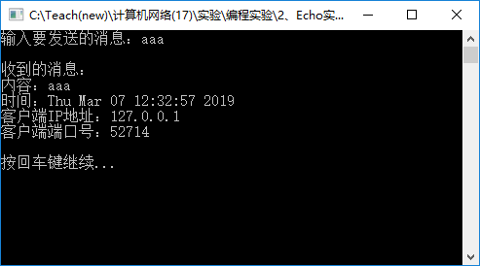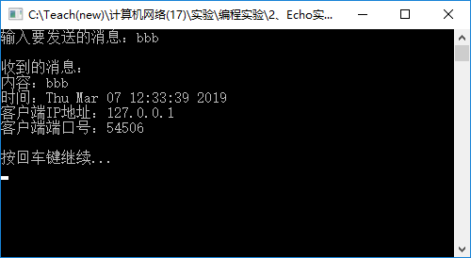
服务器
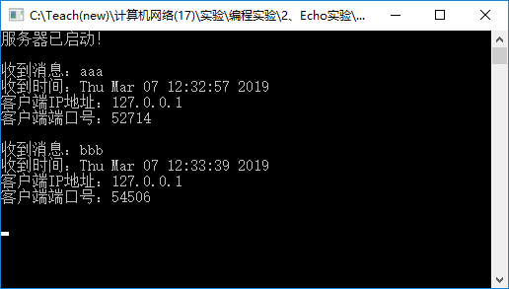
- 截屏服务器和客户端的运行结果(注明客户端和服务器)：
客户端：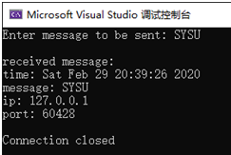 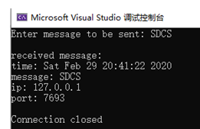
服务器：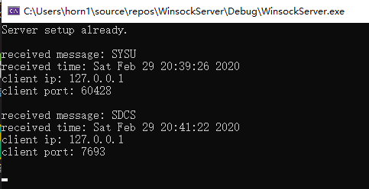
- 服务器的全部源代码（或自选主要代码）
#ifndef WIN32_LEAN_AND_MEAN
#define WIN32_LEAN_AND_MEAN
#endif

#include <windows.h>
#include <winsock2.h>
#include <ws2tcpip.h>
#include <iphlpapi.h>
#include <stdio.h>
#include <conio.h>
#include <stdlib.h>

#pragma comment(lib, "Ws2_32.lib")

#define DEFAULT_BUFLEN 512
#define DEFAULT_PORT "27015"

int main()
{
WSADATA wsaData;
int iResult;

SOCKET ListenSocket = INVALID_SOCKET;
SOCKET ClientSocket = INVALID_SOCKET;

struct sockaddr_in ClientAddr;
struct addrinfo* result = NULL;
struct addrinfo hints;

int AddrLen = (int)sizeof(sockaddr_in);
int iSendResult;
char sendbuf[DEFAULT_BUFLEN];
char recvbuf[DEFAULT_BUFLEN];
char ip_addr[DEFAULT_BUFLEN];
int recvbuflen = DEFAULT_BUFLEN;

// Initialize Winsock
iResult = WSAStartup(MAKEWORD(2, 2), &wsaData);
if (iResult != 0) {
printf("WSAStartup failed with error: %d\n", iResult);
return 1;
}

ZeroMemory(&hints, sizeof(hints));
hints.ai_family = AF_INET;
hints.ai_socktype = SOCK_STREAM;
hints.ai_protocol = IPPROTO_TCP;
hints.ai_flags = AI_PASSIVE;

// Resolve the server address and port
iResult = getaddrinfo(NULL, DEFAULT_PORT, &hints, &result);
if (iResult != 0) {
printf("getaddrinfo failed with error: %d\n", iResult);
WSACleanup();
return 1;
}

// Create a SOCKET for connecting to server
ListenSocket = socket(result->ai_family, result->ai_socktype, result->ai_protocol);
if (ListenSocket == INVALID_SOCKET) {
printf("socket failed with error: %ld\n", WSAGetLastError());
freeaddrinfo(result);
WSACleanup();
return 1;
}

// Setup the TCP listening socket
iResult = bind(ListenSocket, result->ai_addr, (int)result->ai_addrlen);
if (iResult == SOCKET_ERROR) {
printf("bind failed with error: %d\n", WSAGetLastError());
freeaddrinfo(result);
closesocket(ListenSocket);
WSACleanup();
return 1;
}

freeaddrinfo(result);

iResult = listen(ListenSocket, SOMAXCONN);
if (iResult == SOCKET_ERROR) {
printf("listen failed with error: %d\n", WSAGetLastError());
closesocket(ListenSocket);
WSACleanup();
return 1;
}

printf("Server setup already.\n\n");
while (!_kbhit()) {

// Accept a client socket
ClientSocket = accept(ListenSocket, (struct sockaddr*) & ClientAddr, &AddrLen);
if (ClientSocket == INVALID_SOCKET) {
printf("accept failed with error: %d\n", WSAGetLastError());
closesocket(ListenSocket);
WSACleanup();
return 1;
}

// Receive until the peer shuts down the connection
do {

iResult = recv(ClientSocket, recvbuf, recvbuflen, 0);
if (iResult > 0) {

time_t now = time(0);
char* dt = ctime(&now);
sprintf(ip_addr, "%d.%d.%d.%d", int(ClientAddr.sin_addr.S_un.S_un_b.s_b1), int(ClientAddr.sin_addr.S_un.S_un_b.s_b2),
int(ClientAddr.sin_addr.S_un.S_un_b.s_b3), int(ClientAddr.sin_addr.S_un.S_un_b.s_b4));

printf("received message: %s\n", recvbuf);
printf("received time: %s", dt);
printf("client ip: %s\n", ip_addr);
printf("client port: %d\n\n", int(ClientAddr.sin_port));
sprintf(sendbuf, "time: %smessage: %s\nip: %s\nport: %d", dt, recvbuf, ip_addr, int(ClientAddr.sin_port));

// Echo the buffer back to the sender
iSendResult = send(ClientSocket, sendbuf, (int)strlen(sendbuf) + 1, 0);
if (iSendResult == SOCKET_ERROR) {
printf("send failed with error: %d\n", WSAGetLastError());
closesocket(ClientSocket);
WSACleanup();
return 1;
}

}
else if (iResult == 0)
continue;
else {
printf("recv failed with error: %d\n\n", WSAGetLastError());
closesocket(ClientSocket);
WSACleanup();
return 1;
}

} while (iResult > 0);

// shutdown the connection since we're done
iResult = shutdown(ClientSocket, SD_SEND);
if (iResult == SOCKET_ERROR) {
printf("shutdown failed with error: %d\n", WSAGetLastError());
closesocket(ClientSocket);
WSACleanup();
return 1;
}

// cleanup
closesocket(ClientSocket);
}

closesocket(ListenSocket);
WSACleanup();

return 0;
}

(3)编写UDP Echo增强程序
- 实验要求：
修改UDP例程，完成Echo功能，即当客户端发来消息时，服务器显示出服务器的当前时间、客户端的IP、客户端的端口号和客户发来的信息，并把它们一并发回给客户端，客户端然后把它们显示出来。
服务器可以直接从recvfrom()的参数from中得到客户端的IP地址和端口号，并且服务器用sendto()发回给客户端消息时可以直接用该参数from作为参数toAddr。可以使用inet_ntoa()转换客户端IP地址。
客户端程序的recvfrom()可以直接使用原来sendto使用的sock。该sock已经绑定了客户端的IP地址和端口号，客户端可以直接用来接收数据。
- 参考运行截屏：
客户端（两次运行）
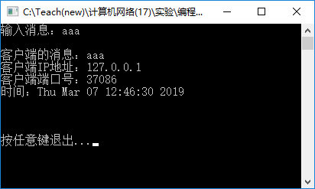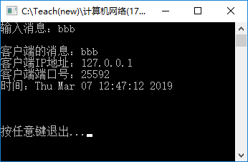
服务器：
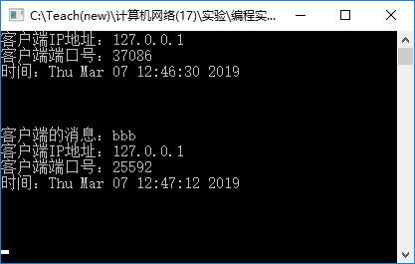
- 只运行客户端程序而不运行服务器程序会出现什么错误，截屏并说明原因。
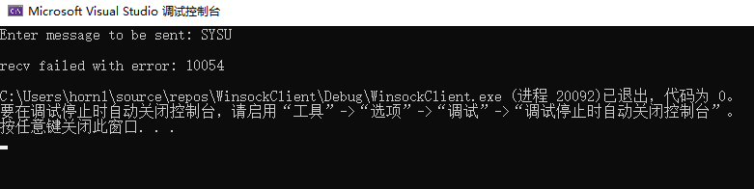
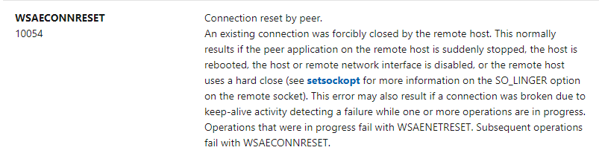
只运行客户端程序而不运行服务器程序的情况下，仍然可以输入信息并完成发送操作即sendto函数，但是在接受操作即recvfrom函数过程中会返回错误码10054，经过查询Microsoft Doc官方文档可以了解到出现该错误的原因便是即与目标主机的连接被关闭，即服务器端没有正常运行。UDP数据报通过sendto函数发送到服务端后，由于服务端端口没有打开，服务端将返回错误信息被recvfrom所接收，该错误信息则会被解析为10054错误代码被程序检查代码识别和打印在屏幕上。
- 截屏服务器和客户端的运行结果（注明客户端和服务器）：
客户端：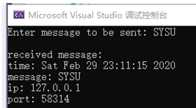 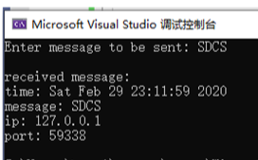
服务器：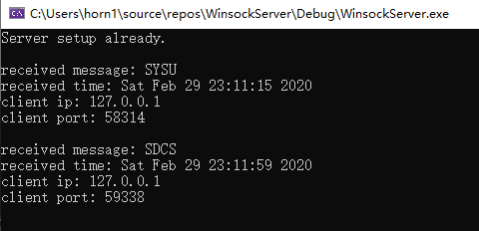
- 服务器的全部源代码（或自选主要代码）：
#ifndef WIN32_LEAN_AND_MEAN
#define WIN32_LEAN_AND_MEAN
#endif

#include <windows.h>
#include <winsock2.h>
#include <ws2tcpip.h>
#include <iphlpapi.h>
#include <stdio.h>
#include <conio.h>
#include <stdlib.h>

#pragma comment(lib, "Ws2_32.lib")

#define DEFAULT_BUFLEN 512
#define DEFAULT_PORT "27015"

int main()
{
WSADATA wsaData;
int iResult;

SOCKET Socket = INVALID_SOCKET;

struct sockaddr_in from;
struct addrinfo* result = NULL;
struct addrinfo hints;

int fromlen = (int)sizeof(sockaddr_in);
int iSendResult;
char sendbuf[DEFAULT_BUFLEN];
char recvbuf[DEFAULT_BUFLEN];
char ip_addr[DEFAULT_BUFLEN];
int recvbuflen = DEFAULT_BUFLEN;

// Initialize Winsock
iResult = WSAStartup(MAKEWORD(2, 2), &wsaData);
if (iResult != 0) {
printf("WSAStartup failed with error: %d\n", iResult);
return 1;
}

ZeroMemory(&hints, sizeof(hints));
hints.ai_family = AF_INET;
hints.ai_socktype = SOCK_DGRAM;
hints.ai_protocol = IPPROTO_UDP;
hints.ai_flags = AI_PASSIVE;

// Resolve the server address and port
iResult = getaddrinfo(NULL, DEFAULT_PORT, &hints, &result);
if (iResult != 0) {
printf("getaddrinfo failed with error: %d\n", iResult);
WSACleanup();
return 1;
}

// Create a SOCKET for connecting to server
Socket = socket(result->ai_family, result->ai_socktype, result->ai_protocol);
if (Socket == INVALID_SOCKET) {
printf("socket failed with error: %ld\n", WSAGetLastError());
freeaddrinfo(result);
WSACleanup();
return 1;
}

// Setup UDP socket
iResult = bind(Socket, result->ai_addr, (int)result->ai_addrlen);
if (iResult == SOCKET_ERROR) {
printf("bind failed with error: %d\n", WSAGetLastError());
freeaddrinfo(result);
closesocket(Socket);
WSACleanup();
return 1;
}

freeaddrinfo(result);

printf("Server setup already.\n\n");
while (!_kbhit()) {

iResult = recvfrom(Socket, recvbuf, recvbuflen, 0, (struct sockaddr*) & from, &fromlen);
if (iResult > 0) {

time_t now = time(0);
char* dt = ctime(&now);
sprintf(ip_addr, "%d.%d.%d.%d", int(from.sin_addr.S_un.S_un_b.s_b1), int(from.sin_addr.S_un.S_un_b.s_b2),
int(from.sin_addr.S_un.S_un_b.s_b3), int(from.sin_addr.S_un.S_un_b.s_b4));

printf("received message: %s\n", recvbuf);
printf("received time: %s", dt);
printf("client ip: %s\n", ip_addr);
printf("client port: %d\n\n", int(from.sin_port));
sprintf(sendbuf, "time: %smessage: %s\nip: %s\nport: %d", dt, recvbuf, ip_addr, int(from.sin_port));

// Echo the buffer back to the sender
iSendResult = sendto(Socket, sendbuf, (int)strlen(sendbuf) + 1, 0, (struct sockaddr*) & from, fromlen);
if (iSendResult == SOCKET_ERROR) {
printf("send failed with error: %d\n", WSAGetLastError());
closesocket(Socket);
WSACleanup();
return 1;
}

}
else {
printf("recv failed with error: %d\n\n", WSAGetLastError());
closesocket(Socket);
WSACleanup();
return 1;
}

}

// cleanup
closesocket(Socket);
WSACleanup();

return 0;
}

- 客户端的全部源代码（或自选主要代码）：
#ifndef WIN32_LEAN_AND_MEAN
#define WIN32_LEAN_AND_MEAN
#endif

#include <windows.h>
#include <winsock2.h>
#include <ws2tcpip.h>
#include <iphlpapi.h>
#include <stdio.h>
#include <ctime>

#pragma comment(lib, "Ws2_32.lib")

#define DEFAULT_BUFLEN 512
#define DEFAULT_PORT "27015"

int main(int argc, char** argv)
{
WSADATA wsaData;
SOCKET Socket = INVALID_SOCKET;
struct addrinfo* result = NULL, hints;
char sendbuf[DEFAULT_BUFLEN];
char recvbuf[DEFAULT_BUFLEN];
int iResult;
int recvbuflen = DEFAULT_BUFLEN;
int tolen = (int)sizeof(sockaddr_in);

// Validate the parameters
if (argc != 2) {
printf("usage: %s server-name\n", argv[0]);
return 1;
}

// Initialize Winsock
iResult = WSAStartup(MAKEWORD(2, 2), &wsaData);
if (iResult != 0) {
printf("WSAStartup failed with error: %d\n", iResult);
return 1;
}

ZeroMemory(&hints, sizeof(hints));
hints.ai_family = AF_INET;
hints.ai_socktype = SOCK_DGRAM;
hints.ai_protocol = IPPROTO_UDP;

// Resolve the server address and port
iResult = getaddrinfo(argv[1], DEFAULT_PORT, &hints, &result);
if (iResult != 0) {
printf("getaddrinfo failed with error: %d\n", iResult);
WSACleanup();
return 1;
}

Socket = socket(result->ai_family, result->ai_socktype, result->ai_protocol);
if (Socket == INVALID_SOCKET) {
printf("socket failed with error: %ld\n", WSAGetLastError());
WSACleanup();
return 1;
}

freeaddrinfo(result);

// Send specified buffer
printf("Enter message to be sent: ");
scanf("%s", sendbuf);

iResult = sendto(Socket, sendbuf, (int)strlen(sendbuf) + 1, 0, result->ai_addr, tolen);
if (iResult == SOCKET_ERROR) {
printf("send failed with error: %d\n", WSAGetLastError());
closesocket(Socket);
WSACleanup();
return 1;
}

// Receive message from server
iResult = recvfrom(Socket, recvbuf, recvbuflen, 0, result->ai_addr, &tolen);
if (iResult > 0)
printf("\nreceived message:\n%s\n", recvbuf);
else
printf("\nrecv failed with error: %d\n", WSAGetLastError());

// cleanup
closesocket(Socket);
WSACleanup();

return 0;
}

【完成情况】
是否完成以下步骤？(√完成 ×未做)
(1) [√] (2) [√] (3) [√]

【实验体会】
本次实验是计算机网络课程的第一次实验，起初对于各种概念尤其是TCP和UDP的异同之处了解不是太深，在编写代码时需要频繁查阅官方文档或ppt课件的内容，例如TCP协议需要进行connect操作、UDP协议需要使用recvfrom函数获取数据报来源ip和端口号而不是recv函数等，但随着查阅次数的增加和知识的扩充，对套接字编程也有了更深入的了解。
在实验过程中，遇到的主要困难是send函数的参数值，在客户端传输字符串时buf的长度应设置为strlen(sendbuf)+1，而不是strlen(sendbuf)！！否则在服务器端接受得到的字符串将没有‘\0’结尾，导致打印该字符串的时候会出现乱码，在sprintf过程中也会溢出，发现并解决该问题后客户端和服务器端便能正常地收发字节流。

