院 系 数据科学与计算机学院 班 级 计科一班 学号 18340013 姓名 陈琮昊
【实验题目】文件传输实验
【实验目的】学习利用套接字传送文件
【实验内容】
1、 (FtpClient)写一个Ftp客户端程序，用FTP协议下载多个文件到指定目录。
（1）参考运行截屏：
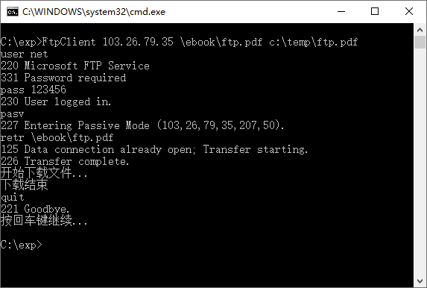
注意，其中的命令不是键入的而是编程把字符串直接输出给服务器的。
经验证,下载的文件可以打开。

（2）老师用的函数(仅作参考)：
strchr(); strrchr(); sprintf(buf, "retr %s\r\n", filename);
sscanf(st, "%d,%d,%d,%d,%d,%d", &ip1, &ip2, &ip3, &ip4, &port1, &port2);

SOCKET dataConn() { … } 建立数据连接
unsigned __stdcall recvFromNet(void *p){…} 接收服务器的消息（线程函数）
void sendmsg(SOCKET sock, char *msg){ … } 发送控制消息
int saveFile(SOCKET sock, char * fileName) { … }接收数据并保存为文件

（3）源代码：
#ifndef WIN32_LEAN_AND_MEAN
#define WIN32_LEAN_AND_MEAN
#endif

#include <windows.h>
#include <winsock2.h>
#include <ws2tcpip.h>
#include <iphlpapi.h>
#include <process.h>
#include <cstdio>
#include <cstdlib>
#include <ctime>
#include <cstring>
#include <csignal>

#pragma comment(lib, "Ws2_32.lib")

#define DefaultFtpPort "21"
#define DefaultBufLen 2000

SOCKET mySocket = INVALID_SOCKET;
HANDLE myThread = nullptr;

int rdy;
char msg[DefaultBufLen];

unsigned __stdcall socketRecv(void* p)
{
int result;
char* recvBuf = new char[DefaultBufLen];
int recvTimeout = 3000;
setsockopt(mySocket, SOL_SOCKET, SO_RCVTIMEO, (char*)&recvTimeout, sizeof(recvTimeout));

while (true)
{
result = recv(mySocket, recvBuf, DefaultBufLen, 0);
if (result > 0)
{
recvBuf[result] = '\0';
printf("%s\n", recvBuf);
if (!strncmp(recvBuf, "227", 3))
{
rdy = 1;
strcpy(msg, recvBuf);
}
}
else if (result == 0)
{
shutdown(mySocket, SD_SEND);
closesocket(mySocket);
break;
}
else if (result == SOCKET_ERROR && GetLastError() == WSAENOTSOCK) break;
}
delete[] recvBuf;
return 0;
}

void strProcess(int* ipAddr, char* ip, char* port)
{
char tmp[DefaultBufLen] = "";

itoa(ipAddr[0], tmp, 10);
strcpy(ip, tmp);
strcpy(ip + strlen(ip), ".");

itoa(ipAddr[1], tmp, 10);
strcpy(ip + strlen(ip), tmp);
strcpy(ip + strlen(ip), ".");

itoa(ipAddr[2], tmp, 10);
strcpy(ip + strlen(ip), tmp);
strcpy(ip + strlen(ip), ".");

itoa(ipAddr[3], tmp, 10);
strcpy(ip + strlen(ip), tmp);

itoa(ipAddr[4] * 256 + ipAddr[5], port, 10);
}

void saveFile(SOCKET socket, char* fileName)
{
FILE* fp = fopen(fileName, "wb");

int result;
char recvBuf[DefaultBufLen];
int recvTimeout = 3000;
setsockopt(socket, SOL_SOCKET, SO_RCVTIMEO, (char*)&recvTimeout, sizeof(recvTimeout));

while (true)
{
result = recv(socket, recvBuf, DefaultBufLen, 0);
if (result > 0) fwrite(recvBuf, 1, result, fp);
else
{
shutdown(socket, SD_SEND);
closesocket(socket);
break;
}
}
fclose(fp);
}

int main(int argc, char* argv[])
{
WSADATA wsaData;
struct addrinfo* result = NULL;
struct addrinfo hints;

WSAStartup(MAKEWORD(2, 2), &wsaData);

ZeroMemory(&hints, sizeof(hints));
hints.ai_family = AF_INET;
hints.ai_socktype = SOCK_STREAM;
hints.ai_protocol = IPPROTO_TCP;
getaddrinfo(argv[1], DefaultFtpPort, &hints, &result);

mySocket = socket(result->ai_family, result->ai_socktype, result->ai_protocol);
connect(mySocket, result->ai_addr, (int)result->ai_addrlen);
freeaddrinfo(result);

myThread = (HANDLE)_beginthreadex(NULL, 0, &socketRecv, NULL, 0, NULL);

char msg1[] = "user net\r\n";
char msg2[] = "pass 123456\r\n";
char msg3[] = "type I\r\n";
char msg4[] = "pasv\r\n";
char msg5[] = "retr ";
char msg6[] = "quit\r\n";

send(mySocket, msg1, strlen(msg1), 0);
send(mySocket, msg2, strlen(msg2), 0);
send(mySocket, msg3, strlen(msg3), 0);
send(mySocket, msg4, strlen(msg4), 0);

char sendBuf[DefaultBufLen];
strcpy(sendBuf, msg5);
strcpy(sendBuf + strlen(sendBuf), argv[2]);
strcpy(sendBuf + strlen(sendBuf), "\r\n");

send(mySocket, sendBuf, strlen(sendBuf), 0);

while (!rdy) continue;
int rdy = 0;

SOCKET dataSocket = INVALID_SOCKET;
char* ptr1 = strchr(msg, '(');
int ipAddr[6];
sscanf(ptr1, "(%d,%d,%d,%d,%d,%d)", &ipAddr[0], &ipAddr[1],
&ipAddr[2], &ipAddr[3], &ipAddr[4], &ipAddr[5]);
char ip[DefaultBufLen] = "";
char port[DefaultBufLen] = "";
strProcess(ipAddr, ip, port);

ZeroMemory(&hints, sizeof(hints));
hints.ai_family = AF_INET;
hints.ai_socktype = SOCK_STREAM;
hints.ai_protocol = IPPROTO_TCP;
getaddrinfo(ip, port, &hints, &result);

dataSocket = socket(result->ai_family, result->ai_socktype, result->ai_protocol);
connect(dataSocket, result->ai_addr, (int)result->ai_addrlen);
freeaddrinfo(result);

saveFile(dataSocket, argv[3]);

send(mySocket, msg6, strlen(msg6), 0);
WaitForSingleObject(myThread, INFINITE);
CloseHandle(myThread);
WSACleanup();

return 0;
}

（4）运行截屏及说明：
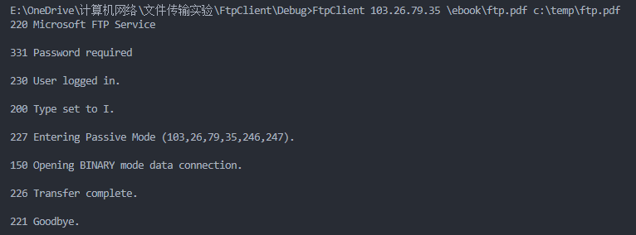
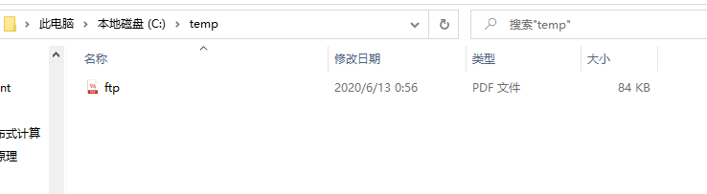
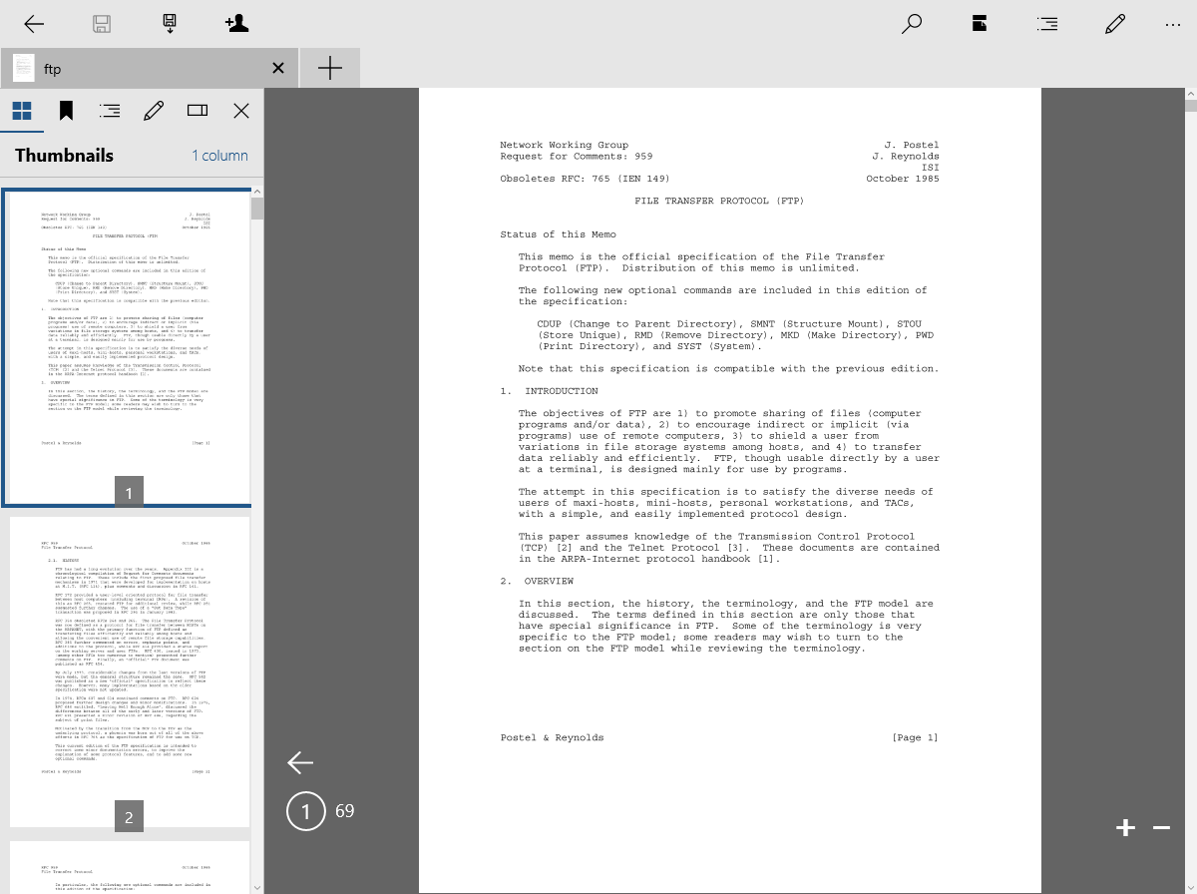

- (P2pChat)通过建立TCP连接实现一对一的聊天和传输文件功能。
（1）功能说明：
在客户和服务器之间建立TCP连接之后，任何一方可以输入并执行命令：
>rdir d:\test 设置接收文件的目录d:\test
>chat hello 向对方发送聊天字符串“hello”或者 >hello (非命令即可)
>send c:\temp\ftp.pdf 向对方发送文件ftp.pdf，接收方对重名文件加编号。
>quit 退出程序

（2）数据包设计（仅作参考）：
    - 一个包由三部分构成：结构1，结构2(多种类型)，数据
其中：结构1和结构2分别包含数据类型和数据长度。
      - 在接收结构1之后，通过数据类型确定结构2，不同数据类型的结构2可以不同，再通过结构2中的数据长度接收数据。
      - 接收结构和数据均要根据该结构或数据的长度接收。 要累计已接收的字节数，直到全部接收完毕，再接收下一部分。

（3）老师用的函数(仅作参考)：
// 获得文件大小
__int64 getFileSize(char * fileName);
// 从带文件名的路径中提取文件名
char * getFileName(char *pathName);
// 从filePathName提取长度为len的字符串到fileFullName（不包含扩展名的文件名）
int mystrcpy(char * fileFullName, int len, char * filePathName);
// 获得唯一文件名，即下载的重名文件加序号
void getUniqueName(char *newFileName, char *filePathName);
// 接收len个字节存放到buf中
int recvData(SOCKET sock, char *buf, int len);
// 接收长度为fileSize的文件存放用fileName到路径path中
int recvFile(SOCKET sock, char * fileName, int fileSize, char *path);
// 从网上接收数据（线程函数）
unsigned __stdcall myrecv(void *p);
// 读出文件srcFileName发送到网上
int sendFile(SOCKET sock, char *srcFileName);
// 发送聊天包：发送结构1(包含数据类型)，发送结构2（包含数据长度），发送聊天数据
void sendChatPacket(SOCKET sock,char *chatData);
// 发送文件包：发送结构1(包含数据类型)，发送结构2（包含数据长度），发送文件
void sendFilePacket(SOCKET sock, char * fullFileName);
// 执行命令：quit,exit,rdir,chat,file。返回值：0-正常，-1-退出
int executeCmd(char * cmdLine);
// 建立连接，循环：输入命令和执行命令
void main(int argc, char *argv[]);
（4）参考程序：P2PServer.exe，P2PClient.exe
（5）参考运行情况：
起始时，c:\test为空目录，c:\temp有两个文件
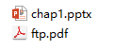
运行：
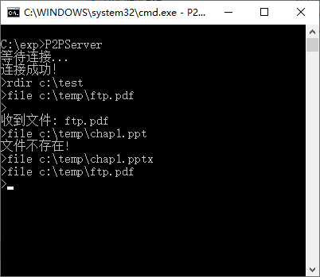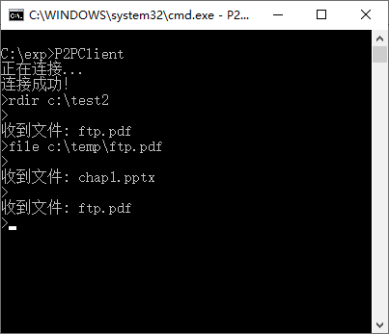
1
4
8
9
10
6
7
11
2
13
3
5
12
* 数字为输入或显示次序

运行后：c:\test有一个文件，c:\test2有三个文件。它们均可以正常打开。
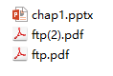
（5）源代码：
（用户端）
#ifndef WIN32_LEAN_AND_MEAN
#define WIN32_LEAN_AND_MEAN
#endif

#include <windows.h>
#include <winsock2.h>
#include <ws2tcpip.h>
#include <iphlpapi.h>
#include <process.h>
#include <cstdio>
#include <cstdlib>
#include <ctime>
#include <cstring>
#include <csignal>
#include <sstream>
#include <iostream>

#pragma comment(lib, "Ws2_32.lib")

using namespace std;

#define DefaultBufLen 2000

typedef struct PacketHead1
{
unsigned char dataType;
}PacketHead1;

typedef struct PacketHead2a
{
long long dataSize;
}PacketHead2a;

typedef struct PacketHead2b
{
char fileName[300];
long long fileSize;
}PacketHead2b;

SOCKET mySocket = INVALID_SOCKET;
HANDLE myThread = nullptr;
char recvPath[DefaultBufLen];

int getFileSize(char* fileName)
{
FILE* fp = fopen(fileName, "rb");
if (!fp) return -1;
fseek(fp, 0L, SEEK_END);
int size = ftell(fp);
fclose(fp);
return size;
}

int getUniqueName(char* newFileName, char* filePathName)
{
char result[DefaultBufLen];

strcpy(result, filePathName);
strcpy(result + strlen(result), "\\");
strcpy(result + strlen(result), newFileName);

FILE* fp = fopen(result, "rb");
if (!fp)
{
strcpy(newFileName, result);
return strlen(newFileName);
}
fclose(fp);

int count = 1;
while (true)
{
strcpy(result, filePathName);
strcpy(result + strlen(result), "\\");
strcpy(result + strlen(result), newFileName);

char* ptr = strrchr(result, '.');
char extension[DefaultBufLen];
strcpy(extension, ptr);

char number[DefaultBufLen];
char fileId[DefaultBufLen];
itoa(count, number, 10);
strcpy(fileId, "(");
strcpy(fileId + strlen(fileId), number);
strcpy(fileId + strlen(fileId), ")");

strcpy(ptr, fileId);
strcpy(result + strlen(result), extension);

fp = fopen(result, "rb");
if (!fp)
{
strcpy(newFileName, result);
return strlen(newFileName);
}
fclose(fp);
count++;
}
}

int recvData(SOCKET sock, char* buf, int len)
{
char recvBuf[DefaultBufLen];
int result, count;
count = len;
while (count)
{
if (count < DefaultBufLen)
result = recv(sock, recvBuf, count, 0);
else result = recv(sock, recvBuf, DefaultBufLen, 0);
if (result <= 0) return count;
strncpy(buf + len - count, recvBuf, result);
count -= result;
}
return len;
}

int recvFile(SOCKET sock, char* fileName, int fileSize, char* path)
{
char newFileName[DefaultBufLen];
strcpy(newFileName, fileName);
getUniqueName(newFileName, path);

FILE* fp = fopen(newFileName, "wb");
char recvBuf[DefaultBufLen];
int result, count;
count = fileSize;

while (count)
{
if (count < DefaultBufLen)
result = recv(sock, recvBuf, count, 0);
else result = recv(sock, recvBuf, DefaultBufLen, 0);
if (result <= 0) return (fileSize - count);
fwrite(recvBuf, 1, result, fp);
count -= result;
}

fclose(fp);
return fileSize;
}

unsigned __stdcall myrecv(void* p)
{
int result;
char recvBuf[DefaultBufLen];
int recvTimeout = 3000;
setsockopt(mySocket, SOL_SOCKET, SO_RCVTIMEO, (char*)&recvTimeout, sizeof(recvTimeout));

while (true)
{
result = recv(mySocket, recvBuf, sizeof(PacketHead1), 0);

if (result > 0)
{
PacketHead1 tmpph1;
memcpy(&tmpph1, recvBuf, sizeof(PacketHead1));
if (tmpph1.dataType == (unsigned char)1)
{
result = recv(mySocket, recvBuf, sizeof(PacketHead2a), 0);
PacketHead2a tmpph2a;
memcpy(&tmpph2a, recvBuf, sizeof(PacketHead2a));

char str[DefaultBufLen * 5];
result = recvData(mySocket, str, (int)tmpph2a.dataSize);
str[result] = '\0';
printf("\n< receive message: %s\n> ", str);
}
else if (tmpph1.dataType == (unsigned char)2)
{
result = recv(mySocket, recvBuf, sizeof(PacketHead2b), 0);
PacketHead2b tmpph2b;
memcpy(&tmpph2b, recvBuf, sizeof(PacketHead2b));

result = recvFile(mySocket, tmpph2b.fileName, (int)tmpph2b.fileSize, recvPath);
printf("\n< receive file: %s size: %dB\n> ", tmpph2b.fileName, (int)tmpph2b.fileSize);
}
}
else if (result == 0)
{
shutdown(mySocket, SD_SEND);
closesocket(mySocket);
break;
}
else if (result == SOCKET_ERROR && GetLastError() == WSAENOTSOCK) break;
}

return 0;
}

int sendFile(SOCKET sock, char* srcFileName)
{
int result, fileSize, count;
fileSize = getFileSize(srcFileName);
count = fileSize;
FILE* fp = fopen(srcFileName, "rb");
char sendBuf[DefaultBufLen];

while (count)
{
if (count < DefaultBufLen)
{
fread(sendBuf, 1, count, fp);
result = send(sock, sendBuf, count, 0);
if (result <= 0) return (fileSize - count);
count -= result;
}
else
{
fread(sendBuf, 1, DefaultBufLen, fp);
result = send(sock, sendBuf, DefaultBufLen, 0);
if (result <= 0) return (fileSize - count);
count -= result;
}
}
fclose(fp);
return (fileSize - count);
}

int sendChatPacket(SOCKET sock, char* chatData)
{
PacketHead1 tmpph1 = { (unsigned char)1 };
PacketHead2a tmpph2a = { (long long)strlen(chatData) };

int result, len, count;
len = strlen(chatData);
count = len;
char sendBuf[DefaultBufLen];

memcpy(sendBuf, &tmpph1, sizeof(PacketHead1));
result = send(sock, sendBuf, sizeof(PacketHead1), 0);
if (result <= 0) return -1;

memcpy(sendBuf, &tmpph2a, sizeof(PacketHead2a));
result = send(sock, sendBuf, sizeof(PacketHead2a), 0);
if (result <= 0) return -1;

while (count)
{
if (count < DefaultBufLen)
{
strncpy(sendBuf, chatData + len - count, count);
result = send(sock, sendBuf, count, 0);
if (result <= 0) return (len - count);
count -= result;
}
else
{
strncpy(sendBuf, chatData + len - count, DefaultBufLen);
result = send(sock, sendBuf, DefaultBufLen, 0);
if (result <= 0) return (len - count);
count -= result;
}
}
return (len - count);
}

int sendFilePacket(SOCKET sock, char* fullFileName)
{
PacketHead1 tmpph1 = { (unsigned char)2 };
char* fileName = strrchr(fullFileName, '\\');
int fileSize = getFileSize(fullFileName);

PacketHead2b tmpph2b;
strcpy(tmpph2b.fileName, fileName + 1);
tmpph2b.fileSize = (long long)fileSize;

int result;
char sendBuf[DefaultBufLen];
memcpy(sendBuf, &tmpph1, sizeof(PacketHead1));
result = send(sock, sendBuf, sizeof(PacketHead1), 0);
if (result <= 0) return -1;

memcpy(sendBuf, &tmpph2b, sizeof(PacketHead2b));
result = send(sock, sendBuf, sizeof(PacketHead2b), 0);
if (result <= 0) return -1;

result = sendFile(sock, fullFileName);
return result;
}

int main(int argc, char* argv[])
{
if (argc < 3)
{
printf("Invalid IpAddr/Port\n");
return 1;
}

WSADATA wsaData;
struct addrinfo* result = NULL;
struct addrinfo hints;

WSAStartup(MAKEWORD(2, 2), &wsaData);

ZeroMemory(&hints, sizeof(hints));
hints.ai_family = AF_INET;
hints.ai_socktype = SOCK_STREAM;
hints.ai_protocol = IPPROTO_TCP;
getaddrinfo(argv[1], argv[2], &hints, &result);

mySocket = socket(result->ai_family, result->ai_socktype, result->ai_protocol);
connect(mySocket, result->ai_addr, (int)result->ai_addrlen);
freeaddrinfo(result);

myThread = (HANDLE)_beginthreadex(NULL, 0, &myrecv, NULL, 0, NULL);

char command[DefaultBufLen];
char subcommand[DefaultBufLen];
while (true)
{
printf("> ");
fgets(command, DefaultBufLen, stdin);
istringstream iss(command);
iss >> subcommand;
if (!strcmp(subcommand, "rdir"))
{
iss >> subcommand;
strcpy(recvPath, subcommand);
}
else if (!strcmp(subcommand, "chat"))
{
iss >> subcommand;
sendChatPacket(mySocket, subcommand);
}
else if (!strcmp(subcommand, "send"))
{
iss >> subcommand;
sendFilePacket(mySocket, subcommand);
}
else if (!strcmp(subcommand, "quit"))
{
closesocket(mySocket);
break;
}
}

WaitForSingleObject(myThread, INFINITE);
CloseHandle(myThread);
WSACleanup();

return 0;
}

（服务器端main函数修改部分）
int main(int argc, char* argv[])
{
if (argc < 3)
{
printf("Invalid IpAddr/Port\n");
return 1;
}

WSADATA wsaData;
struct addrinfo* result = NULL;
struct addrinfo hints;

WSAStartup(MAKEWORD(2, 2), &wsaData);

ZeroMemory(&hints, sizeof(hints));
hints.ai_family = AF_INET;
hints.ai_socktype = SOCK_STREAM;
hints.ai_protocol = IPPROTO_TCP;
getaddrinfo(argv[1], argv[2], &hints, &result);

SOCKET listenSocket;
listenSocket = socket(result->ai_family, result->ai_socktype, result->ai_protocol);
bind(listenSocket, result->ai_addr, (int)result->ai_addrlen);
listen(listenSocket, SOMAXCONN);
freeaddrinfo(result);

mySocket = accept(listenSocket, nullptr, nullptr);
myThread = (HANDLE)_beginthreadex(NULL, 0, &myrecv, NULL, 0, NULL);

char command[DefaultBufLen];
char subcommand[DefaultBufLen];
while (true)
{
printf("> ");
fgets(command, DefaultBufLen, stdin);
istringstream iss(command);
iss >> subcommand;
if (!strcmp(subcommand, "rdir"))
{
iss >> subcommand;
strcpy(recvPath, subcommand);
}
else if (!strcmp(subcommand, "chat"))
{
iss >> subcommand;
sendChatPacket(mySocket, subcommand);
}
else if (!strcmp(subcommand, "send"))
{
iss >> subcommand;
sendFilePacket(mySocket, subcommand);
}
else if (!strcmp(subcommand, "quit"))
{
closesocket(mySocket);
break;
}
}

WaitForSingleObject(myThread, INFINITE);
CloseHandle(myThread);
WSACleanup();

return 0;
}

（6）服务器运行截屏：
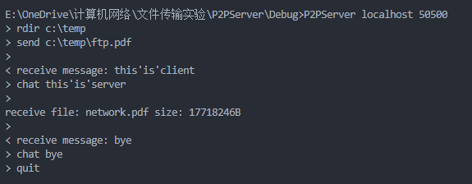
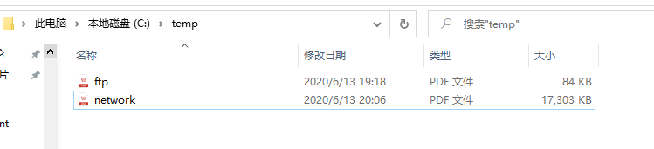
（7）客户端运行截屏：
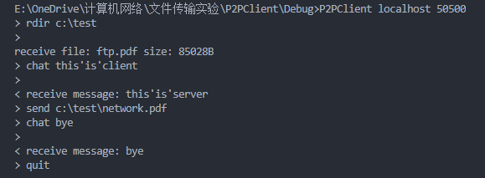
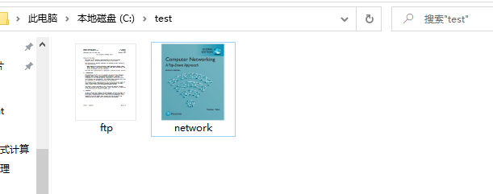
（8）与同学互测（选做）
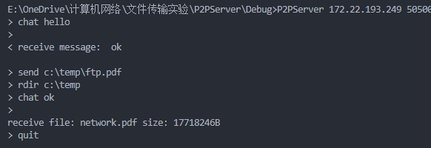
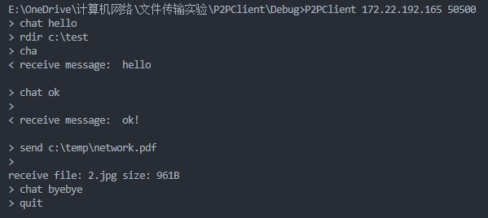
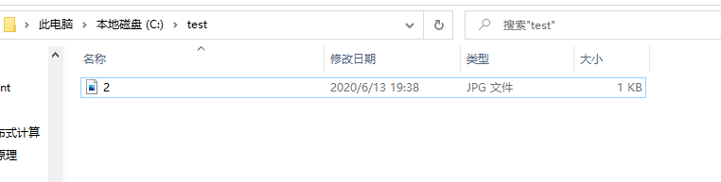
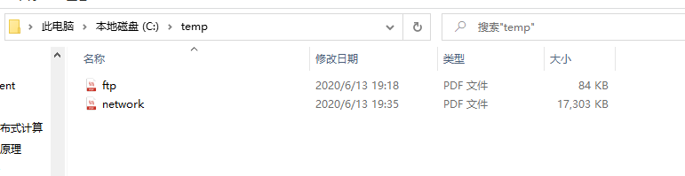
（互测同学服务器端↓）
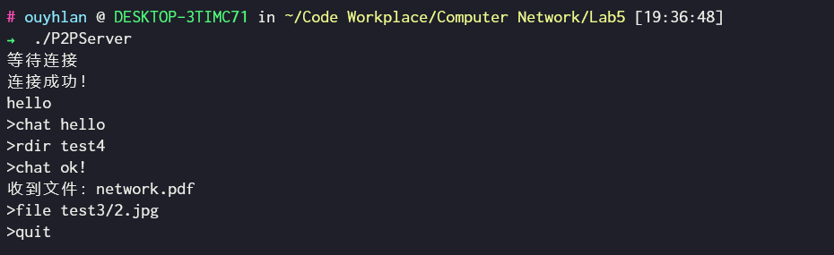
【完成情况】
是否完成以下步骤？(√完成 ×未做)
1 [√] 2 [√]

第2(8)步互测（选做）的同学的学号姓名： 18340133欧阳浩岚

【实验体会】

本次实验的核心内容在于区分聊天内容和文件内容的接收与发送，接收方面需要先接收携带数据包类型的结构1，我采用的方式是1表示聊天，2表示文件，如果识别出数据包是聊天内容，则在下一步需要接收携带内容字节大小的结构2，然后根据该大小接收相同字节的聊天内容，反之如果识别出数据包是文件内容，则在下一步需要接收携带文件字节大小和文件名的结构2，然后根据文件大小接收相同大小的文件，注意在第二步中聊天内容和文件内容的结构2是不同的。总体来说完成本次实验耗费了较多时间，但在这个过程中也学到了很多东西。

【交实验报告】
(1) 每位同学单独完成本实验内容并填写实验报告。
(2) 上交网址：http://103.26.79.35/netdisk/default.aspx?vm=18net 实验上交/编程实验
(3) 截止日期（不迟于）：2020年6月13日 23:00 （周六）。
上传文件：学号_姓名_文件传输实验.doc
学号_姓名_文件传输实验.rar

