**作業系統實驗 Lab03 - 4108056005 資工三 江尚軒**

Ex1.

1. Write a program “printid.c” with the authority of superuser to print the real user ID and the effective user ID.

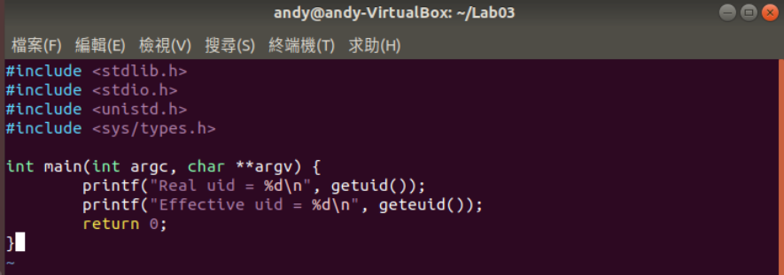

1. Create a new user

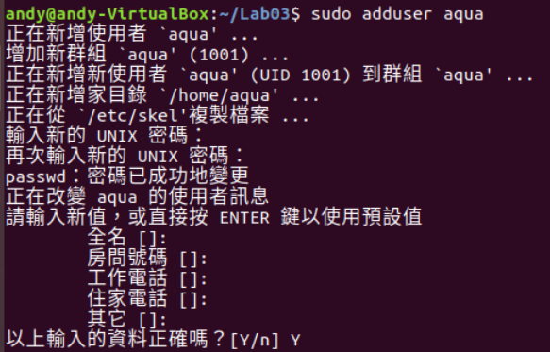

1. Add the setuid attribute

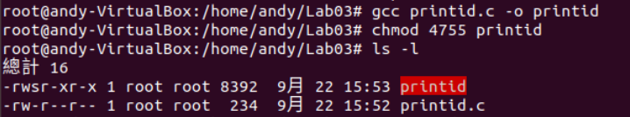

1. Change to the new user



1. Execute the “printid” to print the real user ID and the effective user ID

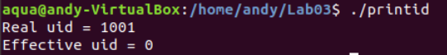

Ex2.

1. An empty file for writing data, and should be writable only by the root.

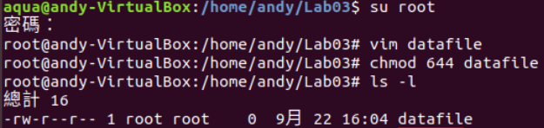

Changefile.c

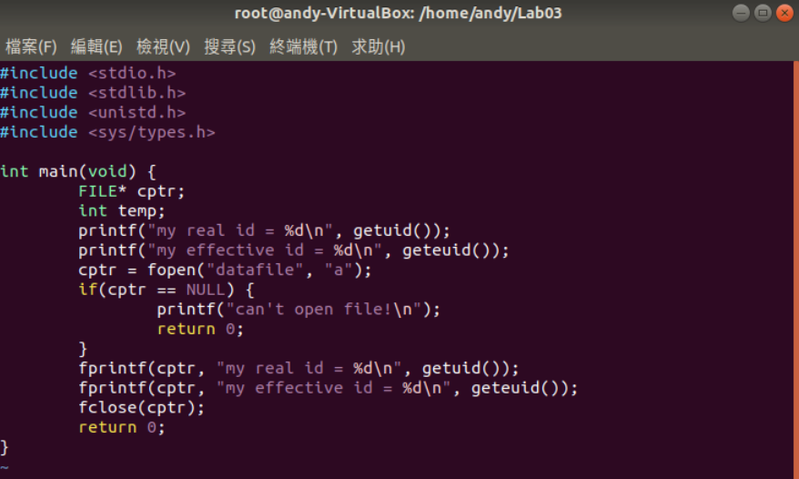

Compile and change privilege

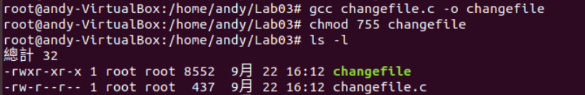

Execute changefile with the authority “root”

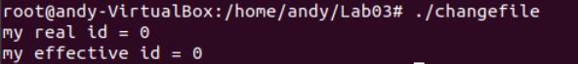

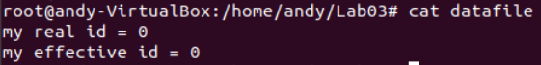

Switch to another user and execute changefile



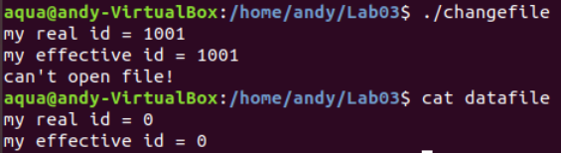

2. Your job is to make a solution to the problem

A: By setting changefile with a SUID attribute.

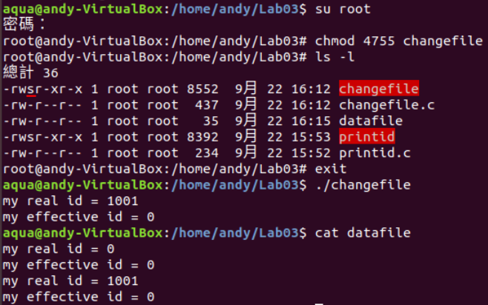

1. 因為我將changefile加上**SUID attribute**，因此其他使用者在執行該程式時，是以root的權限執行的，又因為root有更改datafile的權限，所以就成功了!! 真是可喜可賀可喜可賀(拍手

seteuid()只有root可以使用，其他使用者不可使用。