**作業系統實驗Lab04 – 4108056005 資工三 江尚軒**

EX1(P8~P20)

1. Get the Linux kernel source code

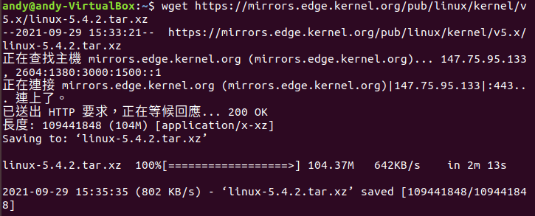

1. Extract tar.xz File



1. Soft link

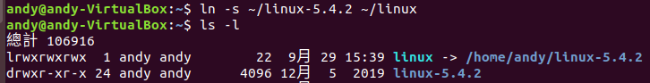

1. Install the Compile Tools



1. Transfer the Current Kernel Configuration

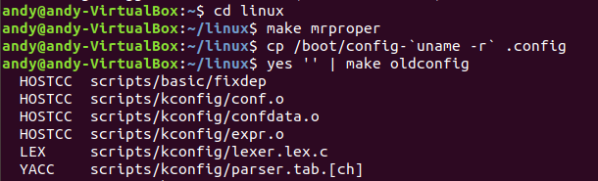

1. Add Customized System Call



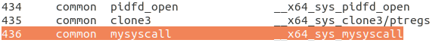



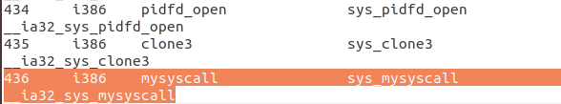



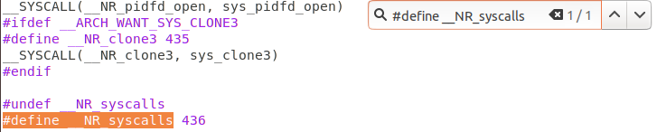

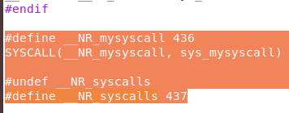

1. Implement the System Call Function



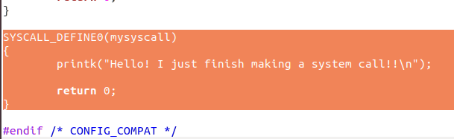



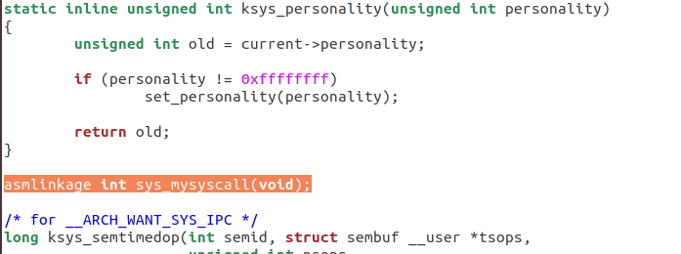



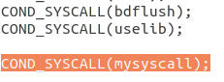

EX2(P21~P25)

1. Get thread or cpu core

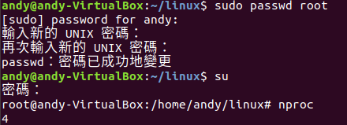

1. Compile the Kernel(大概跑了45分鐘)



1. Install the Kernel





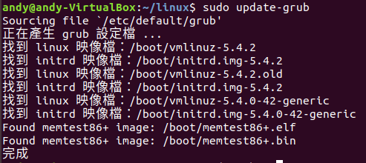

1. Verify





EX03(P26~P29)

1. Test system call



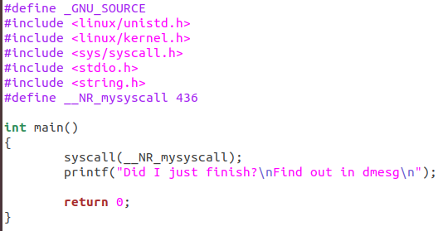

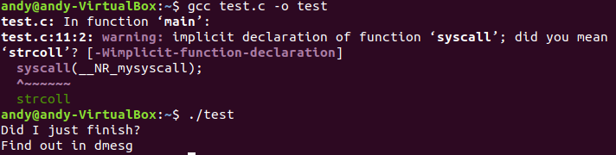

1. Kernel message



