**Lab 2 - DQN**

**312553024 江尚軒**

* **Experimental Results (30%)**
  + **Screenshot of Tensorboard training curve and testing results on DQN.**

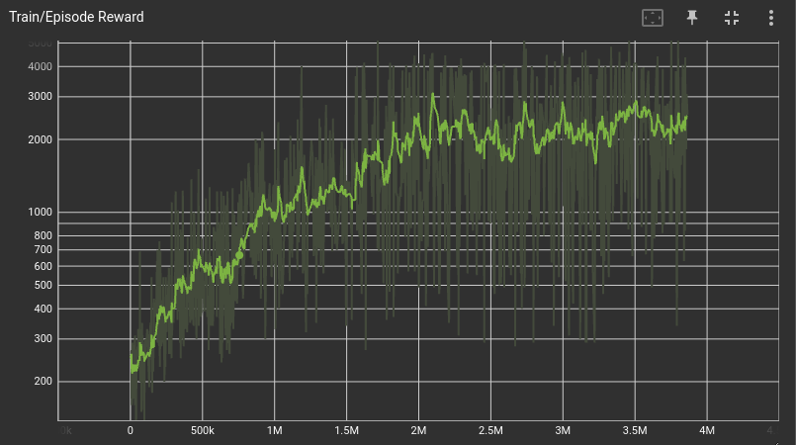

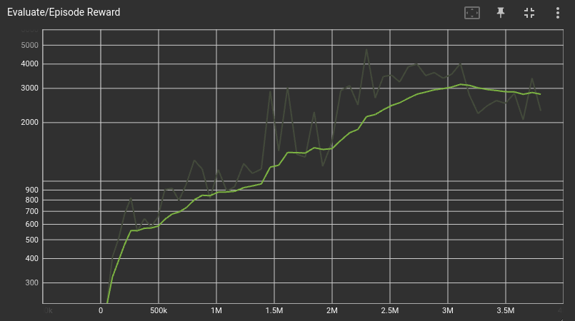

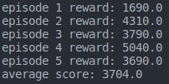

* **Experimental Results and Discussion of bonus parts (bonus) (20%)**
  + **Screenshot of Tensorboard training curve and testing results on DDQN, and discuss the difference between DQN and DDQN (3%).**

(I am sorry that I don’t have enough time to train the DDQN model, so I only train 100 episodes.)

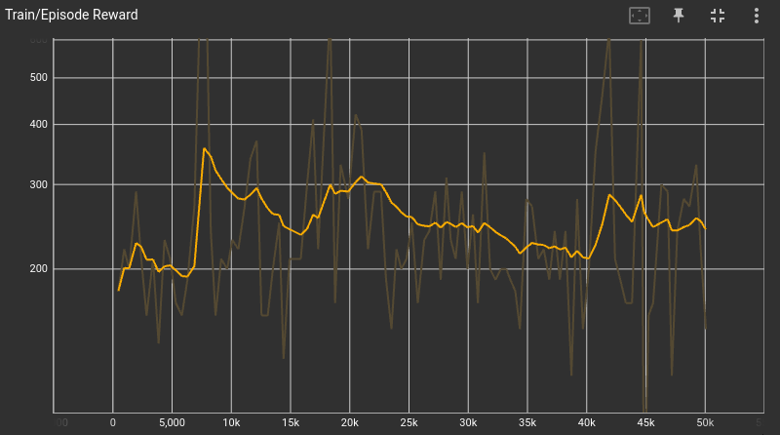

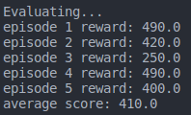

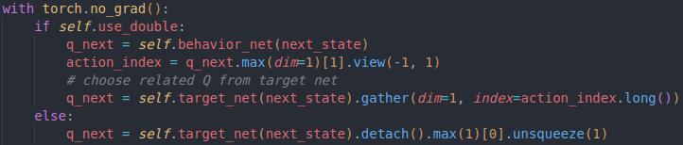

Both DQN and DDQN are reinforcement learning algorithms based on Q-learning. DDQN improves upon DQN by addressing overestimation bias through a double Q-learning approach. In DDQN, two Q-networks are used to select and evaluate actions separately, resulting in more stable and accurate Q-value estimates. This helps in training more robust and effective decision-making agents.

* + **Screenshot of Tensorboard training curve and testing results on Dueling DQN, and discuss the difference between DQN and Dueling DQN (3%).**

(I am sorry that I don’t have enough time to train the Dueling DQN model, so I only train 100 episodes.)

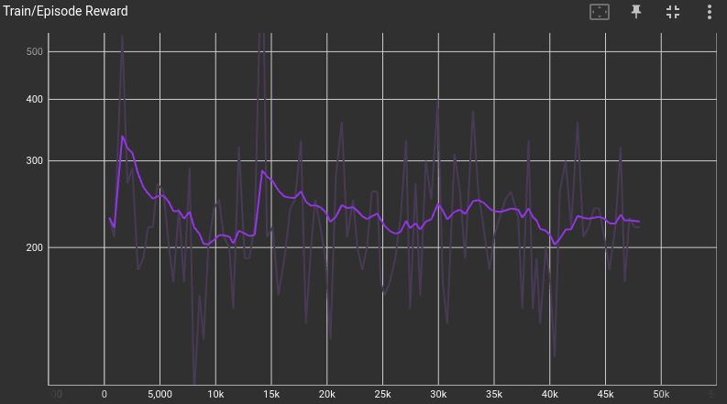

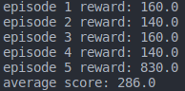

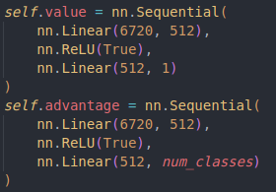

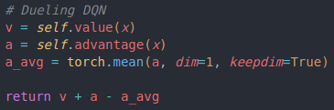

DQN and Dueling DQN are both reinforcement learning algorithms, but Dueling DQN improves upon DQN by using a specific neural network architecture that separates the estimation of state values and action advantages, addressing issues like overestimation bias and enhancing learning efficiency.

* + **Training curve comparison (DQN vs. DDQN vs. Dueling DQN)**

