Writing Corporate Articles using LaTeX

A. Clifton

# Executive Summary

This document is a guide to writing corporate documents with a consistent graphic design using the LaTeX document preparation system.

LaTeX is not WYSIWYG and has different reviewing and editing tools compared to typical word processing software. For this reason special care has to be taken when preparing documents in LaTeX.

This document also serves as a template. It is intended for people with familiarity with LaTeX.

# What is LaTeX?

LaTeX is a mark-up language that describes how a document should be prepared.

Three things are needed to make a LaTeX document:

1. A source latex document
2. Some packages and classes that help turn what’s in the source document into something helpful
3. A compiler, also referred to as a working LaTeX installation.

LaTeX source files are usually rendered into PDF, but can also be turned in to HTML and proprietary formats such as .docx.

At first glance the source document looks like a programming language, and that’s because it is: LaTeX is not WYSIWYG, like many of the document preparation tools in common use today. A good analogy to LaTeX is html code, which can be read in any text editor but is rendered by web browsers into a finished product.

## Printed Resources

Several excellent LaTeX references exist and may be found useful by some users. Examples include those by and .

## Online Resources

The wikibook at [en.wikibooks.org/wiki/LaTeX](http://en.wikibooks.org/wiki/LaTeX) is an excellent resource. There are also several internet forums such as <tex.stackexchange.com> that may be useful.

Documentation for the packages used in the class files (Section 2.1) can be found at <ctan.org>.

# Using LaTeX For Corporate Documents

Corporate documents usually try to have a common look and feel. They do this by using consistent fonts, colours, spacing and other graphic elements across all of their written products. This is challenging to achieve using WYSIWYG editors, especially if the author is given any leeway in document formatting.

This document and the associated examples in the repository show how a common corporate design can be implemented and – to some degree – hidden from the user, in LaTeX. They use the *corporate*.cls* files to implement common formatting in LaTeX articles and reports.

## Corporate class files

Class files control the formatting and presentation of documents. The class files currently available include:

CorporateReport.cls

compiles the document using the LaTeX *report* class, with corporate formatting. This is intended for longer documents and allows the use of chapters.

CorporateArticle.cls

compiles the document using the LaTeX *article* class, with corporate formatting. This is intended for shorter documents such as journal articles. This class does not support the use of chapters.

CorporateCompact.cls

is like *CorporateArticle*, but with reduced spacing.

*../resources/CorporateResources.sty* contains the common packages and formatting descriptions that are implemented by the *Corporate*.cls* classes.

As with normal classes, options are passed to the class in the \documentclass line:

\documentclass[option 1, ..., option n]{CorporateArticle}

All of the usual options can be used with the *Corporate*.cls* classes, including *twocolumn, letterpaper,* and so-on.

Options specific to *Corporate*.cls* include:

draft

add a ‘draft’ watermark to all pages.

blacklinks

make all links the same color as the rest of the body text.

logo

add the logo to all pages.

tagged

used PDF tagging

The *Corporate*.cls* files call a variety of other packages. Packages are codes that modify the appearance or behaviour of LaTeX to achieve something. Table [Tab:Packages] lists the packages that are explicitly called by *Corporate*.cls* or *CorporateResources.tex* in the order they are called in. These packages often call other packages, so this is not an exhaustive list.

|  |  |
| --- | --- |
| Package | Function |
| accessibility | generates the PDF document structure and tagging |
| amsfonts, amssymb | supplies AMS fonts, which are useful for mathematics |
| array | better tables |
| babel | activates language-appropriate hyphenation rules |
| booktabs | improves the formatting of tables |
| caption | required to generate captions for floats |
| fontenc | enables direct typing of international characters |
| geometry | sets page size and margins |
| graphicx | graphics handling, including *.eps* figures |
| hyphenat | improves spacing and breaking of hyphenated words |
| listings | enables the inclusion of high-quality computer code listings |
| mathptmx | changes fonts |
| nag | checks that packages are up to date and looks for bad habits in LaTeX code |
| opensans | sets Google’s *Open Sans* as the default font |
| parskip | required for better spacing |
| pdfcomment | required for tool-tips. Also calls the *hyperref* package. |
| setspace | required for better spacing |
| subcaption | provides the subfigure environment to produce sub figures |
| tocloft | improved table of contents and list of figures/tables in memoir documents |
| tocbibind | Adds bibliography, index, and contents entries to the Table of Contents in memoir documents |
| todonotes | inline and margin to-do notes |
| xcolor | Driver-independent color extensions for LaTeX and pdfLaTeX |

It should be noted that the ‘english‘ option to Babel really means American english.

## Corporate Design

The corporate design is implemented in *CorporateResources.sty*. This file controls design choices such as colors, font types and sizes, and other formatting depending on the underlying LaTeX class.

I cannot provide detailed support for the *CorporateResources.sty* file.

## Starting new documents

I suggest you use this document and its file structure as a template.

You can download the latest version of this document from <https://github.com/AndyClifton/CorporateLaTeX>. You can get a .zip file by clicking the icon on the lower right hand side of the page.

## Creating a file structure

Try to split your text up into different files. This helps you move blocks of text around and can make it easier to collaborate as your coauthors can work on different parts of the document simultaneously.

In this template, the main file that needs to be compiled to create the PDF is *main.tex*. I use this naming convention to help editors and coauthors identify where to start. I then use \input{} to import other files into my main file at compilation.

Each of the chapters and sections in this document are in separate files, called *WhatIsLatex*, *LatexForDocs*, and so-on. They are stored in the *../DemoFiles* directory so that each of the *Corporate*.cls* files can use the same text.

My *main.tex* file has a simple internal structure:

\documentclass[option 1, ..., option n]{CorporateArticle}  
...  
\begin{document}  
% content  
\input{files/WhatIsLatex}  
\input{files/LatexForDocs}  
...

There are very few if any lines in the preamble; almost all of the document formatting is inside the *Corporate*.cls* and *CorporateResources.sty* files.

## Front, main, and back matter

The convention in this corporate class is to have Roman numerals in the front matter, and then arabic numerals in the main matter of the document (after the tables of contents, figures and tables). Tables and figures in the front matter are also numbered differently (Table A, B, C, ...) than in the main matter (Table 1, 2, 3, ...).

This change in page and float numbering is implemented using the \frontmatter, \mainmatter, and \backmatter commands at the start of these sections of the document:

\begin{document}  
  
\maketitle  
\frontmatter  
...  
\tableofcontents  
\clearpage  
\listoffigures  
\listoftables  
\mainmatter  
...  
\backmatter  
\end{document}

Page numbering in the front matter (i.e. the Abstract, Summary, and Foreword chapters or sections) starts at page 3 to allow for cover pages.

If you don’t use the \frontmatter commands, you may need to increment the page counter manually. To increment the counter $n$ pages, use \setcounter{page}{n} after \begin{document}.

## Cross references

Use labels and references to refer back and forth to figures, equations, tables and sections.

For example, an equation can be added using the following text:

\begin{equation}  
y = mx+c  
\label{eqn:line}  
\end{equation}

This gives the following:

$$y=mx+c$$

And using the text Eqn. \ref{eqn:line} provides a cross reference to Eqn. [eqn:line].

## Floats

Floats are images, tables or other pieces of the document that are free to move to the best place in the document for them. The two most common floats are the tabular environment (for tables) and the figure environment for figures.

Use the tabular environment to produce basic tables. Table [tab:widgets] is produced using this code:

\begin{table}[!h]  
\centering  
\caption{An example table.}\label{tab:widgets}  
\begin{tabular}{lr}  
Item & Quantity \\  
\hline  
Widgets & 42 \\  
Gadgets & 13  
\end{tabular}  
\end{table}

An example table.

|  |  |
| --- | --- |
| Item | Quantity |
| Widgets | 42 |
| Gadgets | 13 |

If all of the delimiters (&) are included in each row, the table will be complete and will produce a better PDF.

To include a figure in a document, use the figure environment and the includegraphics command. The *subcaption* package is used to generate subfigures. The example below generates Figure [fig:NRELimages].

\begin{figure*}  
 \centering  
 \begin{subfigure}[t]{.45\linewidth}  
 \centering  
 \includegraphics[height=2in]{../DemoFiles/21206}  
 \caption{Wind turbines at the Forward Wind Energy Center in Fond du Lac and Dodge Counties, Wisconsin. (Photo by Ruth Baranowski / NREL)}\label{fig:21206}  
 \end{subfigure}%  
 \hfill  
 \begin{subfigure}[t]{.45\linewidth}  
 \centering  
 \includegraphics[height=2in]{../DemoFiles/20018}  
 \caption{Aerial view of the National Wind Technology Center. (Photo by Dennis Schroeder / NREL)}\label{fig:20018}  
 \end{subfigure}  
 \caption{Images}\label{fig:NRELimages}  
\end{figure*}

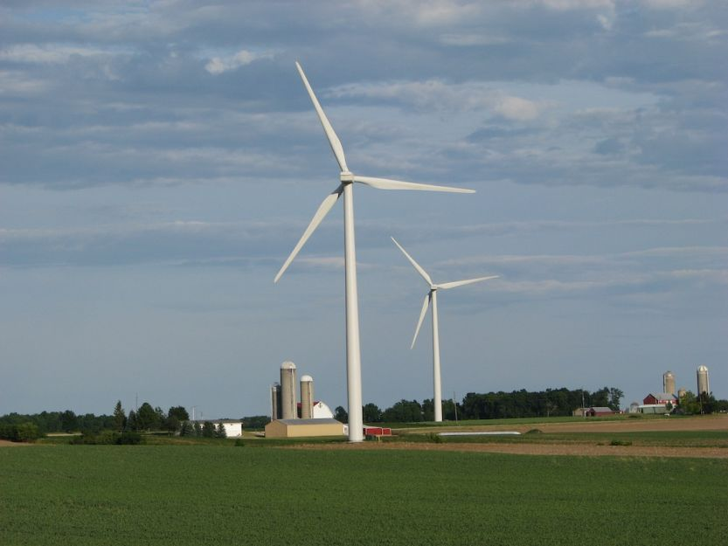

Wind turbines at the Forward Wind Energy Center in Fond du Lac and Dodge Counties, Wisconsin. (Photo by Ruth Baranowski / NREL)

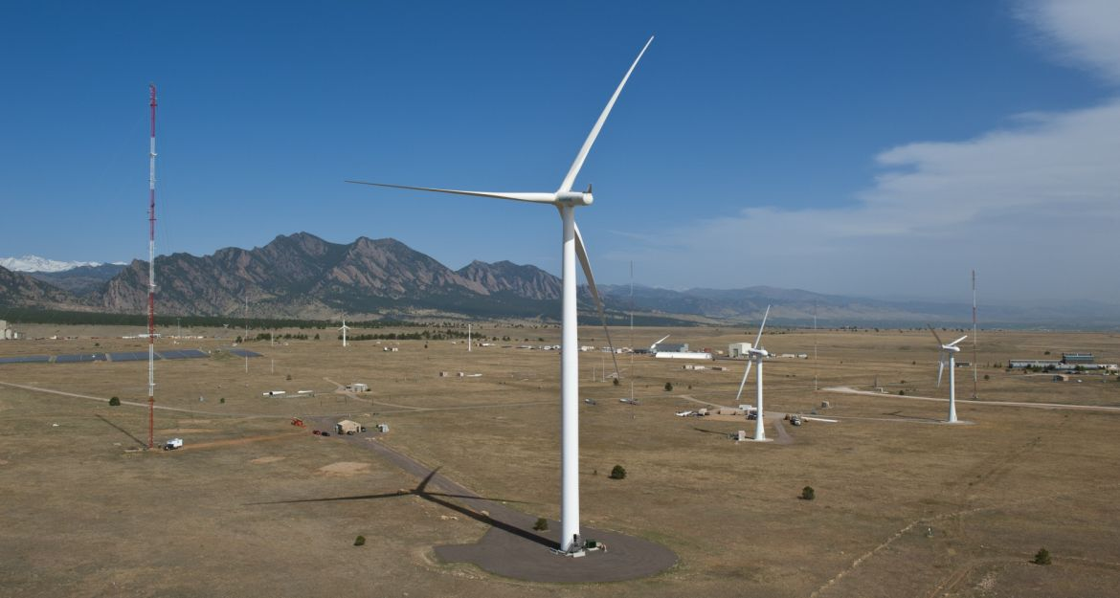

Aerial view of the National Wind Technology Center. (Photo by Dennis Schroeder / NREL)

## Including computer code

The *listings* package is called by *Corporate*.cls*.

To change the syntax highlighting use \begin{lstlisting}[language={[dialect]language}] before each listing where the language changes. For more details see the *lstlisting* package documentation.

## Citations

Use *bibtex* to organize references and store them in a single file. The bibliography will then contain entries with ‘keys’ for each source, like Lamport_1986_a. See ../resources/bibliography.bib for an example of this file.

Authors can then insert citations to this key throughout their document, using different styles of citation. Citations are generated using the *biblatex* package, which also formats references in the correct style. Ways to generate citations are described in the *biblatex* documentation, and include:

* \cite{Lamport_1986_a} prints .
* \citep{Lamport_1986_a} prints .
* \citet{Lamport_1986_a} prints .

To cite URLs, use the ’misc’ style. For example, the bibtex entry for <http://tex.stackexchange.com>  looks like this:

@misc{texstackexchange,  
 Author = {Anon.},  
 Howpublished = {Accessed July 21, 2014: \url{http://tex.stackexchange.com}},  
 Title = {\TeX -- LaTeX Stack Exchange},  
 Year = {2014}}

This format will allow you to include the date on which a URL was accessed.

The citations should work with journal articles , books , technical reports , and URLs .

Any unknown publication types will be formatted using the ‘misc’ type when you are using the *Corporate*.cls* classes.

## Bibliographies

This document class uses "Chicago A" style-references produced using Biblatex. The reference style can be changed in the *Corporate*.cls* file.

To include a bibliography in the document give the bibliography file location in the preamble and insert the bibliography at the appropriate location:

% give the bibliography file location  
\bibliography{files/bibliography.bib}  
...  
\begin{document}  
...  
% insert the bibliography into the document  
\cleardoublepage  
\label{sec:Bib}  
\printbibliography  
...  
\end{document}

An example bibliography is included in this document on page .

## Footnotes

Footnotes can be inserted using the \footnote{} command[1]. Footnotes are numbered in the main matter[2]. In the appendices symbols are used instead.

## Best practice in writing a document in LaTeX

Create a structure before you get too far.

Authors will find it easier to write documents and make changes if they separate the content of the document from the structure.

1. Each new LaTeX document should be placed in it’s own directory.
2. Create a main LaTeX file that just contains the preamble, custom commands and uses \input{} to call the content. See Section 2.4 for an example where each chapter is contained in its own file. In an article, each section could be contained in its own file.
3. Keep the number of packages used to a minimum. Not all packages can be used as they lack compatibility.

Focus on content, not appearance.

Don’t spend hours trying to adjust fonts, headers or spacing between lines.

1. Don’t use \clearpage{} or other commands to push material around. LaTeX is designed to handle that.
2. Resist the temptation to add or subtract space, change lengths or do other things to modify the layout.
3. Write!

# Preparing an Accessible PDF from LaTeX

Care has to be taken to produce a PDF that meets best practice for accessibility. This may require special steps such as tagging, alt-text, and embedding fonts for documents that will be used with electronic document readers.

## PDF tagging

PDF tagging is a process whereby the components of the PDF document (headings, figures, tables, text) are marked so that a document reader can understand the document. This is useful when text to speech converters are being used. The process of tagging is also known as structuring, so that a tagged document might also be referred to as a structured document[3].

The *accessibility* package can be used to add tags to a LaTeX document. This package is called by choosing the *tagged* option when calling the *Corporate*.cls* document class:

\documentclass[option 1, ..., tagged]{CorporateArticle}

Tags do not always work reliably. It may be easier to add them after the PDF is compiled using a PDF editor such as Adobe’s Acrobat Pro.

## Alternative text

Alternative text, or ‘Alt text’, is a textual description of an equation, link or figure that can be used to replace the visual information in that element. This is often seen as a text ‘pop-up’ in PDF readers.

Alt text can be added after the PDF is compiled using a PDF editor such as Adobe’s Acrobat Pro.

Alternatively – and probably best for ensuring that the final document is what the author intended – the pop up can be generated from within the source document using the \pdftooltip environment from the *pdfcomment* package. For example, \pdftooltip{a^2+b^2=c^2}{An equation} produces a pop-up when the cursor passes over the equation:

$$\pdftooltip{a^2+b^2=c^2}{An equation}$$

The same approach can be used to create alt text for images. Figure [fig:TestImagesWithAltText] has been labeled with a tool tip.

## Embedded fonts

All fonts should be embedded in the the final PDF. Check the PDF for embedded fonts using a PDF viewer. For example, in Adobe Acrobat Reader, look at the ‘fonts’ tag of the document properties. If any fonts are not shown as being an *embedded subset*, try the conversion again.

Encapsulated postscript figures are particularly prone to having undefined fonts. Check by compiling the document in draft mode, and seeing if the fonts are still present in the output PDF. To fix this problem, change *.eps* files to *.png* files. To do this ‘on the fly’, use this in the document’s preamble:

\usepackage{epstopdf}  
\epstopdfDeclareGraphicsRule  
 {.eps}{png}{.png}{convert eps:\SourceFile.\SourceExt png:\OutputFile}  
\AppendGraphicsExtensions{.png}

# Exporting LaTeX into other formats

LateX source files are usually converted into PDF files. But, they can be converted into other formats for easier editing or for publishing to the internet.

The best approach to exporting LaTeX documents is to use *Pandoc* to parse the .tex source and reformat it for other uses.

Pandoc is an open-source program that you have to install. Details can be found at <https://pandoc.org/>.

Pandoc is called from the command line / terminal of your computer:

pandoc -s ArticleMain.tex -o pandocDemo.docx

An example.docx file generated using pandoc 2.03 is included in the CorporateArticle directory of this repository.

# Acknowledgments

This document is based on the NREL LaTeX class files developed by the author and then forked for this project.

I wish to thank members of the TeX – LaTeX StackExchange site for useful suggestions concerning LaTeX and typography .

This report was typeset using the LaTeX typesetting system originally developed by Leslie Lamport, based on TeX created by Donald Knuth.

[sec:TheBibliography]

# How to Use Appendices

Appendices can be included in *Corporate*.cls* documents.

## How to switch to appendixes

To switch to appendices, use the *appendix* command in your source *.tex* file:

\appendix  
\input{files/AppendixA}  
\input{files/AppendixB}

## Changes to Figure, Table, and Footnote Numbering

The following table (Table [tab:AppAWidgets]) should have a different caption numbering style than Table [tab:widgets]. The table number should start with the appendix label (in this case ,) be followed by a period, and then be numbered. Numbering should restart in each new appendix.

An example table.

|  |  |
| --- | --- |
| Item | Quantity |
| Widgets | 42 |
| Gadgets | 13 |

The following table should use the same letter as Table [tab:AppAWidgets], but the number should be incremented by one.

An example table.

|  |  |
| --- | --- |
| Item | Quantity |
| Widgets | 42 |
| Gadgets | 13 |

Footnotes use symbols in place of numbers in the appendices[4].

1. like this
2. except in the *CorporateCompact* class
3. This is a test
4. this is a test