**Chapter**

# Executive Summary

This document is a guide to writing documents for publication by NREL using the LaTeX document preparation system. LaTeX is not WYSIWYG and has different reviewing and editing tools compared to typical word processing software. For this reason special care has to be taken when preparing NREL documents in LaTeX. This document serves both as a guide to implementing NREL’s style and formatting guidelines in LaTeX, and as a template. This document is intended for people with some familiarity with LaTeX.

**Chapter**

# Acknowledgments

This document and the NREL LaTeX class file were developed by staff at the National Wind Technology Center, including Andrew Platt, Andrew Clifton, Andrew Ning, Mike Lawson, and Paul Fleming. Alexsandra Lemke provided support relating to NREL communications. A first demonstration of an NREL class file was created by Chuck Booten from NREL’s Electricity, Resources, and Building Systems Integration group, which inspired this effort. The class file and this template were developed as part of work on several NREL reports, journal articles, and conference publications.

We thank members of the TeX – LaTeX StackExchange site for useful suggestions concerning LaTeX and typography (Anon., 2014).

This report was typeset using the LaTeX typesetting system originally developed by Leslie Lamport, based on TeX created by Donald Knuth.

Contents

Executive Summary 1

Acknowledgments 1

Requirements for NREL documents 6

1 Use of english and other conventions 6

2 Formatting 6

Using LaTeX to make documents that meet NREL’s requirements 7

1 What is LaTeX? 7

2 General Process 7

3 The NREL LaTeX style file 8

3.1 Getting nrel.cls 8

3.2 Installing nrel.cls 8

3.3 Using nrel.cls 8

3.4 Options in nrel.cls 9

3.5 Classes and packages in nrel.cls 9

4 Front, main, and back matter 10

5 Citations 11

6 NREL-style bibliographies 12

7 Putting it all together 12

8 Best practice in writing a document in LaTeX 13

Some LaTeX examples 14

1 Headings 14

1.1 Chapter 14

1.2 Sections 14

2 Body text 15

3 Mathematics 15

4 Cross references 15

5 Floats 15

5.1 Tables 15

5.2 Figures 16

5.3 Subfigures 16

6 Lists 18

7 Computer code 18

8 Creating a file structure 18

Preparing a high-quality PDF from LaTeX 20

1 PDF tagging 20

2 Alt-text on images and equations 21

3 Embedded fonts 23

List of Figures

1 NREL images 18

1 NREL images 22

List of Tables

1 NREL’s process for producing and reviewing LaTeX files 7

2 Packages supported by nrel.cls. Unless otherwise stated, packages are not supported by latex2rtf. 9

1 An example table. 16

**Chapter 1**

# Requirements for NREL documents

There are well-defined requirements for all documents that are published by NREL.

## 1 Use of english and other conventions

The NREL in-house style is described at http://www.nrel.gov/extranet/communications/styleguide.html  (http://www.nrel.gov/extranet/communications/styleguide.html). This details the conventions that should be used when writing NREL documents.

## 2 Formatting

NREL publishes templates for reports and other technical documents. These are designed to be used with most common WYSIWYG programs and latex. Templates are posted online at http://www.nrel.gov/extranet/communications/report_template.html  (http://www.nrel.gov/extranet/communications/report\_template.html) and updated regularly.

**Chapter 2**

# Using LaTeX to make documents that meet NREL’s requirements

## 1 What is LaTeX?

LaTeX is a mark-up language that describes how a document should be prepared. Three things are needed to make a LaTeX document:

1. A source document, usually with extension *.tex*

2. Some packages and classes that help turn what’s in the source document into something helpful

3. A compiler, also referred to as a working LaTeX installation.

At first glance the source document looks like a programming language, and that’s because it is: LaTeX is not WYSIWYG, like many of the document preparation tools in common use today. A good analogy is html.

The wikibook at http://en.wikibooks.org/wiki/LaTeX  (http://en.wikibooks.org/wiki/LaTeX) is an excellent resource. There are also several internet forums such as tex.stackexchange.com  (tex.stackexchange.com) that may be useful.

## 2 General Process

An outline of the process for producing NREL documents using LaTeX is given in Table 1. Please note that this process is subject to revision without warning.

Table 1: NREL’s process for producing and reviewing LaTeX files

|  |  |  |  |
| --- | --- | --- | --- |
| Phase | Lead | Steps | More Information |
| Draft | Author | 1. Prepare document in LaTeX using the *nrel.cls* class file | Section 3 |
|  |  | 2. Prepare PDF | Section 4 |
|  |  | 3. Convert the tex document to rich text format (*.rtf*) using latex2rtf | Chapter **Error! Reference source not found.** |
|  |  | 5. Archive all files, including: |

• LaTeX source files

• Images

• Final PDF

|  |  |
| --- | --- |
|  |  |
| Review | Communications | Review the structure of the PDF |  |
|  |  | Edit the supplied *.doc* or *.docx* file using track changes |  |
| Revision | Author | Implements required changes in the LaTeX files. |  |
|  |  | Create the final, tagged and structured PDF |
| Publish | Publications | Combine the PDF with the appropriate cover sheet(s) |  |

## 3 The NREL LaTeX style file

A LaTeX class called *nrel.cls* has been written that implements the NREL formatting requirements in LaTeX.

### 3.1 Getting nrel.cls

The current version of *nrel.cls* can be downloaded from https://github.com/NREL/latex\s\do6(e)diting  (https://github.com/NREL/latex\_editing). This is a public repository.

### 3.2 Installing nrel.cls

Place *nrel.cls* and *nrel.bst* in the same directory as the LaTeX files you are trying to compile. This will make the files available to that project, only. This approach can be used on a desktop computer, or on a network drive, or for online collaborative tools such as www.writelatex.com  (www.writelatex.com) or www.sharelatex.com  (www.sharelatex.com). Advanced LaTeX users may wish to copy these files to their local tree.

### 3.3 Using nrel.cls

To use the class file, insert the following text in the preamble, before \begin{document}:

\newif\iflatextortf

\iflatextortf

% tell latex2tortf if this is an article or report

\documentclass[10pt,letterpaper]{report}

\input{NRELLatex2rtf.tex}

\else

\documentclass[draft,report]{nrel}

\fi

This tells LaTeX to use the correct class file, and defines a set of commands that will be used by *latextortf* to properly convert the latex to a rich text document for reviewing (see Chapter **Error! Reference source not found.**).

### 3.4 Options in nrel.cls

The line

\documentclass[draft,report]{nrel}

specifies the options (inside the square brackets) that will be passed to the *nrel* class. The options include:

**book** compile the document using the LaTeX *book* class. This is intended for longer documents and allows the use of chapters.

**report** compile the document using the LaTeX *report* class. This is intended for longer documents and allows the use of chapters.

**article** compile the document using the LaTeX *article* class. This is intended for shorter documents such as journal articles. This class does not support the use of chapters.

**memoir** compile the document using the LaTeX *memoir* class. This option is not recommended because of the challenge with later converting to RTF format for communications review.

**draft** add a ‘draft’ watermark to all pages and colours all links in blue.

**10pt, 12pt** set the font size accordingly. The default is 12 point.

**letterpaper, a4paper** set the paper size. the default is letter paper.

### 3.5 Classes and packages in nrel.cls

*nrel.cls* calls a variety of other packages. Packages are codes that modify the appearance or behaviour of LaTeX to achieve something. Table 2 lists the packages that are explicitly called by *nrel.cls* in the order they are called in. These packages often call other packages, so this is not an exhaustive list.

Table 2: Packages supported by nrel.cls. Unless otherwise stated, packages are not supported by latex2rtf.

|  |  |  |  |
| --- | --- | --- | --- |
| Packages | options | functionality | latex2rtf support |
| nag |  | checks that packages are up to date and looks for bad habits in LaTeX code. |  |
| geometry |  | sets page size and margins | y |
| mathptmx |  | changes fonts |  |
| helvet |  | changes fonts |  |
| courier |  | changes fonts |  |
| amsfonts, amssymb |  | supplies the AMS fonts, which are useful for mathematics |  |
| booktabs |  |  |  |
| graphicx |  | graphics handling, including *.eps* figures | y |
| natbib | sort | handles citations and allows the \cite, \citep and \citet citation commands (see Section 3). | y |
| fontenc | T1 |  |  |
| xcolor |  |  |  |
| babel | english |  |  |
| subfig |  | provides the subfloat environment to produce sub figures | y(*subfloat* is mapped to the *subfigure* command) |
| hyphenat |  |  |  |
| setspace |  |  |  |
| parskip |  |  |  |
| toclof | subfigure |  |  |
| toclifbind | nottoc, notlot, notlof |  |  |
| todonotes |  | inline and margin to-do notes | y(‘to do’ is prefaced with **To Do:** in the output) |
| listings |  |  |  |
| caption |  |  |  |
| pdfcomment |  | tool-tips. Also calls the package hyper ref | y(the tool tip is suppressed) |

## 4 Front, main, and back matter

NREL’s convention is to have Roman numerals in the front matter, and then arabic numerals in the main matter of the document (after the tables of contents, figures and tables). Tables and figures in the front matter are also numbered differently (Table A, B, C, ...) than in the main matter (Table 1, 2, 3, ...).

This change in page and float numbering is implemented using the \frontmatter, \mainmatter, and \backmatter commands in the document:

\begin{document}

\maketitle

\frontmatter

...

\renewcommand{\contentsname}{Table of Contents}

\tableofcontents

\clearpage

\listoffigures

\listoftables

\mainmatter

...

\backmatter

\end{document}

Page numbering in the front matter (i.e. the Abstract, Summary, and Foreword chapters or sections) starts at page 3 to allow for NREL cover pages.

If you don’t use the \frontmatter commands, you may need to increment the page counter manually. To increment the counter *n* pages, use \setcounter{page}{n} after \begin{document}.

## 5 Citations

Use bibtex to organize references and store them in a single file (e.g. /Documents/bibliography/bibliography.bib). The bibliography will then contain entries with ‘keys’, like Lamport_1986_a. Authors can then insert citations to this key throughout their document, using different styles of citation:

• \cite{Lamport_1986_a} prints a simple Lamport (1986).

• \citep{Lamport_1986_a} puts parentheses around it (Lamport, 1986).

• \citep[e.g][]{Lamport_1986_a} puts parentheses around it, and some text in there as well (e.g. Lamport, 1986).

• \citet{Lamport_1986_a} prints it inline, so that according to Lamport (1986), ….

To cite URLs, use the ’misc’ style. For example, the bibtex entry for http://tex.stackexchange.com  (http://tex.stackexchange.com)Anon. (2014) looks like this:

@misc{texstackexchange,

Author = {Anon.},

Howpublished = {Accessed July 21, 2014: \url{http://tex.stackexchange.com}},

Title = {\TeX -- LaTeX Stack Exchange},

Year = {2014}}

This format will allow you to include the date on which a URL was accessed.

The citations should work with journal articles, books (Lamport, 1986), technical reports (Other and Nother, 2014), and URLs (Anon., 2014)

## 6 NREL-style bibliographies

Use *nrel.bst* to create a bibliography that conforms to NREL’s requirements. To include a bibliography in the document, use the following commands where you want the bibliography to occur:

...

\cleardoublepage

\bibliographystyle{nrel}

\label{sec:Bib}

\bibliography{/Users/me/Documents/bibliography/bibliography}

...

This will probably be somewhere near to the end of the document.

## 7 Putting it all together

The source of your LaTeX document should probably look like this:

\newif\iflatextortf

\iflatextortf

% tell latex2tortf if this is an article or report

\documentclass[10pt,letterpaper]{report}

\input{NRELLatex2rtf.tex}

\else

\documentclass[draft,report]{nrel}

\fi

\title{Writing NREL documents using LaTeX}

\author{A. Clifton, A. Platt, P. Fleming, M. Lawson}

\begin{document}

\maketitle

\frontmatter

\input{ExecSummary}

\tableofcontents

\clearpage

\listoffigures

\listoftables

\mainmatter

\input{Introduction}

\input{Theory}

\cleardoublepage

\bibliographystyle{nrel}

\label{sec:Bib}

\bibliography{~/Documents/bibliography/bibliography}

\end{document}

## 8 Best practice in writing a document in LaTeX

**Create a structure before you get too far.** Authors will find it easier to write documents and make changes if they separate the content of the document from the structure.

1. Each new LaTeX document should be placed in it’s own directory.

2. Create a main LaTeX file that just contains the preamble, custom commands and uses input to call the content. See Section 8 for an example where each chapter is contained in its own file. In an article, each section could be contained in its own file.

3. Keep the number of packages used to a minimum. If authors feel that something is desperately missing, they can contact the maintainers of the *nrel.cls* file. Not all packages can be used as they lack compatibility.

**Focus on content, not appearance.** Don’t spend hours trying to adjust fonts, headers or spacing between lines.

1. The document produced should meet NREL’s requirements if it is compiled using *nrel.cls*.

2. Don’t throw in lots of clearpages or other commands to push material around. LaTeX is designed to handle that.

3. Resist the temptation to add or subtract space, change lengths or do other things to modify the layout.

4. Write!

**Chapter 3**

# Some LaTeX examples

This chapter includes examples of how to do common tasks using LaTeX. Although most users will be familiar with these commands and environments, these serve as a) a test of the class file and conversion process, and b) examples that are known to work with the class and conversion process. So, when all else fails, users can copy these examples and tailor them to their particular case.

## 1 Headings

LaTeX allows a very simple definition of the document’s structure. This document has the following structure:

• Chapter 1: what is LaTeX?

• Section 1: Headings

• Section 2: Floats

• Section 3: Mathematics

• Section 4: Lists

• etc. …

### 1.1 Chapter

To define a new chapter, simply write \chapter{What is LaTeX?}.

To use chapters, pass the memoir, book, or report option to *nrel.cls* (see Section 3.4).

### 1.2 Sections

If Chapters are the highest level headings in a document, sections come next, followed by subsections. Although there don’t have to be chapters in a document, a LaTeX document does need to have Sections.

So:

\section{Headings}

LaTeX{} allows a very simple definition of the document's structure.

This document has the following structure:

...

\subsection{Chapter}

## 2 Body text

Body text does not need to be specially identified in LaTeX. Non-printing comments are identified in the source document(s) using the % symbol.

## 3 Mathematics

LaTeX is great at typesetting mathematics. The following example is taken from the www.writelatex.com  (www.writelatex.com) website:

Making inline equations is easy. Let be a sequence of independent and identically distributed random variables with and , and let

denote their mean. Then as *n* approaches infinity, the random variables converge in distribution to a normal .

Alternatively, if numbered equations are required, use the equation environment. For example:

\begin{equation}

y = mx +c \textrm{.}

\label{eqn:line}

\end{equation}

would give:

*y*=*mx*+*c*. (1)

## 4 Cross references

Use labels and references to refer back and forth to figures, equations, tables and sections. For example, Eqn. \ref{eqn:line} gives a reference to Eqn. 1.

## 5 Floats

Floats are images, tables or other pieces of the document that are free to move to the best place in the document for them. Literally, they ‘float’. The two most common floats are the tabular environment (for tables) and the figure environment for figures.

### 5.1 Tables

Use the tabular environment to produce basic tables. Table 1 is produced using this code:

\begin{table}[!h]

\centering

\caption{An example table.}\label{tab:widgets}

\begin{tabular}{lr}

Item & Quantity \\\hline

Widgets & 42 \\

Gadgets & 13

\end{tabular}

\end{table}

Table 1: An example table.

|  |  |
| --- | --- |
| Item | Quantity |
| Widgets | 42 |
| Gadgets | 13 |

Resist the temptation to stop table rows early. If all of the delimiters (&) are included in each row, the table will be complete and will better translate to RTF later.

### 5.2 Figures

To include a figure in a document, use the figure environment and the includegraphics command.

\begin{figure}

\includegraphics[width=\textwidth]{figure's-file-name}

\caption{Caption goes here.}\label{fig:figuresLabel}

\end{figure}

### 5.3 Subfigures

Subfigures are implemented using the subfig package. Although this package is deprecated (apparently subcaption is now the preferred package), it plays fairly nicely with latex2rtf so will be used for the foreseeable future.

The labels in the example below allow us to make references using the ref command, both to the overall figure (Figure **Error! Reference source not found.**) and the subfigures (Figures 1 and **Error! Reference source not found.**) directly. Unfortunately, latex2rtf does not allow multiple labels in a Figure environment, and so only the first label will be kept: therefore, it’s best to just use a single label in any one figure environment.

\begin{figure}

\centering

\hfill

\subfigure[Wind turbines at the Forward Wind Energy Center in Fond du Lac

and Dodge Counties, Wisconsin. (Photo by Ruth Baranowski / NREL)

\label{fig:21206}]{\includegraphics[height=2.5in]{21206}}

\hfill

\subfigure[Aerial view of the National Wind Technology Center.

(Photo by Dennis Schroeder / NREL)\label{fig:20018}]

{\includegraphics[height=2.5in]{20018}}

\hfill

\caption{NREL images}\label{fig:NRELimages}

\end{figure}

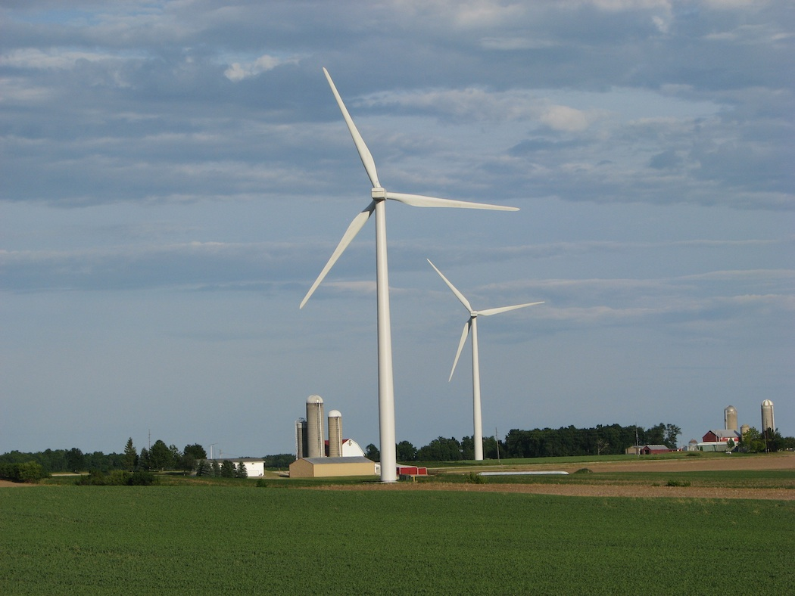

(a) Wind turbines at the Forward Wind Energy Center in Fond du Lac and Dodge Counties, Wisconsin. (Photo by Ruth Baranowski / NREL)

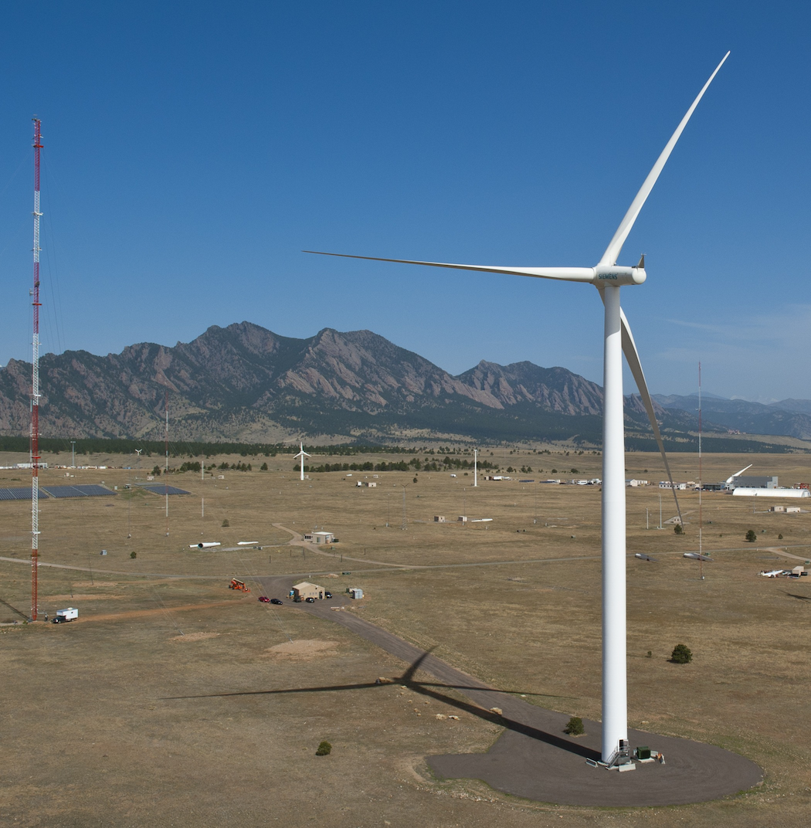

(b) Aerial view of the National Wind Technology Center. (Photo by Dennis Schroeder / NREL)

Figure 1: NREL images

If a subfigure is split over two lines using \\, make sure those symbols are on their own line.

## 6 Lists

To make lists with automatic numbering, use the enumerate environment:

1. Like this,

2. and like this.

…or bullet points …

• Like this,

• and like this.

## 7 Computer code

The lstlisting package has been loaded.

## 8 Creating a file structure

Use the input command to import other files into your main file. For example, each of the chapters in this report could be in separate files, called *NRELRequirements* (Chapter 1), *LatexAtNREL* (Chapter 2), and so-on.

...

% content

\input{NRELRequirements}

\input{LatexAtNREL}

\input{LatexExamples}

\input{ConvertingToDoc}

...

**Chapter** **4**

# Preparing a high-quality PDF from LaTeX

If the author chooses to complete the publications process using LaTeX the author must incorporate feedback and edits in to the LaTeX source files and prepare the final PDF, following these guidelines.

## 1 PDF tagging

PDF tagging is a process whereby the components of the PDF document (headings, figures, tables, text) are marked so that a document reader can understand the document. This is useful when text to speech converters are being used. The process of tagging is also known as structuring, so that a tagged document might also be referred to as a structured document.

LaTeX does not prepare a tagged PDF document. The current solution to this is to use the tagging capability built in to Adobe’s Acrobat Pro.

To prepare a tagged document, follow these steps:

1. Add tags. Go to the ‘Advanced’ menu. Select ‘Accessibility’, then ‘Add tags to document’.

2. Add alternative text for figures. Context-click the Figure, select ‘Properties’, and fill in ‘Alternate Text’. Alternatively, try the process outlined below.

3. Specify the document language. Go to the ‘File’ menu. Select ‘Document Properties’, then the ‘Advanced’ tab, ‘Language’ field. In some versions of Acrobat, the sequence is ‘File’, ‘Properties’, ‘Reading Options’, ‘Language’.

4. Define tab order.

(a) Go to the ‘View’ menu. Select ‘Navigation tabs’, then ‘Pages’.

(b) Click on any page, then type Ctrl-A (or Command-A on a Mac) to select all the pages.

(c) Go to the ‘Options’ menu in the top right of the dialog box, and select ‘Page Properties’

(d) In the ‘Tab Order’ tab, select ‘Use document structure’.

5. Make sure tables have headings.

(a) Go to the ‘View’ menu. Select ‘Navigation tabs’, then ‘Tags’.

(b) Select the ‘Tags’ tab. This panel shows the document structure as a tree.

(c) Navigate to the table cells that should be headers.

(d) Check they have the type <TH>. If not, then right click on the header cell, select ‘properties’, select the ‘Tag’ tab, and change the value for ‘Type’ to <TH>.

6. Make sure all Chapters (or sections, if there are no chapters in the document) are correctly tagged.

## 2 Alt-text on images and equations

‘Alt text’ is a textual description of an equation, link or figure. The following short equation should pop-up some text when a user passes a mouse over it. This should work in most PDF readers:

(1)

The alt text can be added after the PDF is compiled, or written in to the source document. The rest of this section describes how it can be added to the source and generated by LaTeX using the pdfcomment  (http://www.ctan.org/pkg/pdfcomment) package. The general form of the command is:

\pdftooltip{<item>}{<pop-up text>}

The previous equation was generated using this code:

\begin{equation}

\pdftooltip{a^2+b^2=c^2}{An equation}

\end{equation}

The same approach can be used to create alt-text for images. For example, Figure 1 has been labeled. The code for this image is:

\begin{figure}[!h]

\centering

\hfill

\subfigure[Wind turbines at the Forward Wind Energy Center in Fond du Lac and Dodge Counties, Wisconsin. (Photo by Ruth Baranowski / NREL)] {\pdftooltip{\includegraphics[height=2.5in]{21206}}{This is an image}}

~

\hfill

\subfigure[Aerial view of the National Wind Technology Center. (Photo by Dennis Schroeder / NREL)] {\includegraphics[height=2.5in]{20018}}

\hfill

\caption{NREL images}\label{fig:NRELimagesWithAltText}

\end{figure}



(a) Wind turbines at the Forward Wind Energy Center in Fond du Lac and Dodge Counties, Wisconsin. (Photo by Ruth Baranowski / NREL)



(b) Aerial view of the National Wind Technology Center. (Photo by Dennis Schroeder / NREL)

Figure 1: NREL images

Alt-text is not processed by latex2rtf. So, if the author anticipates finishing the publication solely as a .DOC or .DOCX file, they do not need to use alt-text.

## 3 Embedded fonts

NREL requires that all fonts be embedded in the the final PDF. Check the PDF for embedded fonts using a PDF viewer. For example, in Adobe Acrobat Reader, look at the ‘fonts’ tag of the document properties. If any fonts are not shown as being an *embedded subset*, try the conversion again.

Encapsulated postscript figures are particularly prone to having undefined fonts. Check by compiling the document in draft mode, and seeing if the fonts are still present in the output PDF. To fix this problem, consider changing the *.eps* file to a *.png*. To do this ‘on the fly’, use this in the document’s preamble:

\usepackage{epstopdf}

\epstopdfDeclareGraphicsRule

{.eps}{png}{.png}{convert eps:\SourceFile.\SourceExt png:\OutputFile}

\AppendGraphicsExtensions{.png}

References

Anon. (2014). TEX– LATEXStack Exchange. Accessed July 21, 2014: http://tex.stackexchange.com.

Lamport, L. (1986). LATEX: *A Document Preparation System*. Addison-Wesley.

Other, A.N.; Nother, Y.A. (2014). *A technical report*. National Renewable Energy Laboratory. Accessed July 21, 2014: http:www.nrel.gov.