Writing Corporate Articles using LaTeX

A. Clifton

# Executive Summary

This document is a guide to writing corporate documents using the LaTeX document preparation system.

This document also serves as a template. It is intended for people with some familiarity with LaTeX.

# What is LaTeX?

LaTeX is a mark-up language that describes how a document should be prepared.

Three things are needed to make a LaTeX document:

1. A source document, usually with extension *.tex*
2. Some packages and classes that help turn what’s in the source document into something helpful
3. A compiler, also referred to as a working LaTeX installation. This could be local or web-based, for example at [overleaf.com](www.overleaf.com).

At first glance the source document looks like a programming language, and that’s because it is: LaTeX is not WYSIWYG, like many of the document preparation tools in common use today. A good analogy to LaTeX is html code, which can be read in any text editor but is rendered by web browsers into a finished product.

## Printed Resources

Several excellent LaTeX references exist and may be found useful by some users. Examples include those by Knuth (1984) and Lamport (1986).

## Online Resources

The wikibook at <http://en.wikibooks.org/wiki/LaTeX> is an excellent resource. There are also several internet forums such as <tex.stackexchange.com> that may be useful.

Documentation for the packages used in the class files (Section 2.1) can be found at <ctan.org>.

# Using LaTeX to Make Corporate Documents

A LaTeX style file called *corporateIdentity.sty* has been written to implement common formatting in LaTeX article and book documents.

## Corporate style files

Style files control the formatting and presentation of LaTeXdocuments. These are available as *.sty* files for different journals, institutions, and other applications.

The *corporateIdentity.sty* file has been written to format documents created with the latex article, scrartcl, and book classes. The usual options can still be used with the document classes, including *twocolumn, letterpaper*, and so-on.

Options can be passed to *corporateIdentity* style in the preamble:

\usepackage[option 1 = true, ..., option n= string]{corporateIdentity}

Options include:

blackLinks = true

make all links the same color as the rest of the body text.

compactLayout = true

reduce white space around headings and lists.

draft = true

add a ‘draft’ watermark to all pages.

logo = true

show the corporate logo in headers (defaults to true).

logoPath = ...

use a specific file for the logo (defaults to *logo.png*).

coverLogoPath = ...

use a specific file for the logo on the front cover of reports (defaults to *logo_big.png*).

The *corporateIdentity* style calls the packages listed in Table [tab:incpacks]. These packages often call other packages in turn, so this is not an exhaustive list.

Packages loaded by the *corporateIdentity* style.

|  |  |
| --- | --- |
| Package | Functionality |
| amsfonts, amssymb | supplies AMS fonts, which are useful for mathematics |
| babel | activates language-appropriate hyphenation rules |
| booktabs | improves the formatting of tables |
| caption | required to generate captions for floats |
| courier | changes fonts |
| fontenc | enables direct typing of international characters |
| geometry | sets page size and margins |
| graphicx | graphics handling, including *.eps* figures |
| hyphenat | improves spacing and breaking of hyphenated words |
| listings | enables the inclusion of high-quality computer code listings |
| mathptmx | changes fonts |
| nag | checks that packages are up to date and looks for bad habits in LaTeX code |
| opensans | sets Google’s *Open Sans* as the default font |
| parskip | required for better spacing |
| pdfcomment | required for tool-tips. Also calls the hyperref package. |
| setspace | required for better spacing |
| subcaption | provides the subfigure environment to produce sub figures |
| tocloft | improved table of contents and list of figures/tables in memoir documents |
| tocbibind | Adds bibliography, index, and contents entries to the Table of Contents in memoir documents |
| todonotes | inline and margin to-do notes |
| xcolor | Driver-independent color extensions for LaTeX and pdfLaTeX |

It should be noted that the ‘english‘ option to Babel really means American English.

## Starting new documents

Its probably easiest to use this document as a template for a new document. You should also make sure that you have the most recent version of the style file.

You can find the most up-to-date version of this template and the style file at <https://github.com/AndyClifton/CorporateLatex>.

## Creating content

### Front, main, and back matter

The *frontmatter, mainmatter*, and *backmatter* commands can be used to implement different formatting in each of these sections of the document:

\begin{document}  
\maketitle  
\frontmatter  
% Abstract, Summary, and Foreword chapters or sections  
...  
\tableofcontents  
\clearpage  
\listoffigures  
\listoftables  
\mainmatter  
% Main body  
...  
\backmatter  
\end{document}

The front matter pages, figures, and tables will be numbered using Roman numerals (page i, ii, etc, and Table A, B, C, ...). The first page in the front matter will be numbered as page 3 to allow for cover pages. The main pages, figures, and tables will be numbered using Arabic symbols (1, 2, 3, ...). If you don’t use the *frontmatter* command, you may need to increment the page counter manually. To increment the counter pages, use \setcounter{page}{n} after \begin{document}.

### Cross references

Use labels and references to refer back and forth to figures, equations, tables and sections.

For example, an equation can be added using the following text:

\begin{equation}  
y = mx+c  
\label{eqn:line}  
\end{equation}

This gives the following:

And using the text Eqn. \ref{eqn:line} provides a cross reference to Eqn. [eqn:line].

### Floats

Floats are images, tables or other pieces of the document that are free to move to the best place in the document for them. The two most common floats are the tabular environment (for tables) and the figure environment for figures.

Use the tabular environment to produce basic tables. Table [tab:widgets] is produced using this code:

\begin{table}[!h]  
\centering  
\caption{An example table.}\label{tab:widgets}  
\begin{tabular}{lr}  
Item & Quantity \\  
\hline  
Widgets & 42 \\  
Gadgets & 13  
\end{tabular}  
\end{table}

An example table.

|  |  |
| --- | --- |
| Item | Quantity |
| Widgets | 42 |
| Gadgets | 13 |

If all of the delimiters (&) are included in each row, the table will be complete and will produce a better PDF.

To include a figure in a document, use the figure environment and the includegraphics command.

\begin{figure}  
\includegraphics[width=\textwidth]{figure's-file-name}  
\caption{Caption goes here.}\label{fig:figuresLabel}  
\end{figure}

Subfigures are implemented using the subcaption package. The example below generates Figure [fig:NRELimages].

\begin{figure*}  
 \centering  
 \begin{subfigure}[t]{.45\linewidth}  
 \centering  
 \includegraphics[height=2in]{../common_files/21206.jpg}  
 \caption{Wind turbines at the Forward Wind Energy Center in Fond du Lac and Dodge Counties, Wisconsin. (Photo by Ruth Baranowski / NREL)}\label{fig:21206}  
 \end{subfigure}%  
 \hfill  
 \begin{subfigure}[t]{.45\linewidth}  
 \centering  
 \includegraphics[height=2in]{../common_files/20018.jpg}  
 \caption{Aerial view of the National Wind Technology Center. (Photo by Dennis Schroeder / NREL)}\label{fig:20018}  
 \end{subfigure}  
 \caption{Images}\label{fig:NRELimages}  
\end{figure*}

Note that the subfig and subfigure packages are deprecated. The subcaption package appears to be the most frequently maintained package at this time, and contains the same functionality as the subfig and subfigure packages.

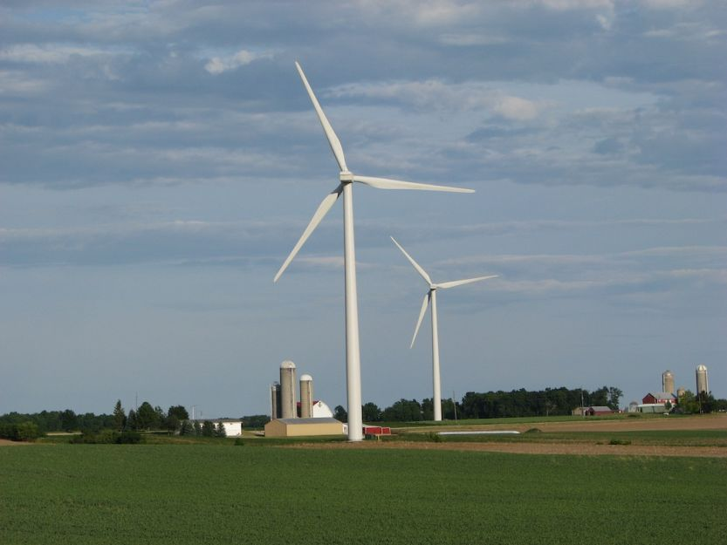

Wind turbines at the Forward Wind Energy Center in Fond du Lac and Dodge Counties, Wisconsin. (Photo by Ruth Baranowski / NREL)

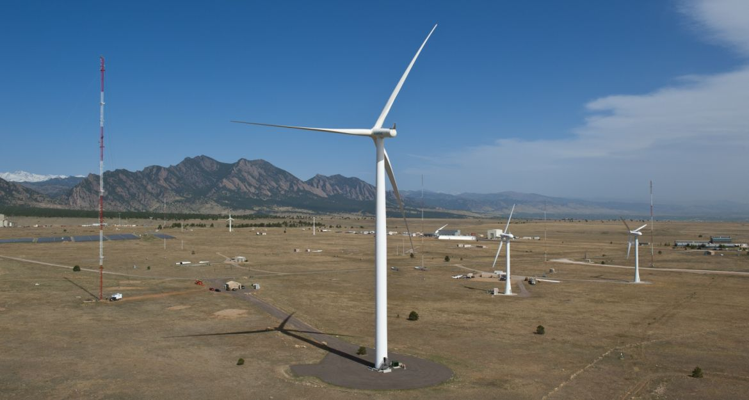

Aerial view of the National Wind Technology Center. (Photo by Dennis Schroeder / NREL)

### Including computer code

The listings package has been loaded. Note: this does not work if the ‘draft’ document option is used.

To insert code with syntax highlighting, you can use the lstlisting environment, for example

\begin{lstlisting} ...\end{lstlisting}.

You can change the language that is used to control the syntax highlighting using \lstset{language=[dialect]language}. This document uses...

\lstset{language=[LaTeX]Tex,columns=fullflexible,keepspaces=true,breaklines=true}

... because most of the code is LaTeX. This can be changed for each block of code but should be changed back afterwards. For example, the next block of code is written in C.

/* Hello world in C* */  
  
#include <stdio.h>  
  
main()  
{  
 printf("Hello World!\n");  
}

For more details see the lstlisting documentation or the [wikibook](https://en.wikibooks.org/wiki/LaTeX/Source_Code_Listings).

### Citations

Use bibtex to organize references and store them in a single file (e.g. /Documents/bibliography/bibliography.bib). The bibliography will then contain entries with ‘keys’ for each source, like Lamport_1986_a.

Authors can then insert citations to this key throughout their document, using different styles of citation. Citations are generated using the biblatex package, which also formats references in the correct style. Ways to generate citations are described in the biblatex documentation, and include:

* \cite{Lamport_1986_a} prints (Lamport 1986).
* \citep{Lamport_1986_a} prints (Lamport 1986).
* \citet{Lamport_1986_a} prints Lamport (1986).

To cite URLs, use the ’misc’ style. For example, the bibtex entry for <http://tex.stackexchange.com> (Anon. 2014) looks like this:

@misc{texstackexchange,  
 Author = {Anon.},  
 Howpublished = {Accessed July 21, 2014: \url{http://tex.stackexchange.com}},  
 Title = {\TeX -- LaTeX Stack Exchange},  
 Year = {2014}}

This format will allow you to include the date on which a URL was accessed.

The citations should work with journal articles (Clifton et al. 2013), books (Knuth 1984; Lamport 1986; Turibain 1982), technical reports (Other and Nother 2014), and URLs (Anon. 2014). Any unknown publication types will be formatted using the ‘misc’ type.

### Bibliographies

This style uses "Chicago A" style-references produced using Biblatex. The style can be changed by modifying the style file.

To include a bibliography in the document give the bibliography file location in the preamble and insert the bibliography at the appropriate location:

% give the bibliography file location  
\bibliography{files/bibliography.bib}  
...  
\begin{document}  
...  
% insert the bibliography into the document  
\cleardoublepage  
\label{sec:Bib}  
\printbibliography  
...  
\end{document}

An example bibliography is included in this document on page .

### Footnotes

Footnotes can be inserted using the \footnote{} command[1]. Footnotes are numbered in the main matter[2], and use daggers, etc instead of numers in the appendices.

## Creating a file structure

Your main file should be called *main.tex*. This helps editors and coauthors identify where to start. Then, use input to import other files into your main file at compilation.

For example, each of the chapters in this report is in separate files, called *WhatIsLatex* (Chapter 1), *LatexForDocs* (Chapter 2), and so-on. In the example available on Github, they are stored in the *files* directory. *main.tex* then looks like this:

...  
\begin{document}  
% content  
\input{files/WhatIsLatex}  
\input{files/LatexForDocs}  
...

## Best practice in writing a document in LaTeX

Create a structure before you get too far.

Authors will find it easier to write documents and make changes if they separate the content of the document from the structure.

1. Each new LaTeX document should be placed in it’s own directory.
2. Create a main LaTeX file that just contains the preamble, custom commands and uses input to call the content. See Section 2.4 for an example where each chapter is contained in its own file. In an article, each section could be contained in its own file.
3. Keep the number of packages used to a minimum. Not all packages can be used as they lack compatibility.

Focus on content, not appearance.

Don’t spend hours trying to adjust fonts, headers or spacing between lines.

1. Don’t throw in lots of clearpages or other commands to push material around. LaTeX is designed to handle that.
2. Resist the temptation to add or subtract space, change lengths or do other things to modify the layout.
3. Write!

# Preparing high-quality PDFs from LaTeX

Producing a high-quality PDF from LaTeX may require special steps such as tagging, alt-text, and embedding fonts for documents that will be used with electronic document readers.

## PDF tagging

PDF tagging is a process whereby the components of the PDF document (headings, figures, tables, text) are marked so that a document reader can understand the document. This is useful when text to speech converters are being used. The process of tagging is also known as structuring, so that a tagged document might also be referred to as a structured document[3].

At this time tags cannot be added reliably within LaTeX. Instead, they should be added after the PDF is compiled using a PDF editor such as Adobe’s Acrobat Pro.

## PDF/A files

PDF/A documents may be required for some applications. These files can be created using the LaTeX PDFx package.

To do this, add \usepackage[a-1b]{pdfx} *before* \usepackage[...]{corporate}, and a file called main.xmpdata with the metadata to the directory where this file is.

For more details of how to do this, see the tutorial at [https://www.mathstat.dal.ca/ selinger/pdfa/](https://www.mathstat.dal.ca/~selinger/pdfa/).

An example of the main.xmpdata file is included with the example article.

## Alternative text

Alternative text, or ‘Alt text’, is a textual description of an equation, link or figure that can be used to replace the visual information in that element. This is often seen as a text ‘pop-up’ in PDF readers.

Alt text can be added after the PDF is compiled using a PDF editor such as Adobe’s Acrobat Pro.

Alternatively – and probably best for ensuring that the final document is what the author intended – it can be generated from within the source document using the pdftooltip environment from the pdfcomment package. For example, it could be added to the previous equation using \pdftooltip{a^2+b^2=c^2}{An equation}.

The same approach can be used to create alt text for images. The general form is {\pdftooltip{\includegraphics[config]{path}}{alt-text}}.

## Embedded fonts

All fonts should be embedded in the the final PDF. Check the PDF for embedded fonts using a PDF viewer. For example, in Adobe Acrobat Reader, look at the ‘fonts’ tag of the document properties. If any fonts are not shown as being an *embedded subset*, try the conversion again.

Encapsulated postscript figures are particularly prone to having undefined fonts. Check by compiling the document in draft mode, and seeing if the fonts are still present in the output PDF. To fix this problem, change *.eps* files to *.png* files. To do this ‘on the fly’, use this in the document’s preamble:

\usepackage{epstopdf}  
\epstopdfDeclareGraphicsRule  
 {.eps}{png}{.png}{convert eps:\SourceFile.\SourceExt png:\OutputFile}  
\AppendGraphicsExtensions{.png}

# Exporting LaTeX into other formats

LateX source files are usually converted into PDF files. But, they can be converted into other formats for easier editing or for publishing to the internet.

The best approach to exporting LaTeX documents is to use *Pandoc* to parse the .tex source and reformat it for other uses.

Pandoc is an open-source program that you have to install. Details can be found at <https://pandoc.org/>.

Pandoc is called from the command line / terminal of your computer:

pandoc -s ArticleMain.tex -o pandocDemo.docx

An example.docx file generated using pandoc 2.03 is included in this repository.

# Acknowledgments

This document is based on the NREL LaTeX class files developed by the author and then forked for this project.

I wish to thank members of the TeX – LaTeX StackExchange site for useful suggestions concerning LaTeX and typography (Anon. 2014).

This report was typeset using the LaTeX typesetting system originally developed by Leslie Lamport, based on TeX created by Donald Knuth.

[sec:TheBibliography]

# How to Use Appendices

The style file also controls the appearance of the appendices.

## How to switch to appendixes

To switch to appendices, use the *appendix* command:

\appendix  
\input{files/AppendixA}  
\input{files/AppendixB}

## Changes to Figure, Table, and Footnote Numbering

The following table (Table [tab:AppAWidgets]) should have a different caption numbering style than Table [tab:widgets]. The table number should start with the appendix label (in this case ,) be followed by a period, and then be numbered. Numbering should restart in each new appendix.

An example table.

|  |  |
| --- | --- |
| Item | Quantity |
| Widgets | 42 |
| Gadgets | 13 |

The following table should use the same letter as Table [tab:AppAWidgets], but the number should be incremented by one.

An example table.

|  |  |
| --- | --- |
| Item | Quantity |
| Widgets | 42 |
| Gadgets | 13 |

Footnotes use symbols in place of numbers in the appendices[4].

# Including Multiple Appendices

This chapter is included to demonstrate that the style file correctly formats a second appendix[5].

## Changes to numbering

The following table (Table [tab:AppBWidgets]) caption should have a different numbering style than Table [tab:widgets]. Instead, the caption numbering style should be the same as Table [tab:AppAWidgets]. Numbering in this chapter should start with .

An example table.

|  |  |
| --- | --- |
| Item | Quantity |
| Widgets | 42 |
| Gadgets | 13 |

Anon. 2014. “TeX– Latexstack Exchange.” Accessed July 21, 2014: <http://tex.stackexchange.com>.

Clifton, A., L. Kilcher, J. K. Lundquist, and P. Fleming. 2013. “Using Machine Learning to Predict Wind Turbine Power Output.” *Environmental Research Letters* 8 (2): 024009. <https://doi.org/10.1088/1748-9326/8/2/024009>.

Knuth, Donald E. 1984. *The TeXbook*. Addison-Wesley.

Lamport, Leslie. 1986. *LaTeX: A Document Preparation System*. Addison-Wesley.

Other, A. N., and Y. A. Nother. 2014. “A Technical Report.” A Very Important Laboratory; Accessed July 21, 2014: <http:www.example.com>.

Turibain. 1982. *The Chicago Manual of Style*. Thirteenth. University of Chicago Press.

1. like this
2. and like this as well
3. This is a test
4. this is a test
5. this is also a test