**中医药系统病历修改功能**

**注意：**

1. 病历修改功能包含四个部分：中医四诊，西医治疗，诊断治疗(诊断信息 + 处方详情)，其他信息
2. 提供 4 个接口，都是 POST 方式

**接口参数以及属性说明：**

以如下病人信息为例：

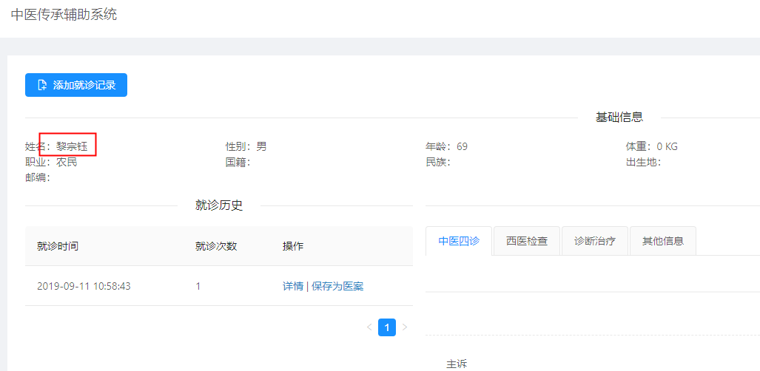

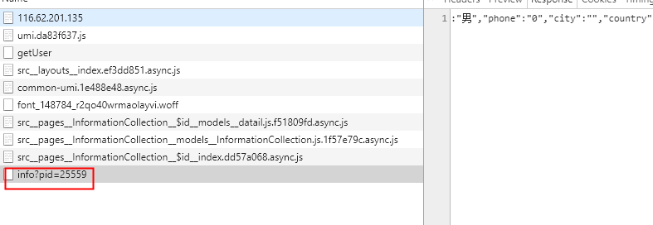

从前端可得到如下信息：



**接口**

1. 修改中医四诊部分

**API**: <http://localhost:9090/medicine/records/TCM/modify>

**参数**：

对应记录的id

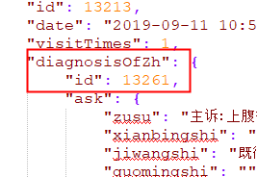

var tcmRecord = {

"id":13261,

"gerenshi":"个人史123",

"guomingshi":"过敏史",

"hunyushi":"婚育史",

"jiazhushi":"家族史",

"jiwangshi":"既往史",

"maizhen":"脉诊",

"maizhenSel":"脉诊(四诊摘要)",

"pifimaofa":"皮肤毛发",

"qinahoueryinjipaixiewu":"前后二阴",

"qita":"其他",

"sehz":"舌诊",

"shensexingtai":"神色形态",

"shezheng":"舌诊(四诊摘要)",

"toumainwuguanjinxiang":"头面五官",

"wenzhen":"闻诊",

"xianbingshi":"现病史",

"xiongfu":"胸腹",

"yaobeishizhizhuajia":"腰背十指",

"zhenzhuang":"症状",

"zusu":"主诉",

"shezhenimgId":0

}

**对比后台属性列表以及数据库字段**：

private Long id;

/* 个人史 */

@Column(name = "gerenshi")

private String gerenshi;

/* 过敏史 */

@Column(name = "guomingshi")

private String guomingshi;

/* 婚育史 */

@Column(name = "hunyushi")

private String hunyushi;

/* 家族史 */

@Column(name = "jiazhushi")

private String jiazhushi;

/* 既往史 */

@Column(name = "jiwangshi")

private String jiwangshi;

/* 脉诊 */

@Column(name = "maizhen")

private String maizhen;

/* 脉诊(四诊摘要) */

private String maizhenSel;

/* 皮肤毛发 */

@Column(name = "pifimaofa")

private String pifimaofa;

/* 前后二阴及排泄物 */

@Column(name = "qinahoueryinjipaixiewu")

private String qinahoueryinjipaixiewu;

/* 其它 */

@Column(name = "qita")

private String qita;

/* 舌诊 */

@Column(name = "sehz")

private String sehz;

/* 神色形态 */

@Column(name = "shensexingtai")

private String shensexingtai;

/* 舌诊(四诊摘要) */

@Column(name = "shezheng")

private String shezheng;

/* 头面五官颈项 */

@Column(name = "toumainwuguanjinxiang")

private String toumainwuguanjinxiang;

/* 闻诊 */

@Column(name = "wenzhen")

private String wenzhen;

/* 现病史 */

@Column(name = "xianbingshi")

private String xianbingshi;

/* 胸腹 */

@Column(name = "xiongfu")

private String xiongfu;

/* 腰背十指爪甲 */

@Column(name = "yaobeishizhizhuajia")

private String yaobeishizhizhuajia;

/* 症状(四诊摘要) */

@Column(name = "zhenzhuang")

private String zhenzhuang;

/* 主诉 */

@Column(name = "zusu")

private String zusu;

/* 舌诊图片id，必须传递原来的已经有的id，否则会报错；如果不知道，就传递 0 */

@Column(name = "shezhenimg_id")

private Long shezhenimgId;

2, 修改西医诊断部分接口

**API**：<http://localhost:9090/medicine/records/WM/modify>

**参数**：

对应的记录的id

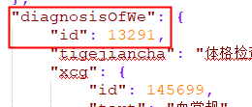

var wmRecord = {

"id":13291,

"tigejiancha":"测试修改功能"

}

**对比后台属性列表以及数据库字段**：

private Long id;  
/* 体格检查 */  
private String tigejiancha;

3, 修改诊断治疗部分接口

**API**：<http://localhost:9090/medicine/records/DAT/modify>

**参数**：该部分有点特殊，因为包含了两个部分的内容：基本信息和处方信息

对应记录的id：

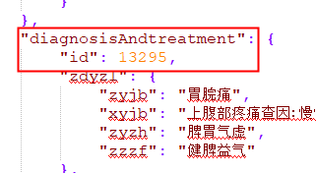

var datParam = {

"datRecord":{

"id":13295,

"doctor":"处方医师",

"medicinec":"中成药",

"medicinew":"西成药",

"number":"2",

"other":"其他",

"type":"处方类型",

"xyjb":"西医疾病",

"zfm":"处方名称",

"zyjb":"中医疾病",

"zyzh":"中医证候",

"zzzf":"治则治法"

},

"medicines":[

{

"id": 31421,

"datid":13295,

"name": "薏苡仁",

"liang": "30",

"zhuyong": "",

"yongfa": "一天一次"

},

{

"id": 31420,

"datid":13295,

"name": "山药",

"liang": "15",

"zhuyong": "",

"yongfa": "一天一次"

},

{

"id": 31419,

"datid":13295,

"name": "厚朴",

"liang": "10",

"zhuyong": "",

"yongfa": "一天一次"

},

{

"id": 31418,

"datid":13295,

"name": "干姜",

"liang": "10",

"zhuyong": "",

"yongfa": "一天一次"

},

{

"id": 31417,

"datid":13295,

"name": "黄芪",

"liang": "15",

"zhuyong": "一天一次",

"yongfa": "一天一次"

},

{

"id": 31416,

"datid":13295,

"name": "甘草",

"liang": "10",

"zhuyong": "一天一次",

"yongfa": "一天一次"

},

{

"id": 31415,

"datid":13295,

"name": "白术",

"liang": "10",

"zhuyong": "",

"yongfa": "一天一次"

},

{

"id": 31414,

"datid":13295,

"name": "茯苓",

"liang": "10",

"zhuyong": "",

"yongfa": "一天一次"

},

{

"id": 31413,

"datid":13295,

"name": "党参",

"liang": "10",

"zhuyong": "",

"yongfa": "一天一次"

}

]

}

**对比后台属性列表以及数据库字段**：

datRecord:

private Long id;  
/* 处方医师 */  
private String doctor;  
/* 中成药 */  
private String medicinec;  
/* 西成药 */  
private String medicinew;  
/* 处方剂数 */  
private String number;  
/* 其他 */  
private String other;  
/* 处方类型 */  
private String type;  
/* 西医疾病 */  
private String xyjb;  
/* 处方名称 */  
private String zfm;  
/* 中医疾病 */  
private String zyjb;  
/* 中医证候 */  
private String zyzh;  
/* 治则治法 */  
private String zzzf;

medicine:

private long id;  
@Column(name="liang")  
private String liang;  
@Column(name="name")  
private String name;  
@Column(name="yongfa")  
private String yongfa;  
@Column(name="zhuyong")  
private String zhuyong;  
@Column(name="dat_id")  
private long datid;

4, 修改其他信息接口

**API:** <http://localhost:9090/medicine/records/OM/modify>

**参数**：

对应记录的id：

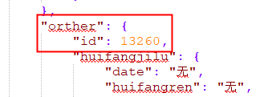

var omRecord = {

"id":13260,

"date":"2019-09-24",

"grxd":"个人心得",

"huifangneirong":"回访内容",

"huifangren":"回访人",

"lsdy":"老师答疑",

"qita":"其他",

"xylxpj":"西医疗效评价",

"zjdp":"专家专家，一到晚上不钻这家钻那家",

"zylxpj":"中医疗效评价"

}

**对比后台属性列表以及数据库字段**：

private Long id;  
/* 回访时间 */  
private String date;  
/* 个人心得 */  
private String grxd;  
/* 回访内容 */  
private String huifangneirong;  
/* 回访人 */  
private String huifangren;  
/* 老师答疑 */  
private String lsdy;  
/* 其他 */  
private String qita;  
/* 西医疗效评价 */  
private String xylxpj;  
/* 专家点评 */  
private String zjdp;  
/* 中医疗效评价 */  
private String zylxpj;

接口文件：

