第五章作业如下：

5-1  Consider the network of Fig.5-7, but ignore the weights on the lines. Suppose that it uses flooding as the routing algorithm. If a packet sent by A to D has a maximum hop count of 3, list all the routes it will take. Also tell how many hops worth of bandwidth it consumes.

答：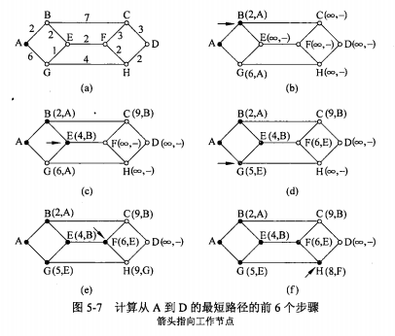

5-2  Consider the network of Fig. 5-12(a). Distance vector routing is used, and the following vectors have just come in to router C: from B: (5, 0, 8, 12, 6, 2); from D: (16, 12, 6, 0, 9, 10); and from E: (7, 6, 3, 9, 0, 4). The cost of the links from C to B, D, and E, are 6, 3, and 5, respectively. What is C’s new routing table? Give both the outgoing line to use and the cost.

答：图5.12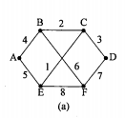

B的矢量是（5，0,8,12,6,2）代表B到ABCDEF的成本，所以C通过B到达其他节点的成本是（11,6,14,18，12,8），通过D到其他节点的成本（19,15,9,3,12,15），通过E到其他节点的成本（12,11,8,14,5,9）其中除到达自身的链路成本是0，其他值选出三个表对应位置最小的值为（11,6,0,3,5,8）出去的链路分别是（B,B,-,D,E,B）

5-3 Looking at the network of Fig. 5-6, how many packets are generated by a broadcast from B, using

(a) Reverse path forwarding?

(b) The sink tree?

答：图5.6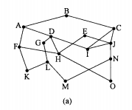

逆向路径转发：AC ,DFIJ ,DEGHIJKN ,GHKM,LMO总共有21个包

汇集树是4轮，共14个包

5-4  Suppose that host A is connected to a router R 1, R 1 is connected to another router, R 2, and R 2 is connected to host B. Suppose that a TCP message that contains 900 bytes of data and 20 bytes of TCP header is passed to the IP code at host A for delivery to B. Show the Total length, Identification, DF, MF, and Fragment offset fields of the IP header in each packet transmitted over the three links. Assume that link A-R1 can support a maximum frame size of 1024 bytes including a 14-byte frame header, link R1-R2 can support a maximum frame size of 512 bytes, including an 8-byte frame header, and link R2-B can support a maximum frame size of 512 bytes including a 12-byte frame header.

答：在第一条线路上不需要分段，数据包包括900个字节的数据，20个字节的TCP头和20个字节的IP头。

1. R1:Length=940 ID=x;DF=0;MF=0;Offset=0

R1-R2:

Length=500;ID=x;DF=0;MF=1;Offset=1

Length =460;ID=x;DF=0;MF=1;Offset=60

R2-B:

Length=500;ID=x;DF=0;MF=1;Offset=0

Length=460;ID=x;DF=0;MF=0;Offset=60

5-5  A router is blasting out IP packets whose total length (data plus header) is 1024 bytes. Assuming that packets live for 10 sec, what is the maximum line speed the router can operate at without danger of cycling through the IP datagram ID number space?

答：如果线路的比特率为b,则路由器可以发出的数据包/秒数为b/8192,因此发出数据包所需的秒数为8192/b，ID重绕也就是ID字段溢出，ID字段为16位，所以编号为0~65536，需要输出65535个数据包，即需要65535/(b/8192)=229/b秒，把它等同于最大值数据包的寿命，我们得到229/b=10然后，b约为53687091bps.

5-6  An IP datagram using the Strict source routing option has to be fragmented. Do you think the option is copied into each fragment, or is it sufficient to just put it in the first fragment? Explain your answer.

答：由于路由每个片段都需要该信息，该选项必须出现在每个片段中

5-7 Suppose that instead of using 16 bits for the network part of a class B address originally, 20 bits had been used. How many class B networks would there have been?

答：B类网络地址开端为10，如果使用20位网络地址，那么还有18位可以分配，即网络数为2^18=262144，但是全0与全1不能使用，所以一共有262142个网络，

5-8  A network on the Internet has a subnet mask of 255.255.240.0. What is the maximum number of hosts it can handle?

答：主机位数为12位，所以可以 容纳的主机数为2^12-2=4094（全0全1不使用）

5-9   A large number of consecutive IP addresses are available starting at 198.16.0.0. Suppose that four organizations, A, B, C, and D, request 4000, 2000, 4000, and 8000 addresses, respectively, and in that order. For each of these, give the first IP address assigned, the last IP address assigned, and the mask in the w.x.y.z/s notation.

答：A：198.16.0.0-198.16.15.255 掩码198.16.0.0/20

B：198.16.16.0-198.16.23.255 掩码 198.16.16.0/21

C:198.16.32.0-198.16.47.255 掩码198.16.32.0/20

D:198.16.64.0-198.16.95.255 掩码 198.16.64.0/19

5-10. A router has the following (CIDR) entries in its routing table:

|  |  |
| --- | --- |
| Address/mask | Next hop |
| 135.46.56.0/22 | Interface 0 |
| 135.46.60.0/22 | Interface 1 |
| 192.53.40.0/23 | Router 1 |
| default | Router 2 |

For each of the following IP addresses, what does the router do if a packet with that address arrives?  
(a) 135.46.63.10  
(b) 135.46.57.14  
(c) 135.46.52.2  
(d) 192.53.40.7  
(e) 192.53.56.7

答：a)下一跳为interface1

b）下一跳为interface0

c) 下一跳为router2

d)下一跳为router1

e)下一跳为router2