R文件读取与储存

读取:
exercise8_2<-read.csv("C:/exercise/ch8/exercise8_2.csv")

save(exercise8_2,file="C:/exercise/ch8/exercise8_2.RData")

load("C:/exercise/ch8/exercise8_2.RData")

exercise8_2

data11<-read.csv("C:/example/ch11/data11.csv")

save(data11,file="C:/example/ch11/data11.RData")

load("C:/example/ch11/data11.RData")

data11

R数据框转化为矩阵

load("C:/exercise/ch2/exercise2_4.RData") # 载入数据框
matrix2_4=as.matrix(exercise2_4[,2:4])
rownames(matrix2_4)=exercise2_4[,1]
save(matrix2_4,file="C:/exercise/ch2/matrix2_4.RData")
matrix2_4

colSums(matrix1_3[,1:5]) # 对矩阵matrix1_3的第1到5列求和
rbind(matrix1_3,Totls=colSums((matrix1_3 [,1:5])))
# 将求和结果加到原数据框

绘制概率密度图

x<-seq(from=-4,to=+4,length.out=100)
y<-dnorm(x)
plot(x,y,type='l',ylab="Density",xlab="z", cex.lab=0.8,cex.axis=0.8)
abline(h=0)
region.x<-x[1<=x&x<=2]
region.y<-y[1<=x&x<=2]
region.x<-c(region.x[1],region.x,tail(region.x,1))
region.y<-c(0,region.y,0)
polygon(region.x,region.y,density=-1,col="red")
mtext(expression(概率是阴影部分的面积:P("1<x<2")),cex =0.7,side=1,line=-4,adj=0.85)
mtext(expression(z==1),cex =0.6,side=1,line=-0.87,adj=0.62)
mtext(expression(z== 2),cex =0.6,side=1,line=-0.87,adj=0.75)

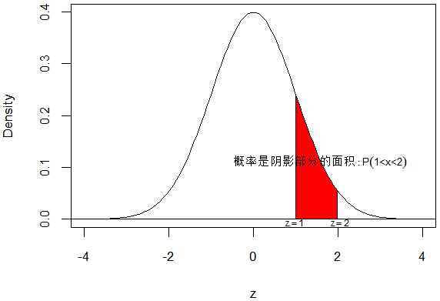

x<-seq(from=-4,to=+4,length.out=100)
y<-dnorm(x)
plot(x,y,type='l',ylab="Density",xlab="z", cex.lab=0.8,cex.axis=0.8)
abline(h=0)
region.x<-x[x<=0]
region.y<-y[x<=0]
region.x<-c(region.x[1],region.x,tail(region.x,1))
region.y<-c(0,region.y,0)
polygon(region.x,region.y,density=-1,col="red")
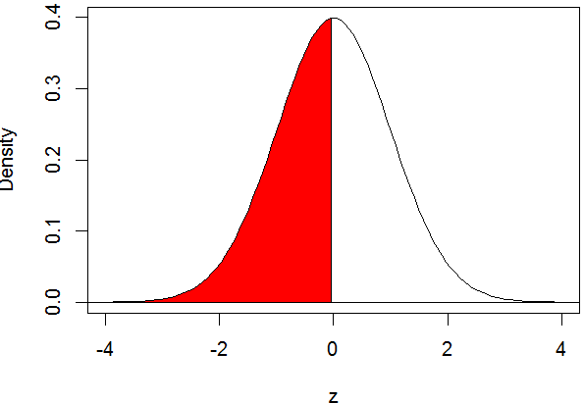

x<-seq(from=-4,to=+4,length.out=100)
y<-dnorm(x)
plot(x,y,type='l',ylab="Density",xlab="z", cex.lab=0.8,cex.axis=0.8)
abline(h=0)
region.x<-x[x<=-1.96]
region.y<-y[x<=-1.96]
region.x<-c(region.x[1],region.x,tail(region.x,1))
region.y<-c(0,region.y,0)
polygon(region.x,region.y,density=-1,col="red")
mtext(expression(z[0.025]==-1.96),cex =0.6,side=1,line=-0.8,adj=0.2)
mtext(expression(P("x<-1.96")),cex =0.7,side=1,line=-2,adj=0.1)

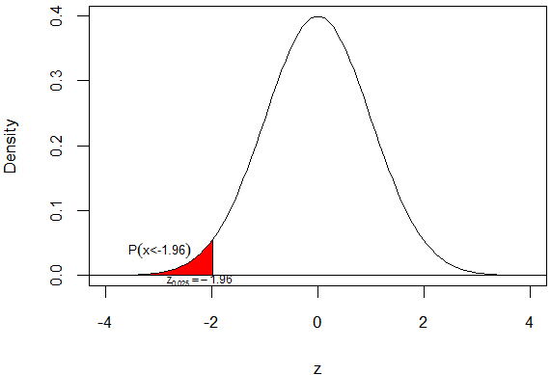

x<-seq(from=-4,to=+4,length.out=100)
y<-dnorm(x)
plot(x,y,type='l',ylab="Density",xlab="z", cex.lab=0.8,cex.axis=0.8)
abline(h=0)
region.x<-x[x>=1.96]
region.y<-y[x>=1.96]
region.x<-c(region.x[1],region.x,tail(region.x,1))
region.y<-c(0,region.y,0)
polygon(region.x,region.y,density=-1,col="red")
mtext(expression(z[0.025]== 1.96),cex =0.6,side=1,line=-0.8,adj=0.8)
mtext(expression(P("x>1.96")),cex =0.7,side=1,line=-2,adj=0.9)

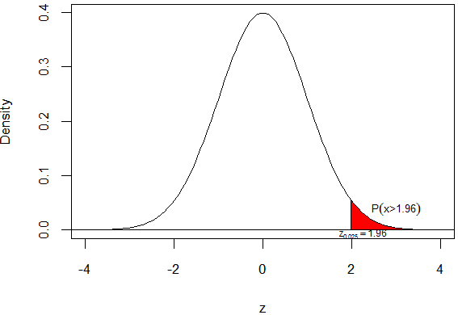

x<-seq(from=-4,to=+4,length.out=100)
y<-dnorm(x)
plot(x,y,type='l',ylab="Density",xlab="z", cex.lab=0.8,cex.axis=0.8)
abline(h=0)
region.x<-c(x[x<=-1.96])
region.y<-c(y[x<=-1.96])
region.x<-c(region.x[1],region.x,tail(region.x,1))
region.y<-c(0,region.y,0)
polygon(region.x,region.y,density=-1,col="red")
region.x<-c(x[x>=1.96])
region.y<-c(y[x>=1.96])
region.x<-c(region.x[1],region.x,tail(region.x,1))
region.y<-c(0,region.y,0)
polygon(region.x,region.y,density=-1,col="red")
mtext(expression(z[0.025]==-1.96),cex =0.6,side=1,line=-0.8,adj=0.2)
mtext(expression(z[0.025]== 1.96),cex =0.6,side=1,line=-0.8,adj=0.8)
mtext(expression(P("x<-1.96")),cex =0.7,side=1,line=-2,adj=0.1)
mtext(expression(P("x>1.96")),cex =0.7,side=1,line=-2,adj=0.9)

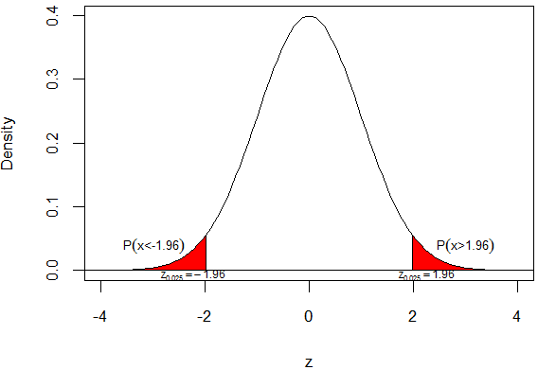

x<-seq(from=-4,to=+4,length.out=100)
y<-dnorm(x)
plot(x,y,type='l',ylab="Density",xlab="z", cex.lab=0.8,cex.axis=0.8)
abline(h=0)
region.x<-x[x>=1.96]
region.y<-y[x>=1.96]
region.x<-c(region.x[1],region.x,tail(region.x,1))
region.y<-c(0,region.y,0)
polygon(region.x,region.y,density=-1,col="red")
region.x<-x[x>=2.5]
region.y<-y[x>=2.5]
region.x<-c(region.x[1],region.x,tail(region.x,1))
region.y<-c(0,region.y,0)
polygon(region.x,region.y,density=-1,col="gold")
mtext(expression(P("x>1.96")),cex =0.7,side=1,line=-2.5,adj=0.85)
mtext(expression(P("x>2.5")),cex =0.7,side=1,line=-1.5,adj=0.95)
mtext(expression(z[alpha]== 1.96),cex =0.6,side=1,line=-0.8,adj=0.72)
mtext(expression(z[alpha]== 2.5),cex =0.6,side=1,line=-0.8,adj=0.85)

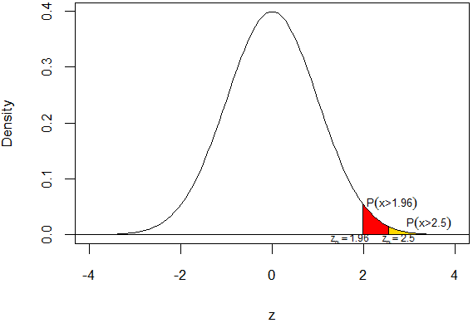

x<-seq(from=-4,to=+4,length.out=100)
y<-dnorm(x)
plot(x,y,type='l',ylab="Density",xlab="z", cex.lab=0.8,cex.axis=0.8)
abline(h=0)
region.x<-c(x[x<=-1.96])
region.y<-c(y[x<=-1.96])
region.x<-c(region.x[1],region.x,tail(region.x,1))
region.y<-c(0,region.y,0)
polygon(region.x,region.y,density=-1,col="red")
region.x<-c(x[x>=1.96])
region.y<-c(y[x>=1.96])
region.x<-c(region.x[1],region.x,tail(region.x,1))
region.y<-c(0,region.y,0)
polygon(region.x,region.y,density=-1,col="red")
region.x<-c(x[x<=-2.58])
region.y<-c(y[x<=-2.58])
region.x<-c(region.x[1],region.x,tail(region.x,1))
region.y<-c(0,region.y,0)
polygon(region.x,region.y,density=-1,col="gold")
region.x<-c(x[x>=2.58])
region.y<-c(y[x>=2.58])
region.x<-c(region.x[1],region.x,tail(region.x,1))
region.y<-c(0,region.y,0)
polygon(region.x,region.y,density=-1,col="gold")
