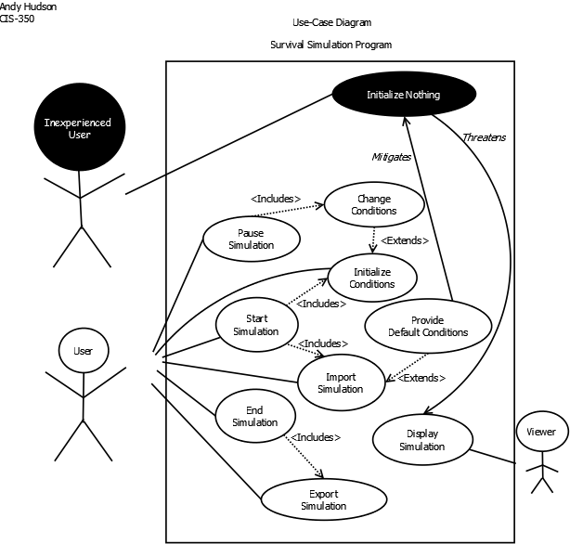

**Survival Simulation Program**

**Use-Case Definitions:**

Use-Case: **Start Simulation**

**Actors:** User

**Type:** Primary and essential

**Description:** Runs the given simulation with the specified initial conditions or imported simulation conditions, handing the simulation over to the survival-of-the-fittest logic.

**Use-Cases:** Requires that User has completed **initialize conditions** or **import simulation** use-cases.

Use-Case: **Pause Simulation**

**Actors:** User

**Type:** Primary

**Description:** Pauses a running simulation so that artificial (user) changes can be made to the simulation or the specific properties of simulation entities can be viewed.

**Use-Cases:** Requires that User has completed **start simulation** use-case.

Use-Case: **End Simulation**

**Actors:** User / Automatic

**Type:** Primary

**Description:** Stops a simulation, whether by manual input for the user or determined automatically by the simulation logic. Once the simulation has ended, the entire simulation can be viewed step-by-step.

**Use-Cases:** Requires that User has completed **start simulation** use-case.

Use-Case: **Import Simulation**

**Actors:** User

**Type:** Secondary

**Description:** Imports the entirety of a simulation in text, then uses the **initialize conditions** use case to prepare the simulation for **start simulation**.

**Use-Cases:** Requires that User has completed **end simulation** use-case for a previous simulation.

Use-Case: **Export Simulation**

**Actors:** User

**Type:** Secondary

**Description:** Exports the entirety of an ended simulation as a text file to be imported and viewed later to demonstrate specific facets of survival-of-the-fittest.

**Use-Cases:** Requires that User has completed **end simulation** use-case.

Use-Case: **Initialize Conditions**

**Actors:** User

**Type:** Primary

**Description:** Takes user input to initialize the conditions that the simulation logic will use to start and run the simulation, using a GUI to manipulate data. Imported text can also be initialized into simulation conditions. These conditions will include (at least) the initial states of terrain, weather, water level, and lifeforms.

Use-Case: **Change Conditions**

**Actors:** User

**Type:** Secondary

**Description:** Takes user input to change the conditions (data) of a simulation independent of the simulation logic (artificial changes) using a GUI. This would be used to demonstrate how simple changes in a dynamic survival environment can have dramatic results.

**Use-Cases:** Requires that User completed **pause simulation** use-case.

Use-Case: **Display Simulation**

**Actors:** Viewer

**Type:** Primary and essential

**Description:** Displays simulation data to the viewer using a graphical interface (from a text-based, side-view grid) to demonstrate the general principles of survival-of-the-fittest and evolution.

**Use-Cases:** Requires that User completed **start simulation** use-case.

Use-Case: **Provide Default Conditions**

**Actors:** User

**Type:** Primary

**Description:** Provides default conditions for a new simulation to start with. After importing simulation conditions, these conditions can be set to be used as default later before running the simulation. The program should come with default conditions loaded in already.

**Use-Cases:** Requires that User imported the conditions via **import simulation** use-case. Solves misuse-case **initialize nothing.**

**Misuse-Case Definitions**

Misuse-Case: **Initialize Nothing**

**Actors:** User

**Type:** Primary (Misuse)

**Description:** The user is inexperienced with the program and doesn’t include enough components in the simulation (whether it be environment variables, survival subjects, or other factors) to run a demonstrable simulation.

**Mitigated By:** The **provide default conditions** use case should prevent an inexperienced user from trying to run (intentionally or unintentionally) an empty simulation.

**Threatens:** The **display simulation** case is threatened by using a blank simulation because the viewer expects to have a survival simulation demonstrated to them, and the simulation is pointless if there aren’t any conditions to change.