Yazhuo Liu
Final Exam

1. ( 30 points ) A parametric curve C(t) is described by:
C(t) = (-cos(t), √3 t, sin(t) )
a) Find a Frenet frame ( N(t), B(t), T(t) ) for this curve.
b) Find the 4x4 transformation matrix M that brings the world coordinate system (i, j, k ) into this new coordinate system ( N(t), B(t), T(t) ).

a) sin(t)
C' (t) = ( √3 )
cos(t)
0

sin (t)
T (t) = 1/2 ( √3 )
cos (t)
0

cos (t)
N (t) = ( 0 )
-sin (t)
0

√3 sin (t) √3/2 sin(t)
B (t) = T (t) * N (t) = 1/2 ( 1 ) = ( 1/2 )
-√3 cos (t) -√3/2 cos (t)
0 0

b) In homogeneous coordinates,

cos (ti) √3/2 sin(ti) sin (ti) -cos (ti)
M = { 0 1/2 √3 √3ti }
-sin (ti) -√3/2 cos (ti) cos (ti) sin (ti)
0 0 0 0

2. (30 points ) Write a shader program that renders a scene where a red particle is moving along a diagonal of the screen window.
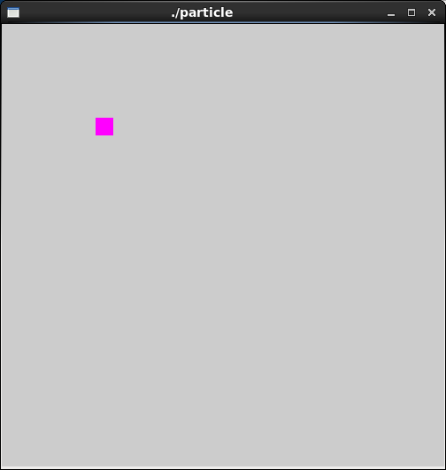
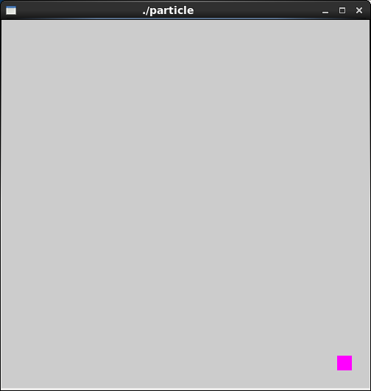

Code:

//particle.vert

uniform float time; //value provided by application program
attribute vec3 vel; //value provided by application program
attribute vec3 temp;
varying vec3 color;

void main(void)
{
color = temp;

float s = 1000.0; //scale factor
float g = -10.0;
float t;
t = time / s; //time in ms
vec4 object_pos = gl_Vertex; //starting position

object_pos.x = object_pos.x + vel.x*t;
object_pos.y = object_pos.y - vel.y*t;
object_pos.z = object_pos.z + vel.z*t;

gl_Position = gl_ModelViewProjectionMatrix * object_pos;
}

3. (30 points) Write an shader program that renders a regular pentagon with different colors at the vertices. Pass a time parameter to the shader from the application, so that the pentagon shrinks and expands periodically.
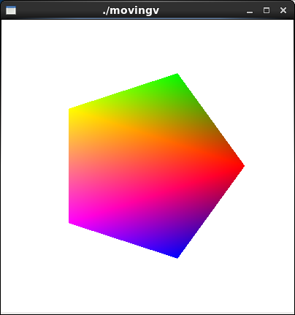
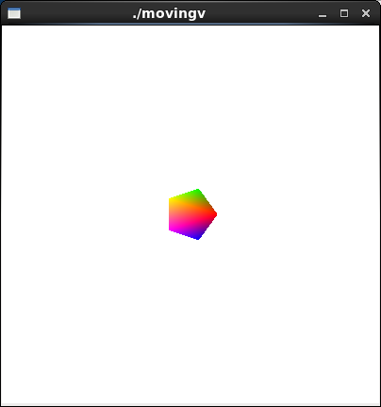

Code:

//pentagon.cpp

...

void display(void)
{
GLfloat vec[4];

glClear(GL_COLOR_BUFFER_BIT | GL_DEPTH_BUFFER_BIT);
glClearColor( 1.0, 1.0, 1.0, 0.0 ); //get white background color

int loc = glGetAttribLocation(programObject, "temp" );

glPushMatrix();
glRotatef( anglex, 1.0, 0.0, 0.0); //rotate the cube along x-axis
glRotatef( angley, 0.0, 1.0, 0.0); //rotate along y-axis
glRotatef( anglez, 0.0, 0.0, 1.0); //rotate along z-axis

float a = 2 * 3.14159265 / 5;
float a1 = 0;

glBegin ( GL_POLYGON );
glVertexAttrib3f(loc,1,0,0);
glVertex2f (cos (a1 ), sin (a1) );
a1 += a;
glVertexAttrib3f(loc,0,1,0);
glVertex2f (cos (a1 ), sin (a1) );
a1 += a;
glVertexAttrib3f(loc,1,1,0);
glVertex2f (cos (a1 ), sin (a1) );
a1 += a;
glVertexAttrib3f(loc,1,0,1);
glVertex2f (cos (a1 ), sin (a1) );
a1 += a;
glVertexAttrib3f(loc,0,0,1);
glVertex2f (cos (a1 ), sin (a1) );
glEnd();

glPopMatrix();

glutSwapBuffers();
glFlush();
}

...

//pentagon.vert

uniform float time; //value provided by application program

attribute vec3 temp;
varying vec3 color;

void main(void)
{
float s = 0;

angle += 2.0 * sin ( 0.0005 * time );

s = s + 2.0 * sin ( 0.0005 * time );

color = temp;

gl_Position = gl_ModelViewProjectionMatrix * (vec4(s, s, s, 1.0) * gl_Vertex );
}

//pentagon.frag

varying vec3 color;

void main(void)
{
gl_FragColor = vec4( color, 1);
}

Report:
I have finished all parts of the final, and I have shown the professor the output of my program. Therefore, I am giving myself 100 points.

