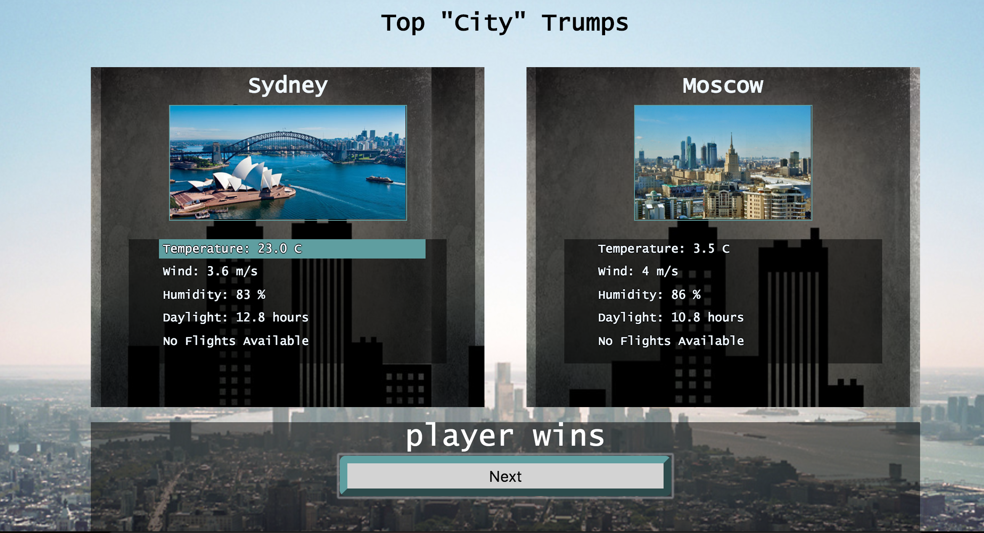

MVP --- Trumps – Cities

Based on the popular card game where one player attempts to trump another.
2 cards to be displayed, 1 visible , 1 not visible, player to select a feature on their card in an attempt to trump the computer, once selected the computer then reveals there card and determines a winner

Cards are to contain the Following choices
- Temperature
- Wind
- Humidity
- Daylight Hours
- Flight Price ( from London )

Weather info to be obtained from - api.openweathermap.org
Flight info to be obtained from - partners.api.skyscanner.net

Extension – Have the Computer take a turn
Create a Leaderboard of least about of moves to win the game

