 |  | testword | 111-11-1111 | secret | testword

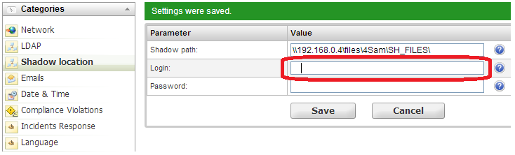

Hi, Jivchik!
How do you do?!

224-24-2512

[Cite your source here.]

