Student Name: Chan Shek Kwan Student ID: 21010505g

Section A

1. C
2. D
3. D
4. B
5. D
6. B
7. A
8. D
9. C
10. B

Section B

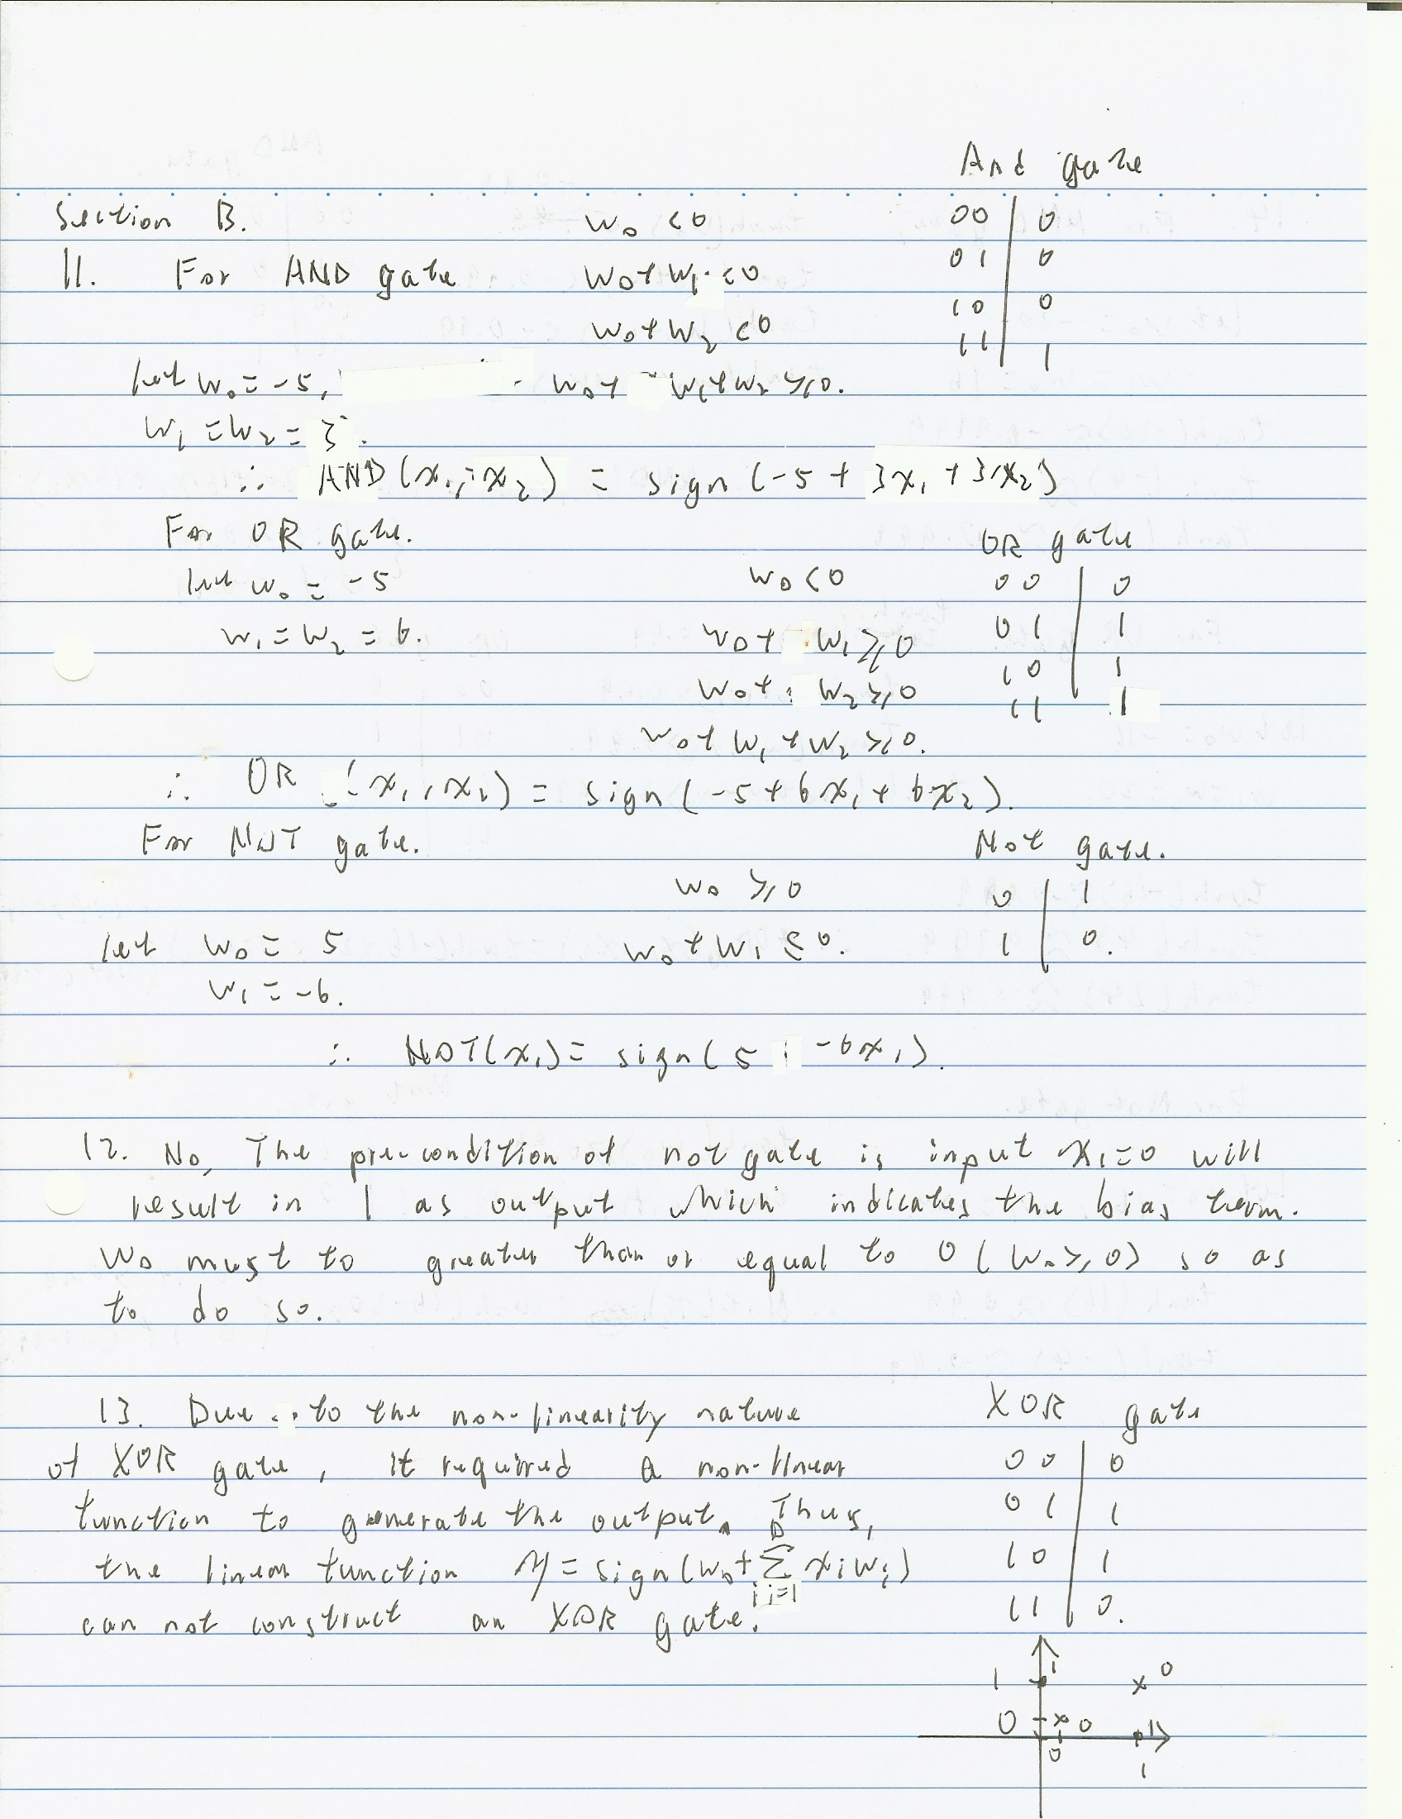

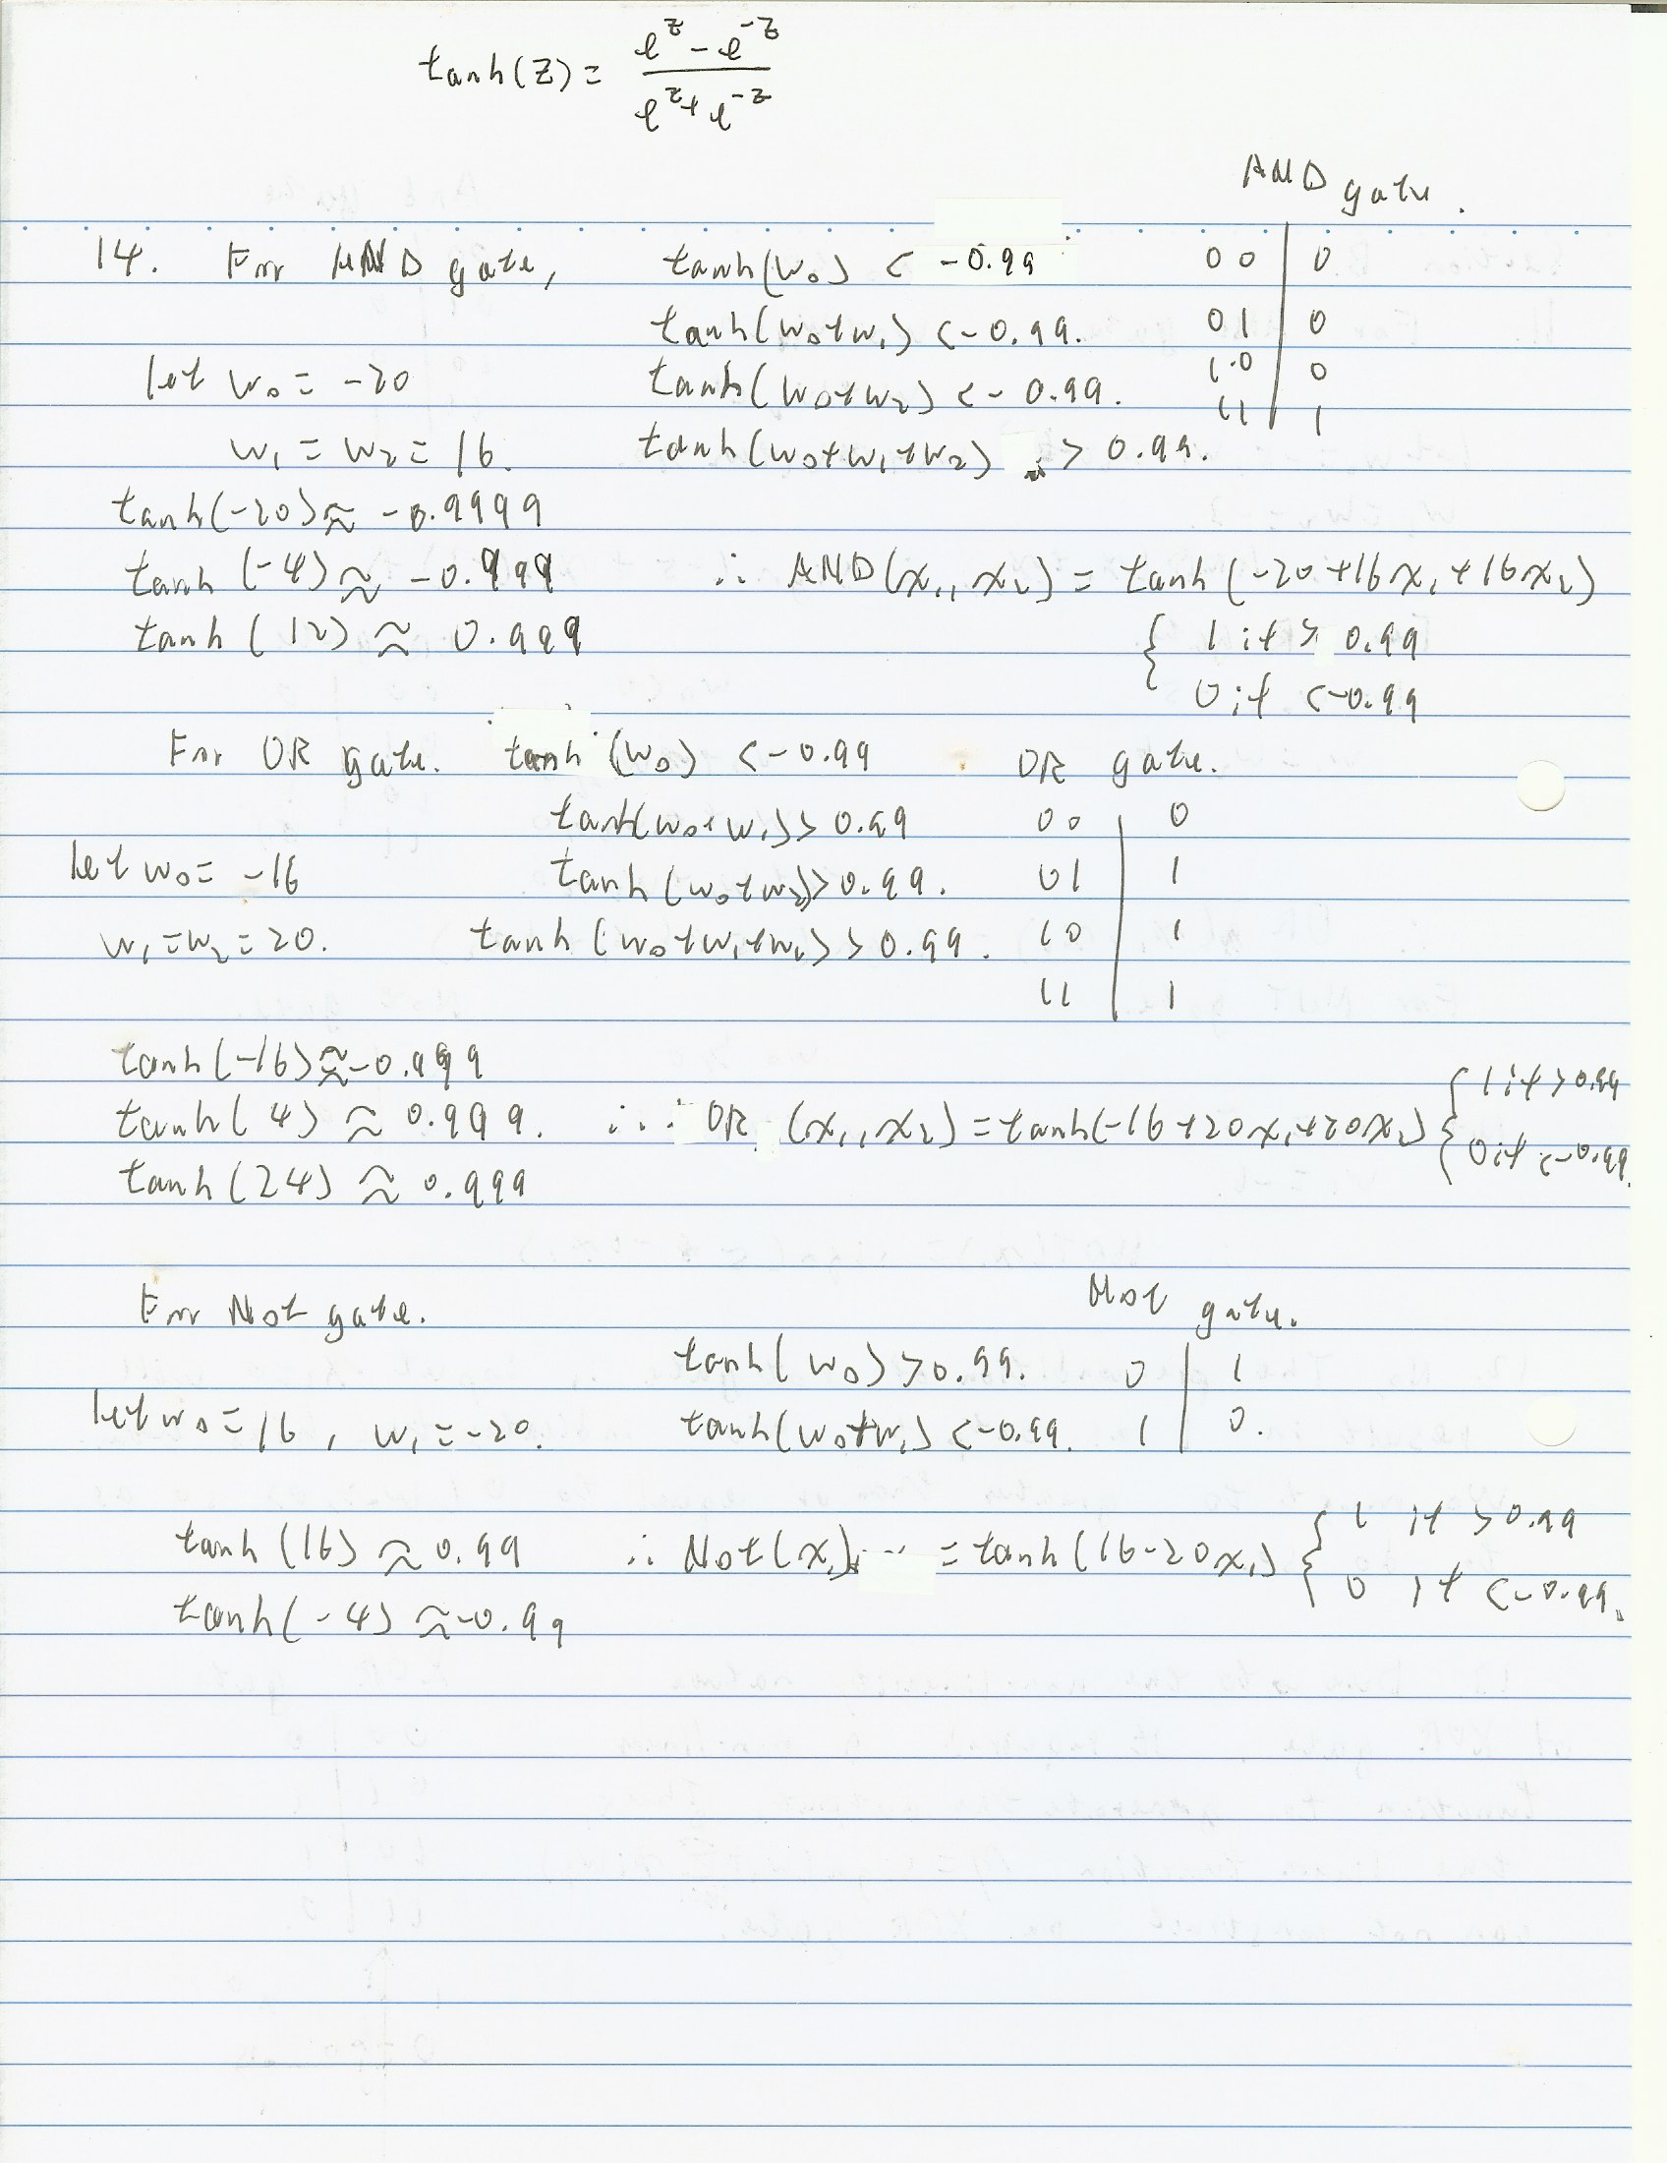

Section C

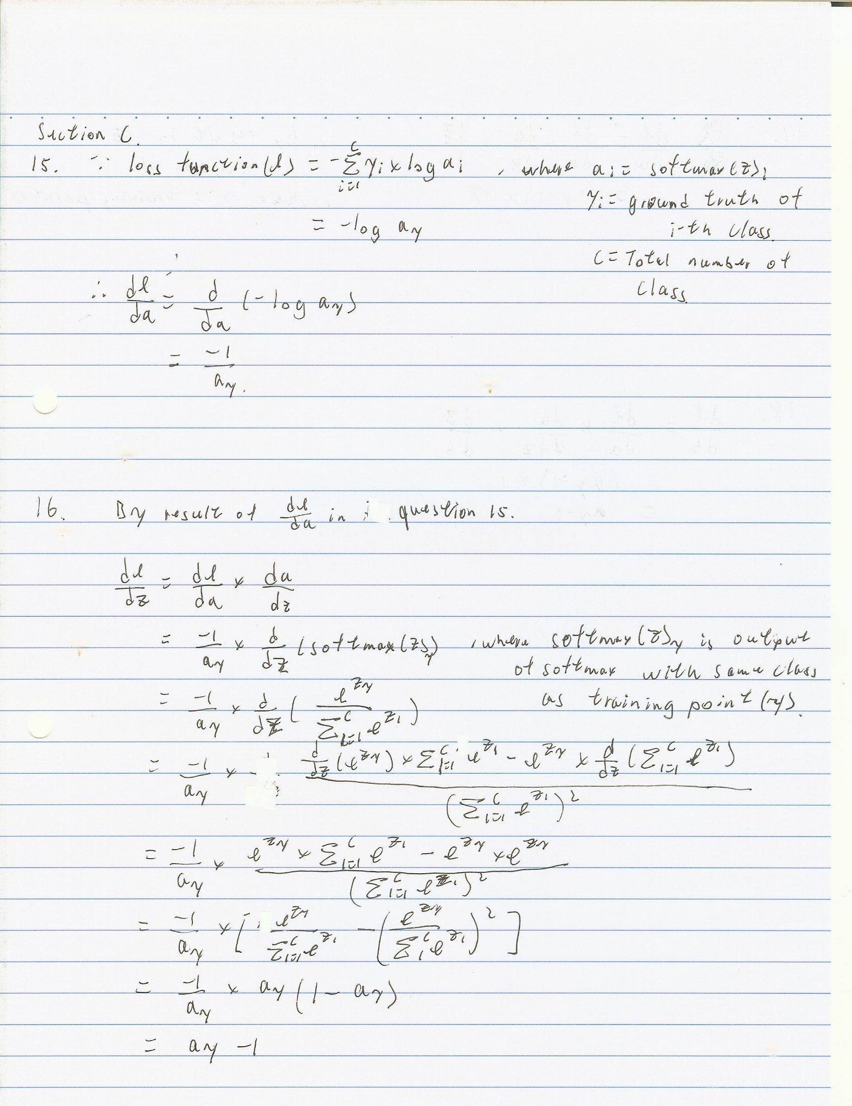

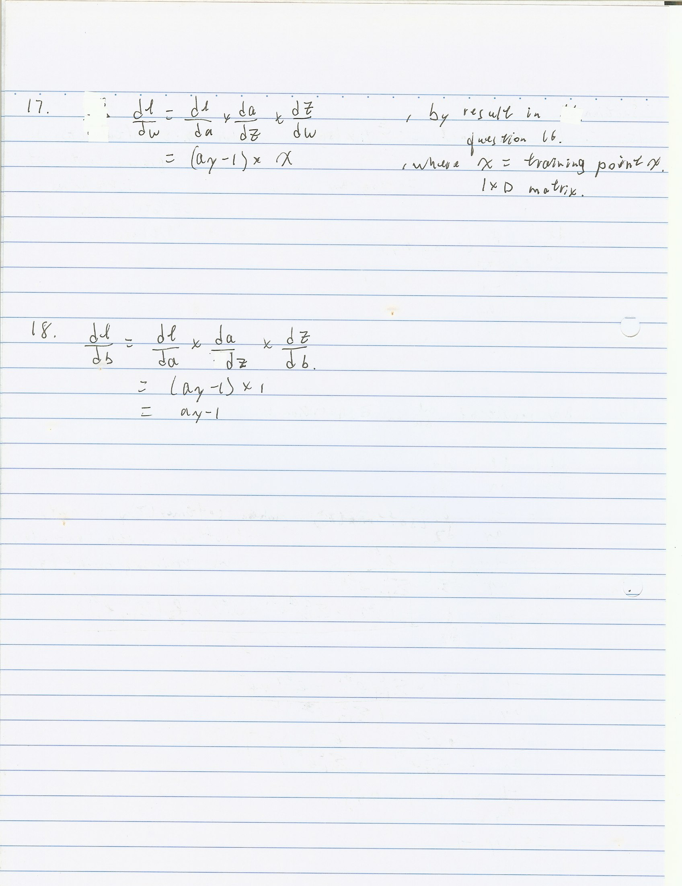

Section D

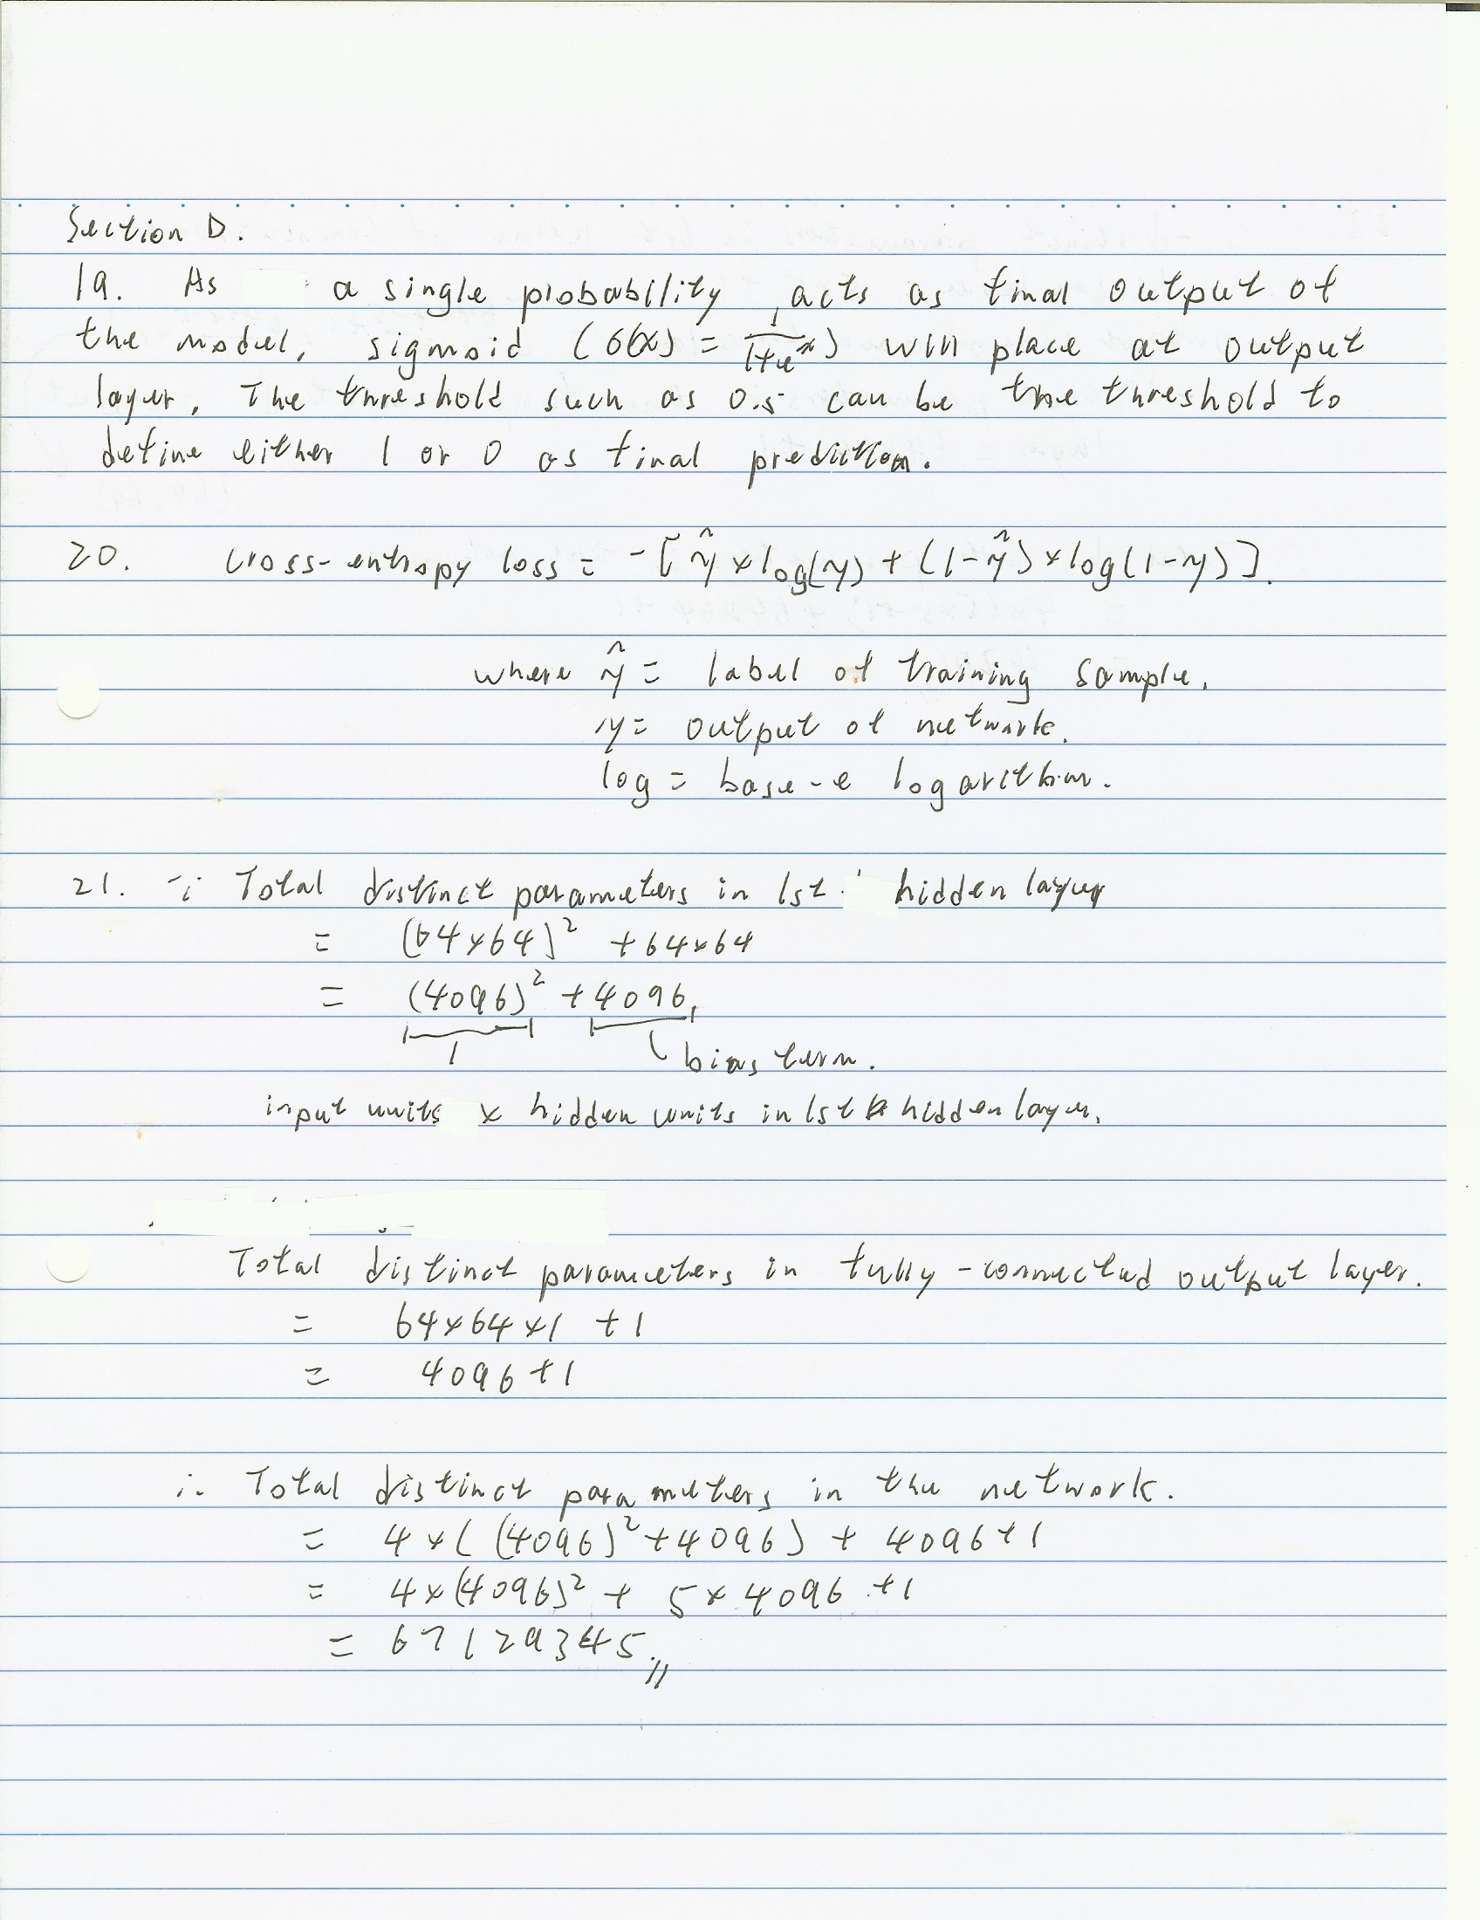

22. As there are four fully-connected hidden layers with as many neurons each as the input layer, it will learn the global pattern in the whole input image. Thus, the performance of the network trained with flipped image would not be similar to the network trained with original training data since the global pattern between both of them are not the same. The network trained by upside down image will result in relatively poor performance when it is evaluated with the normal image (without upside down).

23.

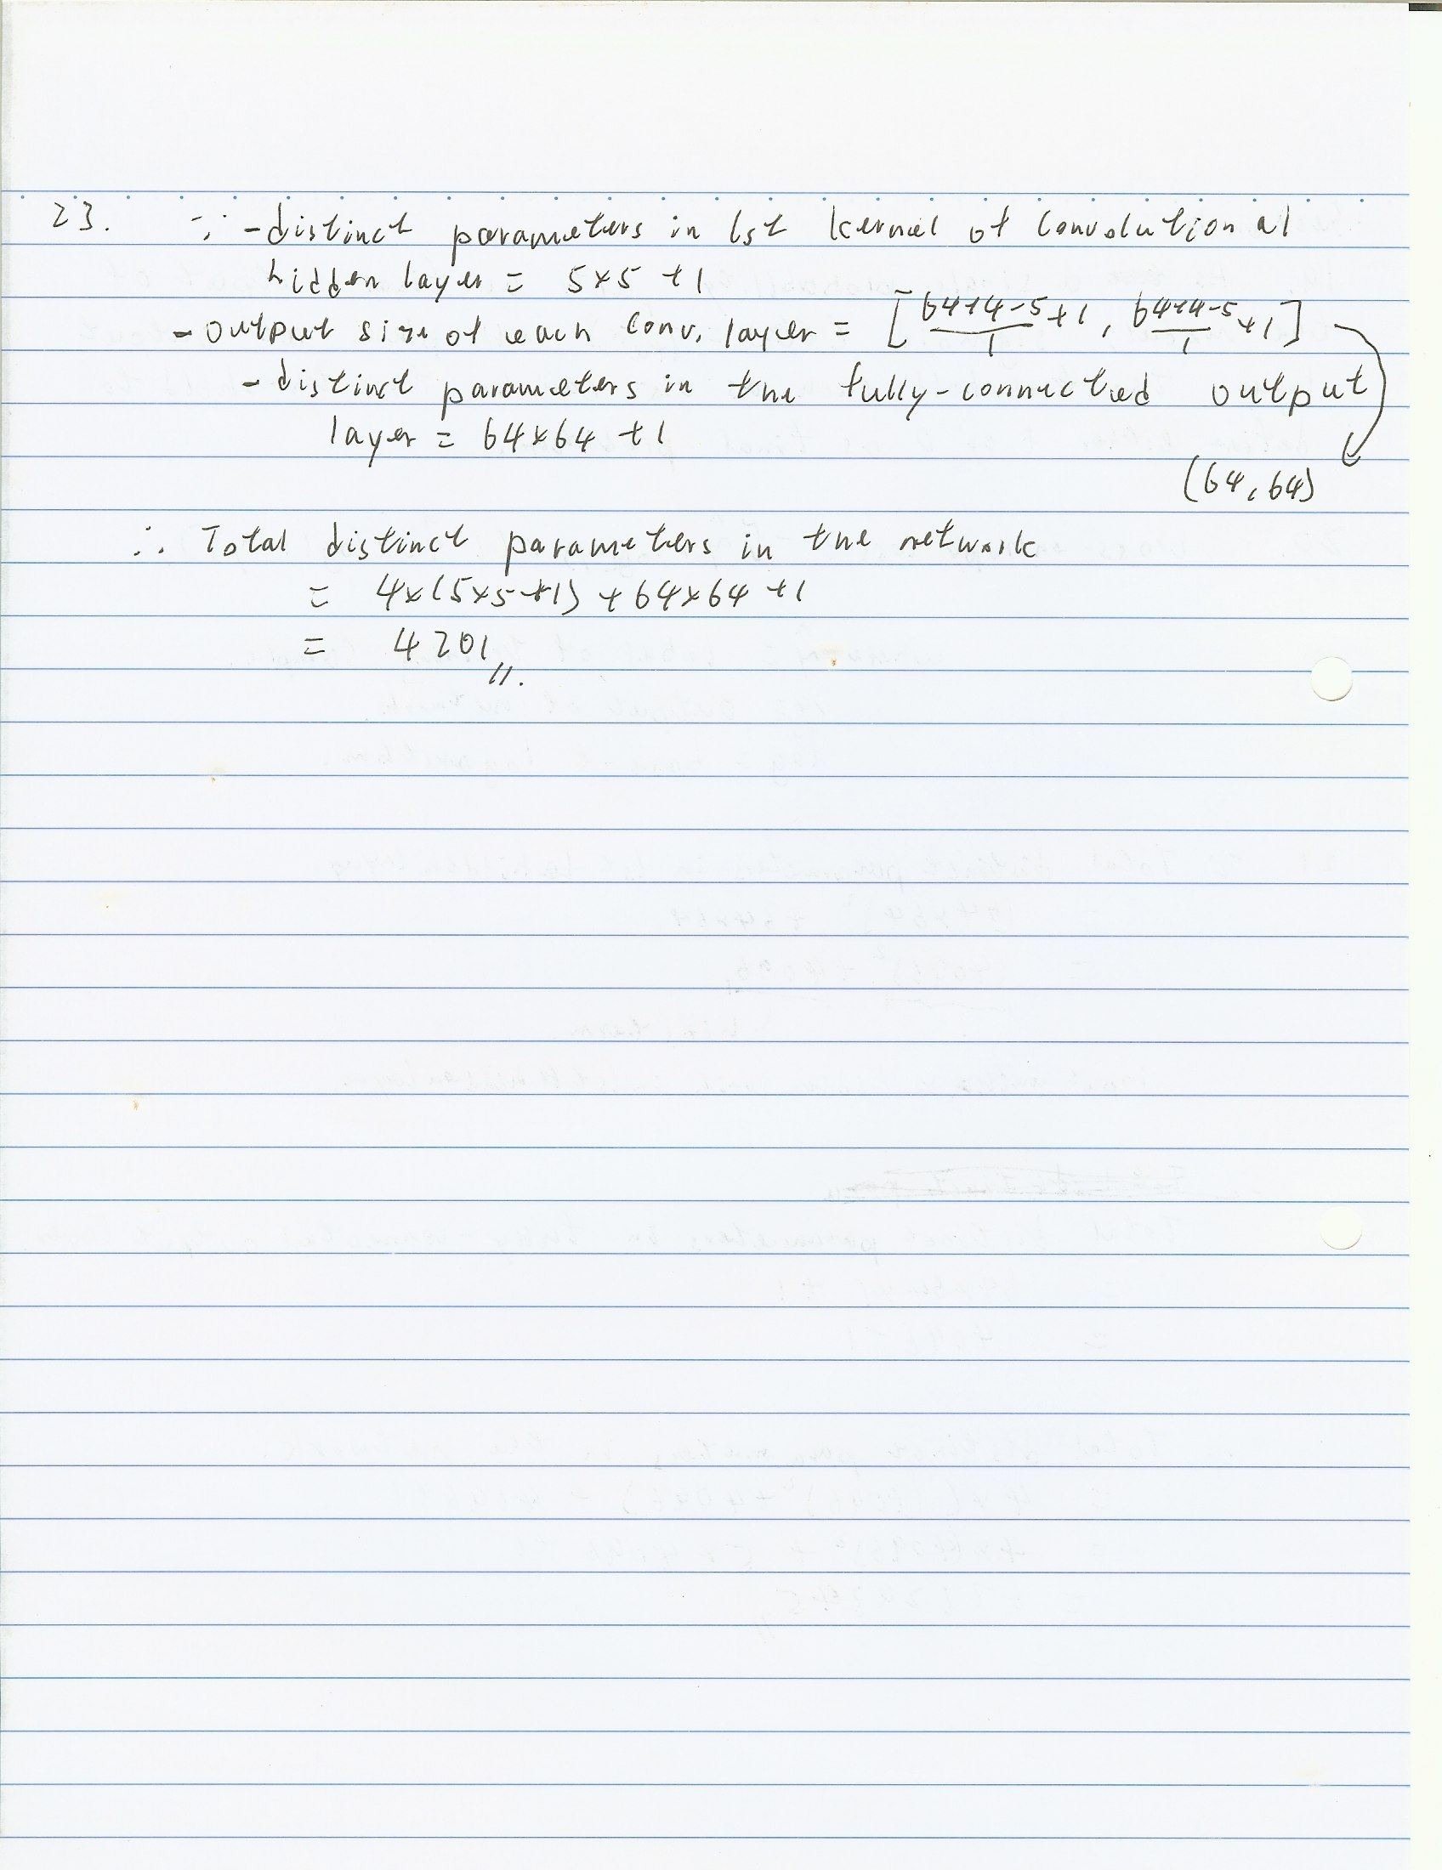

24. As the convolutional layer is able to learn the local pattern in the input image, it is expected that the network with convolutional layer is still work that network is trained with the original image while it is tested by using the image flipped upside down.it is because the local spatial features of person such as eyes and nose can still able to detect by the network.

25. Compared to the network with all fully connected layers to the network with convolutional layers, the network with fully connected layer (in question 21) required more examples to train. Few training data in the network with all fully connected layer may easy to suffer overfitting problem.

In addition, the network with convolutional layers (in question 23) makes more prior assumptions about the data. The convolutional neural network with many kernels assumes there are many local patterns to learn in the image.