## 1056 HangOver

### 一、题目

#### 问题描述

How far can you make a stack of cards overhang a table? If you have one card, you can create a maximum overhang of half a card length. (We’re assuming that the cards must be perpendicular to the table.) With two cards you can make the top card overhang the bottom one by half a card length, and the bottom one overhang the table by a third of a card length, for a total maximum overhang of 1/2 + 1/3 = 5/6 card lengths. In general you can make n cards overhang by 1/2 + 1/3 + 1/4 + … + 1/(n + 1) card lengths, where the top card overhangs the second by 1/2, the second overhangs tha third by 1/3, the third overhangs the fourth by 1/4, etc., and the bottom card overhangs the table by 1/(n + 1). This is illustrated in the figure below.

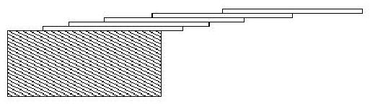

img

#### 输入数据

The input consists of one or more test cases, followed by a line containing the number 0.00 that signals the end of the input. Each test case is a single line containing a positive floating-point number c whose value is at least 0.01 and at most 5.20; c will contain exactly three digits.

#### 输出数据

For each test case, output the minimum number of cards necessary to achieve an overhang of at least c card lengths. Use the exact output format shown in the examples.

#### 输入样例

24 39 0

#### 输出样例

6 3

#### 题目来源

HDU 1056 http://acm.hdu.edu.cn/showproblem.php?pid=1056

### 二、题解

#### 解题思路

题目大意是给定一个实数，求调和级数img 大于该实数时的项数。

不过要注意本题k从2开始计数。

我们采用模拟的方法。也就是一个数一个数地加，直到总和大于等于该实数为止。

注意本题不能用 n减少的方式算出项数，因为浮点数本身的误差可能会导致WA。具体可以自行百度。

#### 参考程序

#include<stdio.h>  
int main()  
{  
 double n,sum;  
 int i;  
 while(scanf("%lf",&n) != EOF && n != 0)  
 {  
 sum=0;  
   
 for(i=2;sum<n;i++)  
 sum+=1.0/i;  
   
 printf("%d card(s)\n",i-2);  
 }  
}

#### 复杂度分析

实数 n <= 5.20 ，经测试 i <= 273

时间复杂度为O( T*(e^n) ) , T是测试点数

#### 编程技巧

无