AndyMark AM-2645 LED Strip Kit
Quick Setup

Suggested Parts List:
- AM-2645 5V LED Addressable Light Strip Kit
- AM-2578 Lever Nut Kit

Wiring Notes:
- Pay close attention as the colors can be confusing
- Connect all grounds together
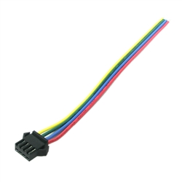
4 wire LED connector
- Yellow wire is ground!
- Red wire is +5V in
- Green wire is SPI Data
- Blue wire is SPI Clock

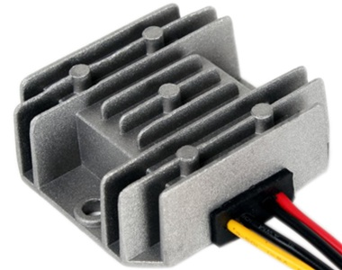
Power Converter
- Yellow is +5V out!
- Red wire is +10V-30V in
- Black wires are ground

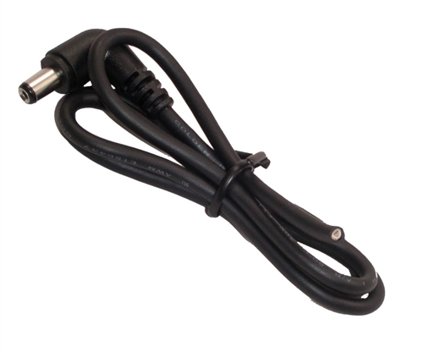

DC Power Cable
- Coaxial Shield is ground
- Center Wire is +V
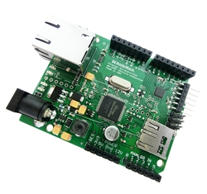
Arduino Ethernet
- Pin 13 SPI Clock
- Pin 11 SPI Data

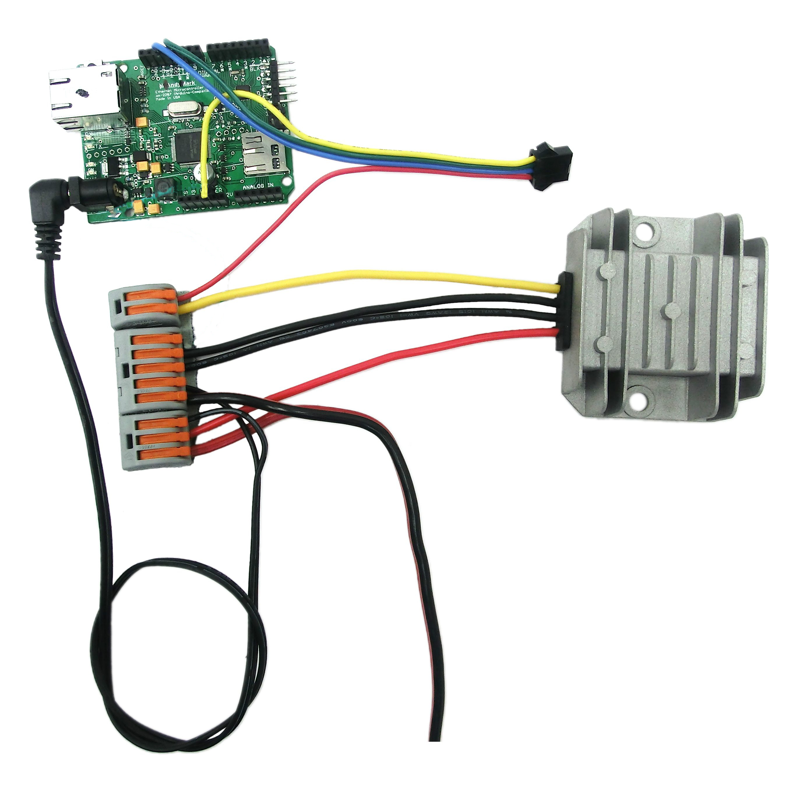
Connection Example

