AndyMark, Inc.
Motor Meter^{tm}
Handheld Motor Tester

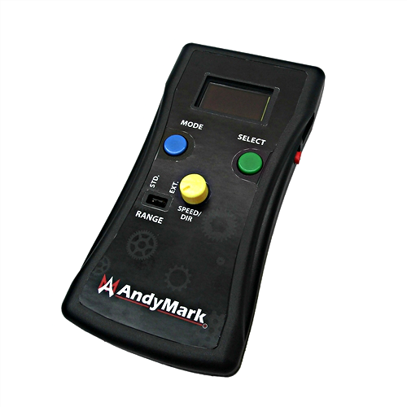

User Manual
Version 2.0

Overview
The AndyMark Handheld Motor Meter allows teams to test their electro-mechanical systems before the control software is complete. It generates a PWM that can be used to drive motor controllers such as the Talon. It can also measure current up to 100 amps when paired with the Current Sensor Assembly.

While there are a number of other devices that can generate PWM signals, this product was designed specifically to run motor controllers and has a number of features that make it uniquely useful for this task.

Features
- No-Slam^{tm} speed control
  - Software damping designed to prevent gear slamming caused by rapid direction changes
  - Uses soft braking when changing control modes
- PWM generation
  - Standard servo range - 1000ms-2000ms
  - Arduino extended range - 500ms-2500ms
- Current Sensor Attachment
  - Current sensing up to 100 Amps
  - Allows user to
    - Determine motor power usage
    - Detect mechanical drive inefficiencies bindings, jams etc.
- Sweep generation
  - Cycle through speeds and direction
  - Speed of cycling is user adjustable
- Quick and Dirty Talon Calibration
- Handheld
  - Comfortable form factor
  - Optional Silicone Boot for added protection
- complete with nerd-worthy belt loop
  - 9V battery operation (battery not included)
- User customizable platform
  - Hardware
    - Arduino Pro Mini
    - 128X64 Pixel OLED Display
    - Circuit board has breakouts for all the Arduino pins
    - User inputs
      - Two buttons
      - One potentiometer
  - Firmware
    - User editable, Arduino-based open-source code
    - Feel free to modify the code to meet your needs

Getting Started
- Remove back cover and install 9V battery (not included).
- Switch the unit on with the red power switch on the right side.
  - You should soon see AndyMark scroll across the screen.
  - The screen will then change to a one-time help screen.
- Connect the PWM cable to the PWM output on the Motor Meter – black wire toward the GND indicator on the end label.
- Install Current Sensor between supply and the Speed Controller (e.g. Talon). The Anderson Powerpole connecter with the label “Motor” plugs into the side feeding the speed controller.
- Connect the Current Sensor “PWM” cable to the Current input connection on the Motor Meter – black wire toward the GND indicator on the end label.

Basic Operation
The blue button is the Mode button and is used to cycle between Speed, Sweep and Calibrate modes. Use the Mode button to exit a mode when you are done.

The green button is the Select button. Once you have chosen the mode you want with the Mode button, press the Select button to enter that mode.

The yellow knob is used to adjust the speed and direction of the motor when in Speed Mode and adjusts the sweep speed when in Sweep mode.

NOTE: This unit produces a PWM signal only; it does not supply power to devices. Devices such as servos, speed controllers etc. need a separate power supply.

Mode Descriptions

Speed
This mode generates PWM values based on the yellow speed knob setting. This mode can be used to drive a motor in either direction and at variable speeds via a PWM based speed controller. Once this mode is selected you can set your speed first and the press Select again to enable/disable the PWM output. You adjust the speed in 10us increments with the motor enabled or disabled.
This will probably be the most used mode when testing and setting up motors and drive trains.

Sweep
This mode sweeps the PWM value through the range selected by the range jumper*, causing the motor to go through its full speed range in both directions.
The speed of the sweep is set by the yellow speed knob.

Calibrate
NOTE: To prevent injury caused by accidental activation of your motor/drive assembly, disconnect the output of the speed controller before activating CAL mode.

This mode is used to do a quick calibration of the speed controller. For a speed controller to operate properly it needs to know the Max and Min PWM input values as well as the PWM value that represents the neutral/brake position. The Motor Meter Calibrate Mode does this quickly for you.

Have something like a paper clip handy to press the recessed CAL button on the speed controller when asked to so by the screen prompt. See your speed controller documentation for procedures specific to that controller. For the Talon click here.

Once this mode is entered, you will be asked to press select one more time to start the calibration process. This is to give you time press and hold the CAL button on the controller. If you take longer than 10 seconds to press the select button again this mode will timeout.

While in this mode, press and hold the controller’s CAL button and then press the Motor Meter’s Select button. The Motor Meter will now send 3 PWM values out; one for full forward, one for full reverse and one for neutral/brake. The process is quick and the screen will prompt you when finished.

* Range Selection
For all the modes, the standard PWM values range from 1000us – 2000us. This is the typical PWM range for servos. And extended range is possible by holding the Select button for about 1 second when selecting a Mode. With extended range selected, the PWM values range from 500us - 2500us.

Hacking the Motor Meter
The motor meter is built on an Arduino Pro Mini 5v, 16Mhz module. As such it can be programmed like any other Arduino. A programming header has been provided via a slot just to the right of the display module. All you need is an Arduino programming cable. This allows you to upgrade the firmware if new versions are released.
You can also modify the source code (available here) to make its behavior better suit your needs. If you are really creative you can use this module as a platform to create your own custom handheld device.

If you do hack the Motor Meter for your own creation please tell us about it!

