DriX-8 Fuel Gauge
Linearity, Scale and What the Reserve Is Worth
3 operating days measured against the flow meter · 26.7 L over 13 indicated points
11 August 2026
The short version
The gauge does not read litres. Over the 72–85% band it delivers 2.06 ± 0.11 litres per indicated point, against 2.50 for a linear 250 L tank — 4 sigma below, and in close agreement with the independent DD2024 refuel figure of 2.09. That is a solid result and it points at a usable capacity near 206 L. Whether the gauge is also NON-LINEAR — reading different litres-per-point at different levels — is NOT established by this data, and an earlier reading of these same days overstated it. Section 5 sets that record straight.

1. Why this matters
Two operating decisions rest on the gauge, and both are quantitative.
- The 25% return-to-port reserve is expressed in indicated percent. If a point is not a fixed number of litres, then "25%" is not a fixed amount of fuel — and the reserve is either more or less protective than intended, without anyone being able to tell from the wheelhouse.
- Endurance predictions scale directly with usable capacity. Range and hours-remaining are computed as usable litres times efficiency. Take the capacity wrong and every planning number inherits the error, in proportion.
The gauge is also the only fuel instrument available on a vehicle without a working flow meter, so understanding its behaviour transfers to hulls that cannot be measured this way.

2. Method
The flow meter is used as the ruler. It measures litres directly and is independent of the gauge, so comparing the two isolates the gauge's behaviour without assuming a tank volume or a fuel model anywhere in the chain.
litres per indicated point = ∫ fuel_rate dt ÷ Δ indicated %
Two details do the work. Fuel rate is integrated over each day with gaps longer than 30 s excluded, so a recording break cannot inflate the total. And each end of the gauge span is taken as a ten-minute median rather than a single reading, because the gauge is quantised to whole percent and bounces by a point or more as fuel moves in the tank.
Days burning less than 2 L are excluded from the calibration entirely. On an idle day the gauge still wanders a point or two on essentially no fuel, and letting such a day anchor one end of a span moves the answer by roughly a tenth for no physical reason.
Day | Metered litres | Gauge span | Points | L per point | Uncertainty
2026-08-05 | 8.82 | 81–85% | 4 | 2.21 | ± 0.39
2026-08-06 | 9.59 | 77–81% | 4 | 2.40 | ± 0.42
2026-08-08 | 8.31 | 72–77% | 5 | 1.66 | ± 0.23
POOLED | 26.7 | 72–85% | 13 | 2.06 | ± 0.11
2026-08-04 | 0.18 | — | — | idle — excluded | —
2026-08-07 | 0.00 | — | — | idle — excluded | —
2026-08-09 | 0.00 | — | — | idle — excluded | —
Table 1 — Every cached day. Uncertainty is dominated by the gauge span: a ten-minute median of a 1%-quantised signal still carries about ±0.5 point at each end, so ±0.7 on the difference. A day spanning only four points therefore carries about ±18% on its litres-per-point, which is the crux of section 5.
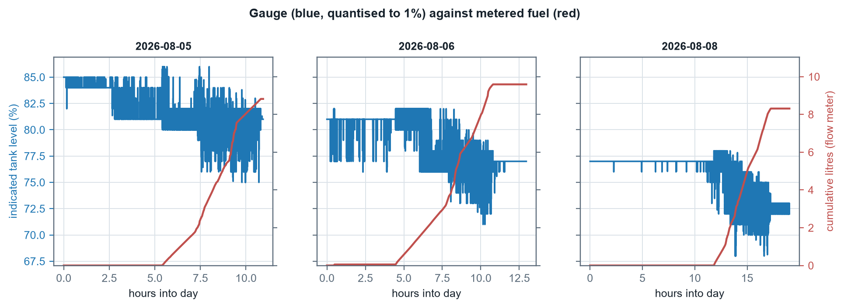
Figure 1 — The raw evidence, one panel per operating day. The gauge (blue) descends in visible 1% steps with bounce at each transition; metered fuel (red) rises smoothly. The staircase against the ramp is the entire measurement.

3. The calibration curve
Chaining the operating days end to end gives cumulative metered litres against indicated level across the whole observed band.
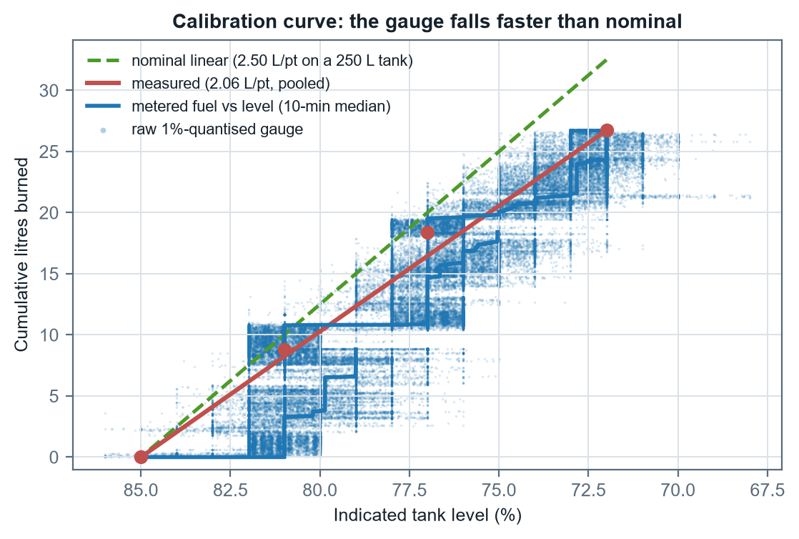
Figure 2 — Cumulative litres against indicated level. The measured slope sits below the nominal line throughout: each indicated point is buying fewer litres than a linear 250 L tank would give. The scatter behind the staircase is the raw quantised gauge, shown so the noise is not hidden by the smoothing that removes it.
Across the full observed span the gauge delivers 2.06 ± 0.11 L per indicated point. If that rate held across the whole tank it would imply about 206 L of usable capacity, against the 250 L nominal.

4. Four independent lines of evidence
Source | Band | L per point | Litres are… | Strength
Nominal assumption | 0–100% | 2.50 | assumed | No measurement behind it
2022 telemetry | 54–92% | 1.73 | MODELLED | Precise arithmetic, but the litres come from a fuel model, not a meter
DD2024 refuel event | 9–97% | 2.09 | metered (pumped) | Real litres over nearly the whole range; the fill may not be one clean event
MCAP flow meter | 72–85% | 2.06 | metered | Direct and continuous, but spans only a narrow band
Table 2 — The 2022 figure is the weakest of the three non-nominal sources despite looking the most precise: its litres are what a fuel model predicts for that window, so it inherits both model error and any in-service burn premium. It should not be weighed equally with the two metered figures.
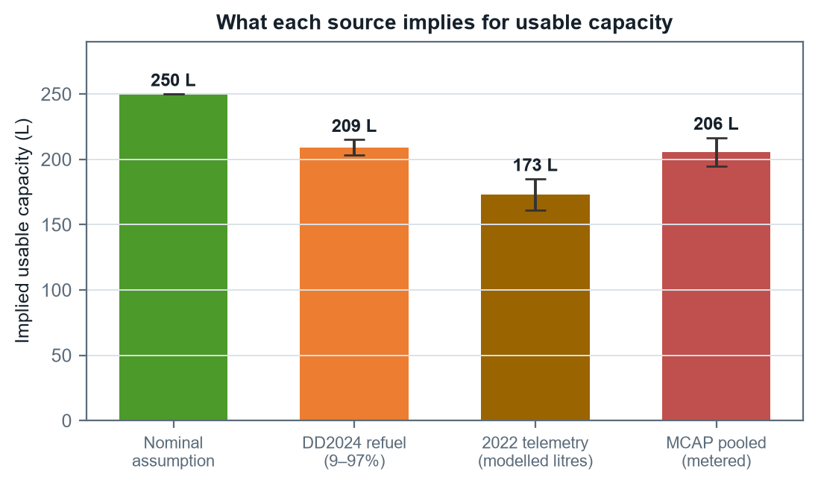
Figure 4 — Implied usable capacity by source. The two metered sources agree closely; the nominal figure stands apart, and the modelled 2022 figure sits low for the reasons in Table 2.
The two sources that measure real litres — the DD2024 refuel and the flow meter — agree to within 0.3 sigma despite sharing no data, no method and no year. That agreement is the strongest single result here.

5. Is the gauge non-linear? Not established.
The three operating days each cover a different band, and their litres-per-point differ: 2.21 over 81–85%, 2.40 over 77–81%, 1.66 over 72–77%. Read quickly, that looks like the gauge changing scale down the tank — and an earlier pass over these same days recorded it as exactly that.
It does not survive an error analysis.
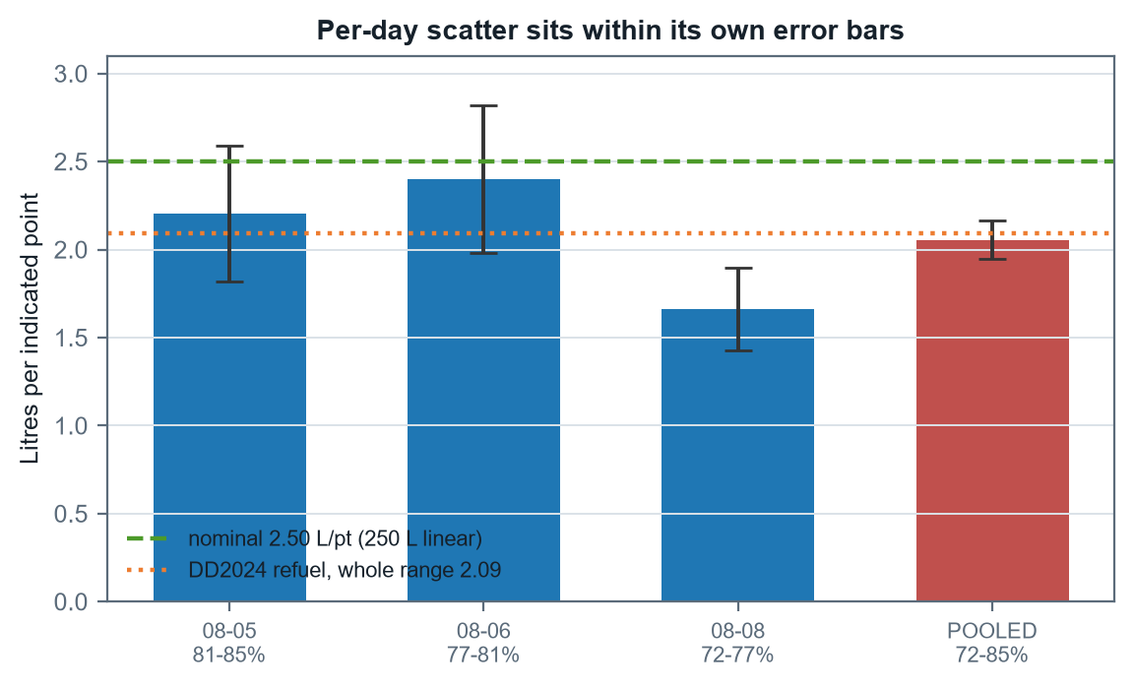
Figure 3 — The same per-day figures with their uncertainties. Every bar overlaps its neighbours. The pooled value (red) is tight because it spans three times as many points.
widest gap: 2.40 − 1.66 = 0.74 L/pt
combined 1σ: 0.48
separation: 1.5 σ → not significant
Each day spans only four or five indicated points, so the ±0.7 point uncertainty on a span becomes roughly ±18% on that day's litres-per-point.
A 1.5 sigma separation is what random noise produces routinely. The per-day spread is therefore consistent with measurement scatter, and it is not evidence of non-linearity. Pushing to finer resolution makes this worse rather than better: computing litres for each individual gauge point gives values ranging from about 0.2 to 5.0 L — a scatter larger than the quantity being measured.
None of this disproves non-linearity — a float sender in a tank that is not a uniform prism has every physical reason to be non-linear, and the DD2024 whole-range figure sitting close to the narrow-band figure is mildly reassuring rather than conclusive. The honest statement is that the effect, if present, is smaller than this measurement can resolve.
Correction to the earlier record
A previous analysis of these days recorded the per-day spread as demonstrating non-linearity, and that statement propagated into the model file and the project notes. It was over-read. The correct position: the gauge SCALE is firmly established as 2.06 L per point over the measured band, well below nominal; the question of whether that scale varies with level is open, and this data cannot close it. The model file and notes have been corrected to say so.

6. What the reserve is actually worth
The reserve is set in indicated percent, so its value in litres follows directly from the calibration.
Basis | L per point | 15 points = | Against nominal
Nominal 250 L linear | 2.50 | 37.5 L | —
Measured (this band) | 2.06 | 30.8 L | -6.7 L
DD2024 whole range | 2.09 | 31.3 L | -6.2 L
Table 3 — What fifteen indicated points buys. The measured figures assume the low band behaves like the measured band, which is precisely the untested assumption.
On the measured scale the reserve is worth about 31 L rather than the 38 L a nominal reading implies — roughly 7 L less margin than assumed. At survey speed that is on the order of an hour of endurance. It does not make the reserve unsafe, but it does mean the reserve is smaller than the number suggests, and it argues for planning on the evidence-based capacity rather than the nominal.
The band that matters is the one never measured
Every measurement here comes from the top third of the tank, because the reserve policy means the vehicle rarely goes lower and returns are made well above the floor. The 25% reserve sits in a region for which there is no direct calibration at all. If the gauge is non-linear anywhere, the bottom is where a float sender is most likely to misbehave — and that is exactly where the reserve decision is made.

7. What would settle it
- Sound the tank. A dowel against a known fill ends the capacity question outright and costs one afternoon alongside. It was suggested in the DD2024 thread and remains the single highest-value measurement available.
- Log litres pumped against indicated level at every refuel. Record the level before and after with the volume. Fills that start from different levels build the calibration curve across bands the vehicle never burns through in normal operation.
- Deliberately run one tank low, once. A single controlled drawdown into the reserve band, with the flow meter logging, would calibrate the region every planning decision depends on. Nothing else available does this. From the lowest level ever recorded (68%) down to the 25% floor is 43 indicated points: about 111 L and 33 hours at survey speed, or 116 hours at loiter, and it would fix litres per point to 1.6%. Half of it — down to 46% for 55 L and 16 hours — buys 3.3% and halves the blind band. No new instrumentation: both channels are already recorded.
- Keep accumulating operating days. Each new day extends the band and tightens the pooled figure. Three more days at the current rate would roughly halve the uncertainty on any single band, which is what a non-linearity test actually needs.

Appendix — Reproducing this report
python tools/extract_bags.py D:/Claude/Fuel/D8_2040
python tools/build_gauge_report.py [OUT.docx]
The report recomputes every figure and every number from the day caches, so re-running it after adding data produces a corrected document rather than a stale one. The significance test in section 5 is part of that recomputation — if accumulating data ever makes the band-to-band difference real, the document will say so.

