Technical Manual
How the numbers are produced, and what they are worth
Transit Calculator
Version 1.0 · 14 August 2026
Who this is for
Anyone deciding whether to trust a figure this tool produced: the algorithms, the data sources, the assumptions, and the limits.

Where the numbers come from
Every figure in this document was produced by the code it describes, at the moment the document was built. Nothing here is transcribed by hand.
Quantity | Value | Source
Sample line length | 77.68 NM | geo.inverse over survey_transit_line.shp
Legs | 6 | the same file
Vessel model | placeholder-1.0.0 | model.json
Configurations | config_a, config_b | model.json
Tank / reserve | 250 L / 25% | model.json
Checks in the suite | 371 | tests/test_transit.py
Mutations | 58 | tests/mutate.py
Export formats | 7 | exporters.FORMATS

1 Geodesy
Distances and bearings are ellipsoidal, using Vincenty's inverse formula on WGS84. This is a deliberate departure from the companion ASV console, which uses an equirectangular approximation appropriate to a survey box a few kilometres across.
A transit is not a survey box. The longest leg of the supplied line is 42.6 NM, where the flat-earth approximation is 213 m long — small in relative terms, but it is the number the fuel and the ETA hang off.
Verified against the published Vincenty test vector: distance to 0.14 mm and both azimuths to 0.003 arcsec.
One convention worth knowing
inverse() returns the FORWARD azimuth at the destination — the course still being steered on arrival. Published test tables often list the reverse azimuth instead, which is that value minus 180. Checking this function against such a table without lining up the convention makes it look broken when it is not.

2 The passage is integrated, not divided
Distance over speed is the wrong calculation on a tidal coast. The current reverses roughly every six hours; the supplied passage takes about ten. A vessel that leaves on a fair tide meets the foul one before it is halfway, and evaluating the current once — at the start, or at each leg's midpoint — answers a question nobody asked.
So the calculation MARCHES. Each leg is stepped in half-mile increments. At each step the current is looked up at the position the vessel has reached and the clock time it reached it; the resulting speed advances the clock, which changes where the vessel is at the next lookup.
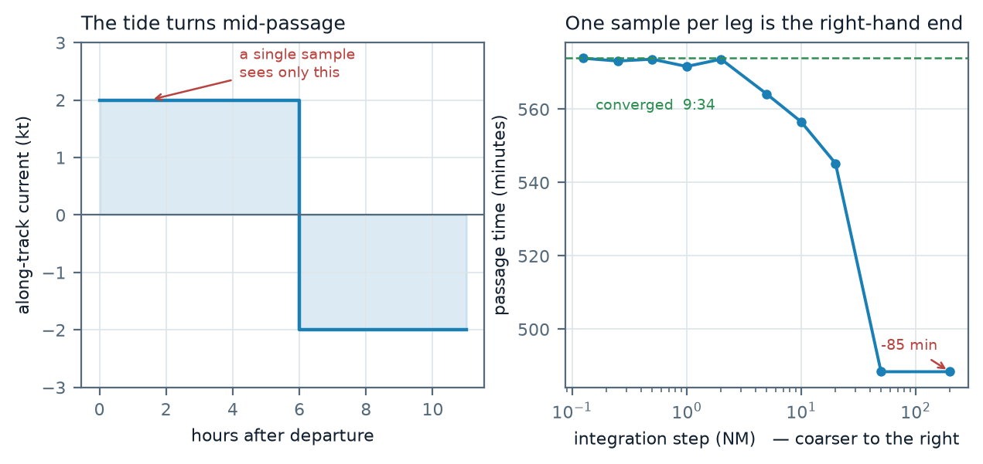
Left: a synthetic current reversing on a six-hour cycle. Right: passage time against integration step, computed by the real planner. The right-hand end is one sample per leg.
The half-mile default is proven converged: halving it again moves the passage by under a minute, and a test enforces that.

3 Currents

3.1 The source
NOAA Operational Forecast System models, read over OPeNDAP from the CO-OPS THREDDS server as hourly surface fields. A cycle is downloaded once, cut to the line's bounding box, and cached; all subsequent queries are local.

3.2 One model is one region
An OFS covers a region and stops at a hard edge. A transit does not care where that edge is. The supplied line runs past the Delaware Bay model's southern boundary, leaving its last miles with no current at all.
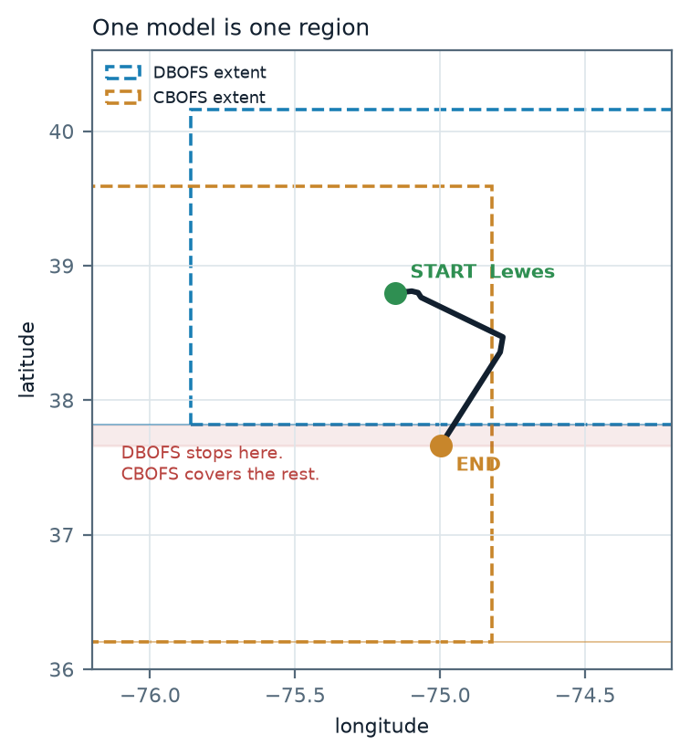
The supplied line against the two model domains that between them cover it. Extents are the probed water extents, read from the cached domain file.
The tool therefore probes which models actually reach a line, fetches each one scoped to the part it is needed for, and serves them through a single source that tries the finest model first and falls through.

3.3 The handover
Where two models overlap they disagree slightly — different grids, different bathymetry, different assimilation. The finer regional model wins in its interior. Within about 15 km of its boundary the two are blended by distance, as VECTORS, so the handover does not put a step in the middle of a leg. Blending directions as angles rather than vectors would make the mean of a flood and an ebb point sideways instead of reading as slack.

3.4 Domain detection
A "regulargrid" file is a rectangular array with fill where the irregular model domain does not reach; its corners read back as latitude 2.0 or 89.0. Reading the corners tells you nothing. The domain is instead probed by walking the grid with a stride, keeping only unmasked water nodes, and storing them as an occupancy raster at 0.05° (about 5.5 km) with a stated one-cell tolerance.

4 Wind and waves
Three sources, because none of them is sufficient alone.
Source | Gives | Resolution | Nature
NDBC buoys | Wind, gust, wave height, period, direction | Point | Observation
NWS gridpoints | Wind, gust, wave height | ~2.5 km, US waters | Forecast
WAVEWATCH III | Wave height, period, direction | 0.5° (~55 km), global | Forecast

The interpolation is per VARIABLE, not per station
This is not a theoretical nicety. On the supplied line, buoy 44009 reports wind with its wave fields blank, and 44084 reports waves with its wind fields blank. Neither answers the question alone. Treating a station as a unit — or reading a blank as zero — manufactures a calm forecast out of a broken sensor.

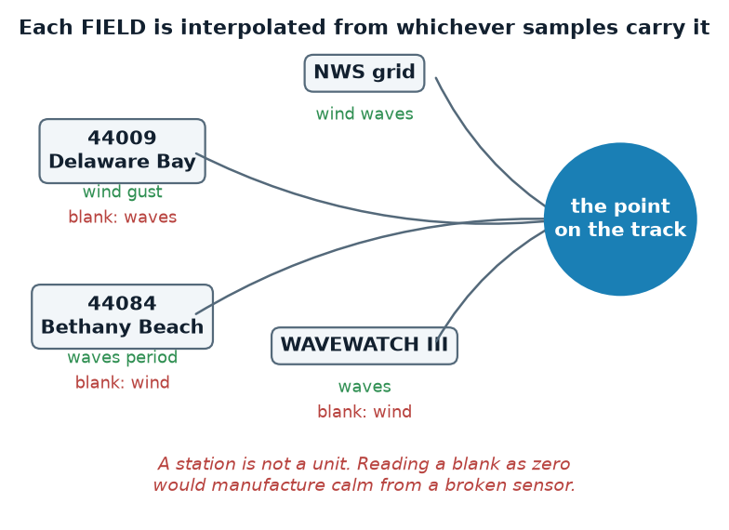
Each field draws only on the samples that actually carry it.
Weighting is inverse distance, w = q / (d^p + e), with p = 2 and q a source-quality factor so an observation outweighs a coarse model cell at equal distance. Directions are averaged as vectors, and wave direction is weighted by wave height so a ripple does not drag the mean off a swell.
IDW is an interpolator, not a model
It cannot invent structure between samples. A point 50 km from anything is a smooth guess. Every interpolated value therefore carries the sources that made it, their distances, and the age of the oldest observation — shown under "Weather sources" in the results.

5 Fuel
The chain runs in this order, and the order matters:
- Target speed and the current give the speed required THROUGH THE WATER.
- Water speed gives benign RPM, from the configuration's speed law.
- Sea state and heading give a fractional premium.
- Actual RPM = benign RPM × (1 + premium).
- Actual RPM gives litres per hour, from the configuration's fuel law.
Taking speed over ground into the fuel law instead of speed through water is the one ordering mistake that makes a favourable current look like free fuel. The engine pushes the hull against the water; a following current costs nothing at the injector.
At 8 kt on the default configuration the model gives 3.47 L/h, i.e. 2.31 NM per litre.

5.1 The same chain, run backwards
Fixed-revs mode inverts it rather than modelling the vessel twice. The premium is extra revs to HOLD a speed, so at a held throttle it comes off the speed instead: benign RPM = actual RPM / (1 + premium), and the speed law then gives the water speed. The consequence is the useful part — litres per hour is fixed by the revs, so weather lengthens the passage instead of making it dearer per hour.
The inversion is exact in still conditions: 2174 RPM is what 8 kt needs, and reading it back gives 8.00 kt.
The floor on the following-sea credit
The heading premium scales with the square of the wind and is negative downwind, with nothing in the fit bounding it. The forward chain multiplies by (1 + premium) and never notices; the inversion DIVIDES by it, and a strong following wind would otherwise report a vessel making half as much again as its own curve allows. The divisor is floored, and a result that hits the floor says so rather than quietly reporting the clamped speed.

5.2 Why premiums are never averaged
The fuel law is convex in RPM. The mean of the rates is strictly greater than the rate at the mean premium, so averaging the premium across a passage understates the fuel. Each step is costed individually.

5.3 Endurance, and where the reserve floor comes from
The burn is a property of the passage; endurance is that burn measured against the boat. Fuel aboard at departure is an optional input — blank means a full tank — and the reserve floor is taken as a fraction of TANK VOLUME, 25% of 250 L = 62.5 L. Usable fuel is therefore what is aboard less that floor.
The distinction is not pedantry. The floor exists because of the tank — pickup height, sloshing, the margin an operator will not plan into — so it does not scale with the load. At 140 L aboard the honest usable figure is 77.5 L; taking the reserve as a fraction of the load instead gives 105.0 L, an overstatement of 27.5 L in the direction that runs a boat dry. A mutation case encodes exactly that error, because it is the version a reviewer would wave through.
What is deliberately NOT modelled here is the gauge. Reading a tank level from a sender is a non-linear profile owned by the source planner; this tool takes litres as stated and says so.

5.4 The sea-state premium is an assumption
It is carried unchanged from the source model, including that caveat. The heading effect is a measured magnitude with an assumed cosine shape. Neither is a fitted law of the same standing as the fuel curve, and a result that leans heavily on either should be read accordingly.

6 Direction is not symmetric
The same line run the other way is a different passage. Current is part of it, but on the supplied line the dominant term is WIND, through the heading premium and the convex fuel law: a swing of about five per cent in RPM becomes roughly a quarter of the fuel.
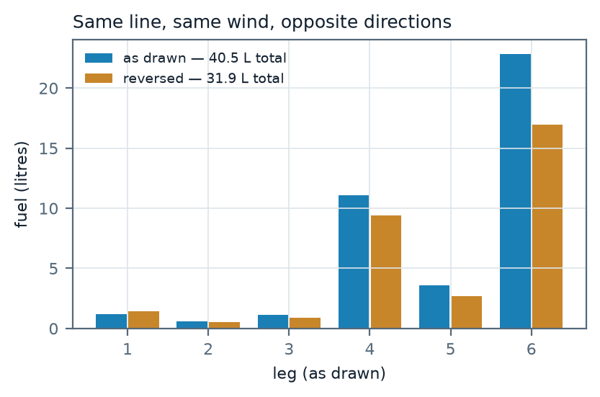
Per-leg fuel in both directions, same wind, same departure, computed at build time.

7 Charts
NOAA ENC raster tiles in the Web Mercator scheme, proxied by the local server because the upstream endpoint sends no CORS header, and cached to disk so a planned area works offline. Reads chain from the local cache through any configured read-only fallback to the network. A tile that cannot be had is served as empty and the client draws its own graticule — an honest blank rather than a black hole.

8 Accuracy and limits
Quantity | Confidence | Limit
Distance, bearing | Sub-millimetre against the reference vector | None that matters at this scale
Current | As good as the OFS forecast | Regional coverage only; gaps are reported, never filled with zero silently
Wind, waves | Observation near a buoy; forecast elsewhere | A point far from any sample is a smooth guess, and says so
Fuel | Follows the vessel model | Only as good as the fitted laws; premiums are partly assumed
Sea state | Derived from wave height via the model's own bands | Inferred, not observed; flagged as derived

9 What the tool refuses to do
Refusals are deliberate, and they are more useful than a confident wrong answer.
- A cross-current stronger than the vessel can crab out marks the leg infeasible rather than returning a plausible slow number.
- A shapefile with no .prj whose coordinates are not lat/lon is refused, because guessing a zone puts the line in the wrong ocean.
- A projection it does not recognise is reported as unknown rather than half-understood.
- Where no model reaches, the current is zero AND COUNTED, and the uncovered fraction is reported per leg and overall.
- A weather field nobody reports comes back null, never calm.

