Reproducible Research: Peer Assessment 1

## Load Required Libraries

library(ggplot2)

## Warning: package 'ggplot2' was built under R version 3.2.4

library(lubridate)

## Warning: package 'lubridate' was built under R version 3.2.4

##   
## Attaching package: 'lubridate'  
##   
## The following object is masked from 'package:base':  
##   
## date

## Loading and preprocessing the data

unzip(zipfile="activity.zip")  
dat1 <- read.csv("activity.csv")  
  
#Convert the dates to days since start  
days <- (yday(dat1$date) - 1)  
dat1$day<-days-(min(days)-1)

## 1 What is mean total number of steps taken per day?

### 1.1 Calculate the total number of steps taken per day

#Now calc sum steps per day  
SumPerDay<- aggregate(x=list(SumSteps=dat1$steps), by=list(day=dat1$day), FUN=sum, na.rm=TRUE)  
head(SumPerDay)

## day SumSteps  
## 1 1 0  
## 2 2 126  
## 3 3 11352  
## 4 4 12116  
## 5 5 13294  
## 6 6 15420

### 1.2 Make a histogram of the total number of steps taken each day

#Histogram Steps per Day  
qplot(SumPerDay$SumSteps, xlab='Total steps per day', ylab='Frequency')

## `stat_bin()` using `bins = 30`. Pick better value with `binwidth`.

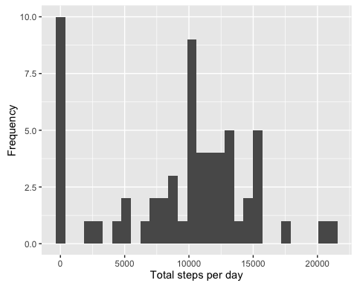 ###1.3 Calculate and report the mean and median of the total number of steps taken per day

mean(SumPerDay$SumSteps)

## [1] 9354.23

median(SumPerDay$SumSteps)

## [1] 10395

## 2. What is the average daily activity pattern?

MeanPerInt<- aggregate(x=list(MeanSteps=dat1$steps), by=list(Interval=dat1$interval), FUN=mean, na.rm=TRUE)  
head(MeanPerInt)

## Interval MeanSteps  
## 1 0 1.7169811  
## 2 5 0.3396226  
## 3 10 0.1320755  
## 4 15 0.1509434  
## 5 20 0.0754717  
## 6 25 2.0943396

## 3.Make a time series plot

#### 3.1 Make a time series plot

ggplot(data=MeanPerInt, aes(x=Interval, y=MeanSteps)) +  
 geom_line() +  
 xlab("5-minute interval") +  
 ylab("average number of steps taken")

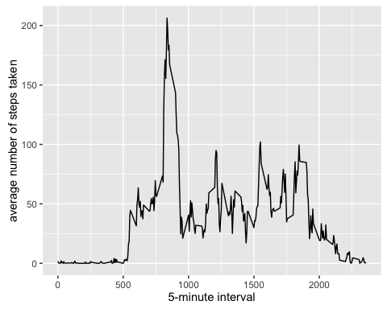

#### 3.2 Which 5-minute interval, on average across all the days in the dataset, contains the maximum number of steps?

MostSteps <-MeanPerInt$Interval[ which.max(MeanPerInt$MeanSteps)]  
MostSteps

## [1] 835

## 4. Imputing missing values

### 4.1 Calculate and report the total number of missing values in the dataset

missing <- is.na(dat1$steps)  
# table of Missing  
table(missing)

## missing  
## FALSE TRUE   
## 15264 2304

#Percent Missing  
round((table(missing)[2]/length(dat1$steps))*100,0)

## TRUE   
## 13

### 4.2 Create a new dataset that is equal to the original dataset but with the missing data filled in

md<-median(dat1$steps,na.rm=TRUE)  
mn<-mean(dat1$steps,na.rm=TRUE)  
dat2<-dat1  
dat2$steps[is.na(dat2$steps)]<-mn  
mean(dat2$steps)

## [1] 37.3826

### 4.3 Make a histogram of the total number of steps taken each day

#Now calc sum steps per day  
SumPerDay2<- aggregate(x=list(SumSteps=dat2$steps), by=list(day=dat2$day), FUN=sum, na.rm=F)  
head(SumPerDay2)

## day SumSteps  
## 1 1 10766.19  
## 2 2 126.00  
## 3 3 11352.00  
## 4 4 12116.00  
## 5 5 13294.00  
## 6 6 15420.00

#Histogram Steps per Day  
qplot(SumPerDay2$SumSteps, xlab='Total steps per day', ylab='Frequency')

## `stat_bin()` using `bins = 30`. Pick better value with `binwidth`.

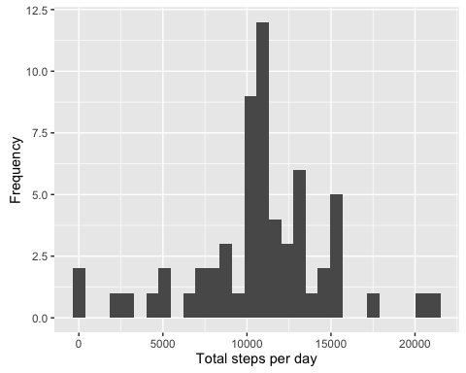

### 4.4 Calculate and report the mean and median total number of steps taken per day

mean(SumPerDay2$SumSteps)

## [1] 10766.19

median(SumPerDay2$SumSteps)

## [1] 10766.19

### 4.5 Do these values differ from the estimates from the first part of the assignment?

yes more values have been included

### 4.6 What is the impact of imputing missing data on the estimates of the total daily number of steps?

They are higher

## 5. Are there differences in activity patterns between weekdays and weekends?

First we create an additional variable showing which intervals are weekend and which weekday

dat2$WkPart <- ifelse(as.POSIXlt(dat2$date)$wday %in% c(0,6), 'weekend', 'weekday')

Create the mean activity per day and plot weekends against weekday

MeanActivityDat2 <- aggregate(steps ~ interval + WkPart, data=dat2, mean)  
  
ggplot(MeanActivityDat2, aes(interval, steps)) +   
 geom_line() +   
 facet_grid(WkPart ~ .) +  
 xlab("5-minute interval") +   
 ylab("avarage number of steps")

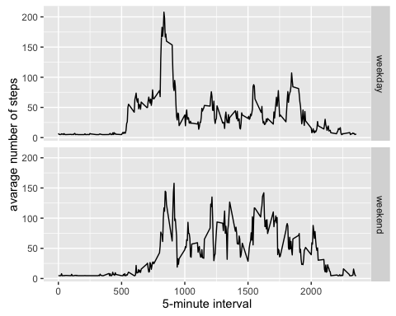 There are differences, the highest peak of activity at 500 to 1000 is lower at weekend, but the activity from there on is higher.