Skillabus: matching job ads, resumes and UTS subjects on one skills vocabulary
36118 Applied Natural Language Processing, Assignment 2: technical report
Quan, Phuong Nhi, Van Thong, Hoai Thuong, Akash
17 October 2026
App: https://skillabus.streamlit.app · Code: https://github.com/AndyPham2004/ANLP-AT2-Skillabus

1 Introduction

1.1 The problem
A UTS subject outline and a Sydney job ad can describe the same skill in words that never overlap. Subject 36120’s first learning objective reads “Implement and evaluate advanced machine learning techniques to real-world problems”; a Robert Walters Data Scientist ad (Sydney CBD, September 2026) asks for “in-depth knowledge of deep learning, Generative AI, and other advanced AI technologies”. A student cannot tell which subject taught what the ad asks for, or which elective would close the gap, and their resume uses a third vocabulary. The market also moves faster than the Handbook: large language models appear in none of 3,204 Seek Data Scientist ads from 2019-22 and in 36% of the Data Scientist ads of 2026 (section 3).

1.2 Users and scope
Skillabus answers one question for a UTS student, or someone about to enrol: which subjects move me closest to the job I want? The goal is one of 11 data and IT roles in five families or a specific job ad; a student who is not sure yet sees the roles ranked by how close they already are. Demand comes from 1,932 Australian ads posted between 1 September and 16 October 2026 (89 to 216 per role); supply from 360 UTS Handbook subjects in 44 courses, plus 56 outside courses, 250 self-study resources and 49 certifications for skills UTS does not teach.

1.3 What is new
Existing tools stop one step short of the student’s decision (section 2). Job platforms compare a profile with a job but know nothing about university subjects. Curriculum analytics such as Lightcast Skillabi align whole programs with the labour market for program leaders, with a proprietary taxonomy. UniSkill links course sentences to ESCO skills but not to a resume or a live ad. Handbooks list subjects with no link to demand.
Skillabus closes that loop for the individual student. It puts ads, resumes and subject outlines on one skills vocabulary (ESCO plus 145 skills that Australian ads ask for and ESCO lacks) and recommends the few UTS subjects that close the most demand-weighted gaps. Each recommendation quotes the sentence of the subject outline that justifies it and says whether it came from a learning objective, a weekly topic or the description. Gaps no subject covers are filled with outside courses and certifications, marked as not counting for credit. For a sample Data Scientist ad the path is 36106, 36121, 32130, which cover 82.8% of the demand-weighted gap.

1.4 Contributions
- One vocabulary for three document types, with a five-step normalisation that keeps skills ESCO lacks instead of dropping or mislabelling them (section 4).
- Evidence by layer. Reading learning objectives alone hid that 36118 and 43023 teach large language models as topics, so weaker layers are shown, not discarded.
- A demand-weighted learning path that respects prerequisites and teaching sessions.
- Measured stages. Each stage is scored against a baseline on labelled data (section 6), and students can vote on whether a subject really teaches a skill.

2 Related work
Skill extraction. ESCO (European Commission, 2017) gives a shared, multilingual skill inventory that most research systems map to. SkillSpan (Zhang, Jensen, Sonniks & Plank, 2022) annotated skill spans in English job ads, and a weak-supervision follow-up linked spans to ESCO by embedding similarity (Zhang, Jensen, van der Goot & Plank, 2022). Both note that a fixed inventory misses new skills. Large language models now extract skills from ads, resumes and course descriptions with few examples (Frej et al., 2024); an LLM can, however, return skills that are not in the text. This motivates our design: a vocabulary lookup as the precise backbone, spaCy and GPT-4o-mini for what it misses (with every skill checked against the text), and an explicit class for skills ESCO lacks.
Job–resume matching. LinkedIn’s Skills Match and resume checkers such as Jobscan compare a profile or resume with a job. They stop at “add this keyword” or point to their own short courses, never to a university subject, and they show no evidence for a match.
Course recommendation. Karakolis et al. (2022) recommend university courses from a learner’s CV using ESCO, but read course descriptions only and show relevance scores instead of evidence. Skill Scanner (Schlippe & Bothmer, 2023) embeds ads, CVs and one master’s curriculum and reports which market skill clusters a document covers, without recommending subjects. JCRec (Frej et al., 2024) uses reinforcement learning to choose course sequences that maximise the jobs a learner qualifies for, evaluated on simulated users. UniSkill (Musazade, Mezei & Zhang, 2026) shows that sentence-level course–skill matching works with fine-tuned encoders, which supports sentence embeddings over keywords for subject evidence. None of these evaluates recommendations against labelled ground truth.
Closest system. Lightcast Skillabi (Lightcast, 2025) maps curriculum text to the Lightcast taxonomy and scores how well a program aligns with occupations: it compares “taught” with “sought” skills, as we do. It works at program level for program leaders, is proprietary, and shows no evidence sentences. The similar names are a coincidence.
The gap Skillabus fills. No system we found does all of the following for one student and one target ad or role: finds the gaps in their resume, links each gap to a specific UTS subject with the Handbook sentence that justifies it (from learning objectives, assessments and weekly topics, not only the description), ranks gaps by Australian ad demand, chooses the two or three subjects the student can actually enrol in, and keeps skills that ESCO lacks. Each stage is measured against a baseline on hand-labelled data (section 6).

3 Data
Skillabus needs four kinds of data: job ads for demand, subject text for supply, resumes to test the input side, and one skills vocabulary that ties them together. It covers 11 IT roles in five families (data and AI, software, cloud and infrastructure, security, business analysis). Every number below comes from notebooks/vt_eda.ipynb, which runs on committed files only, or from the file named next to it; Appendix A lists every source with its licence, Appendix C every data file.

3.1 Sources
Table 3.1. The main sources (all sources and licences: Table A.1).
Source | What we use | Period | Role in Skillabus
JobsPipe API (LinkedIn, Indeed and job boards) | 1,932 Australian ads, 89–216 per role; skills and links only | Sep–Oct 2026 | demand for every role
Adzuna API; public job boards of 51 employers | live search counts per skill and role; 392 ads, 85 in the 11 roles | Oct 2026 | two more 2026 views
Seek Australia (Kaggle, CC0) | 3,204 Data Scientist ads; 2,362 IT ads in 10 roles | 2019–22; 2020–21 | the trend before 2022
ESCO, O*NET, Australian Skills Classification | core skills of each role’s occupation; base of the vocabulary | 2021–26 | roles and normalisation
Jobs and Skills Australia | 2025 Occupation Shortage List | 2025 | “in national shortage” label
UTS Handbook; students’ Canvas reports | 360 subjects in 44 courses; 305 taught-skill rows for 9 MDSI subjects | 2026 | subject profiles
Resume Dataset (Kaggle, CC0) | 2,481 resumes | 2021 | test inputs
Skills are found with one vocabulary (data/1_knowledge/skills/skills_vocabulary.csv, 504 rows): the 148 skills of our original dictionary, IT tools added from O*NET, tool lists and the 2026 ads, the ESCO skills each occupation lists, and 49 certifications. ESCO is the base: every skill keeps its ESCO link with a match grade, and every added one a reason. Skillabus extends ESCO with 145 skills that Australian ads ask for but ESCO lacks or names only as a wider concept, each named by at least 3 Australian ads from at least 2 employers (notebook section 10), among them dbt, LangChain and prompt engineering.

3.2 Collection
We scraped none of Seek, LinkedIn, Indeed or Glassdoor, whose terms forbid it. Older ads come from published datasets; 2026 ads come from APIs built to be read by software. JobsPipe is a licensed aggregator whose terms forbid redistributing ad text, so we keep only the skills our matcher finds in each ad and its link. Handbook pages were read one request at a time, at least 1.2 seconds apart. Section 7 discusses these choices.

3.3 Cleaning
The Seek ads had lost their spaces where HTML was stripped (“Power BI and TableauSuperior”); we split a glued word only where the ad’s second rendering shows a break (13,181 splits), which raised Python from 82.8% to 84.5% of ads and left the ranking unchanged (rank correlation 0.9996). For 2026 job-board ads we keep only ads posted within 60 days of the fetch and one per company and title, because boards keep “evergreen” ads open for years. Emails and phone numbers are masked in the 2026 ad files and the resumes, and so are 1,146 names in the resumes, which are de-identified rather than anonymous; the 2019–22 Seek ads keep the recruiter contacts published in the Kaggle dataset. Two traps would have misled a keyword matcher: UTS’s peer-review tool SPARKPlus read as Apache Spark in eight subjects, and a bare “AI” in ads that are not about the skill (recruiting tools, company names). The tool name is now one word, and Artificial intelligence counts only in phrases such as “AI models” or “AI/ML”.

3.4 Subject profiles
Each of the 360 subjects is split into one row per sentence of text, labelled by layer: learning objective, assessment task, weekly topic or description (6,853 rows; Table A.4). The assessment and weekly-topic layers, which the poster lacked, show what students actually do and cover: 36118 lists large language models as a weekly topic, which its objectives never mention. A further 2,200 prerequisite items and 301 anti-requisite rows let a learning path respect order. The Handbook still under-states teaching: 62 dictionary skills are named by no subject, and the first two students’ Canvas reports already cover 28 of the 61 technical ones, among them TensorFlow, XGBoost and scikit-learn (notebook section 7).

3.5 What employers ask for in 2026
Table 3.2. Top three skills per role, share of 2026 JobsPipe ads (notebook section 10).
Role (ads) | Top skills
Data Scientist (89) | Python 82%, SQL 68%, Machine learning 67%
Data Analyst (205) | SQL 68%, Data quality 58%, Data visualisation 56%
Data Engineer (188) | SQL 85%, ETL 81%, Python 72%
Machine Learning Engineer (204) | Artificial intelligence 78%, Python 72%, Cloud platforms 62%
Software Engineer (195) | Teamwork 52%, Cloud platforms 44%, JavaScript 43%
QA/Test Engineer (212) | Test automation 62%, Agile 49%, CI/CD 44%
Cloud Engineer (101) | Cloud platforms 99%, Azure 75%, Terraform 73%
DevOps/SRE (187) | Cloud platforms 83%, CI/CD 72%, Terraform 68%
Network/Systems Administrator (203) | Documentation 56%, Cloud platforms 40%, Teamwork 40%
Cybersecurity Analyst (132) | Cyber security 80%, Incident response 64%, Cloud platforms 55%
Business Analyst (216) | Stakeholder management 76%, Requirements gathering 62%, Documentation 58%
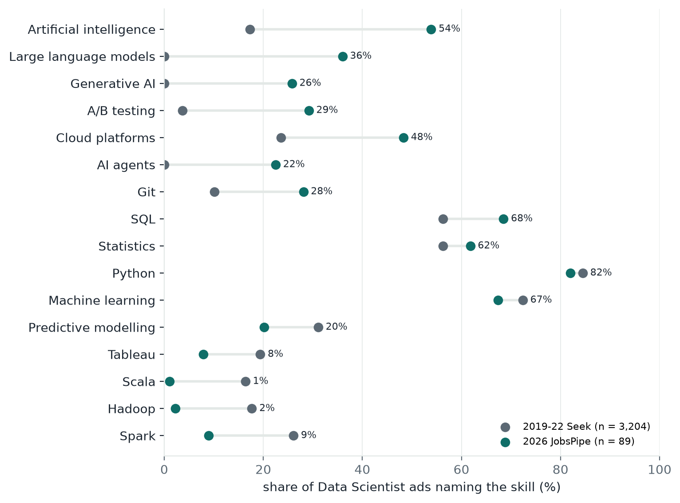
Figure 3.1. Share of Data Scientist ads naming each skill: 3,204 Seek ads of 2019–22 against 89 JobsPipe ads of 2026, same matcher and vocabulary. Labels give the 2026 share.
Figure 3.1 shows the shift that motivates Skillabus. The core holds: Python stays above 80%, and SQL and statistics grow (to 68% and 62%, from 56%). Around it, the LLM era has arrived: large language models went from no ad to 36% of Data Scientist ads (95% Wilson interval 27–46%; Wilson, 1927), generative AI to 26% and AI agents to 22%, while Spark fell from 26% to 9% and Hadoop and Scala from 18% and 16% to 2% and 1%. The shift is not limited to data scientists: 61% of Machine Learning Engineer ads name large language models, and 12% of Software Engineer ads do. With 89 Data Scientist ads, one ad moves a share by 1.1 points and the intervals are about ±10 points, so we report directions and large differences only.

3.6 Can the counts be trusted?
Two annotators labelled the same 20 ads independently and agree with a Cohen’s kappa (Cohen, 1960) of 0.856 on dictionary skills (0.686 including free-text labels), so the labels of the first test set agree well (on the 2026 ads agreement is lower, section 6.2). On the Seek ads, our matcher agrees with the dataset author’s own tool flags with a median kappa of 0.637 over 14 tools; most disagreements are the author’s flags firing on ads that never name the tool. Rankings hold across platforms and periods: rank correlation 0.75 with Glassdoor Australia and 0.82 with LinkedIn US, and 0.40–0.97 between live Adzuna counts and the 2023 tool lists of seven roles (Table A.3). Shares from different kinds of source are not comparable, though: Python is in 82% of 2026 Data Scientist ads but 59% of 2023 tool lists, so the app always shows a share with its source, period and number of ads. Limits of the data are in section 7.

4 Methods
Each stage pairs a traditional method with a newer one on the same inputs, so section 6 can show what the newer method adds and where it fails (Table 4.1).
Table 4.1 Traditional and newer method per stage.
Stage | Traditional | Newer | Why we keep the newer one | Its typical failure
Extraction | Vocabulary lookup | + spaCy rules, + GPT-4o-mini | Plurals, verbs and tools outside the vocabulary | Candidates that are not skills (“Social Club”)
Normalisation | ESCO exact label | + fuzzy string, + MiniLM embedding, “emerging” class | Paraphrases; skills ESCO lacks are kept | A broader concept (“data extraction” → information extraction)
Emerging skills | Added by hand | n-grams, spaCy, GPT, scored by weighted log-odds | New terms found without a person noticing first | Career-site boilerplate
Matching | Same skill | + umbrella rule for “partial” | Credits part of a broad skill | — (rule-based)
Subject evidence | Alias match | + TF-IDF, + sentence embeddings | Subjects that teach a skill without naming it | Generic sentences (“key concepts and algorithms”)
Learning path | Best subject per gap | Greedy cover with prerequisites and sessions | Fewest subjects, ones the student can take | Long prerequisite chains

4.1 Skill extraction
A rule-based splitter treats each bullet or line of an ad or resume as a unit, so a skill carries the same evidence sentence whichever tier found it.
Tier 1, vocabulary lookup. We match the ad aliases of the 283 detection rows of the skill vocabulary (section 3): the 148 skills of the original dictionary plus IT tools and certifications that Australian ads name. Bare ambiguous forms (“R”, “Go”) are not aliases, some aliases are case-sensitive (R, SAS, React), and the longest alias wins (“SQL Server” does not also give “SQL”). Lookup is fast, transparent and precise, so it stays the backbone.
Tier 2, spaCy. The pretrained NER model has no skill label (it tagged Python and Tableau as places), and training one would need labelled ads beyond our test set. Tier 2 instead uses the tagger and parser: it drops a one-word alias used as a verb (“spark new ideas”), folds plurals (“REST APIs”), and proposes phrases outside the vocabulary from noun chunks after a cue (“experience with”, “such as”).
Tier 3, GPT-4o-mini. A fixed prompt at temperature 0 returns skills as JSON. A returned skill must occur verbatim in the text and its evidence sentence is cut from the text, so the model cannot invent skills or quotes; contact details are masked first and responses are cached.
Every mention is also tagged required or preferred from a cue in its sentence (“must”, “desirable”) or the heading it sits under (“Essential criteria”, “Nice to have”). On dictionary skills the three tiers are close (section 6); the newer tiers matter for what lies outside the vocabulary, and that is also their weak point: of 211 distinct phrases outside the dictionary that spaCy proposed, 69 (33%) are not skills (employers, perks, job titles).

4.2 Normalisation
Each mention passes five steps, first hit wins: the vocabulary; an exact ESCO label (after dropping filler such as “skills”); the nearest ESCO label by MiniLM embedding (cosine ≥ 0.82); a Lightcast Open Skills lookup (built, not run: no API key); and an explicit emerging class. A vocabulary skill keeps its own id, and the ESCO id only when the link is exact: a broad link would merge distinct tools (Tableau and Power BI fall under one ESCO concept).
Table 4.2 Mapping 211 phrases outside the dictionary to ESCO, judged by hand.
 | Exact label | Fuzzy string (≥ 0.85) | Embedding (≥ 0.82)
Right / mapped | 12 / 12 | 12 / 24 | 10 / 14
Precision | 1.00 | 0.50 | 0.71
Exact matching is never wrong but maps only 12 of the 142 real skills. Fuzzy matching maps twice as many phrases, but half of them wrongly, because it matches letters, not meaning (gRPC → gel permeation chromatography, Canva → Canvas). The embedding errs more subtly, moving to a broader concept (“customer analytics” → marketing analytics); beyond the exact step it adds one right mapping. The threshold was not changed on these results, because 58 of the phrases come from test ads.
Skills outside ESCO. ESCO v1.2.1 has no concept for large language models or generative AI. Forcing a phrase ESCO lacks onto the nearest label would be wrong (DuckDB → breed ducks, cosine 0.56, below the 0.82 cut-off). Large language models and generative AI therefore skip the embedding step; they and phrases below the cut-off are kept as emerging skills, shown with a ✦ in the app. The vocabulary adds 145 skills Australian ads ask for and ESCO lacks, each with its nearest ESCO concept recorded as broad or none.

4.3 Emerging-skill detection
LLMs and generative AI are in the vocabulary only because we added them by hand. To find the next ones, skillabus.emerging proposes phrases three ways (1–3-word n-grams, spaCy candidates, GPT skills) and scores all three the same way: the weighted log-odds of the 2026 ads against the 3,204 Seek ads of 2019–22, with an informative Dirichlet prior (Monroe, Colaresi & Quinn, 2008). A candidate needs z ≥ 1.96, at least 3 ads from 2 employers (one employer’s boilerplate cannot qualify), and must be neither a vocabulary alias nor an ESCO label; only requirement sentences are counted, because the career-site prose of 2026 ads otherwise makes any word look new. spaCy keeps fewer, cleaner phrases than n-grams (agentic workflows, Claude); the output is a list for a person to accept, not an automatic update.

4.4 Matching and demand
A skill the ad asks for is have when the resume names the same vocabulary skill, missing when nothing supports it, and partial when the ad asks for the umbrella skill of a category (machine learning, cloud, statistics, …) and the resume shows a part of it (scikit-learn for machine learning). Programming languages are never partial, and soft skills are listed apart. We tested counting close substitutes (Tableau and Power BI) as partial by embedding similarity, but true substitutes scored lower than unrelated pairs (Tableau–Power BI 0.30, Airflow–MLflow 0.54), so the rule was dropped.
Each gap carries demand: the share of the target role’s 2026 job-board ads that name it (for an ad, the ads of its own role, read from its title, else Data Scientist), with the source and period on every row so the app can say where the number comes from. The pre-2022 Seek share (2019–22 for Data Scientist, 2020–21 for nine other roles, none for Machine Learning Engineer) is shown only as the trend, because those ads predate ChatGPT: Data Scientist ads of 2019–22 name LLMs in 0% of cases.

4.5 Subject evidence: keyword → TF-IDF → embeddings
Each UTS subject is a set of rows, one per learning objective, assessment, weekly topic or description sentence (6,853 rows, 360 subjects). A row is evidence for a skill when it names it (aliases), or when it is similar enough: TF-IDF (cosine ≥ 0.35) as the traditional baseline, all-MiniLM-L6-v2 sentence embeddings (Reimers & Gurevych, 2019; cosine ≥ 0.55) as the newer method. Embeddings find paraphrases TF-IDF scores near zero (“Classification and prediction” for machine learning), while TF-IDF’s extra matches share misleading words (“Machine Translation”). The 0.55 threshold was set by reading the closest non-naming rows for 22 data skills, and rechecked for 12 IT skills: all 6 rows at or above 0.55 were right, but all came from one skill (data security); tool names such as Kubernetes never reach it, because the Handbook names concepts, not tools. We kept 0.55, since the IT rows rest on one skill and 0.50 was too loose for data skills. The deployed app runs TF-IDF (no PyTorch on the free host).
A row’s score is its similarity (1.0 when it names the skill) times its layer weight: a skill that is taught and assessed (learning objective, assessment) outweighs one covered in class (weekly topic) or only mentioned (description). A subject’s strength is its best row plus a bonus for further rows and for a title that names the skill, and it covers a skill only at 60% of the strongest subject’s strength, so one passing mention does not count. Reading weekly topics, not only objectives, is what shows that 36118 and 43023 teach large language models.

4.6 Learning path
Choosing at most three subjects that close the most demand is a maximum coverage problem; the greedy algorithm takes the subject that closes the most uncovered demand, then the next (Nemhauser, Wolsey & Fisher, 1978). A subject counts only if the student can enrol in it, read from the scraped access conditions: admission rules must name the student’s course, prerequisites must be taken or planned earlier in the path, and an antirequisite closes a subject in either direction. A subject needing one or two open prerequisites enters with them, valued per place used; one that cannot be taken is listed with the reason. The path is laid out over Autumn and Spring sessions; valuing a step per place gives up the (1 − 1/e) guarantee of plain greedy, a small price for a path the student can take. The sample-ad path is in section 1.
Gaps the UTS path leaves open get a second greedy pass over 250 self-study resources (free, free-to-audit or paid, with the price shown), never mixed with UTS subjects. A course counts for a gap only when its hand-checked skill list names the gap: matching the text alone picked courses that mention a skill in passing (“Sign up for an AWS account” in a Redshift course).
When the goal is a role, it is matched like an ad: its 15 most-asked technical skills in its 2026 ads, with the role’s own shares as demand. Two rankings reuse these weights: the 44 courses, by the share of a role’s demand that the best subjects one can take in each course name in objectives, topics or assessments (4 subjects in a Graduate Certificate up to 24 in a Bachelor); and, for a student not sure of a role, the 11 roles, by the share of each role’s demand the resume and subjects already cover (partial at half).

4.7 Chat
The chat is retrieval-augmented generation (Lewis et al., 2020): MiniLM embeddings in a FAISS index (TF-IDF where PyTorch is absent) retrieve subject passages, a subject code in the question restricts the search, weak passages are dropped, and GPT-4o-mini answers from the rest with citations.

5 System

5.1 Architecture
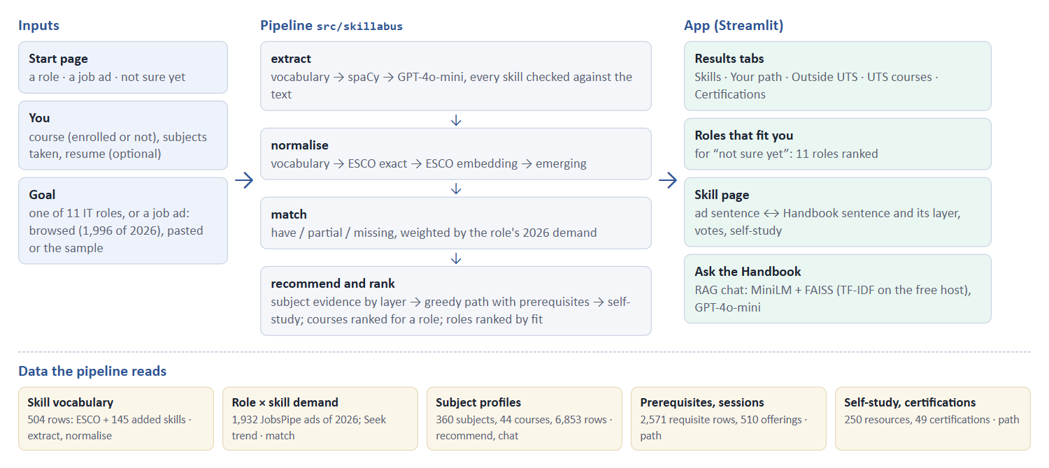
Figure 5.1 The pipeline and the data each stage reads.
The app calls the pipeline through one module (app/backend.py). If a stage fails, it falls back to a dictionary-and-keyword baseline that returns the same JSON (docs/data_contract.md), and the page says which engine produced the result. Without an OpenAI key everything except the GPT-4o-mini tier and the chat’s written answers still runs. The free Streamlit host has no PyTorch, so the deployed app uses the TF-IDF paths for subject evidence and chat retrieval.

5.2 What a user sees
A bar at the top shows the two steps (inputs, results) as links and an “Ask the Handbook” button that opens the chat.
- Start. One line on what the app does, the size of its data and three doors that preset the goal: “I know the role I want”, “I have a job ad” and “I’m not sure yet”.
- Inputs. Enrolled at UTS or not yet; the course (it decides which subjects are open) and the subjects already taken; an optional resume; and the goal: a role (11 IT roles, grouped by field), an ad (browse 1,996 ads of 2026, paste one, or try the sample) or “not sure yet”, which first ranks the 11 roles by fit.
- Results (Figure 5.2), one tab at a time:
  - Skills: how many of the asked-for skills are missing, a bar per skill with its share of the role’s 2026 ads (the pre-2022 Seek share on hover), and emerging skills marked ✦;
  - Your path: the 2–3 UTS subjects that close the most demand, with prerequisites and sessions;
  - Outside UTS: self-study courses for gaps the UTS path leaves open, marked as not for credit, with provider and cost;
  - Certifications (when the goal is a role), from foundational to expert, and UTS courses: the 44 courses ranked for the role, the student’s own marked.
- Skill page (Figure 5.3). For each gap: its share of the role’s 2026 ads next to its pre-2022 Seek share, the ad’s sentence (when the goal is an ad), and why it is missing; below, a row of UTS subject cards, each with the Handbook sentence that justifies it and the layer it came from (learning objective, assessment, weekly topic, description), then up to three self-study cards, beginner first. Students can vote on whether a subject really teaches the skill, and an “I’ve taken this” tick adds the subject to the Inputs list, counts its skills as had and recomputes the gaps and the path.
- Chat. Questions about subjects, answered from Handbook passages with citations.
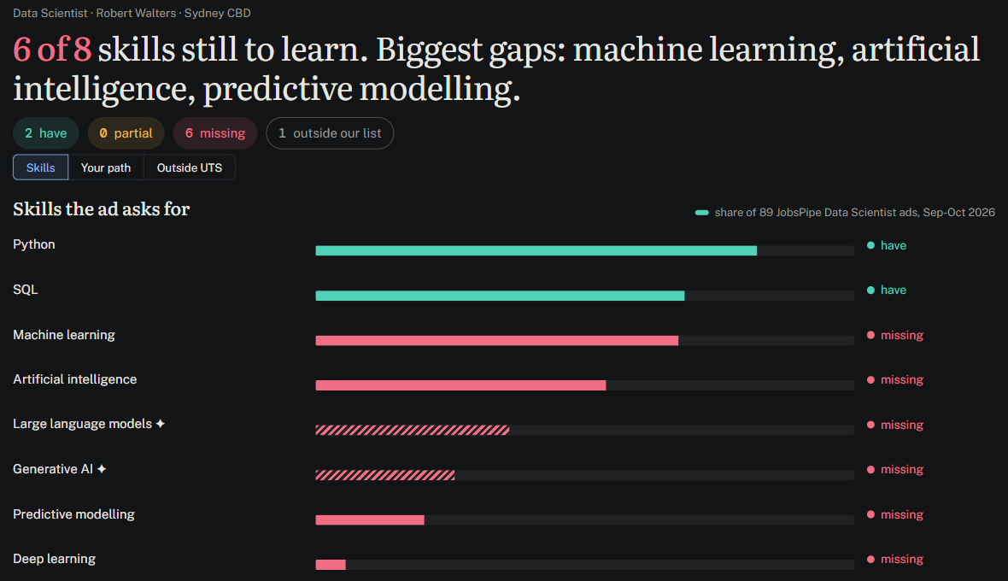
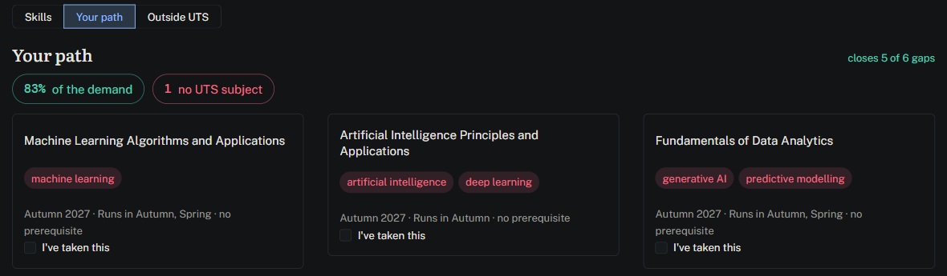
Figure 5.2 Results for the sample Data Scientist ad and resume: the Skills tab (top; bars are the share of the 89 Data Scientist ads of 2026, hatched bars mark emerging skills) and the Your path tab (bottom; three subjects close 5 of 6 gaps, 83% of the demand-weighted gap, with sessions and prerequisites).
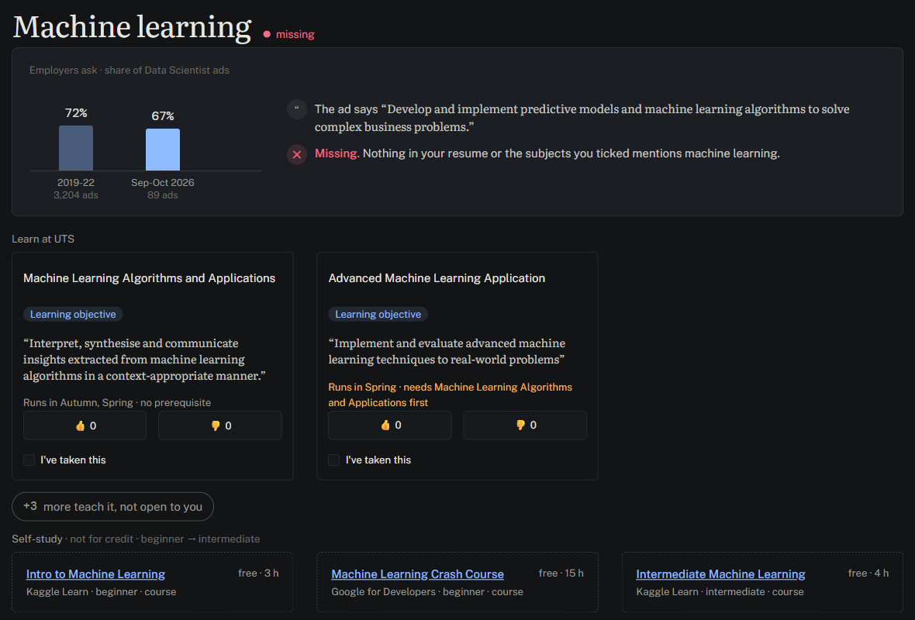
Figure 5.3 The skill page for machine learning: 72% of the 3,204 Seek ads of 2019–22 and 67% of the 89 Data Scientist ads of September–October 2026 ask for it; the ad’s sentence and why it counts as missing; the two UTS subjects open to an MDSI student, each with the learning objective that justifies it (three more teach it but are not open); and self-study from beginner to intermediate.

5.3 How to run it
python -m venv .venv && source .venv/bin/activate
pip install -r requirements.txt
cp .env.example .env # optional: OPENAI_API_KEY for the GPT tier and the chat
streamlit run app/Home.py
The evaluation reruns with python -m skillabus.evaluate --all; GPT answers are read from a committed cache, so only the chat judge needs a key. The deployed app and its QR code are in the appendix.

6 Evaluation and error analysis
We ran every stage of the pipeline on hand-labelled test sets, using python -m skillabus.evaluate --all. Full tables are in Appendix B. The GPT-4o-mini extraction answers are read from a committed cache, so the run is repeatable; only the chat judge needs an API key.

6.1 What was run
Stage | Test set | Result in one line
Extraction | 20 Seek ads, 217 skill labels | Dictionary F1 0.767; spaCy 0.690; GPT-4o-mini 0.585 (0.777 / 0.796 / 0.792 on dictionary skills)
Extraction, 2026 | 18 ATS ads of 10 roles, 273 labels | F1 on vocabulary skills: dictionary 0.742, spaCy 0.744, GPT-4o-mini 0.702
Matching | 45 CV–JD pairs, 287 skill rows | Accuracy 0.909 end to end, 0.927 with gold ad skills
Evidence ranking | 87 have/partial rows | Hit@5 0.943, MRR 0.829
Subject recommendation | 33 pairs, 13 data skills; 30 pairs, 11 IT skills | Data: P@3 0.95 to 1.00 (not a method comparison); IT: 0.87 (y or partly), 0.43 (y only)
Chat | 15 questions | Hit@5 0.933; judge relevance 4.13, faithfulness 4.33 (of 5)
Annotator agreement | 20 ads, two annotators; 6 ads of 2026 | Kappa 0.856 (dictionary skills), 0.686 (all labels); 2026: 0.361, 0.319
The test sets are much smaller than planned (200 ads and 50 pairs), so every figure is a small-sample estimate. Extraction is scored after normalise(), as the app runs it.

6.2 Extraction
Tier | Scored on | Precision | Recall | F1
Dictionary | all skills | 0.841 | 0.705 | 0.767
Dictionary | dictionary skills only | 0.864 | 0.705 | 0.777
spaCy | all skills | 0.648 | 0.737 | 0.690
spaCy | dictionary skills only | 0.865 | 0.737 | 0.796
GPT-4o-mini | all skills | 0.502 | 0.700 | 0.585
GPT-4o-mini | dictionary skills only | 0.910 | 0.700 | 0.792
The labels contain only skills from the 148-row seed dictionary, while tiers 1 and 2 read the 283 detection rows of the skill vocabulary (section 4.1). Any skill outside the labels counts as wrong, even when the ad does ask for it. That is why spaCy (87 false positives) and GPT-4o-mini (151, of which 136 are outside the dictionary) look weak on all skills. Those off-dictionary skills are what the tiers are for. On dictionary skills the three tiers are close: F1 0.777, 0.796 and 0.792, with GPT-4o-mini the most precise (0.910). The differences are within what 20 ads can resolve.
Where the dictionary fails. Of 64 misses, 25 are soft skills, 13 programming and 12 machine learning. Eleven of the 13 programming misses are the bare letter “R”, which the dictionary refuses to match by design (section 4.1). Of the 29 false positives, 12 are real errors, such as a degree list (“Statistics, Data Science, Mathematics”) read as skills or “Dash” read as Plotly. The other 17 are judgement calls or label gaps, such as tools that entered the dictionary after labelling. Precision is 0.934 if these count as correct. GPT-4o-mini recovers the bare “R” (programming misses fall from 13 to 2) but misses more soft skills (30); spaCy recovers four soft skills and no “R”.
2026 ads of ten roles. Van Thong labelled 18 ATS ads of 2026 on the skill vocabulary (two per role for eight roles, one each for Cloud Engineer and Data Engineer; no QA ad in the source): 273 labels, 178 of them vocabulary skills. On vocabulary skills the three tiers are again close (F1 0.742, 0.744 and 0.702; Appendix B.2), with GPT-4o-mini the most precise (0.843). Phuong Nhi labelled six of the ads: kappa is only 0.361, mostly because she labelled fewer skills (9 shared, 29 only Van Thong’s, 2 only hers), so the 2026 gold set rests on one annotator’s broader reading.

6.3 Matching
We ran match() end to end (ad skills from the extractor) and with the gold ad skills, which removes extraction misses.
Setting | Accuracy | Macro F1 | have P / R | missing P / R
End to end | 0.909 | 0.739 | 0.98 / 0.79 | 0.91 / 0.97
Gold ad skills | 0.927 | 0.768 | 0.97 / 0.84 | 0.95 / 0.97
The spaCy rows are identical, because the extra skills it finds do not change any status. With GPT-4o-mini accuracy rises to 0.944 end to end and 0.958 with gold skills, mainly through higher have recall (0.89).
Of 287 rows, 21 are wrong with gold ad skills. Eleven are have → missing, eight of them the bare “R” in the resume. Six are false partials: four come from an economics resume whose line about forecasting money supply the umbrella rule counts as machine learning. A stricter rule, requiring a method or library rather than a topic, would remove four of the six (Appendix B.3). There are only six partial rows in the test set, so one row moves partial recall by 17 points. We therefore put the weight on accuracy and on the have and missing classes.

6.4 Evidence ranking
For each have or partial row, rank_evidence() ranks the resume’s sentences; a sentence is correct when it contains the labelled phrase.
Ranker (n = 87) | Hit@5 | MRR
rank_evidence() | 0.943 | 0.829
TF-IDF only | 0.943 | 0.826
Embeddings only | 0.885 | 0.753
The right sentence is in the top five for 94% of rows and is usually first. TF-IDF alone is almost as good, because the sentence that names the skill shares its words; the gap is within noise at n = 87. Embeddings alone are worse, since they pull up sentences about related skills. P@5 is near its ceiling of 0.2 (one gold phrase per row) and says little.

6.5 Subject recommendation and chat
Subject P@3 is 0.950 for keyword and TF-IDF and 1.000 for embeddings against the 33 labelled pairs (Appendix B.5). This is not a comparison of the three methods. For a skill in the dictionary, subject_evidence() gives similarity 1.0 to every subject that names the skill, so those subjects always come first; all three methods share the same top three for 12 of 13 skills. Also, only about half of the recommended subjects carry a label (coverage 0.51 to 0.54), and 25 of the 33 labelled pairs are “y”, so P@3 is optimistic.
IT skills. Phuong Nhi checked the top three subjects for the 15 most demanded IT skills of the seven non-data roles against the Handbook (inputs/it_skill_subjects_to_check.csv). All 30 recommended pairs are labelled, unlike the data set above: P@3 is 0.87 counting “partly” and 0.43 counting only “y”, and the first subject is right (y or partly) for 10 of the 11 skills that have one, and “y” for 6. IT skills are more often touched (one weekly topic, a platform named as an example) than taught. The wrong matches are word-sense errors: incident response matched a clinical incident-management subject, and test automation matched two iOS subjects whose code is graded by automated tests and one on industrial automation. Terraform, CI/CD, Kubernetes and SIEM have no UTS subject; the outside courses cover them.
Learning paths. Van Thong read the 11 role paths of an MDSI student (labels/role_paths_review.csv): 26 of 32 path subjects were sensible, but 16 rows were subjects UTS lists only in Bachelor courses, among them 31250 and 43007 on the sample ad’s path. The Handbook gives them no access rule, so the recommender had treated them as open; enrolment() now closes Bachelor-only subjects to a postgraduate student, and the sample path is 36106, 36121, 32130 (82.8% of the demand-weighted gap).
Chat retrieval. At least one subject named in the reference answer is in the top five for 93.3% of the 15 questions with TF-IDF and 80.0% with embeddings; recall of all cited subjects is 77.8% and 56.7%. The difference is two questions. LLM judge. GPT-4o-mini answered each question from the five TF-IDF passages, and GPT-4o-mini then scored the answer against the reference from 1 to 5. Mean relevance is 4.13 and mean faithfulness 4.33; 14 of 15 answers (93%) score 4 or 5 on faithfulness. The weakest, Q05, gave a wrong subject code and left out techniques the reference lists. The same model writes and judges, which tends to flatter it, and the answers are written afresh each run: three runs gave relevance 4.13 to 4.40 and faithfulness 4.33 to 4.47. A difference below about 0.3 is therefore not a result.

6.6 Limits
- 20 ads (and 18 of 2026), 45 pairs, 33 skill–subject pairs and 15 chat questions give wide confidence intervals; differences between tiers are mostly smaller than the noise.
- Gold labels come from one annotator. A second annotator, on 20 overlap ads, agrees well on dictionary skills (kappa 0.856) and less on free-text skills outside the dictionary (0.686); on 6 ads of 2026 kappa is only 0.361. Extraction scores use the first annotator’s rows only.
- One ad row and one pair row carry an “unsure” mark that the loaders drop, so unsure labels count as gold, which slightly lowers recall.
- Retrieval can fill the top five with one subject under several codes (Machine Learning appears as 31005, 320513 and 321513 for one question), which lowers recall for other subjects. The fix belongs in rag.py.
- The 20 Seek ads are Data Scientist ads of 2019–22, and the 18 ATS ads of 2026 cover ten roles with one or two ads each and are not the JobsPipe ads that drive the role profiles, so the numbers show how well the methods work, not how well the app serves a particular role.

7 Ethics and limitations

7.1 Ethics
Data collection. Seek, LinkedIn, Indeed and Glassdoor forbid scraping, so older ads come from published Kaggle datasets and 2026 ads from APIs. JobsPipe aggregates LinkedIn and Indeed postings under its own licence, which forbids redistributing their text and allows one free account per person: we store only the skills found in each ad and its link, and used three members’ own accounts. How JobsPipe collects postings from platforms that forbid scraping is outside our control. The UTS Handbook’s robots.txt disallows crawling; we read its public pages one request at a time, at least 1.2 seconds apart. Students reported their subjects’ skills by name only; no Canvas material is stored.
Privacy. A pasted resume stays in memory and is never written to disk. Before the GPT-4o-mini tier, emails, URLs and phone numbers are masked, but names are not, a gap the upload screen should state. The response cache keeps only skill lists, and a feedback vote never links to a resume. The test resumes are de-identified, not anonymous.
Bias and over-reliance. “Demand” means demand visible in online ads: 408 of the 1,932 JobsPipe ads are from recruitment agencies, and the job boards we read belong mostly to technology companies. ESCO is European and maps Australian phrasing unevenly. The app checks prerequisites and teaching sessions but not credit-point rules, and its results screen does not yet tell students to confirm choices with their course coordinator.

7.2 Limitations
- Small test sets: 20 labelled ads, 45 CV–JD pairs, 33 skill–subject pairs and 15 chat questions, one annotator (kappa 0.856 on 20 shared ads, but only 0.361 on 6 ads of 2026; section 6.6).
- Small samples: 89–216 ads per role in 2026 (up to ±10 points); a pre-2022 trend exists for 10 roles (Seek 2019–22 for Data Scientist, Seek 2020–21 with 43–944 ads for nine others) but not for Machine Learning Engineer, and shares from different sources are not comparable.
- The “AI” trade-off: counting Artificial intelligence only in phrases such as “AI models” drops recruiter tools and company names but misses ads that write only “AI”: on Adzuna, 19 of 162 live Data Scientist ads (12%, 17 Oct) say “artificial intelligence”, but 112 of 171 (66%, 16 Oct) say “AI”.
- Uneven subject text: nine MDSI subjects have no topic list, two students reported, and “named” is not “taught in depth”.
- Course level: reading the role paths (section 6) found Bachelor-only subjects in an MDSI student’s paths; they are now closed to postgraduates, so IT roles get fewer UTS subjects.
- No user test: the planned test with five classmates did not happen, so ease of use is judged by the team only (section 8).
- Demand is not outcome: ads show what employers ask for, not who is hired.

8 Conclusion, recommendations and next steps

8.1 What works
Skillabus puts ads, resumes and UTS subject outlines on one skills vocabulary and turns a resume-to-ad gap into a short list of subjects, each with a quoted sentence as evidence. On our small test sets the stages hold up (section 6). Dictionary extraction reaches F1 0.767, and on dictionary skills the three tiers are close (0.777, 0.796, 0.792). Matching is right for 90.9% of 287 skill rows. The ranker puts the supporting sentence in the top five for 94% of rows, and the chat finds a cited subject in its top five for 93% of questions.

8.2 What does not work yet
- Soft skills and the bare letter “R” are the main extraction misses, and partial matches are unreliable.
- Subject P@3 does not compare methods, and the chat judge is the same model that writes the answers.
- The test sets are small (20 ads, 45 pairs, 33 skill–subject pairs, 15 questions).
- We did not test the app with students (issue #32), so we do not know whether it changes what they enrol in.

8.3 Recommendations
Use the app as a shortlist with evidence: read the quoted sentence before trusting a subject, and treat partial matches as hints. Have a person confirm new terms from GPT-4o-mini before they enter the vocabulary.

8.4 Next steps
- Tighten the umbrella rule to require a method or library, which removes four of six false partials.
- Rank subjects by similarity alone to compare the three methods.
- Label more ads and resumes with a second annotator.
- Run the user test with students.

9 Phases, contributions and challenges

9.1 Phases
The first pull request merged on 12 October; the deadline is 17 October. The week had five phases.
Dates | Phase | Result
11–12 Oct | Contract and baseline | Data contract and mock gap data; first app on the baseline; extraction tiers 1–2, matching and evidence ranking; evaluation harness; first report drafts
14 Oct | Data and labels | Handbook data (360 subjects, 44 courses); four-layer subject profiles; 2026 ad sample; labels for 20 ads and a second annotator; CV–JD pairs, skill–subject pairs and chat questions; related work
15 Oct | One vocabulary | Data folders reorganised; ESCO base plus 145 skills; occupation skills and certifications for 11 roles; self-study store; one demand table; prerequisites in recommendations
16 Oct | Scale to 11 roles | JobsPipe 2026 ads (1,932); extractors read the vocabulary; outside courses; app for all 11 roles; evaluation run
17 Oct | Report | Evaluation re-run with 2026 labels; app finished (start page, course and role rankings); sections cut and checked, report assembled

9.2 Contributions by member
Counts are merged pull requests on main at 21:50 on 17 October (106 in total).
- Quan (55): Streamlit app and its redesign; data layout and paths.py; Handbook data; one skills vocabulary; self-study store; demand table; JobsPipe 2026 ads; evaluation re-runs; label kits; report integration.
- Phuong Nhi (19): dictionary and spaCy extraction; matching; evidence ranking; recommendation with prerequisites and outside courses; emerging-skill detection; normalisation error table; methods section.
- Van Thong (22): data cleaning; subject profiles; 2026 ad samples and skill counts; FAISS retrieval; second-annotator labels; role profiles; external courses; Adzuna counts; data section.
- Hoai Thuong (8): evaluation harness and Cohen’s kappa; CV–JD pairs; ad labels; skill–subject pairs and chat questions; evaluation run and section 6.
- Akash (2): ethics and limitations draft; related-work section with its comparison table.

9.3 Challenges and solutions
- Data for eleven roles. The first sources covered mainly Data Scientist. We added the JobsPipe 2026 feed, Seek 2020–21 and Adzuna counts, then cleaned and sampled to 89–216 ads per role.
- One bare word, two meanings. A bare “AI” counted as the skill and “R” matched everywhere. We matched only the phrases ads use (#148, #149) and kept “R” out unless written as “R programming”.
- One vocabulary for everything. Dictionary, extraction, demand and subjects each had their own skill list. We merged them into one file and switched every stage to it (#104, #109), then re-ran the evaluation.
- Coordination in one week. Five people worked in one repository. One task per issue, branch and pull request, a review on each, and a freeze before the final run kept merges manageable.

References
arshkon. (2024). LinkedIn job postings (2023–2024) [Data set]. Kaggle. https://www.kaggle.com/datasets/arshkon/linkedin-job-postings
asaniczka. (2024). Data science job postings & skills (2024) [Data set]. Kaggle. https://www.kaggle.com/datasets/asaniczka/data-science-job-postings-and-skills
Barousse, L. (2025). data_jobs [Data set]. Hugging Face. https://huggingface.co/datasets/lukebarousse/data_jobs
Cohen, J. (1960). A coefficient of agreement for nominal scales. Educational and Psychological Measurement, 20(1), 37–46. https://doi.org/10.1177/001316446002000104
European Commission. (2017). ESCO: European Skills, Competences, Qualifications and Occupations. https://esco.ec.europa.eu
European Commission. (2025). ESCO: European skills, competences, qualifications and occupations (Version 1.2.1) [Data set]. https://esco.ec.europa.eu/en/use-esco/download
Frej, J., Dai, A., Montariol, S., Bosselut, A., & Käser, T. (2024). Course recommender systems need to consider the job market. In Proceedings of the 47th International ACM SIGIR Conference on Research and Development in Information Retrieval. https://arxiv.org/abs/2404.10876
Jobs and Skills Australia. (2025). 2025 Occupation Shortage List [Data set]. Commonwealth of Australia. https://www.jobsandskills.gov.au/data/occupation-shortage
Jobscan. (2023). Resume skills: Top resume skills by job title. https://jobscan.co/skills
JobsPipe. (2026). JobsPipe job search API [API]. https://jobspipe.dev
Karakolis, E., Kapsalis, P., Skalidakis, S., Kontzinos, C., Kokkinakos, P., Markaki, O., & Askounis, D. (2022). Bridging the gap between technological education and job market requirements through data analytics and decision support services. Applied Sciences, 12(14), Article 7139. https://doi.org/10.3390/app12147139
Lewis, P., Perez, E., Piktus, A., et al. (2020). Retrieval-augmented generation for knowledge-intensive NLP tasks. NeurIPS 2020.
Lightcast. (2025, June 3). Lightcast addresses higher education’s relevance crisis with real-time skills alignment technology [Press release]. https://lightcast.io/resources/blog/skillabi-press-release-june-3-2025
LinkedIn. (n.d.). LinkedIn Learning Hub: Skill building. Retrieved October 14, 2026, from https://learning.linkedin.com/skill-building
Monroe, B. L., Colaresi, M. P., & Quinn, K. M. (2008). Fightin’ words: Lexical feature selection and evaluation for identifying the content of political conflict. Political Analysis, 16(4), 372–403.
Musazade, N., Mezei, J., & Zhang, M. (2026). UniSkill: A dataset for matching university curricula to professional competencies. In Proceedings of the Fifteenth Language Resources and Evaluation Conference (pp. 456–469). https://aclanthology.org/2026.lrec-1.31/
nadzmiagthomas. (2022). Australia data science jobs [Data set]. Kaggle. https://www.kaggle.com/datasets/nadzmiagthomas/australia-data-science-jobs
National Center for O*NET Development. (2026). O*NET 31.0 database [Data set]. https://www.onetcenter.org/database.html
National Skills Commission. (2021). Australian Skills Classification (Version 1.0) [Data set]. Commonwealth of Australia.
Nemhauser, G. L., Wolsey, L. A., & Fisher, M. L. (1978). An analysis of approximations for maximizing submodular set functions—I. Mathematical Programming, 14, 265–294.
nomilk. (2022). Data science job listings – Australia – 2019–2021 [Data set]. Kaggle. https://www.kaggle.com/datasets/nomilk/data-science-job-listings-australia-20192020
PromptCloud. (2021a). Seek Australia job listing (Oct–Dec 2020) [Data set]. Kaggle. https://www.kaggle.com/datasets/promptcloud/seek-australia-job-listing
PromptCloud. (2021b). Seek job listing Australia (Jan–Mar 2021) [Data set]. Kaggle. https://www.kaggle.com/datasets/promptcloud/seek-job-listing-australia
Reimers, N., & Gurevych, I. (2019). Sentence-BERT: Sentence embeddings using Siamese BERT-networks. EMNLP-IJCNLP 2019.
Schlippe, T., & Bothmer, K. (2023). Skill Scanner: An AI-based recommendation system for employers, job seekers and educational institutions. International Journal of Advanced Corporate Learning, 16(1), 55–64. https://doi.org/10.3991/ijac.v16i1.34779
snehaanbhawal. (2021). Resume dataset [Data set]. Kaggle. https://www.kaggle.com/datasets/snehaanbhawal/resume-dataset
University of Technology Sydney. (2026). UTS handbook 2026. https://coursehandbook.uts.edu.au
Wilson, E. B. (1927). Probable inference, the law of succession, and statistical inference. Journal of the American Statistical Association, 22(158), 209–212. https://doi.org/10.1080/01621459.1927.10502953
Zhang, M., Jensen, K. N., Sonniks, S. D., & Plank, B. (2022). SkillSpan: Hard and soft skill extraction from English job postings. In Proceedings of the 2022 Conference of the North American Chapter of the Association for Computational Linguistics: Human Language Technologies (pp. 4962–4984). https://doi.org/10.18653/v1/2022.naacl-main.366
Zhang, M., Jensen, K. N., van der Goot, R., & Plank, B. (2022). Skill extraction from job postings using weak supervision. In Proceedings of the 2nd Workshop on Recommender Systems for Human Resources (RecSys-in-HR 2022) (CEUR Workshop Proceedings, Vol. 3218). https://ceur-ws.org/Vol-3218/RecSysHR2022-paper_10.pdf

Appendix
Repository: https://github.com/AndyPham2004/ANLP-AT2-Skillabus · App: https://skillabus.streamlit.app


Appendix A. Data
Table A.1. Every data source, what Skillabus uses it for, and its licence.
Source | What we use | Period | Role in Skillabus | Licence or terms
JobsPipe API (aggregates LinkedIn, Indeed and other job boards; our ads come from 9 of them) | 1,932 Australian ads, 89–216 per role, 11 roles; skills found and link only | 1 Sep – 16 Oct 2026 | main demand for every role | API terms: ad text not redistributed, link kept; one free account per person (three members’ own accounts)
Adzuna API | live search counts: 11 role totals, 162 skill × role counts | 16 Oct 2026 | second 2026 view; rank check | API terms (counts only)
Public job boards of 51 employers (65 boards read; Greenhouse, Lever, SmartRecruiters, Ashby, Workable) | 392 ads posted within 60 days, 85 in the 11 roles | Oct 2026 | third 2026 view | employers’ public ads
Seek Australia, Data Scientist (nomilk, 2022) | 3,204 listings, full text | Feb 2019 – Jan 2022 | Data Scientist trend | CC0
Seek Australia samples (PromptCloud, 2021a, 2021b) | 2,362 IT ads out of 65,840, 10 roles (4 more Machine Learning Engineer ads, too few to use) | 2020–21 | pre-2022 baseline per role | CC0
data_jobs (Barousse, 2025) | 10,925 Australian postings in 7 roles, tool lists | 2023 | cross-check | Apache-2.0
LinkedIn data-science postings (asaniczka, 2024) | 122 Australian data roles | Jan 2024 | trend midpoint | ODC-By
LinkedIn job postings (arshkon, 2024) | 247 US Data Scientist ads | 2023–24 | validation | CC BY-SA 4.0
Glassdoor Australia (nadzmiagthomas, 2022) | 193 data roles | Aug – Dec 2022 | validation | CC BY-NC 4.0
ESCO v1.2.1 | 13,960 skills, 100,135 distinct labels; essential and optional skills of each role’s occupation | 2025 | base of the vocabulary; core skills | free reuse with attribution
O*NET 31.0 | 8,753 software products (Technology Skills); the “In Demand” ones per occupation | 2026 | in-demand tools per role | CC BY 4.0
Australian Skills Classification v1.0 | core competencies and tool categories per ANZSCO occupation | 2021 | Australian taxonomy | CC BY 4.0
Jobs and Skills Australia | 2025 Occupation Shortage List; Internet Vacancy Index | 2025–26 | shortage label per role | CC BY 4.0
UTS Handbook 2026 | 360 subjects in 44 courses, 19 of them MDSI | 2026 | subject profiles, prerequisites, sessions | public pages; text kept for matching
Students’ Canvas reports | 305 skill rows for 9 MDSI subjects, 2 students | 2025–26 | what subjects taught | our own data
Official course, tutorial and certification pages | 56 outside courses, 250 self-study resources, 49 certifications (19 vendors) | Oct 2026 | outside courses, self-study, certifications | links and our own summaries
Resume Dataset (snehaanbhawal, 2021) | 2,481 resumes, 24 categories | 2021 | test inputs, CV–JD pairs | CC0
Table A.2. Ads per role and source in data/2_demand/role_skill_demand.csv (4,494 rows; notebook section 10; for data_jobs, the ads that name at least one tool). The app reads the first source that has the role, in the order JobsPipe 2026, Adzuna 2026, job boards 2026, data_jobs 2023, Seek 2019–22 (match.DEMAND_PRIORITY); today that is JobsPipe for all 11 roles. The 2026 job-board ads form three blocks of 26–33 ads: Software Engineer 33, data roles (mixed) 26 and IT roles (mixed) 26.
Family | Role | JobsPipe 2026 | Adzuna 2026 | Seek 2020–21 | data_jobs 2023 | Seek 2019–22
Data & AI | Data Scientist | 89 | 171 | 30 | 1,047 | 3,204
Data & AI | Data Analyst | 205 | 290 | 145 | 1,362 | –
Data & AI | Data Engineer | 188 | 811 | 59 | 4,438 | –
Data & AI | Machine Learning Engineer | 204 | 62 | – | 263 | –
Software | Software Engineer | 195 | 1,171 | 944 | 1,198 | –
Software | QA/Test Engineer | 212 | 105 | 174 | – | –
Cloud & infrastructure | Cloud Engineer | 101 | 395 | 43 | 350 | –
Cloud & infrastructure | DevOps/SRE | 187 | 330 | 130 | – | –
Cloud & infrastructure | Network/Systems Administrator | 203 | 210 | 269 | – | –
Security | Cybersecurity Analyst | 132 | 139 | 179 | – | –
Business analysis | Business Analyst | 216 | 876 | 389 | 576 | –
Table A.3. Do skill rankings agree across sources? Spearman rank correlation over the skills both name (data/5_crosscheck/; notebook section 5).
Compared | What differs | Skills | Rank correlation
Seek 2019–22 vs Glassdoor Australia 2022 (193 ads) | platform | 95 | 0.75
Seek 2019–22 vs LinkedIn US 2023–24 (247 Data Scientist ads) | country and years | 100 | 0.82
Seek 2019–22 vs LinkedIn Australia Jan 2024 (122 data roles) | years and role mix | 84 | 0.61
Adzuna 2026 vs data_jobs 2023, per role (7 roles) | years and kind of source | 6–15 | 0.40 (Business Analyst) to 0.97 (Data Scientist); 0.50 Machine Learning Engineer; 0.69–0.77 the other four
Adzuna 2026 vs Seek 2019–22, Data Scientist | years and kind of source | 15 | 0.57
Only each role’s 15 priority skills were searched on Adzuna, and they were picked from the older sources, so the Adzuna rows test the order within that top group (role_rank_agreement.csv).
Table A.4. Subject profiles (data/1_knowledge/uts/subject_profiles.csv, 6,853 rows, 360 subjects in 44 courses).
Layer | Rows | Subjects | Source
Learning objective | 1,516 | 354 | one row per objective
Assessment | 1,015 | 326 | one row per task: name, type, weight, group or individual, description
Weekly topic | 2,769 | 327 | one row per listed topic
Description | 1,553 | 360 | one row per sentence
Alongside them, prerequisites.csv holds 2,200 requisite items for 290 subjects, 70 empty rules and 301 anti-requisite rows for 172 subjects, and offerings.csv the teaching sessions of 330 subjects. Tables A.5 and A.6 give the layers per course and per MDSI subject.
The Handbook 2026 pages were scraped on 13 Oct 2026 (data/1_knowledge/uts/subject_profiles.md). A dash means the Handbook has no text for that layer.
Table A.5. Courses. A subject in several courses is counted in each, so columns do not add up to the total.
Course | Level | Name | Subjects | Obj. | Assess. | Topics | Desc.
C04256 | Master | AI (Online) | 11 | 50 | 12 | 89 | 43
C04265 | Master | Science (Extension) | 18 | 74 | 45 | 145 | 69
C04277 | Master | Engineering (Extension) | 11 | 42 | 33 | 84 | 43
C04295 | Master | Information Technology | 10 | 44 | 33 | 79 | 39
C04296 | Master | Information Technology | 5 | 22 | 13 | 28 | 17
C04370 | Master | Executive MDSI | 3 | 15 | 9 | 17 | 15
C04372 | Master | MDSI | 19 | 76 | 46 | 75 | 91
C04373 | Master | Quantitative Finance | 9 | 36 | 25 | 71 | 36
C04379 | Master | Business Analytics | 31 | 137 | 99 | 200 | 150
C04380 | Master | Business Analytics | 11 | 44 | 35 | 80 | 45
C04430 | Master | Cybersecurity | 15 | 58 | 52 | 151 | 64
C04431 | Master | Cybersecurity | 15 | 58 | 52 | 151 | 64
C04434 | Master | Technology Management | 18 | 72 | 53 | 150 | 57
C04435 | Master | Technology Management | 12 | 49 | 35 | 112 | 40
C04443 | Master | Artificial Intelligence | 20 | 82 | 56 | 148 | 78
C04450 | Master | Technology Innovation | 11 | 44 | 26 | 83 | 38
C04467 | Master | Business Analytics | 11 | 45 | 29 | 72 | 45
C06113 | Grad. diploma | IT | 62 | 266 | 188 | 499 | 241
C06124 | Grad. diploma | Data Science and Innovation | 16 | 76 | 46 | 75 | 72
C06147 | Grad. diploma | AI | 17 | 68 | 49 | 131 | 67
C09019 | Honours | IT | 3 | 13 | 8 | 26 | 14
C09066 | Honours | Engineering | 27 | 115 | 71 | 160 | 131
C09119 | Honours | Computing Science | 19 | 84 | 69 | 194 | 85
C09129 | Honours | Mathematical Sciences | 10 | 39 | 24 | 51 | 33
C10143 | Bachelor | Information Technology | 78 | 324 | 244 | 665 | 344
C10148 | Bachelor | Information Technology | 9 | 37 | 38 | 117 | 46
C10229 | Bachelor | Games Development | 20 | 83 | 73 | 195 | 90
C10395 | Bachelor | Information Systems | 29 | 125 | 108 | 288 | 137
C10457 | Bachelor | Mathematical Sciences | 14 | 61 | 43 | 143 | 44
C10471 | Bachelor | Cybersecurity | 29 | 117 | 97 | 311 | 132
C10474 | Bachelor | AI | 27 | 113 | 93 | 270 | 117
C10476 | Bachelor | Computing Science | 17 | 75 | 62 | 170 | 77
C11142 | Grad. certificate | IT | 56 | 242 | 173 | 442 | 219
C11191 | Grad. certificate | AI | 4 | 19 | 5 | 44 | 15
C11247 | Grad. certificate | IT | 4 | 18 | 16 | 45 | 19
C11274 | Grad. certificate | Data Science and Innovation | 16 | 76 | 46 | 75 | 72
C11280 | Grad. certificate | Business Analytics | 4 | 15 | 14 | 28 | 16
C11308 | Grad. certificate | Quantitative Finance | 9 | 36 | 25 | 71 | 36
C11329 | Grad. certificate | Health Analytics | 21 | 93 | 55 | 179 | 123
C11339 | Grad. certificate | AI Management | 4 | 16 | 10 | 29 | 13
C11340 | Grad. certificate | Cybersecurity Management | 4 | 16 | 7 | 53 | 15
C11350 | Grad. certificate | Data Visualisation and Storytelling | 4 | 17 | 13 | 42 | 14
C11376 | Grad. certificate | Applied AI for Finance | 4 | 19 | 12 | 28 | 24
C11385 | Grad. certificate | Business Analytics | 4 | 18 | 11 | 31 | 19
All |  | 44 courses | 360 | 1,516 | 1,015 | 2,769 | 1,553
Table A.6. MDSI subjects (C04372).
Code | Subject | Obj. | Assess. | Topics | Desc.
36100 | Data Science for Innovation | 5 | 3 | 5 | 5
36101 | Leading Data Science Initiatives | 5 | 3 | 12 | 5
36103 | Statistical Thinking for Data Science | 5 | 3 | 12 | 5
36104 | Data Visualisation and Narratives | 4 | 3 | 1 | 4
36106 | Machine Learning Algorithms and Applications | 5 | 3 | – | 5
36118 | Applied Natural Language Processing | 5 | 3 | 9 | 3
36120 | Advanced Machine Learning Application | 5 | 3 | 5 | 4
36121 | Artificial Intelligence Principles and Applications | 5 | 3 | 5 | 8
36122 | Python Programming | 8 | 3 | 9 | 7
36123 | Research Paper 1 | 3 | 1 | 2 | 3
36124 | Applied Data Science for Innovation | – | – | – | 5
36125 | Advanced Data Science for Innovation | – | – | – | 4
36126 | Innovation Lab: Research Project | 3 | 2 | – | 3
36127 | Innovation Lab: Capstone Project | 4 | 4 | – | 6
94689 | Special Subject 1 (FTDI) | – | – | – | 10
94691 | Deep Learning | 5 | 3 | – | 3
94692 | Data Science Practice | 5 | 3 | – | 1
94693 | Big Data Engineering | 4 | 3 | 15 | 3
94699 | Innovation Lab: Internship Project | 5 | 3 | – | 7
Total | 19 subjects | 76 | 46 | 75 | 91

Appendix B. Evaluation tables
These tables support section 6. All numbers come from PYTHONPATH=src python -m skillabus.evaluate --all; the saved output is in data/4_evaluation/results/ (eval_tables.md and one JSON file per part).

B.1 Test sets and what was run
Stage | Test set (as labelled) | Tiers run
Extraction | 20 Seek ads, 217 skill labels | Dictionary, spaCy, GPT-4o-mini (read from 30 committed answers)
Extraction, 2026 | 18 ATS ads of 10 roles, 273 labels (178 vocabulary skills) | Dictionary, spaCy, GPT-4o-mini (read from 18 committed answers)
Matching | 45 CV–JD pairs, 287 skill rows (81 have, 6 partial, 200 missing) | match() and rank_evidence(), all three tiers
Subjects P@3 | 33 skill–subject pairs, 13 skills | Keyword, TF-IDF, embeddings
Chat | 15 questions with reference answers | Retrieval: TF-IDF and embeddings; LLM judge on the TF-IDF answers
Annotator agreement | 20 overlap ads, two annotators; 6 ads of 2026 | Cohen’s kappa
Five of the 50 selected pairs (CVJD01, CVJD02, CVJD33, CVJD43, CVJD49) have no scored skills, so 45 remain.

B.2 Extraction
Tier | Precision | Recall | F1 | TP / FP / FN
Dictionary, all skills | 0.841 | 0.705 | 0.767 | 153 / 29 / 64
Dictionary, dictionary skills only | 0.864 | 0.705 | 0.777 | 153 / 24 / 64
spaCy, all skills | 0.648 | 0.737 | 0.690 | 160 / 87 / 57
spaCy, dictionary skills only | 0.865 | 0.737 | 0.796 | 160 / 25 / 57
GPT-4o-mini, all skills | 0.502 | 0.700 | 0.585 | 152 / 151 / 65
GPT-4o-mini, dictionary skills only | 0.910 | 0.700 | 0.792 | 152 / 15 / 65
Of the 64 dictionary-tier misses, 25 are soft skills, 13 programming (11 are the bare letter “R”) and 12 machine learning. The 29 false positives are 12 real errors (a degree list such as “Statistics, Data Science, Mathematics” in six ads; a partner list; a company description; “Dash” read as Plotly) and 17 judgement calls or label gaps (for example “text mining” as NLP, “data pipelines” as ETL, and four tools that entered the dictionary after labelling: Kafka, React, Linux, Microsoft Office).
Extraction on 18 ATS ads of 2026 (10 roles, 273 labels; vocabulary skills are the 178 labels in the skill vocabulary):
Tier | Precision | Recall | F1 | TP / FP / FN
Dictionary, all labels | 0.686 | 0.527 | 0.596 | 144 / 66 / 129
Dictionary, vocabulary skills only | 0.686 | 0.809 | 0.742 | 144 / 66 / 34
spaCy, all labels | 0.500 | 0.674 | 0.574 | 184 / 184 / 89
spaCy, vocabulary skills only | 0.677 | 0.826 | 0.744 | 147 / 70 / 31
GPT-4o-mini, all labels | 0.392 | 0.608 | 0.477 | 166 / 257 / 107
GPT-4o-mini, vocabulary skills only | 0.843 | 0.601 | 0.702 | 107 / 20 / 71

B.3 Matching
Tier | Ad skills from | Accuracy | Macro F1 | have P / R | partial P / R | missing P / R
Dictionary | extract() | 0.909 | 0.739 | 0.98 / 0.79 | 0.33 / 0.50 | 0.91 / 0.97
Dictionary | gold labels | 0.927 | 0.768 | 0.97 / 0.84 | 0.33 / 0.67 | 0.95 / 0.97
spaCy | extract() | 0.909 | 0.739 | 0.98 / 0.79 | 0.33 / 0.50 | 0.91 / 0.97
spaCy | gold labels | 0.927 | 0.768 | 0.97 / 0.84 | 0.33 / 0.67 | 0.95 / 0.97
GPT-4o-mini | extract() | 0.944 | 0.796 | 0.96 / 0.89 | 0.50 / 0.50 | 0.95 / 0.98
GPT-4o-mini | gold labels | 0.958 | 0.811 | 0.97 / 0.94 | 0.40 / 0.67 | 0.98 / 0.97
Confusion (dictionary, gold labels). Of 287 rows, 266 are right and 21 are wrong:
Gold → predicted | Rows | What happened
have → missing | 11 | Eight are the bare “R” in the resume; two are “predictive modelling”, one is “ETL”
missing → partial | 6 | The six false partials below
have → partial | 2 | Data visualisation (CVJD06), Statistics (CVJD24)
partial → have | 2 | Statistics (CVJD26, CVJD28)
The six false partials: in CVJD37–40 (“machine learning”) an economics resume mentions forecasting money supply and the umbrella rule credits “time series forecasting” as part of machine learning; CVJD38 (“data visualisation”) is credited from “Proficient in Excel”; CVJD12 (“data visualisation”) from “MS Visio”, which maps to Microsoft Office. A stricter umbrella rule (a method or library from the category, not a topic) would remove four of the six.

B.4 Evidence ranking (87 have and partial rows)
Ranker | P@5 | Hit@5 | MRR
rank_evidence() (sentences that name the skill first) | 0.200 | 0.943 | 0.829
TF-IDF only | 0.200 | 0.943 | 0.826
Embeddings only | 0.189 | 0.885 | 0.753
Each row has one gold phrase, so P@5 sits near its ceiling of 0.2.

B.5 Subject recommendation (P@3)
Method | P@3 (y or partly) | P@3 (y only) | Labelled / recommended | Coverage
Keyword | 0.950 | 0.900 | 20 / 37 | 0.541
TF-IDF | 0.950 | 0.900 | 20 / 37 | 0.541
Embeddings | 1.000 | 0.947 | 19 / 37 | 0.514
A subject name counts once, and a label on any code with the same name counts. Recommended subjects with no label are left out, so the last column gives how much of the top three was labelled. For a skill in the dictionary, subject_evidence() gives similarity 1.0 to every row that names the skill, so the subjects that name the skill always come first. Keyword and TF-IDF return identical lists for all 13 skills, and all three methods share the same top three for 12 of 13. This table is not a comparison of the methods.

B.6 Chat
Method | Hit@5 | Subject recall@5
TF-IDF | 0.933 | 0.778
Embeddings | 0.800 | 0.567
LLM judge (TF-IDF retrieval, 15 answers, none unparsed): relevance 4.13 / 5, faithfulness 4.33 / 5, 93% of answers with faithfulness 4 or above. Q05 is the weakest (3 / 3): a wrong subject code and missing techniques. Q01 also has a wrong code (431031 for 43031). Across three runs, relevance ranged from 4.13 to 4.40 and faithfulness from 4.33 to 4.47.

B.7 Annotator agreement
Cohen’s kappa between two annotators on 20 ads: 0.856 on dictionary skills (“almost perfect”; observed agreement 0.980) and 0.686 on all labels including free text (“substantial”; 0.966). On 6 ads of 2026: 0.361 on vocabulary skills (observed agreement 0.982; 9 labels shared, 29 only the first annotator’s, 2 only the second’s) and 0.319 on all labels (0.965), both “fair”.

Appendix C. Data dictionary
All files are UTF-8 CSV in five folders under data/; code takes every path from src/skillabus/paths.py. Raw downloads (data/raw/, about 0.9 GB) and files written while the app runs (data/runtime/: feedback votes, caches) are not committed. Files starting with a # provenance line must be read with skiprows=1, not comment="#", which truncates the C# row.

C.1 data/1_knowledge/: what the app looks up
File | Rows | One row = | Key columns
skills/skills_vocabulary.csv | 504 | one skill in the one vocabulary: 148 dictionary skills, added IT skills, ESCO core skills, certifications | skill_id, label, category, source, esco_uri, esco_match, aliases_ads, strict, used_for
skills/skills_seed_v2.csv | 148 | one dictionary skill (# line first) | canonical, category, strict, aliases
skills/skill_to_esco.csv | 132 | one dictionary skill linked to ESCO | canonical, esco_uri, esco_preferred_label, matched_on
skills/esco_link_review.csv, added_skills.csv, onet_tool_map.csv | 148, 125, 79 | the hand files behind the vocabulary | ESCO link and note; candidate IT skills; O*NET tool → label
taxonomies/role_occupations.csv | 34 | one of the 11 IT roles mapped to an ESCO, O*NET or ASC occupation | role, role_family, source, occupation_code, match (exact / close / broad), why
taxonomies/occupation_skills.csv | 1,148 | one skill or tool an occupation requires | ESCO essential/optional, O*NET in-demand tools, ASC core competencies
taxonomies/esco_skills_clean.csv, esco_label_lookup.csv | 13,960; 100,886 | one ESCO v1.2.1 concept; one (label, concept) pair | concept_uri, preferred_label, alt_labels, skill_type
uts/subject_profiles.csv | 6,853 | one piece of subject text | subject_code, subject_name, course (pipe-separated), layer, text, source_url, collected_by
uts/assessments_scraped.csv | 1,015 | one assessment task (before the merge into profiles) | profile columns
uts/prerequisites.csv | 2,571 | one item of a subject’s access rule | subject_code, kind, rule, item, type, requisite_code
uts/offerings.csv | 510 | one subject in one teaching period | subject_code, teaching_period, mode
uts/taught_skills_student_reported.csv | 305 | one skill a student says a subject taught (9 MDSI subjects) | subject_code, skill_id, skill, collected_by, period
learning_resources/external_courses.csv | 1,167 | one piece of text from 56 free courses outside UTS | profile columns + provider, cost, date_checked
learning_resources/resources.csv | 250 | one self-study resource | provider, format, level, hours, cost, certificate, skills, roles, url, date_checked
learning_resources/resource_modules.csv | 2,030 | one description sentence or module title of a resource | for matching
learning_resources/certifications.csv | 49 | one industry certification | cert, vendor, roles, skills, cost_aud, au_ads_count, hot
learning_resources/priority_skills.csv | 165 | one of the 15 top skills of each role | role, skill

C.2 data/2_demand/: what employers ask for
File | Rows | One row = | Key columns
role_skill_demand.csv | 4,494 | the one demand table: one skill for one role from one source and period | role, skill_id, skill, source, period, text_type, n_ads, total_ads, pct, pct_low, pct_high
ads/jobspipe_2026_skills.csv | 1,932 | one JobsPipe ad of Sep-Oct 2026, without its text | role, title, company, date_posted, employer_type, url, skills
ads/seek_2020_21_skills.csv | 2,366 | one Seek Australia IT ad of 2020–21, without its text (2,362 in the 10 roles used, 4 Machine Learning Engineer) | role, title, company, url, skills
ads/ats_2026_clean.csv | 392 | one ad from 51 employers’ public boards, fetched 13–16 Oct 2026; role is one of the 11 roles for 85 ads, “other” for 307 | company, title, role, posted, description, url
ads/jobs_au_seek_datascientist_2019-2022_clean.csv | 3,204 | one Seek Data Scientist ad, glued words repaired | ad text
ads/jobs_au_recent_2024-2026_clean.csv | 192 | one recent data-role ad (job boards 2026, Adzuna, LinkedIn Jan 2024) | ad text, period
adzuna_counts_2026-10.csv | 165 | one live Adzuna search count, skill × role | role, role_query, skill, skill_query, count, role_total, date
role_outlook.csv | 12 | one role and ANZSCO occupation: the official outlook (Jobs and Skills Australia) | anzsco_code, shortage_2025, vacancies_latest, vacancies_12m_ago
skills_not_taught_by_uts.csv | 73 | a skill no UTS subject names (54), or names but 2026 ads ask for a lot (19) | skill, pct_2019_22, pct_2026, covered_by_uts
emerging/emerging_candidates.csv, ..._2024-2026.csv | 55; 77 | one rising phrase from one detection method | method, phrase, df_new, z, is_skill
skill_counts_v2.csv, skill_counts_2026.csv, top_skills.csv, role_profiles.csv | 148, 148, 15, 441 | earlier demand files, superseded by role_skill_demand.csv; only the fallback engine still reads two of them
collection/ |  | the job boards, candidate employers, Adzuna queries and JobsPipe totals used to collect the ads

C.3 data/4_evaluation/ and the other folders
File | Rows | One row =
4_evaluation/labels/ad_skills.csv | 534 | one skill asked for in one labelled ad, by one annotator
4_evaluation/labels/cv_jd_pairs.csv | 287 | one skill in one of 45 CV-ad pairs: gold_status have / partial / missing
4_evaluation/labels/skill_subject_pairs.csv | 33 | one skill-subject claim: teaches y / partly / n, with the Handbook evidence
4_evaluation/labels/chat_questions.csv | 15 | one chat test question with a reference answer
4_evaluation/labels/ad_skills_2026.csv, role_paths_review.csv | 293; 32 | labels of 18 ads of 2026 across 10 roles; a reader’s verdict on each of the 32 role–subject pairs (18 subjects)
4_evaluation/inputs/ | 200; 2,481; 18 | the 200-ad label sample; the de-identified resumes; the 18 ads of 2026 to label
4_evaluation/results/ |  | scores for section 6
3_tuning/ |  | every threshold, where it is set and on what data
5_crosscheck/ |  | other platforms and markets (LinkedIn US, Glassdoor AU), extractor agreement, role rank agreement
The pipeline’s JSON output (gaps with have / partial / missing status, evidence sentences, recommended subjects and the learning path) is defined in docs/data_contract.md and not repeated here.

Appendix D. Glossary
Term | Meaning in this report
Ad (job ad) | A job advertisement; the “JD” in CV-JD pair.
Alias | Another way of writing a dictionary skill (e.g. sklearn for scikit-learn).
Canonical skill | The one name a dictionary skill is stored under.
Cohen’s kappa (κ) | Agreement between two annotators corrected for chance; 1 = perfect, 0 = chance level.
Demand weight | A skill’s share of job ads; used to rank gaps and choose the learning path.
Embedding | A vector representing the meaning of a sentence (here, all-MiniLM-L6-v2), compared by cosine similarity.
Emerging skill | A skill found in ads with no ESCO concept, such as many GenAI terms; kept and flagged. (A Lightcast lookup is designed for these but needs API keys.)
ESCO | European Skills, Competences, Qualifications and Occupations: the EU’s open skills taxonomy.
Evidence | The ad sentence that asks for a skill and the subject sentence that teaches it, shown side by side.
External course | A free or free-to-audit course outside UTS, suggested for skills no UTS subject teaches.
FAISS | A library for fast nearest-neighbour search over embeddings, used to retrieve text for the chat.
Gap | A skill the ad asks for that the CV does not show: missing, or partial when only a related skill is present.
GPT-4o-mini | The OpenAI language model used for tier-3 extraction and the chat.
Hit@5, MRR | Ranking metrics: whether the right item is in the top 5, and the average of 1 / its rank.
Layer | The kind of subject text a match comes from: learning objective, assessment, weekly topic or description.
Learning path | The 2-3 subjects that together close the most demand-weighted gaps, chosen greedily.
Lightcast | A commercial labour-market data company whose open skills taxonomy covers many skills ESCO lacks.
MDSI | Master of Data Science and Innovation at UTS (C04372).
NER | Named entity recognition: finding names of things (here, skills) in text.
P@3, F1 | Precision of the top 3 recommendations; the balance of precision and recall for extraction.
Prerequisite / anti-requisite | A subject that must be passed before another (prerequisite), or one that cannot be counted together with it (anti-requisite).
PII | Personally identifiable information, such as names, emails and phone numbers.
RAG | Retrieval-augmented generation: the model answers from retrieved text, not from memory.
Role profile | The skills most often asked for in one job role (e.g. Data Engineer), with their share of ads; used when a student picks a role instead of an ad.
spaCy | An open-source NLP library, used for tier-2 extraction.
Subject profile | All the Handbook text about one subject, one row per piece, labelled by layer.
TF-IDF | A keyword-weighting method; the baseline for matching and ranking.
Tier 1 / 2 / 3 | The three extraction steps: dictionary, spaCy, GPT-4o-mini.
Adzuna search count | The number of live ads on Adzuna Australia on one day whose title has a role’s words and whose text has a skill’s phrase.
JobsPipe | A licensed job-ad API that aggregates LinkedIn, Indeed and job-board postings; the main 2026 source.
Wilson interval | A 95% confidence interval for a share that stays sensible for small samples.

