Andy Qin

COEN146 L

03 March 2022

Lab 8 GNS3 Set Up

Introduction

* This lab uses a network simulator software GNS3 to help students understand the basics step in creating a computer network that involves the end users, routers, switches, and the ISP.
* Familiar students with how IP addresses are assigned and how each component in the network connect to each other.

Procedures

1. Download GNS3

* Go to <https://www.gns3.com/software/download> and download the GNS3 software
* Choose the GNS3 version that works with your OS (Windows, Linux, IOS, …)
* There are three options for one to run GNS3 on:
  + Local (Recommended)
    - On your own PC
  + Virtual Machine (Need to download additional VM files)
    - On a remote computer, using different RAM, CPU, GPU
  + Virtual Server(optional)
    - On a remote server of the GNS3 server, can work with multiple users.

1. Setup GNS3
   1. Create a New Project

Click on the first icon on the top task bar to create a new project

**Project Area**

New Project Space

* 1. Using Network Components

Group of Components

**List of Model/Components/Models**

**Drag and Drop from left to the project area**

**Project Area**

All Model/Template/Components will display here

To use them, drag and drop the components from the left “All Devices” Bar to the right-side where the project area is.

* 1. Create a New Template/Model/Component

First Click on the “New Template” button on the bottom of “All Devices’ Tab

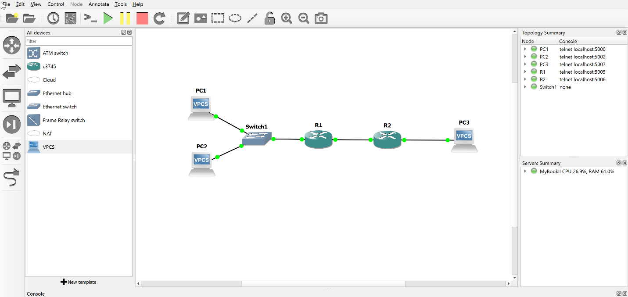

After clicking on the button, a window will pop up that looks like this:

Choose the third option or the “Manually Create a new Template” option, and then click “next”

Then you will see a bunch of options to choose from, which are basic configurations of the types of a network component. For our case. We choose the **Dynamips / IOS routers setup and click “OK”**

You will then be prompted to use an image for your new template. In our case, we are provided with a IOS file image [c3745-advipservicesk9-mz.124-25d-3.bin](https://camino.instructure.com/courses/79020/files/5656177?wrap=1) where we can download from the Lab 8 files. Select the file then upload it to software

Lastly, we need to set the Idle PC value, which will prevent IOS from using 100% of our processor or one of the cores, which can be bad for computer life. Click “finish” and we are done with creating our new components.

If created successfully, you should see the name and image of your newly created component in the “All Devices” tab

* 1. Connect Network Components

Click on the last icon on the left-hand column bar. You should see the Icon changing by adding a “red cross” on top of the original image. That shows that you are now in “link” mode.

Drag multiple devices onto the project area, and connect them by left clicking on one component (to create a link) and dragging to another component to end the link)

Put cursor on one device, click it and drag it to another device; should see a “cross” when dragging

* 1. Build a Working Network

For a working network, we need some end users, routers, switches, and links.

Use the steps above to get components onto the work area and connect them.

But something is still missing,

We learn that each user and routers have to establish a link between each other to communicate. And how do they know if they are communicating with the right person? They exchange IP addresses. We have already established a physical link, and now we need to make sure the devices recognize each other by assigning IP addresses to each side.

As a practice, you can start off building a network that looks like what I showed **in the figures above.**

After building the network, we right click first on the left router.

You will see many options on what you can do with the device.

Notice that all devices are initially set to “stop”, which means they are at rest. You need to click on “start” to make them work.

Next, to assign IP addresses and link, we need to click on the “console” to change the configuration of the device.

You should see something that looks like the picture below:

To assign IP addresses:

* We first go into the configuration by typing “config t”
* Since routers have two link connecters, we need to specify which link we want to modify.
  + Use “interface FastEthernet” + “the interface number” to get into the interface configuration
* Now assigning IP
  + Use “ip addr <IP address> <IP mask>”
* Now we can exit and check if we assign correctly
  + Use “exit” until we are no long in the config
  + Type “show interface” to check assignment of IP.

To establish Connection:

* We right click on one of the PCs, or end users
* We want to first assign our PC an IP by typing “ip <IP address>”
* Then we establish a connection with one the router by typing “ip <PC IP> <Router IP>”
* And now we have an established connection between user and router!

To test connection:

* Try sending messages from users to routers
* Type “ping <router IP>” to send a message from the PC to the router
* If there are responses, that means connection is successful.

Below is all the ping results from PC1 to all other routers, switches after establishing all connection as the links in the graph suggested.

As an example, if using “ping” receive the IP address and return time, it means that the connection is established correctly. Otherwise, a “timeout” or “Unreachable” error will be shown.

Unsuccessful with timeout or unreachable signals

Successful with return time

Play around with it until you are able to establish a connection between all devices in the network. That is when you know you build a network correctly!

Now you are ready to build your own network! Good Luck!