# Custom Models, Layers, and Loss function

* Week 1 Overview
  + Course1: Introduction to Functional APIs

Sequential model:

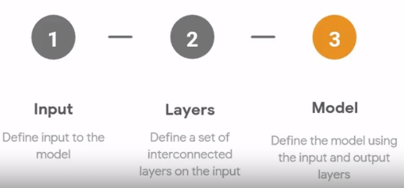

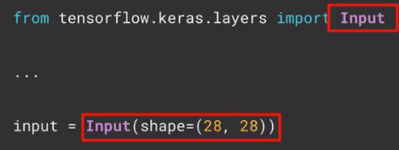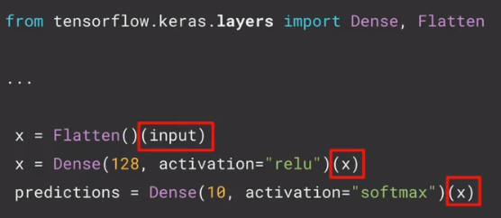

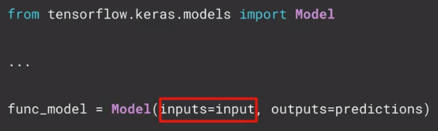

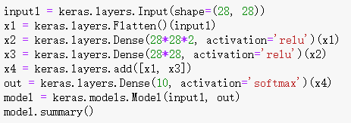

* + Course2: Declaring and stacking layers

Pass

* + Course3: Branching models

Concatenate:

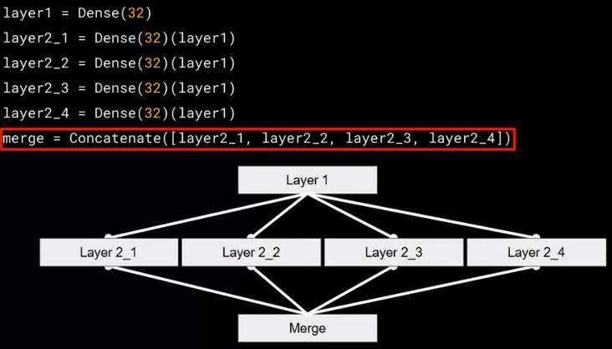

Add:

keras.layers.add([x1, x2])

Reading: [Inception Network](https://towardsdatascience.com/a-simple-guide-to-the-versions-of-the-inception-network-7fc52b863202)

* + Course4: Creating a Multi-Output model

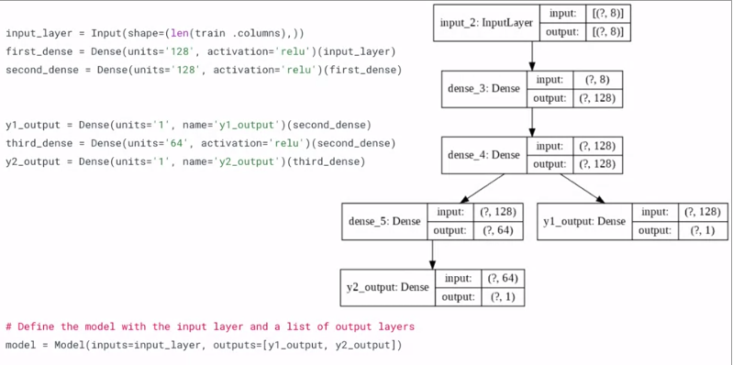

For multiple output:

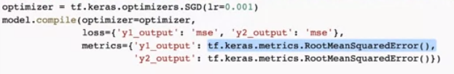

* + Course5: Siamese network: A Multiple-Input model

