**Assignment 02**

# 4 Data type of the columns

* ID: cardinal
* Tstart: time_series
* Tend: time_series
* Gender: nominal
* Age: numeric
* Height: numeric
* Play: nominal
* Watch: nominal
* Earlobes: nominal
* Hair: nominal
* VideoGame: numeric
* Physical: numeric
* Extracurricular: numeric
* Sick: numeric
* GPA: numeric
* EduMother: ordinal
* City: ordinal
* NoseLen: numeric
* FaceWidth: numeric
* HeadLen: numeric
* RightHand: numeric
* LeftHand: numeric
* Instrument: nominal

# 5 Proximity measures

If the data is not numeric, it may be one of the following: nominal, ordinal, or datetime.

Further compute the proximity between values of non-numeric data by encoding them into a numeric representation

Please refer to the code supplied.

# 6 Principal Component Analysis

## 6.1 Now try to carry out PCA of the data for the following cases (do not forget to center and scale the features)

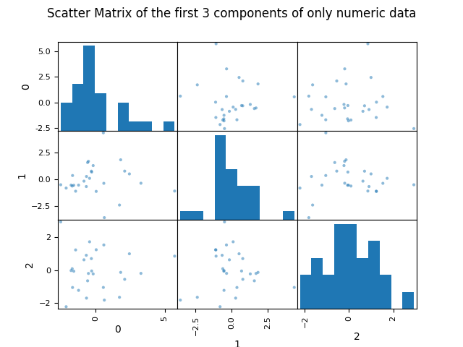

## 6.2 Plot scatter matrices

