Name: Arnab Dey ID:U20210014

6)
test=> select * from r cross join s;
a | b | b | c
---+---+---+---
a | 1 | 1 | x
a | 1 | 1 | y
a | 1 | 3 | z
b | 2 | 1 | x
b | 2 | 1 | y
b | 2 | 3 | z
(6 rows)

The two ‘b’ columns are ambiguous. We don’t know which one belongs to which of the tables.

test=> select r.a as a, r.b as rb, s.b as sb, s.c as c from r cross join s;
a | rb | sb | c
---+----+----+---
a | 1 | 1 | x
a | 1 | 1 | y
a | 1 | 3 | z
b | 2 | 1 | x
b | 2 | 1 | y
b | 2 | 3 | z
(6 rows)

test=> select r.a as a, r.b as rb, s.b as sb, s.c as c from r cross join s where r.b != s.b;
a | rb | sb | c
---+----+----+---
a | 1 | 3 | z
b | 2 | 1 | x
b | 2 | 1 | y
b | 2 | 3 | z
(4 rows)

test=> select r.a as a, r.b as rb, s.b as sb, s.c as c from r cross join s where r.b = s.b;
a | rb | sb | c
---+----+----+---
a | 1 | 1 | x
a | 1 | 1 | y
(2 rows)

10) (594)
sakila=> select * from film where film.rental_duration >= 5;
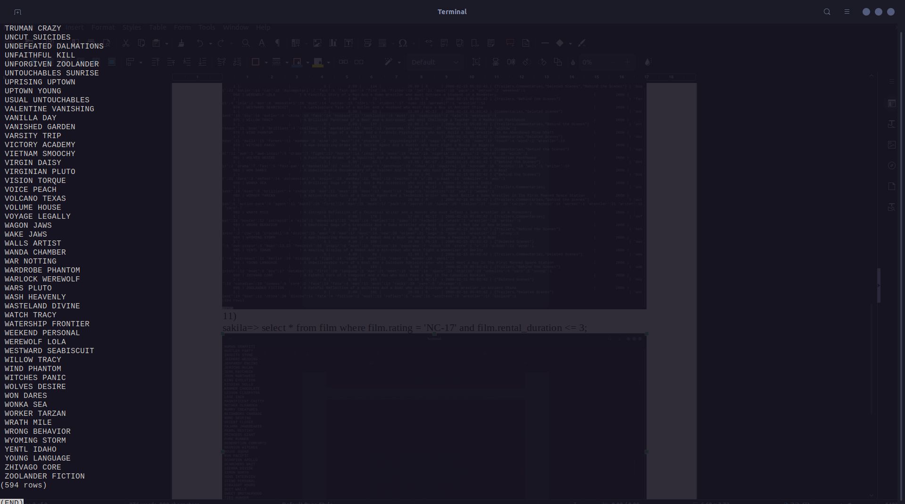
11) (79)
sakila=> select * from film where film.rating = 'NC-17' and film.rental_duration <= 3;

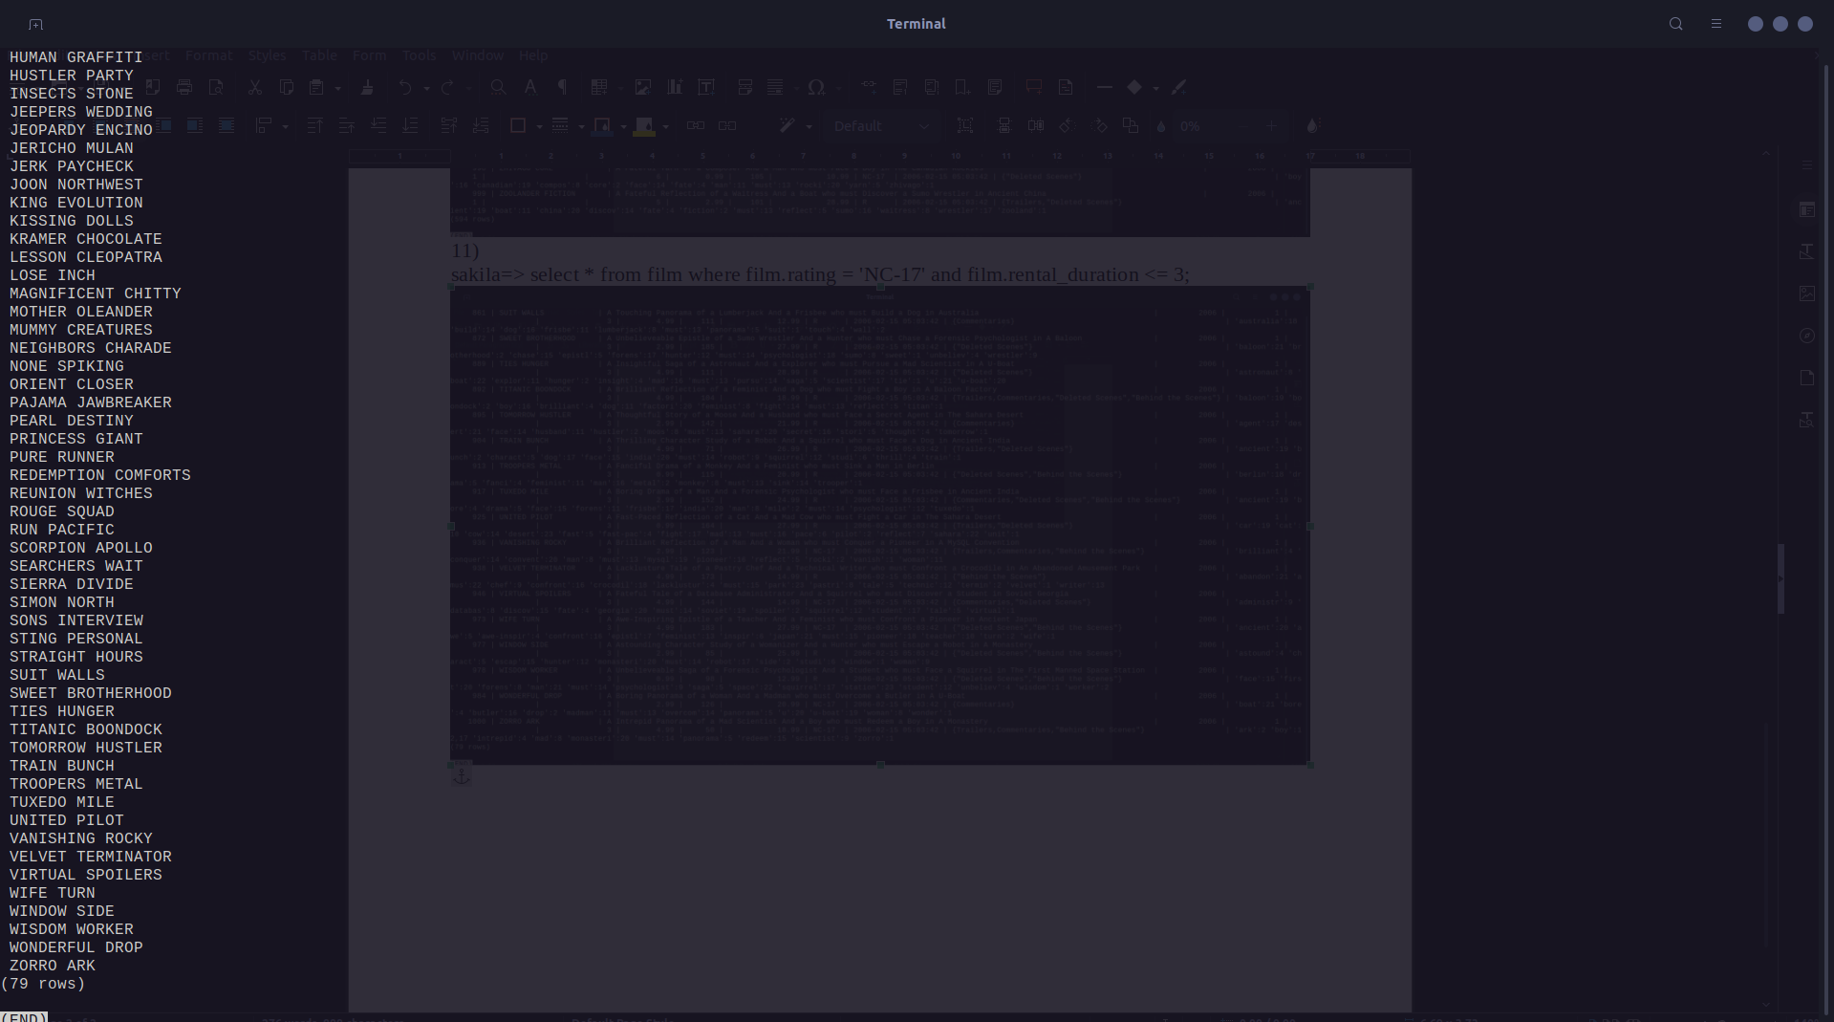

12)
sakila=> select first_name, last_name from customer where customer.address_id in (select address_id from address where postal_code like '1___');
first_name | last_name
------------+-----------
LISA | ANDERSON
RACHEL | BARNES
ELSIE | KELLEY
MARLENE | WELCH
STEPHEN | QUALLS
RAFAEL | ABNEY
KENT | ARSENAULT
(7 rows)

13) (4)
sakila=> select count(*) from customer inner join address using (address_id) where postal_code like '1%1';
count
-------
4
(1 row)

