Principal Component Analysis
DMPR: Lab activities for Week 04
Subhasis Ray February 16, 2023

In this class we shall explore principal component analysis for data re- duction and visualization.

Import libraries
#%%
import numpy as np
from scipy import signal as sig
import h5py as h5 import matplotlib
import matplotlib.pyplot as plt import pandas as pd
from sklearn.decomposition import PCA

Dummy data (inspired by the nature article)
data = pd.DataFrame(data=[[9.0, 10.0, 5.0, 6.0, 11.0, 12.0],
[9.5, 9.0, 6.0, 7.0, 10.0, 11.0],
[10.0, 11.0, 7.0, 5.0, 10.0, 9.0],
[7.0, 6.0, 10.0, 11.0, 12.0, 10.5],
[6.0, 7.0, 11.0, 10.0, 12.0, 11.0],
[4.0, 3.0, 8.0, 7.6, 9.0, 8.6],
[8.0, 8.7, 9.0, 4.3, 5.0, 4.8],
[10.0, 9.6, 10.2, 6.3, 5.9, 5.3],
[7.5, 8.0, 7.7, 2.4, 3.0, 3.1]],
index=['u1', 'u2', 'u3', 'v1', 'v2', 'v3',
‹→ 'w1', 'w2', 'w3'], columns=['a', 'b', 'c', 'd', 'e', 'f'])

Display the data: use dataframe.plot.line: 5 marks
Plot the data so that the rows are plotted as lines on sequential axes (9 axes in a column). Thus in the top axis, you will plot the values of a, b, c, d, e and f on the y axis with the column index on the x axis.
Ans:
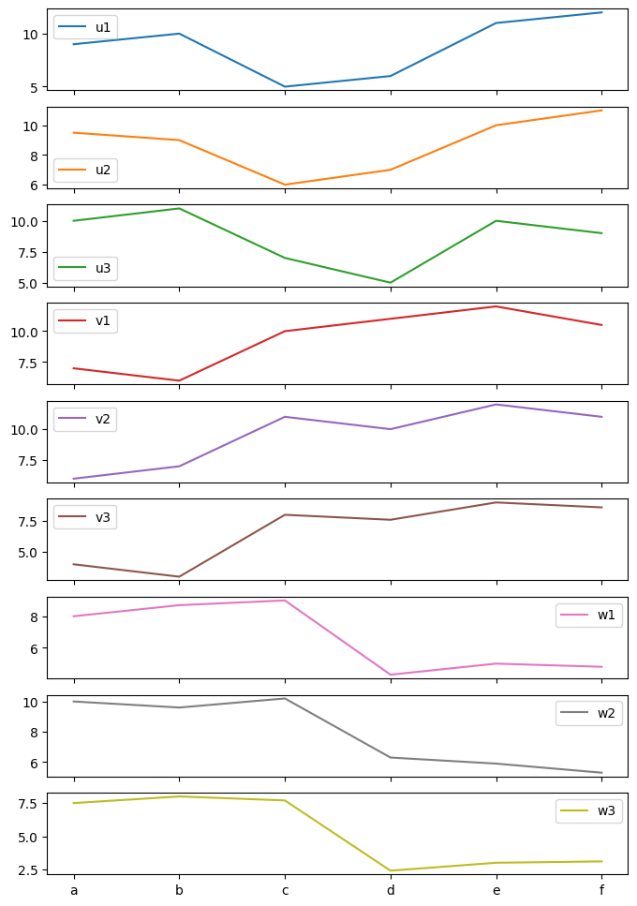

Create a PCA object and then fit the data
#%% Do PCA

pca = PCA(copy=True) ret = pca.fit(data)

print('Components:', ret.components_) print('Explained variance:', ret.explained_variance_)

Ans: Explained variance: [2.57365648e+01 1.14455187e+01 4.18511082e+00 5.35648553e-01 1.41018719e-01 1.30828465e-02]

Now create another PCA object passing n_components=3
and see the results: 5 marks
Also print the number of components and the amount of explained variance.
Ans: Explained variance: [25.73656481 11.4455187 4.18511082]

Plot the explained variance by principal compo- nents in a cumulative manner: 5 marks
Plot the cumulative explained variance as a fraction of the total.
Ans:
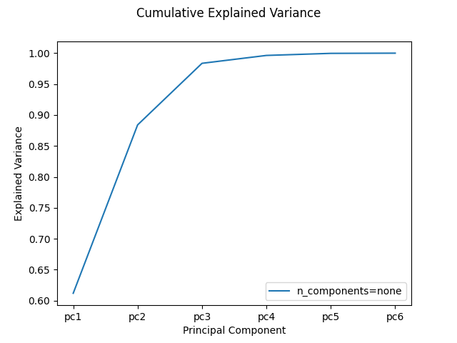
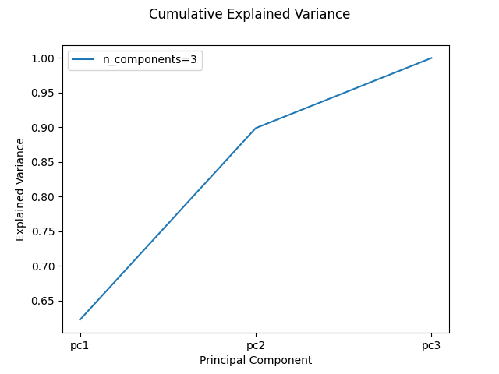

Now transform the data using the 3 component PCA
#%% Transform to PC axes
transformed = pca.transform(data) print(data.shape, transformed.shape)
fig, axes = plt.subplots(nrows=transformed.shape[0], ncols=1)

for ii in range(transformed.shape[0]): axes[ii].plot(transformed[ii])

Now plot the first two PCs: 5 marks
Create a scatter plot of the first two principal components (PC2 vs PC1), pass a list of numbers between 0 and 1 for coloring the three groups of rows (u, v, w, so you should have 3 colors, each repeated thrice). What pattern do you observe?
Ans: It seems like there are three clusters as should be after PCA such that similar data points can be distinguished from one another
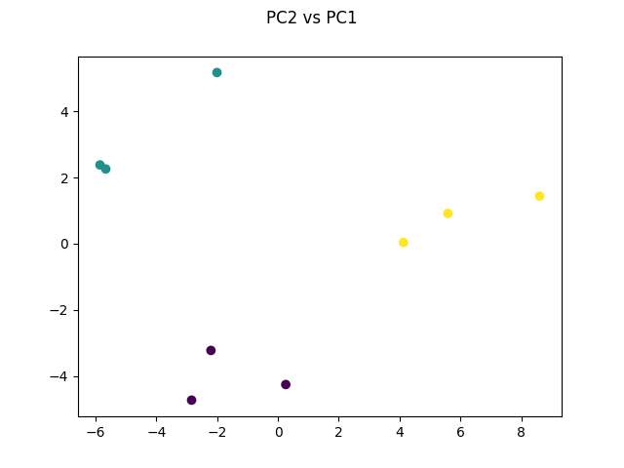

Do the inverse transform on the reduced data and plot it along with the original: 5 marks
Lookup PCA.inverse_transform.
Ans:
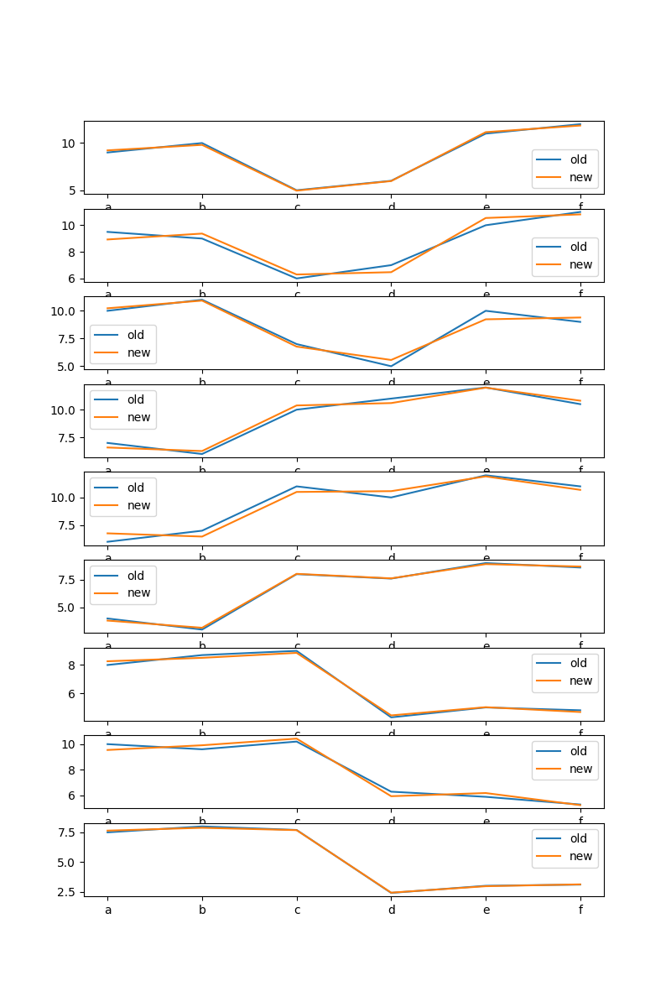

Compute the errors: 5 marks
What is the squared error for each data point after you back converted from the principle components?
Ans: 0.6131112169751007
For each data point:
u1 0.136199
u2 1.163962
u3 1.176982
v1 0.646562
v2 1.546318
v3 0.080107
w1 0.162481
w2 0.568129
w3 0.037262

