CMSC330

Lab6 – NFA's and DFA's

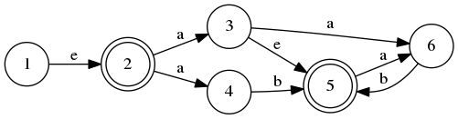1) Consider the following NFA:

For each string, determine if the NFA accepts or rejects it.

1) aabab

2) a

3) aa

4) aaa

3) ab

4) “”

2) Run NFA → DFA conversion using the powerset construction algorithm covered in lecture. Please provide some proof of your work, i.e. a table showing the results of the intermediate steps of the algorithm.

(Note: In the github repo, I've added the source for the graph as a .gv file, a human readable format for graph visualization. If you would like to create your own graphs, using the utility graphviz you can run the command “dot” in Linux to create images of graphs from .gv files.

dot -Tpng Lab6.gv -o graph.png)