# Angular Setup And CLI Lab

## 1. Create Angular project

### 1.1 Using Angular CLI create a new Angular Project

1. Open terminal window and go to location where you want to create your Angular project:

* cd /projects

1. Run the following command to create a new Angular project called calab:

* npx -p @angular/cli ng new calab

1. You will be propted with following: 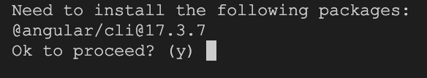
   * Type y
2. You will be asked this also: 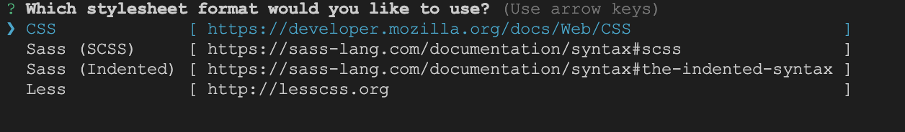
   * Select CSS
3. Finally, you will be asked this: css
   * Type y

### 1.2 Start Angular Development Server

1. Change crrent directory in your terminal to newly created Angular project.

* cd calab

1. Type the following command to start the Angular Project.

* npx -p @angular/cli ng serve

1. When Starting Angular Development serverver for the first time, you will be asked the following question: 
   * Type y or n
2. You should see a message in your Terminal confirming the development server has successfully started: 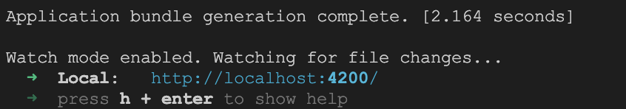
3. Click on a link in the confirmation message above. You should see the following in your newly opened browser window: 