# Create a New Angular Template

## 1. Setup Project

### 1.1 Install Dependencies

1. Change directory to calab:

* cd calab

1. Install dependencies by running the following command:

* npm install

1. You should see a message in your Terminal confirming the npm packages were installed successfully: 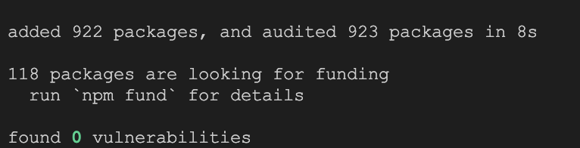

### 1.1 Start The Application

1. Start Angular Development Server if not yet started:

* npx -p @angular/cli ng serve --host 0.0.0.0
* *Otherwise refresh the browser tab to see updated view.*

1. You should see the following getting rendered in your browser:

* 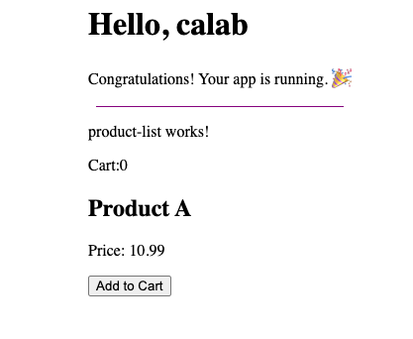
* *You should see similar view to where you left off in previous lab.*

## 2. Create Templates

### 2.1 Update Template For Product Component

1. Open src/app/components/product/product.component.css file and do the following:
   * Create a product-details css class selector: .css .product-details { background-color: #f9f9f9; padding: 20px; margin: 8px 0; border: 1px solid #ddd; box-shadow: 0 2px 4px rgba(0, 0, 0, 0.1); }
   * Create a button-add-to-cart css class selector: ```.css .button-add-to-cart { width: 100%; background-color: #04AA6D; color: white; padding: 14px 20px; margin: 8px 0; border: none; border-radius: 4px; cursor: pointer; }
   * .button-add-to-cart:hover { background-color: #45a049; } ```
2. Open src/app/components/product/product.component.html file and do the following:
   * Update current HTML with css class selectors created in previous step:
   * <div class="product-details">  
      <h2>{{ product.name }}</h2>  
      <p>Price: {{ product.price }}</p>  
      <button class="button-add-to-cart" (click)="onAddToCartClicked()">Add to Cart</button>  
     </div>

### 2.2 Update Template For Product List Component

1. Open src/app/components/product-list/product-list.component.html file and do the following:
   * Update current HTML with the following:
   * <div>  
      <h2>Product List</h2>  
      🛒 {{cart.length}}  
      <app-product [product]="product"(addToCartEvent)="addToCart($event)"></app-product>  
     </div>

### 2.3 Start The Application

1. Start Angular Development Server if not yet started:

* npx -p @angular/cli ng serve --host 0.0.0.0
* *Otherwise refresh the browser tab to see updated view.*

1. You should see the following getting rendered in your browser:

* 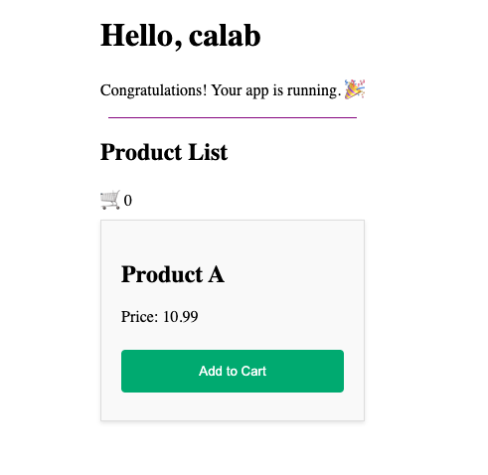

## 3. Template Control Flow

### 3.1 Modify Product List Template To Conditionaly Display Cart Value

1. Open src/app/components/product-list/product-list.component.html file and do the following:
   * Update current HTML to include Angular built-in control flow block that allows conditionaly display elements:
   * @if (cart.length > 0) {  
      🛒 {{cart.length}}  
     } @else {  
      🛒 Empty  
     }

### 3.1 Modify Product List Template To Render List Of Products

1. Open src/app/components/product-list/product-list.component.ts file and do the following:
   * Replace product variable with list of products:
   * products: Product[] = [  
      new Product('Product A', 10.99),   
      new Product('Product B', 7.59),   
      new Product('Product C', 3.20)  
     ];
2. Open src/app/components/product-list/product-list.component.html file and do the following:
   * Update current HTML to include Angular built-in control flow block that allows repeatedly display elements:
   * @for (product of products; track product) {  
      <app-product [product]="product"(addToCartEvent)="addToCart($event)"></app-product>  
     }

### 3.4 Instpect Changes

1. Start Angular Development Server if not yet started:

* npx -p @angular/cli ng serve --host 0.0.0.0
* *Otherwise refresh the browser tab to see updated view.*

1. You should see the following getting rendered in your browser:

* 