# Create Custom Pipe

## 1. Setup Project

### 1.1 Install Dependencies

1. Change directory to calab:

* cd calab

1. Install dependencies by running the following command:

* npm install

1. You should see a message in your Terminal confirming the npm packages were installed successfully: 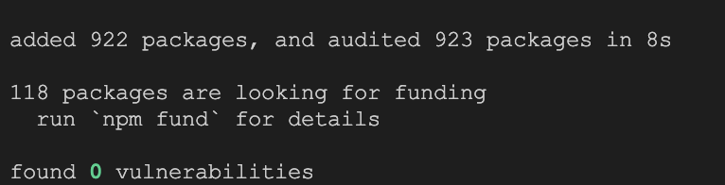

### 1.1 Start The Application

1. Start Angular Development Server if not yet started:

* npx -p @angular/cli ng serve --host 0.0.0.0
* *Otherwise refresh the browser tab to see updated view.*

1. You should see the following getting rendered in your browser:

* 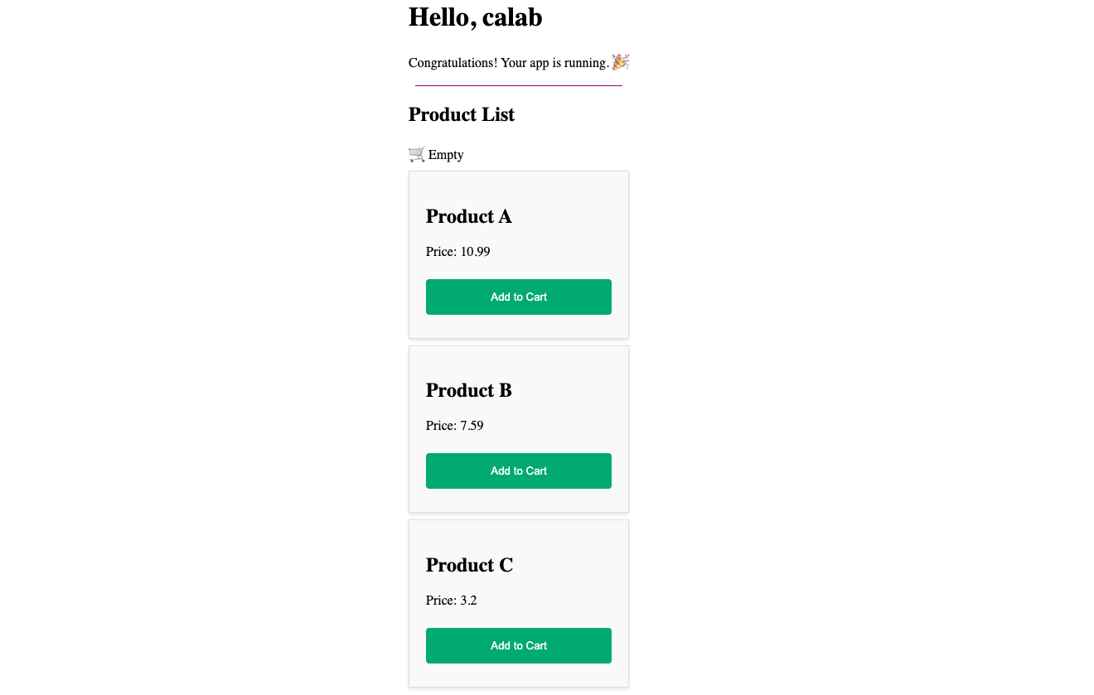
* *You should see similar view to where you left off in previous lab.*

## 2. Use Built-in Pipe

### 2.1 Update Product Component To Use Built-in Corrency Pipe

1. Open src/app/components/product/product.component.ts file and do the following:
   * Import CurrencyPipe from '@angular/common':
   * import { CurrencyPipe } from '@angular/common';​
     1. Update imports to include CurrencyPipe:
   * imports: [CurrencyPipe],
2. Open src/app/components/product/product.component.html file and do the following:
   * Update Paragraph element representing Price to include currency pipe:
   * <p>Price: {{ product.price | currency: "GBP"}}</p>

### 2.2 Instpect Changes

1. Start Angular Development Server if not yet started:

* npx -p @angular/cli ng serve --host 0.0.0.0
* *Otherwise refresh the browser tab to see updated view.*

1. You should see the following getting rendered in your browser:

* 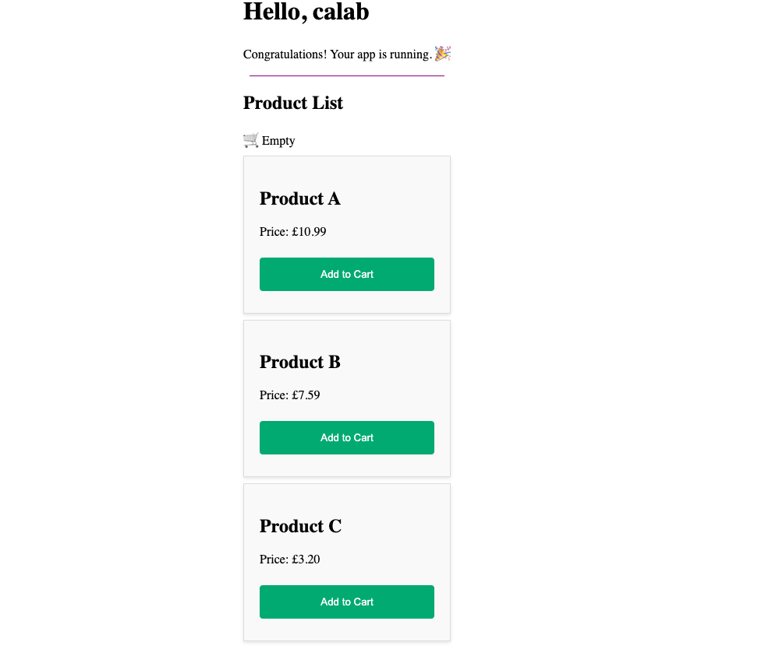

## 3. Create Custom Pipe

### 3.1 Update Product Model with description

* Open src/app/models/product.ts file and extend current implementation with new description property:
* export class Product {  
   constructor(  
   public name: string,  
   public description: string,  
   public price: number,  
   ) {}  
  }

### 3.2 Update Product List Component

* Open src/app/components/product-list/product-list.component.ts file and update current list of Products array. Add description to each instance of a Product:
* products: Product[] = [  
   new Product('Product A', 'This is a very long text that needs to be truncated', 10.99),   
   new Product('Product B', 'All Good', 7.59),   
   new Product('Product C', 'This is a very long text that needs to be truncated ', 3.20)  
  ];

### 3.3 Update Product Component

* Open src/app/components/product/product.component.css file and add a new CSS selector to style product details.
* .product-description {  
   font-size: 16px;  
   color: #666;  
  }
* Open src/app/components/product/product.component.html file and add a new Paragraph just below the product <h2> title element:
* <p class="product-description">{{ product.description }}</p>

### 3.3 Generate Custom Pipe

* In your terminal window type in the following commad:
* npx -p @angular/cli ng generate pipe pipes/truncate
* Open src/app/pipes/truncate.pipe.ts file and add the following implementation to newly created truncate pipe.

@Pipe({  
 name: 'truncate',  
 standalone: true  
})  
export class TruncatePipe implements PipeTransform {  
  
 transform(value: string, maxLength: number = 20): string {  
 if (value.length <= maxLength) {  
 return value;  
 }  
 return value.substring(0, maxLength) + '...';  
 }  
}

### 3.4 Update Product Component To Use Custom Pipe

* Open src/app/components/product/product.component.ts file and do the following:
  + Import TruncatePipe from '../../pipes/truncate.pipe'
  + import { TruncatePipe } from '../../pipes/truncate.pipe';
  + Update imports to include TruncatePipe:
  + imports: [CurrencyPipe, TruncatePipe],
* Open src/app/components/product/product.component.html and update product paragraph to include the truncate pipe: .html <p class="product-description">{{ product.description | truncate}}</p>

### 3.5 Instpect Changes

1. Start Angular Development Server if not yet started:

* npx -p @angular/cli ng serve --host 0.0.0.0
* *Otherwise refresh the browser tab to see updated view.*

1. You should see the following getting rendered in your browser:

* 