# Dependency Injection Lab

## 1. Setup Project

### 1.1 Install Dependencies

1. Change directory to calab:

* cd calab

1. Install dependencies by running the following command:

* npm install

1. You should see a message in your Terminal confirming the npm packages were installed successfully: 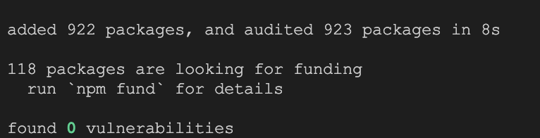

### 1.1 Start The Application

1. Start Angular Development Server if not yet started:

* npx -p @angular/cli ng serve
* *Otherwise refresh the browser tab to see updated view.*

1. You should see the following getting rendered in your browser:

* 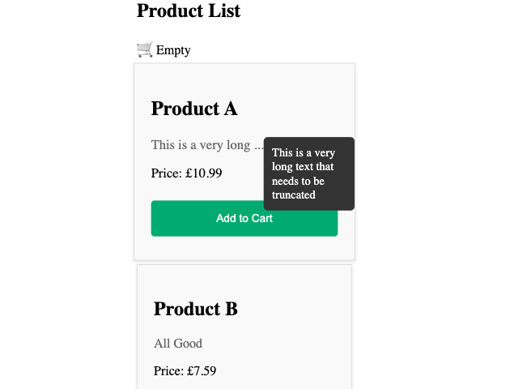
* *You should see similar view to where you left off in previous lab.*

## 2. Create A Service​

### 2.1 Create A Service To Return List Of Products

1. Create a new service called ProductService using CLI:

* npx -p @angular/cli ng generate service services/product

1. Open src/app/services/product.service.ts file and add the following code:

* import { Injectable } from '@angular/core';  
  import DATA from './MOCK_DATA.json';  
    
  @Injectable({  
   providedIn: 'root'  
  })  
  export class ProductService {  
   constructor() { }  
    
   getProducts(){  
   return DATA;  
   }  
  }
* *getProducts() method will return the mock Data imported from MOCK_DATA.json.*

## 3. Inject Service as Dependency Into Component

### 3.1 Update Product Model with id.

1. Open src/app/models/product.ts and update Product model with the follwoing:

* export class Product {  
   constructor(  
   public id: number,  
   public name: string,  
   public description: string,  
   public price: number,  
   ) {}  
  }

### 3.2 Inject Product Service to Product List Component

1. Open src/app/components/product-list/product-list.component.ts file and do the following:
   * Import ProductService:
   * import { ProductService } from '../../services/product.service';
   * Add the ProductService as a parameter into the constructor.
   * constructor(private productService: ProductService) {}
   * Replace static list of Products with a service call.
   * products: Product[] = this.productService.getProducts();

### 3.3 Instpect Changes

1. Start Angular Development Server if not yet started:

* npx -p @angular/cli ng serve --host 0.0.0.0
* *Otherwise refresh the browser tab to see updated view.*

1. You should see the following getting rendered in your browser:

* 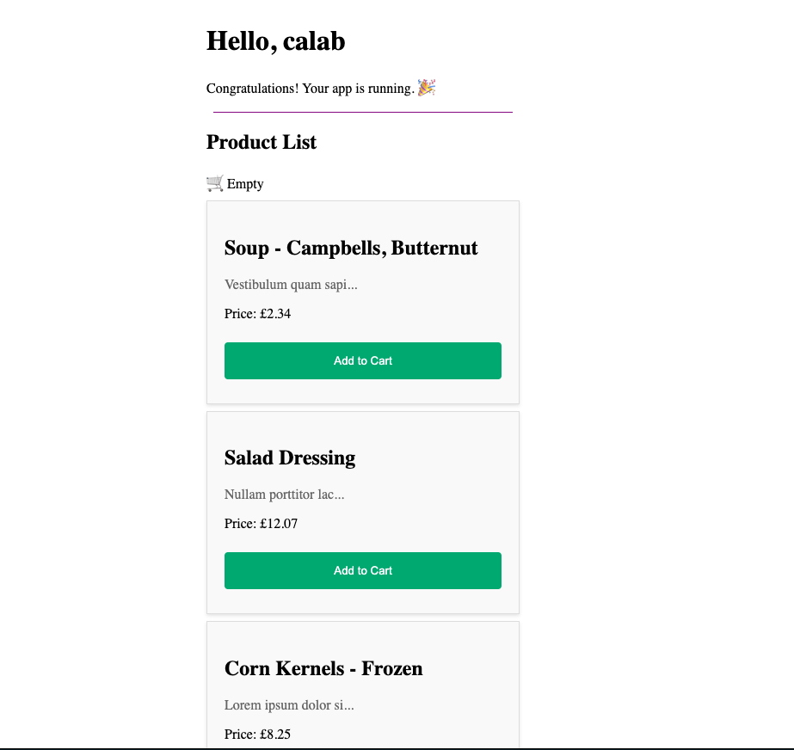

## 4. Injecting Services In Other Services

### 4.1 Create A New Logger And Implement It’s Logic

1. Create a new Logger using CLI:

* npx -p @angular/cli ng generate service services/logger/logger

1. Open src/app/services/logger/logger.service.ts file and do the following:
   * Create logging methods just below the constructor :
   * log(msg: unknown) { console.log(msg); }  
     error(msg: unknown) { console.error(msg); }  
     warn(msg: unknown) { console.warn(msg); }

### 4.2 Inject Logger Service Into Project Service And Log When Projects Are Fetched

1. Open src/app/services/product.service.ts file and do the following:
   * Import Logger service:
   * import { LoggerService } from '../logger/logger.service';
   * Add the LoggerService as a parameter into the constructor.
   * constructor(private logger: LoggerService) { }
   * Inside getProducts() method log that courses are getting fetched.
   * this.logger.log('Fetching Products');

### 4.3 Review Changes

1. Start Angular Development Server if not yet started:

* npx -p @angular/cli ng serve --host 0.0.0.0
* *Otherwise refresh the browser tab to see updated view.*

1. Inspect console and see whether your application logs with Logger. result3

## 5. Configuring Dependency Providers

### 5.1 Creating Enhanced Logger

1. Create a new TimedLoggerService using CLI:

* npx -p @angular/cli ng generate service services/logger/timed-logger

1. Open src/app/services/logger/timed-logger.service.ts file and do the following:
   * Extend LoggerService with TimedLoggerService:
   * export class TimeLoggerService extends LoggerService {...}
   * Override logging methods just below the constructor:
   * constructor() {  
      super()  
     }  
     private getUtcDate(){  
      const timeElapsed = Date.now();  
      const today = new Date(timeElapsed);  
      const utcDate = today.toUTCString();  
      return utcDate;  
     }  
       
     override log(msg: unknown) {   
      const date = this.getUtcDate();  
      console.log(`${date}: ${msg}`);   
     }  
     override error(msg: unknown) {   
      const date = this.getUtcDate();  
      console.error(`${date}: ${msg}`);   
     }  
     override warn(msg: unknown) {   
      const date = this.getUtcDate();  
      console.warn(`${date}: ${msg}`);   
     }

### 5.2 Configure an app-wide provider in the ApplicationConfig of bootstrapApplication, it overrides one configured for root in the @Injectable() metadata.

1. Open app.config.ts file and add the following:
   * Update providers with the following:

* providers: [provideRouter(routes), provideClientHydration(), {provide: LoggerService, useClass: TimedLoggerService}]

### 5.3 Review Changes

1. Start Angular Development Server if not yet started:

* npx -p @angular/cli ng serve --host 0.0.0.0
* *Otherwise refresh the browser tab to see updated view.*

1. Inspect console and see whether your application logs with new Enhanced Timed Logger. result4