# Angular Signals Lab

## 1. Setup Project

### 1.1 Install Dependencies

1. Change directory to calab:

* cd calab

1. Install dependencies by running the following command:

* npm install

1. You should see a message in your Terminal confirming the npm packages were installed successfully: 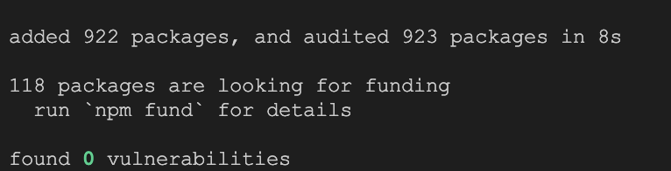

### 1.1 Start The Application

1. Start Angular Development Server if not yet started:

* npx -p @angular/cli ng serve
* *Otherwise refresh the browser tab to see updated view.*

1. You should see the following getting rendered in your browser:

* 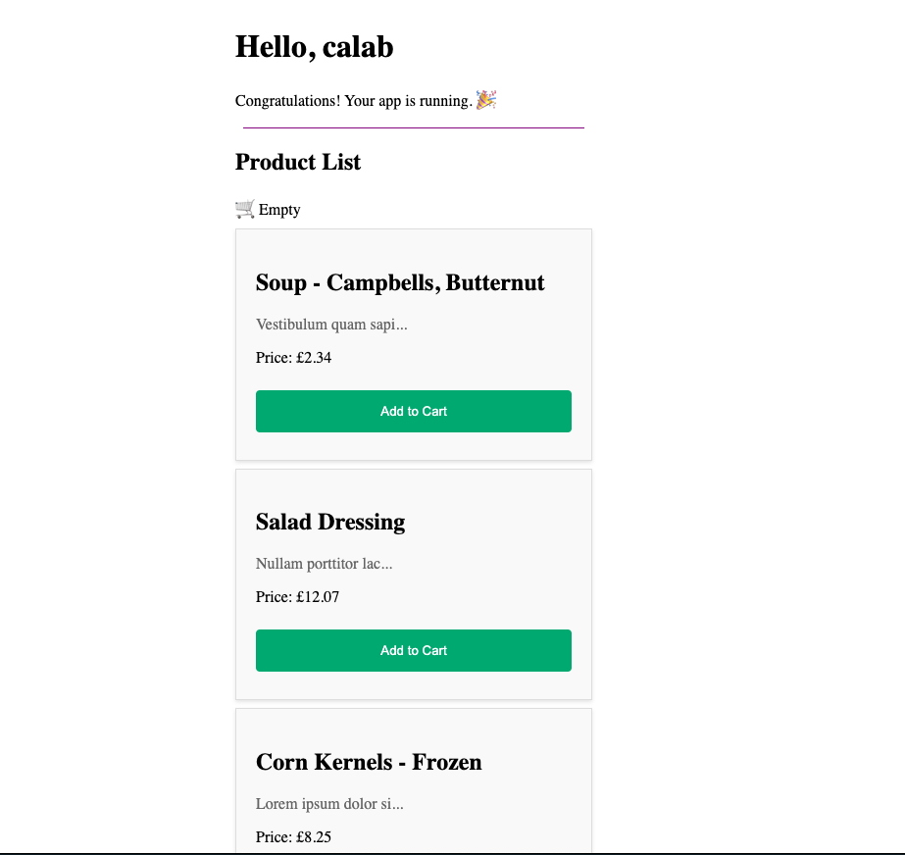
* *You should see similar view to where you left off in previous lab.*

## 2. Move Cart Separate Component

### 2.1 Create A Cart Component

* Create a new Component called Cart using CLI:
* npx -p @angular/cli ng generate component components/cart

### 2.1 Create A Cart Service

* Create a new Component called Cart using CLI:
* npx -p @angular/cli ng generate service services/cart

### 2.2 Implement Signal Inside Cart Service

* Open src/app/services/cart.service.ts file and do the following:
  + Declate a writable signal and set its default value to empty list []:
  + currentCart = signal<Product[]>([]);
  + Inside constructor of CartService, call an effect and log the Signal value:
  + constructor(){  
     effect(() => {  
     console.log(`The current car contains: ${this.currentCart()}`);  
     });  
    }
  + Inside CartService, just below constructor, declare getCart function:
  + getCart(){  
     return this.currentCart;  
    }
  + Inside CartService, just below constructor, declare addToCart function that takes Product as a parameter:
  + addToCart(product: Product){  
     this.currentCart.update(list => {  
     return [...list, product];  
     })  
    }

### 2.2 Inject CartService Into Cart Component

* Open src/app/components/cart/cart.component.ts file and do the following:
  + Declate a writable signal called cartSignal:
  + cartSignal: Signal<Product[]>;
  + Inject CartService into CartComponents constructor and retrieve cart signal and assign it to the variable declared in previous step:
  + constructor(private cartService: CartService){  
     this.cartSignal = this.cartService.getCart();  
    }
  + Inside CartComponent, just below constructor, declare addToCart function that takes Product as a parameter and sends it to CartService:
  + public addToCart(product: Product){  
     this.cartService.addToCart(product)  
    }
* Open src/app/components/cart/cart.component.html and replace current HTML code with the following:
* @if (cartSignal().length > 0) {  
   🛒 {{cartSignal().length}}  
  } @else {  
   🛒 Empty  
  }

### 2.3 Remove Cart From Product List Component

* Open src/app/components/product-list/product-list.component.ts and do the following:
  + Inject CartService into producListComponents constructor:
  + constructor(private productService: ProductService, private cartService: CartService) {}
  + Delete the following line since it’s no longer needed:
  + cart: Product[] = [];
  + Update the addToCart() method to call CartService instead of adding to previously declared list of Products:
  + addToCart(product: Product) {  
     this.cartService.addToCart(product);  
    }
* Open src/app/components/product-list/product-list.component.html and remove the folling code:
* @if (cart.length > 0) {  
   🛒 {{cart.length}}  
  } @else {  
   🛒 Empty  
  }

### 2.3 Move Cart To App Component

* Open src/app/app.component.ts file and do the following:
  + Inside src/app/app.component.ts update imports to include CartComponent:
  + imports: [RouterOutlet, ProductListComponent, CartComponent],
* Open src/app/app.component.html file and do the following:
  + Add the following element after the <div class="divider"..., to render CartComponent.
  + <app-cart></app-cart>

### 5.3 Review Changes

1. Start Angular Development Server if not yet started:

* npx -p @angular/cli ng serve --host 0.0.0.0
* *Otherwise refresh the browser tab to see updated view.*

1. You should see the following getting rendered in your browser: 