# Angular Routing Lab

## 1. Setup Project

### 1.1 Install Dependencies

1. Change directory to calab:

* cd calab

1. Install dependencies by running the following command:

* npm install

1. You should see a message in your Terminal confirming the npm packages were installed successfully: 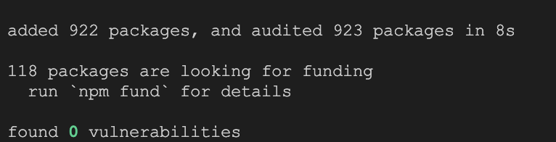

### 1.1 Start The Application

1. Start Angular Development Server if not yet started:

* npx -p @angular/cli ng serve
* *Otherwise refresh the browser tab to see updated view.*

1. You should see the following getting rendered in your browser:

* 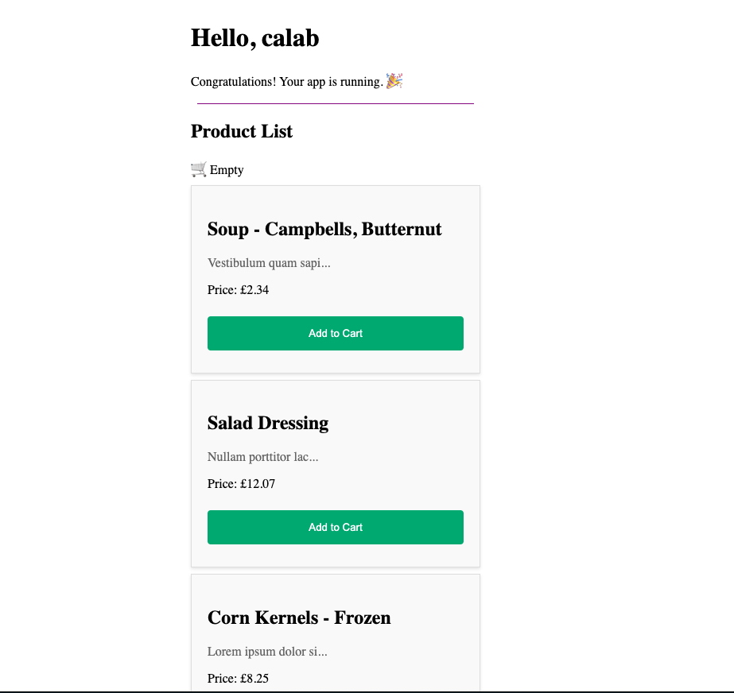
* *You should see similar view to where you left off in previous lab.*

## 2. Create a new Component

### 2.1 Create A New Component Called CreateProduct

1. Create a new Component called Cart using CLI:

* npx -p @angular/cli ng generate component components/create-product

## 3. Define and Use Your Routes

### 3.1 Define Routes In Routes Array

1. Open src/app/app.routes.ts file and do the following:
   * Import components that going to be used in router.
   * import { CreateProductComponent } from './components/create-product/create-product.component';  
     import { ProductListComponent } from './components/product-list/product-list.component';
   * Define each route as an JavaScript object and add it to Routes array:
   * { path: 'create-product', component: CreateProductComponent },  
     { path: 'product-list', component: ProductListComponent }

### 3.2 Use Defined Routs In an Application

1. Open src/app/app.component.ts file and do the following:
   * Import RouterLink from the @angular/router.
2. Open src/app/app.component.html file and do the following:
   * Just above <h1>Hello, {{ title }}</h1>, use a routerLink attributes to add routes to selected elements. Also move <app-cart></app-cart> to navigation bar as well.:
   * <nav class="nav-bar">  
      <ul>  
      <li><a routerLink="/create-product" >Create Product</a></li>​  
      <li><a routerLink="/product-list">Product List</a></li>​  
      <li>  
      <app-cart></app-cart>  
      </li>  
      </ul>  
     </nav>
   * Move <router-outlet /> from bottom of the file to just below <div class="divider"... . .html <div class="divider" role="separator" aria-label="Divider"></div> <router-outlet />
3. Open src/app/app.component.css file and do the following styling for Navigation bar: ```.css .nav-bar { background-color: #a8bef5; padding: 10px; box-shadow: 0 2px 4px rgba(0, 0, 0, 0.3); }

* .nav-bar ul { list-style: none; margin: 0; padding: 0; display: flex; justify-content: space-between; }
* .nav-bar li { margin-right: 20px; }
* .nav-bar a { color: #000000; padding: 10px; text-decoration: none; }
* .nav-bar a:hover { color: #8a7878; } ```

### 3.3 Review Changes

1. Start Angular Development Server if not yet started:

* npx -p @angular/cli ng serve
* *Otherwise refresh the browser tab to see updated view.*

1. You should see the following getting rendered in your browser: 