Towards a simpler ecocrop model

Andy South and Nicole Forstenhaeusler

2017-09-26

### Abstract

A simpler method than the ecocrop model for predicting crop suitability based upon the FAO ecocrop database has been developed. This new simple method produces better true positive rates than the original ecocrop model when tested against MIRCA harvested area data for the year 2000.

The original ecocrop modelling approach has certain details that seem not to be justified by these tests against field data.

The new simpler method simply predicts if an area is suitable or not (0/1), rather than predicting a suitability value between 0 and 1. It aims for a conservative approach, to be able to exclude areas that are unsuitable with some confidence, while being less concerned that some unsuitable areas are classed as suitable.

##### Table 1 : The new simpler method has a better true positive rate than ecocrop for rainfed crops. Comparing global predictions for the year 2000 to Mirca.

|  |  |  |
| --- | --- | --- |
| crop | simple_true_positive | ecocrop_true_positive |
| maize | 0.86 | 0.44 |
| rice | 0.51 | 0.37 |
| wheat | 0.78 | 0.35 |
| soya_bean | 0.60 | 0.51 |

##### Table 2 : The new simpler method has a slightly poorer true negative rate (specificity) than ecocrop for rainfed crops. However the true negative rate is not such a good test because we expect that other factors (e.g. such as history and economy) contribute to crops not being grown in areas that have a suitable climate.

|  |  |  |
| --- | --- | --- |
| crop | simple_true_negative | ecocrop_true_negative |
| maize | 0.12 | 0.15 |
| rice | 0.20 | 0.21 |
| wheat | 0.11 | 0.16 |
| soya_bean | 0.15 | 0.16 |

##### Maps showing how the new simpler predictions compare both to Mirca and the existing ecocrop model.

Both Mirca and ecocrop have a gradation of values, these are converted to 0/1 in the testing process.

In the first set of maps I convert everything to 0/1 to aid comparisons.

In the 2nd set of maps I keep the range of values in the Mirca and ecocrop predictions. In these later maps grey in the Mirca maps represents harvested area greater than 0 (but low). Grey in the suitability maps represents 0 suitability. I think that the fact that the green pattern in the suitability maps follows the grey pattern in the mirca maps is a good sign. I just want us to discuss this and then I can improve the colour schemes.

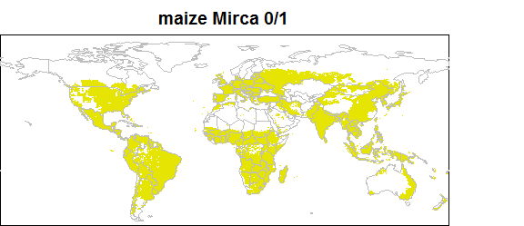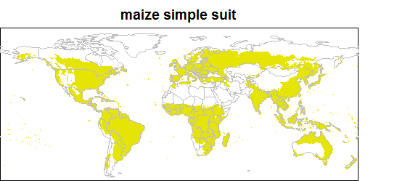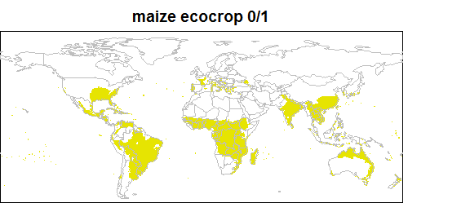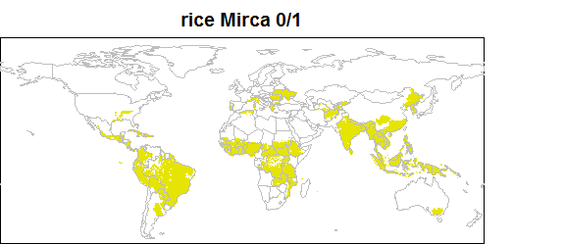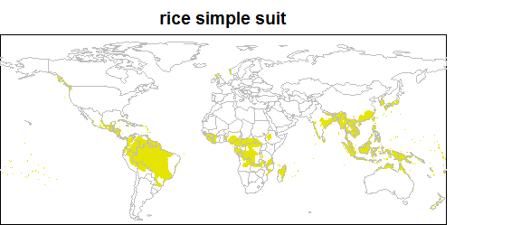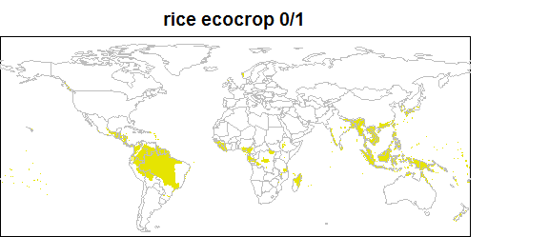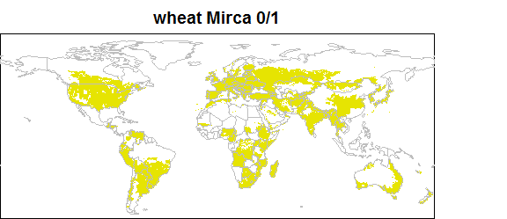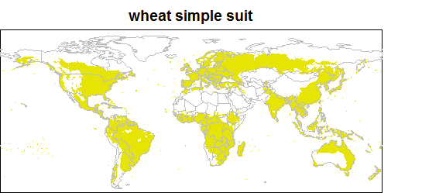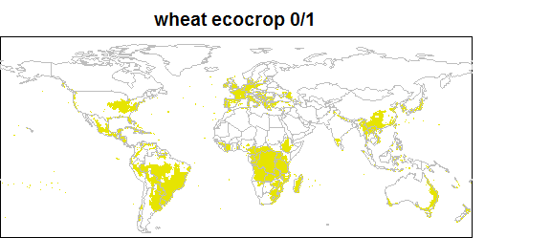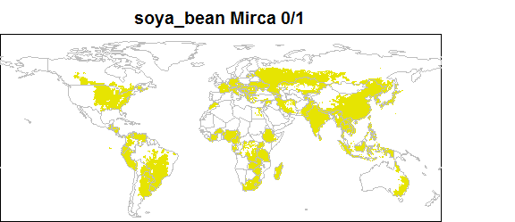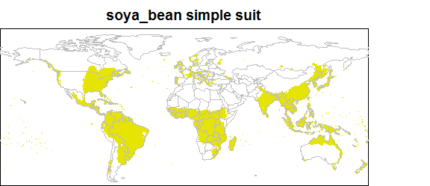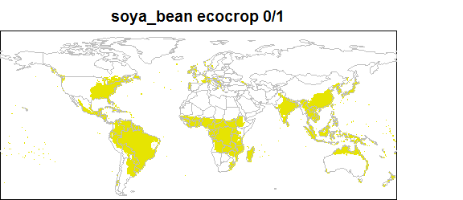

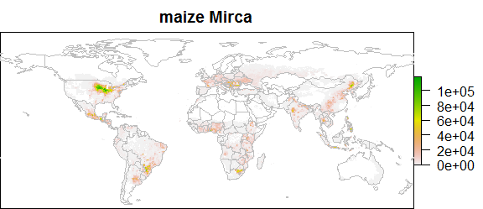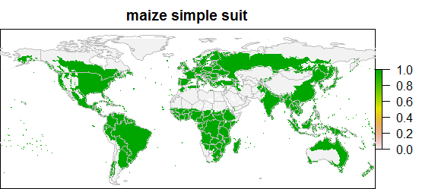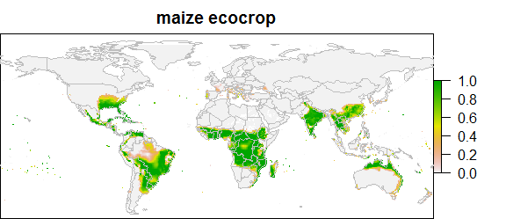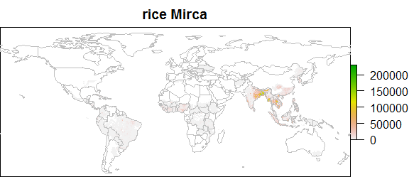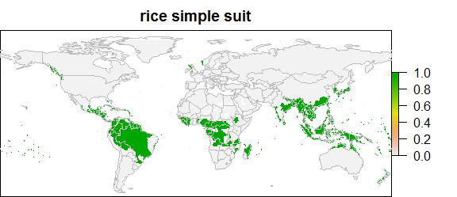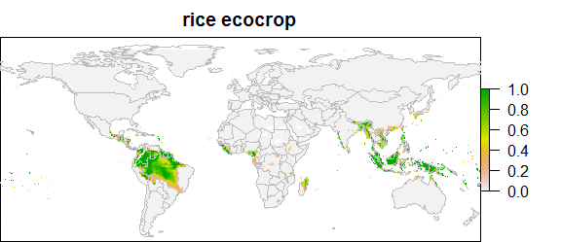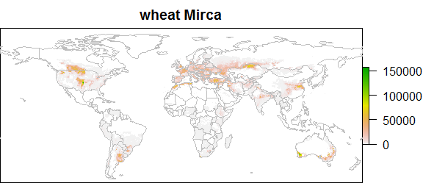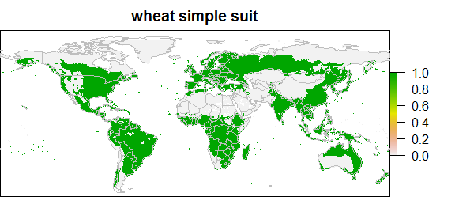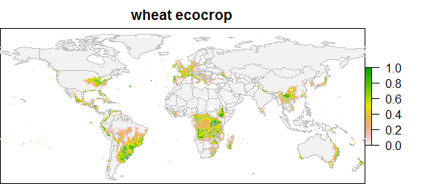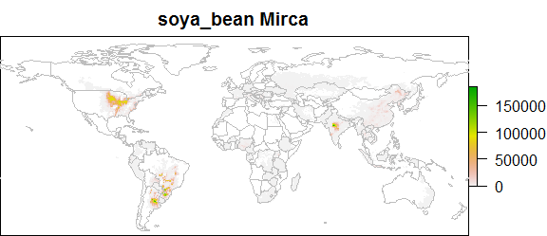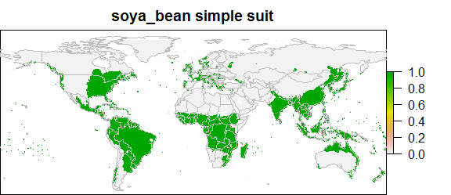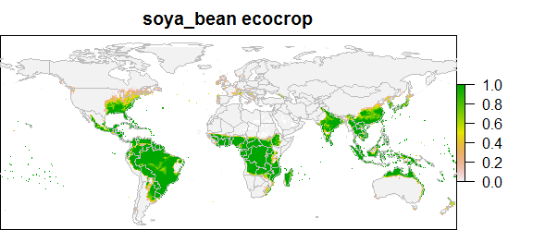

### Background

The FAO ecocrop database holds data for more than 2500 crops including requirements for temperature, rainfall and soils based upon expert judgement. The ecocrop modelling approach estimates suitability for crops based on temperature and precipitation using these requirements. The ecocrop modelling approach has been implemented in a number of slightly different ways. Ecocrop the modelling is designed to be simpler than other crop models allowing it to be applied to a wider range of crops and situations. However ecocrop the model as implemented in R and Diva-GIS has some aspects that are not well justified.

In summary the ecocrop the modelling approach : 1. Calculates a mean of the minimum and maximum crop growth cycle 2. Rounds this mean (up or down) to the nearest number of months to calculate a 'duration' 3. Finds whether there are 'duration' consecutive months in between the ecocrop temperature limits 4. Finds whether there is a concurrent 'duration' period where the total precipitation is between the ecocrop rainfall requirements of the crop.

This is a broad summary of the ecocrop model as implemented within the R package dismo and with Diva-GIS.

In addition the model uses 'optimal' temperature and precipitation limits specified in FAO ecocrop to develop an index of suitability per month, the best month and the value of the index in the best month.

Ecocrop the model as implemented in this way has not been well tested against empirical data.

For what is supposed to be a simple modelling approach the method becomes quite tricky and not very transparent.

Firstly it doesn't seem very mechanistic to me that a mean of the minimum and maximum crop growth cycles is used as one of the most influential parameters. For example for maize the minimum and maximum crop growth cycles are 65 days and 365 days which round to 3 months and 12 months. The ecocrop model thus assesses temperatures for a 7 month growth cycle. The figure below shows the minimum and maximum crop growth cycles stored within ecocrop for some important crops.

### length of crop growth cycles from ecocrop

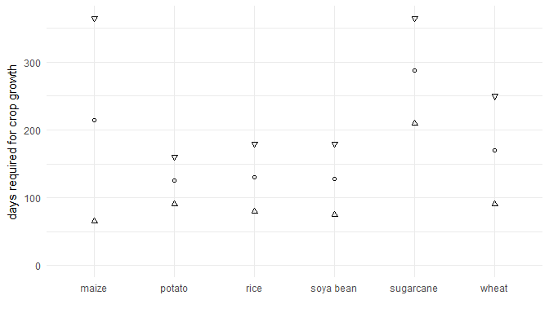

Secondly the crop parameters as specified in the FAO ecocrop database are necessarily very broad. Whilst they are based on expert judgement they cannot hope to capture all of the processes that influence the suitability of an area for a crop. For thi reason I feel it may be pushing the method too far to develop a suitability value between 0 and 1. I note also that there are few data available to test such an index at a global scale. I feel that a more realistic goal would be to try to predict which areas are definitely not suitable for a crop.

A simpler, more transparent, method could allow us to use both the minimum and maximum growth cycles and to develop predictions of which areas are not suitable for a crop.

The proposed method is :

1. Use the minimum crop growth cycle to assess whether there is a minimum period within the year within the crop temperature limits that could allow the crop to grow.
2. Use the maximum crop growth cycle to assess whether there is a period that could allow the crop to get sufficient water. Trials have shown that using either the maximum crop growth cycle to assess temperature or the minimum crop growth cycle to assess rainfall leads to the exclusion of unrealistic areas (e.g. excluding maize from most of Europe).

The base ecocrop predictions have some aspects that also look wrong for example they too predict that maize will not grow in Europe. This is also the problem that Nicole had making predictions far into the future, the ecocrop method of using the mean growing cycle to find time periods without low temperatures was excluding moderately northern latitudes.

The proposed new method predicts that a greater proportion of land is potentially suitable. Indeed it may suggest that too much land is suitable, for example looking at maize predictions in Northern latitudes. However I can't think of another way of mechanistically excluding these areas using the ecocrop data.

As a part of developing this I've developed a series of R functions enabling better access to the ecocrop database and for comparing predictions. I can document these further when we are agreed on the best method to use.

For now I'm keen to establish whether this simpler method is more useful to apply to Nicoles model runs.